Personal, Social, Health, Relationships and Economic Education (including Sex Education)

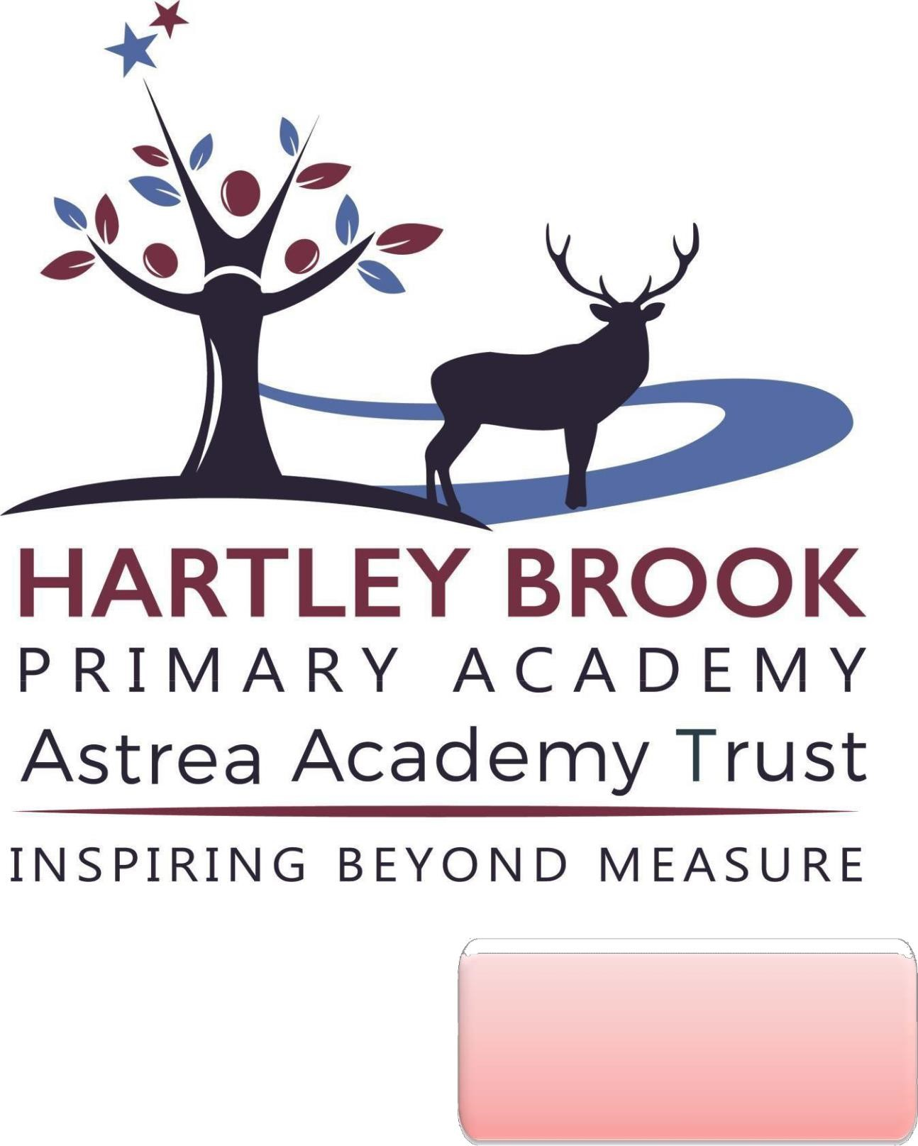
Policy Agreed: April 2023

Policy Review: April 2024

Aims:

To establish a clear policy for PSHRE Education that is understood by all staff, parents and children, providing a sound basis for ensuring that children are taught essential knowledge and skills to grow and develop with confidence, making good choices about health and safety.

This policy includes:
- Statutory requirements
- Priorities for pupils
- How safeguarding fits into PSHRE Education
- Definitions of aspects taught
- Subject content including how it is taught and who is responsible for teaching it
- Assessment
- Withdrawing children from lessons- parental rights.
- Our approach to LGBT relationships.
- Monitoring and evaluation procedures.

Links to other policies:
- Behaviour
- Equality
- Safeguarding
- First Aid
- Health and Safety
- Online Safety

Context:
Hartley Brook is committed to providing a curriculum that is broad, balanced and meets the needs of all pupils. Our policy is informed by existing DfE guidance and has due regard for updated statutory guidance for RSHE. In writing this policy, consideration has been given to the statutory guidance, context of the school, a review of the priority needs of our pupils (particularly with Covid- 19 considerations) and consultation feedback with parents.
Hartley Brook is situated in Sheffield which is 63rd most deprived out of 326 local authority areas in England (2021); the area the school serves was declared the 12th most poverty-stricken area of England out of over 32,000 neighbourhoods (2021). The number of children living in conditions of poverty is higher than the national average. Our school is a large school with an above average proportion of EAL pupils. The school community offers rich opportunities for early socio-cultural and diversity education. An above average percentage of pupils speak more than one language and from an early age the school nurtures respect for diversity, inclusion and equality.
We teach a full, comprehensive PSHRE curriculum but prioritise aspects that we have identified as significant to our pupils and the community in which they live:
- Vocabulary and language to articulate their views and opinions;
- Safe use of technology (online safety) including anxiety/mental health issues linked to social media;
- Personal safety within the community;
- Showing tolerance for different beliefs, cultures and opinions;
- Building positive relationships with family, friends, school staff and the wider community.

The school’s PSHRE curriculum will always be responsive to any emerging issues. As an example, following recent Strength and Difficulties assessments, the school is aware that a high proportion of pupils have low pro-social skills and has priortised social and emotional development as a key focus across school. Pupil Voice informs our curriculum too: if an issue is identified, there is greater emphasis placed on particular aspects of the PSHRE taught curriculum and additionally through assembly themes. There are links with our safeguarding Curriculum: in addition to specific foci, the school’s curriculum will respond to any emerging safeguarding risks.

PSHRE Education – what it all means:
Personal, Social, Health, Relationships & Economic Education is a school subject through which pupils develop the knowledge, skills and attributes they need to manage their lives, now and in the future. These skills and attributes help pupils to stay healthy, safe and prepare them for life and work in modern Britain. (PSHE Association).
Under section 78 of the Education Act 2002 and the Academies Act 2010, a PSHE curriculum:
• promotes the spiritual, moral, cultural, mental and physical development of pupils at the school and of society, and
• prepares pupils at the school for the opportunities, responsibilities and experiences of later life.

TEACHING PSHRE – what pupils are expected to learn by the time they leave primary school:
The table below defines the content of what is taught in PSHRE at Hartley Brook Primary Academy.
Personal Education | Social Education | Health Education | Relationships Education | Economic Education
Supporting pupils to be confident, capable and resilient individuals | Guiding pupils how to work effectively together with the interpersonal skills needed to relate to others | Giving pupils the information they need to make good decisions about their own health and wellbeing | Teaching the fundamental building blocks and characteristics of positive relationships | Helping pupils understand money, careers and the economy, make financial decisions, and prepare them for adult life.
Self-esteem & confidence  Goal setting & aspirations | Understanding friendship, family and other relationships Conflict resolution Communication skills Bereavement and loss Anti-bullying (Inc. cyber and homophobic) | Mental wellbeing Internet safety and harms  Physical health and fitness  Healthy eating  Drugs, alcohol and tobacco  Health & prevention Basic first aid Changing adolescent body | Families and people who care for me  Caring friendships Respectful relationships Online relationships Being safe | The importance of money  Jobs and careers

Sex Education:
The Department for Education recommends that schools have a sex education programme tailored to the age and physical and emotional maturity of its pupils which supports them effectively before moving to secondary school. We agree that pupils should be prepared for the changes that adolescence brings and aim to develop the skills, attitudes and knowledge that they need to form healthy relationships and make well informed choices in the future. Pupils learn what happens in puberty, including periods as a statutory requirement of health education. We understand sex and relationships to be inter-connected and a lifelong learning process but define sex education as the specific teaching of human reproduction –conception and birth. In order to teach this in a scientific context we teach this across our science and PSHRE curriculums. The national curriculum sets out content that relates to sex education and is required to be taught in science:
Key Stage One – Y1/2 | Upper Key Stage Two – Y5/6
Notice that animals, including humans, have offspring which grow into adults.  They DO NOT learn how reproduction occurs. | Describe the differences in the life cycles of a mammal, an amphibian, an insect and a bird.  Describe the changes as humans develop to old age.

Human reproduction is taught to pupils in Year 5/6 and specifically teaches pupils about how a baby is conceived and born. This is taught through science.

Delivery & teaching content:
At Hartley Brook Primary Academy, we teach PSHRE as a whole-school approach through a teaching and learning programme called Jigsaw. This provides a scheme of work that ensures consistency and progression across all the required individual areas across the primary and early years’ phase, including statutory Relationships and Health Education, which is tailored to our children’s needs.
Jigsaw organises learning content into six units (jigsaw puzzles) across the academic year. These are taught across the school; learning deepens and broadens in each year group through a carefully sequenced and planned progression. Lessons are delivered by class teachers to their own classes each week in order to teach the required knowledge and skills in a developmental and age-appropriate way. Where appropriate, outside agencies such as NSPCC, school nurses, may come into school to deliver topics alongside teaching staff to offer advice and give additional support.
The table in appendix 2 gives the learning theme of each of the six puzzles (units). These are taught across the school; the learning deepens and broadens every year.

Assessment:
Assessment is central to the delivery of a bespoke PSHRE curriculum at Hartley Brook Primary. Effective assessment of pupils’ core knowledge, skills and attributes allows us to reflect on what core knowledge has been learned and remembered and plan for the implementation of future learning. At Hartley Brook, this is done through the use of mini quizzes, reflective journal activities and whole class floor-books.
Teachers gather information from lessons about how pupils respond to complex ideas and themes and the extent to which they can reflect on their own understanding and beliefs. They listen to and observe decisions pupils might make and how they might deal with complex situations. Teachers use this assessment information to address individual and class needs, to plan and to feedback to senior leaders.
The introduction of floor-books was in response to feedback from teachers who felt the conventional exercise book format meant the collaborative elements of lessons weren’t being captured. Floor-books are therefore used to bring together a collective class viewpoint on the most important PSHRE themes and discussions. Children take part in meaningful and valuable discussions with their peers and represent their learning as a class that can be revisited throughout the year when appropriate as a class ‘aide memoire’ for retrieval. Floor-books (and pupil reflective journals) are also used by the PSHRE Leader and SLT to ensure implementation of prioritised content is consistent across year groups and to quality assure the scope of class discussions.
The subject leader for PSHRE gathers information half-termly from teachers’ cohort summaries to look at the impact of the curriculum and inform how the curriculum may need to be adapted or repeated. The subject leader also liaises with the DSL for Safeguarding, SLT members and Behaviour Lead to see what impact and adaptations might be needed from information appearing in safeguarding and behaviour analysis.

Wider curriculum opportunities:
Learning is reinforced and enhanced though; assemblies, behaviour reward systems, peer engagement arrangements, School Council initiatives, pastoral provision and our general relationships with each other as a school community.
Hartley Brook provides wider sporting and after/before school clubs and activities to ensure pupils develop their wider interests.
Assemblies focus on celebrating achievement and encouraging ambition, British Values and SMSC. Throughout the school year there are events that teach and reinforce the PSHRE curriculum such as Anti-Bullying weeks, Safer Internet Day, Pupil Voice Week.
Hartley Brook Primary Academy follows the Thrive Approach: a dynamic, developmental and trauma-sensitive way of meeting the emotional and social needs of children. The Thrive Approach aims to ensure children’s needs are understood and met. Pupils may receive additional support for social and emotional development through the Thrive approach. This is led by our dedicated specially trained pastoral team.
The Jigsaw Programme is aligned to the PSHE Association Programmes of Study for PSHE.

Character Education:
Our PSHRE curriculum is designed to embed the character virtues of Hartley Brook. It contributes towards the personal development of the pupils and develops the desired attributes and Intellectual, Moral, Civic and Performance virtues needed for them to thrive and lead successful lives.

Physical education:
At Hartley Brook, P.E is taught as a basis for lifelong learning with the aim that pupils will continue to have a physically active life. We provide opportunities for children to become physically confident in a way which supports their health and fitness and teaches them the importance of keeping active.

Access and inclusion: SEND/EAL learners:
Our PSHRE curriculum is inclusive to all children, whatever their ability, disability or level of English acquisition. Although we follow the Jigsaw scheme which sets out planned intentions and provides activities and resources, teachers adapt the lessons as needed to ensure all children can access learning. It may be that teachers provide alternative resources or teaching methods such as pre-teaching, breaking learning down into meaningful chunks, or over-teaching key vocabulary. In some cases, the content or delivery will have to be adapted to meet an individual’s needs and/or teaching staff will work with individual pupils where required, and if appropriate. It is not our policy to withdraw pupils with special educational needs from PSHRE education to catch up on other national curriculum subjects or work on specific targets: these aspects of personal and social development are as important to all pupils as their academic achievement, but we are mindful where smaller groups, additional discussion or pre-empting sensitive topics may need a different and adapted approach.

Right to withdraw children:
Parents cannot withdraw their child from Personal, Social, Health, Relationships & Economic Education. There is no right to withdraw pupils from any science lessons that relate to human development or reproduction. We are of course happy to discuss the content of the curriculum and encourage parents to raise any questions or concerns with their class teacher in the first instance.
Parents may withdraw their child from PSHRE lessons where Sex Education is taught. These lessons are taught in Y4, Y5 and Y6.

This table shows which lessons/parts of lessons parents may withdraw from:
Y4 | Y5 | Y6
How conception happens. | Understanding the place of sexual intercourse in a relationship and how it can lead to conception and the wonder of a new life. | The story of pregnancy and birth.

Safeguarding:
Our PSHRE curriculum is complemented by our Safeguarding curriculum (see appendix 3) and in addition to specific foci, the school adapts the PSHRE curriculum in response to any emerging safeguarding risks.
Keeping children safe and aware of dangers in society is our absolute priority. Within Sheffield, there is a higher than national average demand for Children’s Services and referral rates to Children’s Social Care are again higher in Sheffield than the national average. We therefore provide extensive early help support through our pastoral team to our school community. Our approach to pupil voice and our rigorous approach to safeguarding is therefore underpinned with an extensively planned and far reaching Safeguarding curriculum that incorporates all aspects of Safeguarding as well as due regard to latest RSHE guidance, in a connected and meaningful way that empowers pupils.
We are mindful due to the content of some PSHRE sessions, there may be disclosures made by pupils during the delivery of PSHRE sessions: the school’s safeguarding procedures are followed in these instances.

Equality and the Public Sector Equality Duty:
This PSHRE policy informs the school’s Equality Policy (available online). As a school, we have a legal duty under the Equality Act (2010) to promote equality and ensure that teaching is accessible to all children, including those who are lesbian, gay, bisexual and transgender (LGBT) in a way that does not subject them to discrimination. The school’s PSHRE curriculum teaches the importance of equality and respect and explores homophobic, sexist, sexual and transphobic bullying. We ensure that we lead our community in tolerant and respectful behaviours to others.

Protected Characteristics:
It is against the law to discriminate against someone because of: age, disability, gender reassignment, marriage and civil partnership, pregnancy and maternity, race, religion or belief, sex or sexual orientation. Hartley Brook ensures its legal duty for all children to have an understanding of the world they are growing up in, learning how to live alongside, and show respect for, a diverse range of people (Equality Act 2010). At Hartley Brook Primary Academy, we promote pupils understanding of the protected characteristics through our curriculum and in developing age-appropriate knowledge and appreciation of tolerance and respect for those who share the protected characteristics during their time at school, for example in the unit ‘Celebrating Difference’.
All Jigsaw lessons are delivered in an age-and stage-appropriate way so that they meet pupils’ needs and can help them understand the wider world.

LGBT relationships:
At Hartley Brook Primary Academy, we promote respect for all and value every individual child. Through our teaching we encourage pupils to be kind, understanding and respectful of others. We teach them that people have rights but there are also responsibilities that go with these. We teach them that there are laws to protect them and others from being hurt or abused and help protect them from bullying.
LGBT is not mentioned specifically in lessons for children aged 3-7. In materials for 7-11-year olds, some lessons about bullying provide opportunities for teachers to discuss and correct homophobic language the children may be using, such as the inappropriate use of the words ‘gay’ and ‘lesbian’, or the use of slang words that are LGBT - phobic.
For further information on how we approach LGBTQ relationships, please refer to the LGBT Parents and Carers Leaflet on our website.

Gender Identity:
The issue of gender identity is rarely treated as an explicit focus in Jigsaw 3-11. There are opportunities for transgender to be included in classroom discussions at the teacher’s discretion, but there is only one lesson (for children aged 10-11 years) where this term is used explicitly. There is one lesson in KS1 which looks at whether being a boy or a girl makes a difference when choosing friends and toys. The lesson includes a character who the children do not know is a girl or a boy to help stimulate discussion about whether this makes a difference.

Sexual Harassment and Consent:
Pupils are taught about healthy relationships in an age appropriate way throughout the programme and particularly through the ‘respectful relationships’ aspects of PSHRE Education. They learn about the context of respect and manners and the importance of permission seeking and giving in relationships with friends, peers and adults (including online). They learn about staying safe and safe boundaries including that each persons’ body belongs to them.

Careers Education:
Pupils have opportunities across all subjects to make links with the world of work (and this begins in the EYFS). The PSHRE long-term plan has opportunities throughout for pupils to explore their own goals and aspirations for the future. Careers education is also intrinsically built into PSHRE education in providing pupils with the opportunity to become confident citizens and this begins with self-belief and self-confidence. Additionally, the school runs various focused initiatives such as; Jobs for Everyone Project in Reception and Y1; and Better Learners, Better Workers in Y5, as part of its wider Personal Development.

Monitoring & Evaluation:
Jigsaw’s complimentary update policy ensures we are always using the most up to date teaching materials and that our teachers are well-supported. The subject leader for PSHRE will liaise with staff, senior leaders and relevant governors to ensure policy and practice is effective and that staff are supported and trained to deliver the curriculum. They gather information from the half-termly teacher summaries, floor-books about the impact the curriculum is having and to quality assure consistency.
Monitoring of the impact of this policy includes prioritising pupil voice. Pupils are interviewed for their views on all aspects of safety and wellbeing by governors and SLT and they participate in important roles as part of the extended School Council to support the school’s monitoring schedule. This supports us in shaping the curriculum to emerging needs and helps in prioritising pupil views.
The Trust undertakes an annual safeguarding review and audit which also includes pupil voice and supports changes where needed to the way the policy is lived.
The Governing Body of Hartley Brook (TMB) monitors this policy at least termly and often more, in line with the school’s monitoring schedule. Additional surveys ensure that all stakeholders can input their views and opinions to policy and practice. School leaders and Governors give serious consideration to any comments from parents about the PSHRE programme. Governors challenge leaders about teaching materials and approaches to check they are in accordance with the school’s ethos.

Policy Review:
This policy is reviewed annually.

