At Hartley Brook, we value the principles of a high-quality mathematics education through a mastery approach to develop scholars who can demonstrate successful acquisition, consolidation and application of core mathematical knowledge.
We are on a journey in developing our core values and aims. In order to do this, we are:
- Using the Haylock and Cockburn approach of “The connective model”.
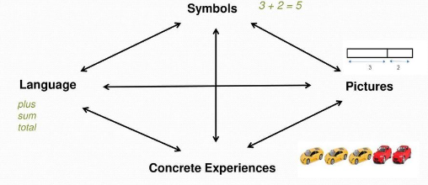

To make connections between their experiences of these different elements that children’s learning is more deeply embedded and their understanding broadened and deepened.
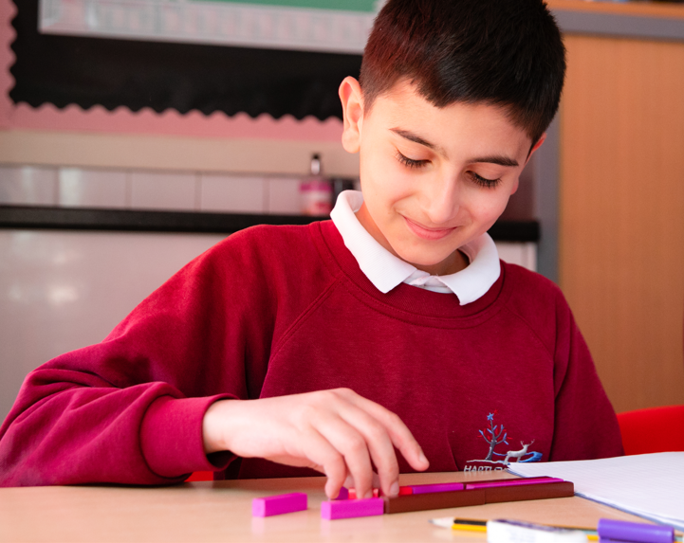

- Enabling all pupils to use mathematical language to communicate related ideas and think mathematically with the concept.
- Supporting all pupils to apply their understanding to a new problem in an unfamiliar situation.
- Developing a love of quick recall multiplication tables throughout the whole school.
- Increasing confidence to be able to use the four operations effectively by the end of LKS2.
- Providing mathematical tools as support in learning to support understanding and answering of a given problem.
- Providing a chance for all pupils to feel successful in a mathematics lesson.
- Developing a strength in presentation; producing well laid out, clear operations and solutions.
How is Maths taught?
We use the National Curriculum and Ark Maths to sequence learning, which is then supported by White Rose, NCETM, Nrich and Sumdog basis for implementing the statutory requirements for the study of mathematics. Over a series of Maths lesson, teachers ensure there are opportunities for children to practise their arithmetic, fluency, problem solving and reasoning skills.

Sumdog
Children from Y1-6 have access to a Sumdog account. This engaging, evidence based learning approach supports our children to consolidate and embed prior learning. Sumdog provides all pupils to further automaticity in recall and use of facts and methods outside of structured Maths lesson time, e.g. home learning and extra-curricular clubs.

Maths lessons at Hartley Brook
Pedagogy underpins our developing teaching ethos. Both arithmetic and reasoning are taught in a manner that ensures scholars know, remember and do more. Rosenshine’s principles of instruction guide our approach to sequencing, modelling, checking for understanding and independent practice.
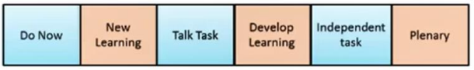
An essential element of the Maths Mastery approach, which is embedded across our school, is the use of a six-part lesson structure:
This structure is used to deliver learning in accordance with Rosenshine’s Principles of Instruction. During the main teaching, pupils will be exposed to concept, fluency, problem solving and reasoning skills. The teacher will model explicitly the methods and thought processes to pupils and will use AFL strategies such as, whiteboards and questioning to provide tailored support and move pupils on effectively.

We believe that this plays a significant role in the children becoming fluent in the fundamentals of mathematics and develops the children’s ability to make connections between their mathematical learning, and to create confident and curious mathematicians who think mathematically.
