How to get onto Teams for home learning

- Open internet browser e.g. Google.
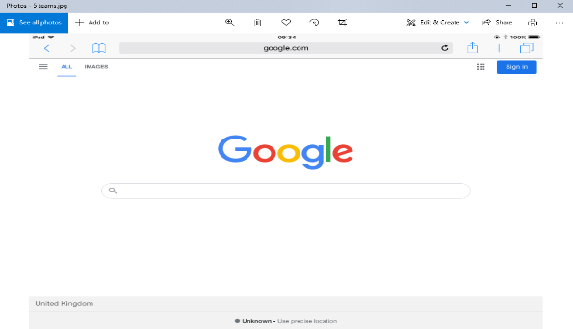

- Type in microsoft online.com
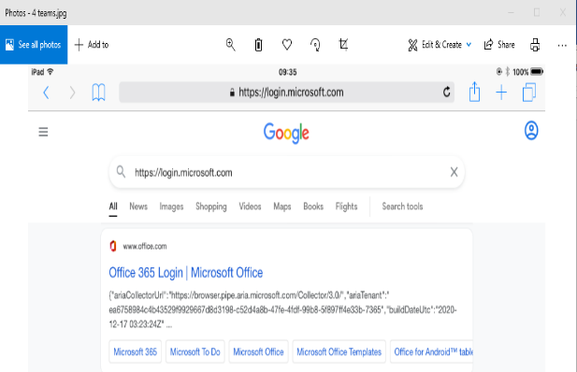

- Login with your given pupil’s school email address.
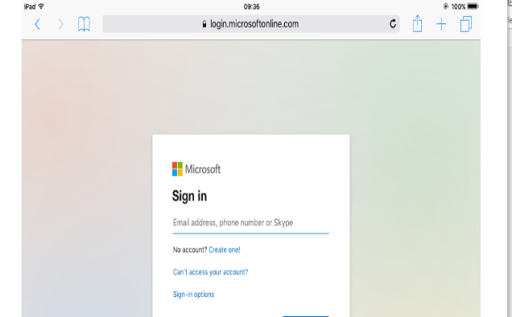

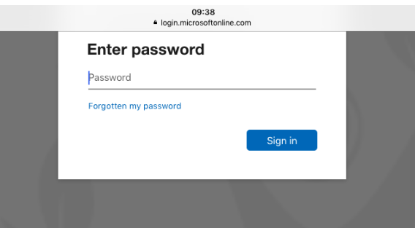
- Then add your given pupil password.

- The icon bar will be on left-hand side.
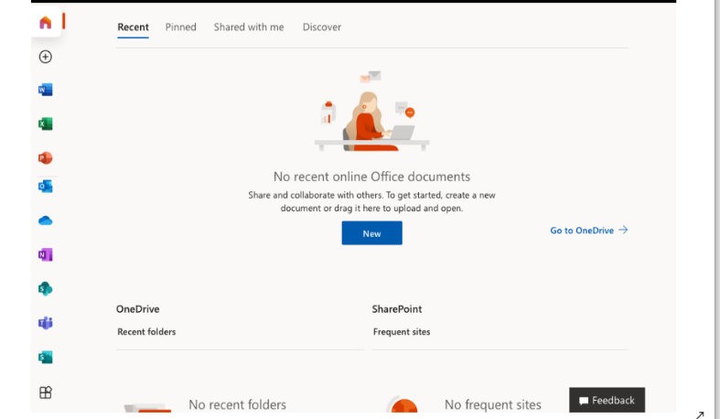
Click on the Teams logo which will take you to your Teams home page ready to join a meeting for your online classes.

