Year 5

Home learning 3.11.2020 – 6.11.2020

Project Work

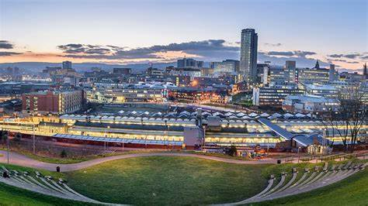

Sheffield

*A local history study: The effects of local industry: The Steel City*

Overarching Question – What makes Sheffield special?

Enquiry Question: Would you like to have been a child living in industrial Sheffield?

**Information**

Child labour, or the use of children as servants and apprentices, has been practiced throughout most of human history, but reached a zenith during the Industrial Revolution. Miserable working conditions including crowded and unclean factories, a lack of safety codes or legislation and long hours were the norm. Crucially, children could be paid less, were less likely to organize into unions and their small stature enabled them to complete tasks in factories or mines that would be challenging for adults. Working children were unable to attend school—creating a cycle of poverty that was difficult to break. Sometimes children workers were orphans who had little choice but to work for food. Nineteenth century reformers and labour organizers sought to restrict child labour and improve working conditions. Britain passed one of the first child labour laws in 1833. It made it illegal for children under the age of 9 to work.

Research Use the following links to find out more:

<https://www.ehow.co.uk/info_7919803_list-done-children-industrial-revolution.html>

<https://www.ducksters.com/history/us_1800s/child_labor_industrial_revolution.php>

<https://www.ehow.co.uk/list_7201960_laws-child-labor-industrial-revolution.html>

<https://factfile.org/10-facts-about-child-labor-during-the-industrial-revolution>

Task

* Read the information about child labour in industrial Britain.
* Look at the images. What do they tell you about life as a child at this time?
* Read the children’s voices talking about their experiences in industrial Britain.
* Answer the key questions
* Create a job advert for a child labourer (look at the examples to help you).

**Read about some of the jobs children did in industrial Britain:**

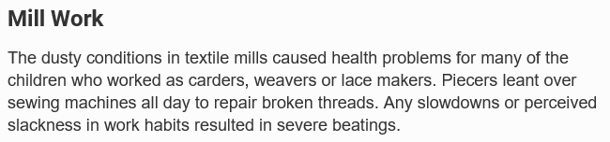

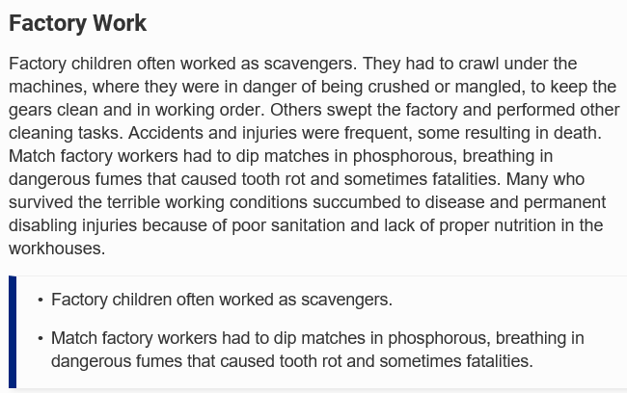

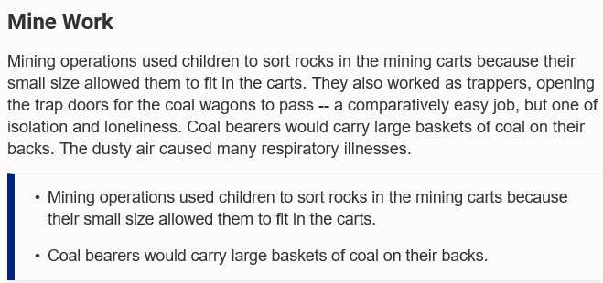

**What do the images tell you about this?**

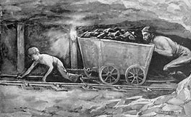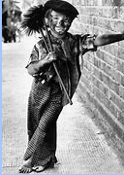

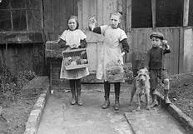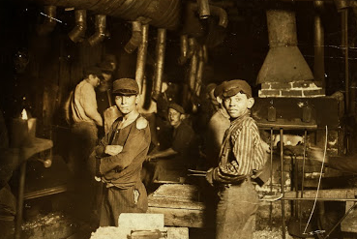

[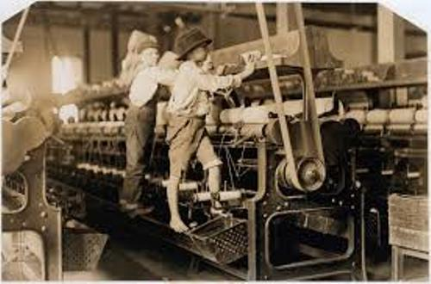](https://factfile.org/wp-content/uploads/2015/12/Child-Labor-During-the-Industrial-Revolution.jpg)

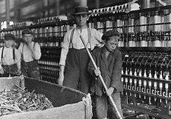

**Here are some of the things children had to say about their experiences:**

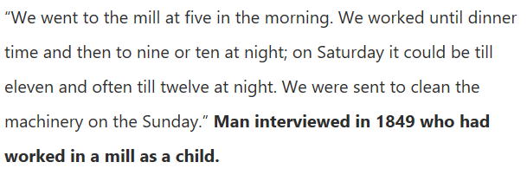

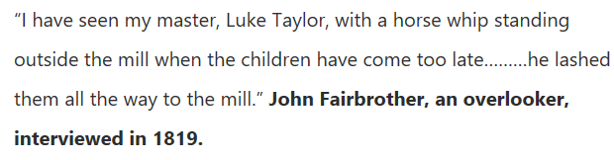

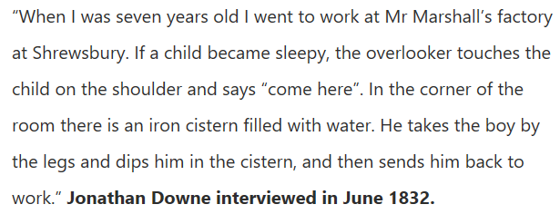

**Life was not the same for children of rich parents:**

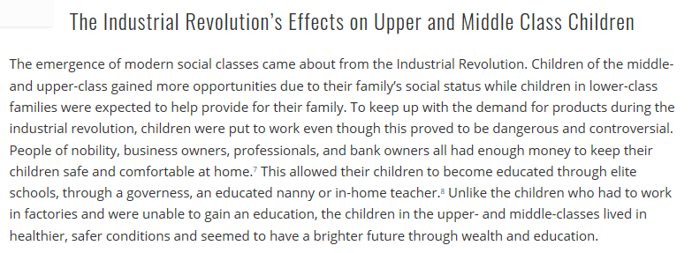

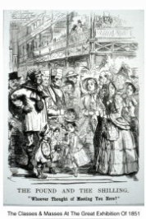

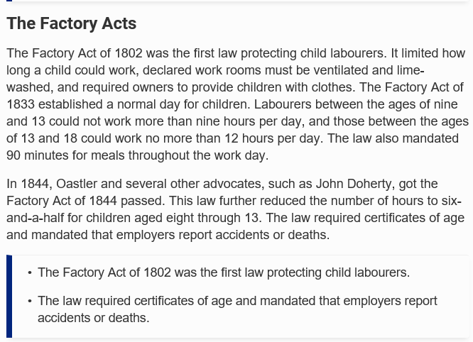**Changes to children’s rights**

|  |
| --- |
| **Why do you think children were used as labour?** |

|  |
| --- |
|  |
|  |
|  |

|  |
| --- |
| **How do you think this work affected children?** |

|  |
| --- |
|  |
|  |
|  |

|  |
| --- |
| **Why do you think their parents allowed this?** |

|  |
| --- |
|  |
|  |
|  |

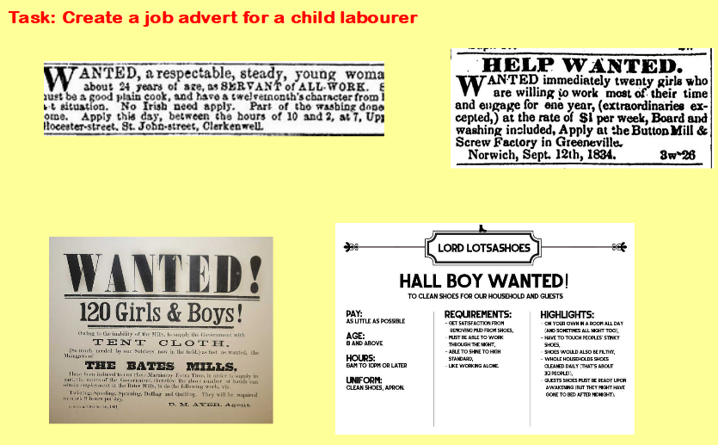

|  |  |  |
| --- | --- | --- |
|  | | |
| **Pay:**  **Age:**  **Hours:** | **Requirements:** | **Conditions:** |

