DATE: 3.11.2020
LO: To use a formal method for addition | S
Star Words
addition calculation plus sum altogether regrouping place value

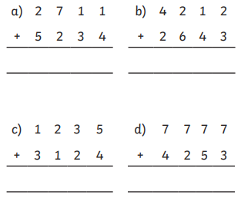
Fluency

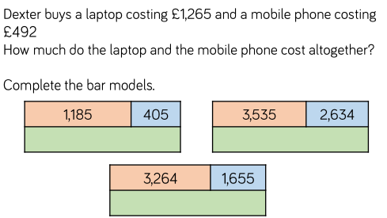

Problem solving and reasoning
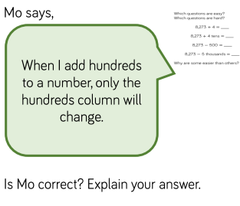
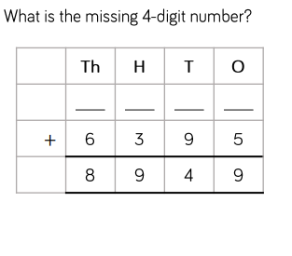

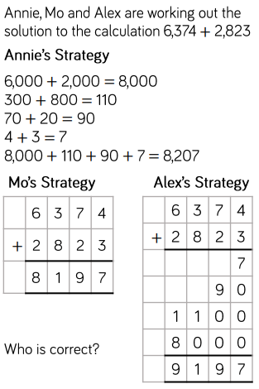

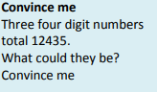

DATE: 4.11.2020
LO: To use a formal method for subtraction | S
Star Words subtraction calculation minus less regrouping place value

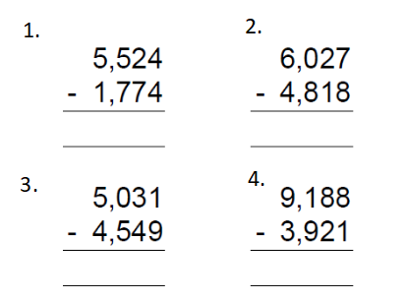

Draw bar models to represent these numbers and then use column subtraction to solve them.
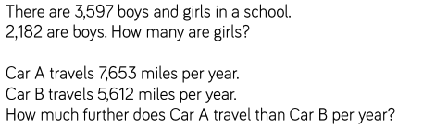
5.

6.

7.
8.

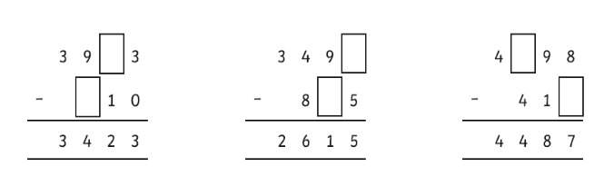

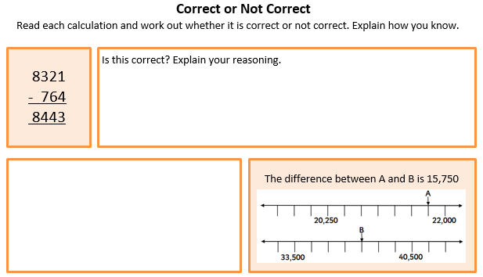

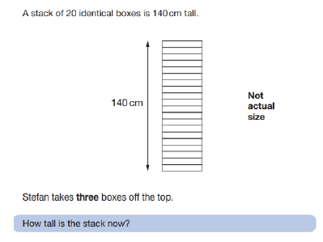
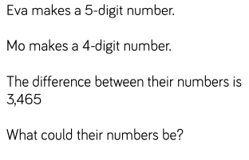

DATE: 5.11.2020
LO: To solve problems using addition and subtraction formal methods.
Star Words subtraction calculation minus less regrouping place value
addition add plus more than difference

Use bar models to represent each step in your calculation. Use the column method to calculate.
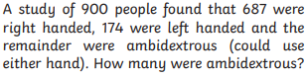
1.

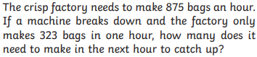
2.

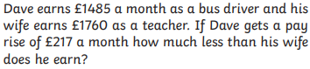
3.

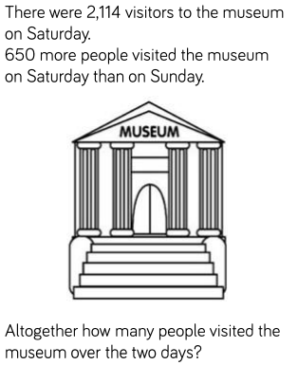
4.

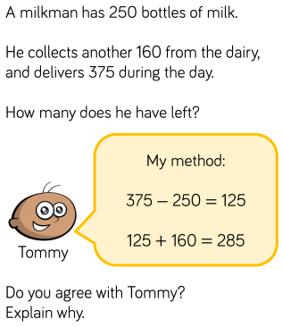
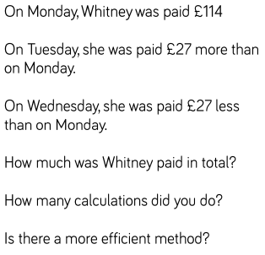

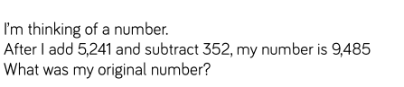
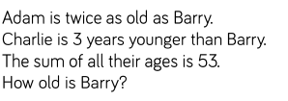

Home Learning
Arithmetic

Arithmetic
Miss Court’s Maths Group
Y5

Name:
Date: 6th November 2020

4219 + 1398 =

2438 + 5671 =

4490 + 10010 =

6455 - 5420 =

4458 + 38658 =

91493 - 10853 =

19262 - 17543 =

34384 - 32795 =

380 ÷ 10 =

4800 ÷ 100 =

864 ÷ 8 =

819 ÷ 9 =

870 x 5 =

432 x 3 =

1936 x 4 =

¾ of 40

5870 x 6 =

¼ of 48 =

¼ of 1616 =

¾ of 448 =

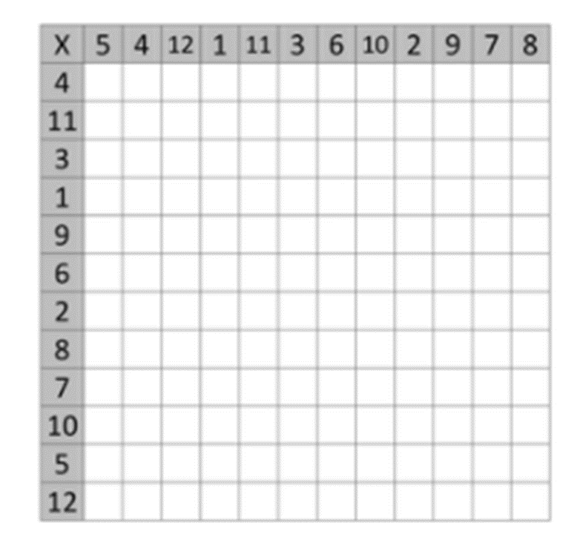
How many times tables can you complete in 5 minutes?

