Monday – Read and discuss the comprehension
Tuesday – Talk about the answers finding evidence in the text.
Wednesday – Record answers.
Thursday – Think of names you the Spider Robot could be called and give reasons for your choices using a range of conjunctions to explain your ideas.
Friday – Write a report from the Spider Robot about its first landing in space .

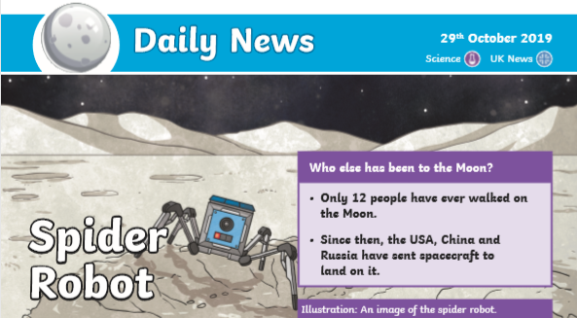

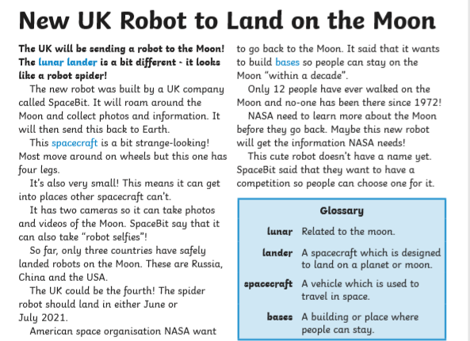

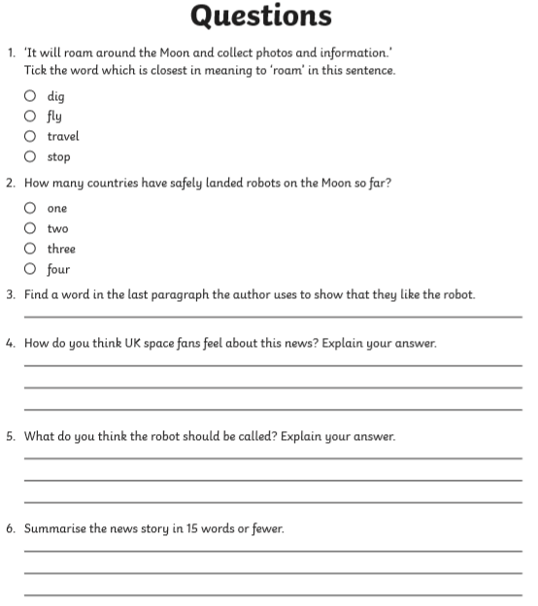

Spider Robot name _________________________________________
Reason

Spider Robot name _________________________________________
Reason why

Spider Robot name _________________________________________
Reason why

Imagine you have looked at the first video of the moon from the Spider Robot.
Write a paragraph to describe what the moon looked like using noun phrases and prepositions.
What was near to the robot? What was in the distance? Use words to create an atmosphere.

