Read, Write Inc
ay – may I play?
Word time!
- Show or write the word and ask your child to spot the “special friends” eg play
- Ask children to say the sounds in “Fred talk” and then to read the words eg p-l-ay - play.
- Count out the sounds on their fingers. Repeat the word and pinch their fingers as they say the sounds.
- Write the word and pinch their fingers as they say the sounds.
- Underline the special friend “ay”
- Tick the word if it is correct or try again.

play may day way say spray
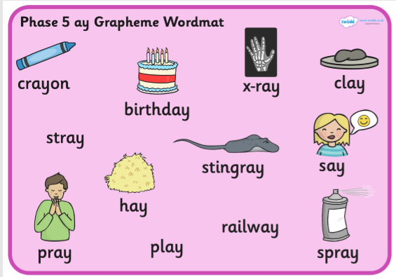

Can your child think of any other “ay” words?

Match the “ay” words to the pictures.
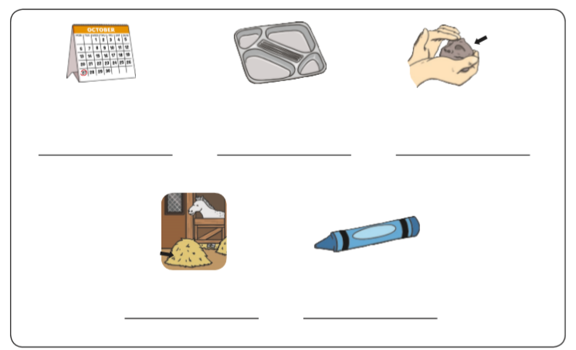

Fill in the missing “ay” words

What date is your ___________?
I have made a model out of _________.
________ can be blue, red, green or yellow.
I love to ________ at the park.
What did you _______? I didn’t hear you.
What ________ is it tomorrow?

Write or say a sentence for 5 different “ay” words. Make sure your sentence has a capital letter and a full stop.

- _________________________________________________________

- _________________________________________________________

- _________________________________________________________

- _________________________________________________________

- _________________________________________________________

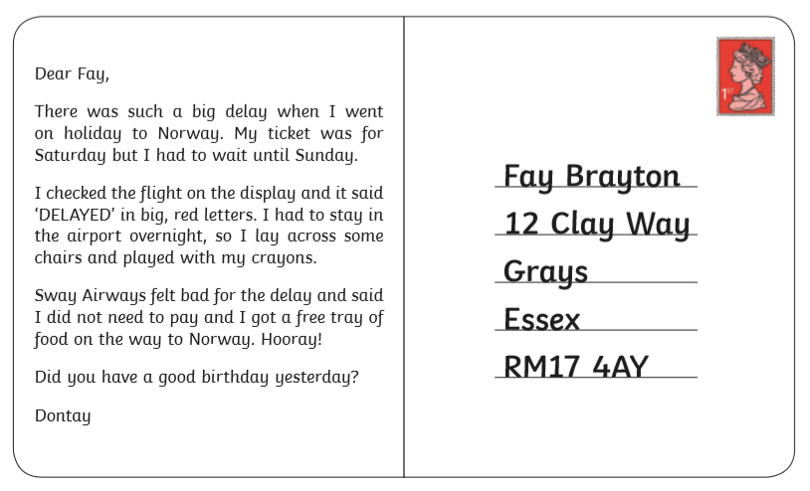
Read the postcard and find the “ay” words.

