Read Write Inc
This week’s “Spag” (spelling, punctuation and grammar) theme is using conjunctions. We will also be reminding ourselves of how and when to use capital letters, question marks and exclamation marks. Here are a variety of activities to work through with your child.
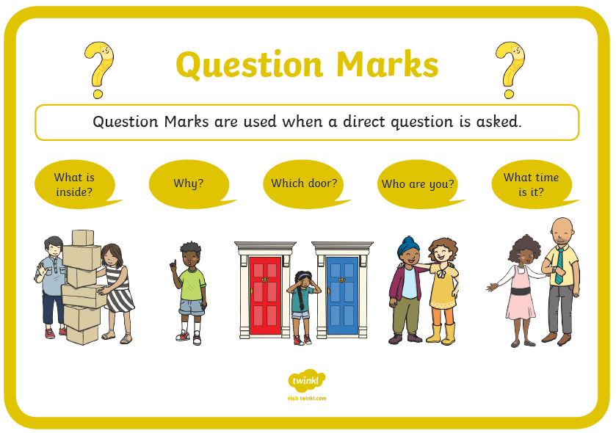
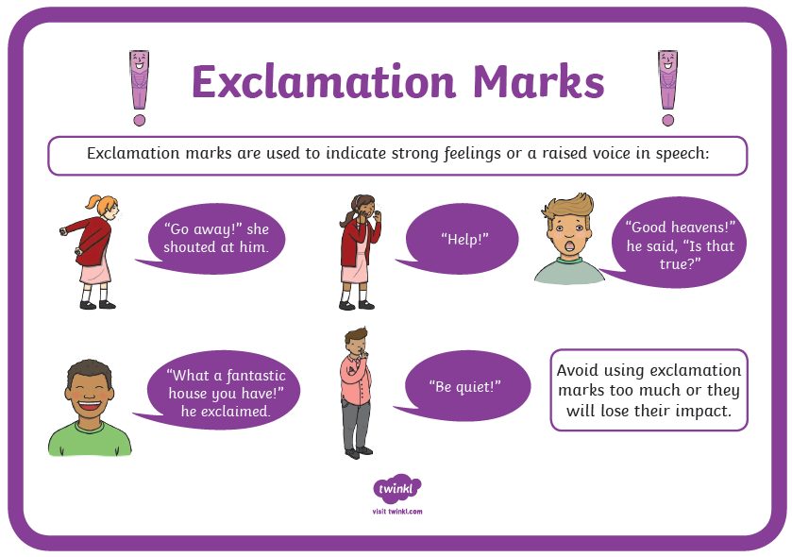
Add a full stop or a question mark at the end of each sentence:
- Where is the postbox

- I saw a funny film last night

- There are lots of fish in my pond

- Do you want a piece of cake

- What time do I need to get up

- It is Saturday tomorrow

Now add a full stop and a capital letter or full stop to each sentence:

- how are you feeling today

- i have a best friend called sam

- where is new york

- have you read “charlie and the chocolate factory”

- it is nearly may

- have a cat called mittens and a dog called buster

Now choose a full stop, exclamation mark or question mark to add to the end of each sentence:

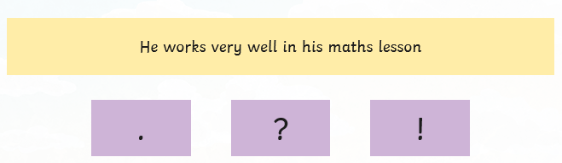

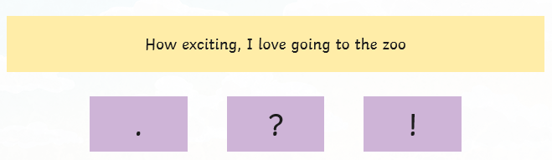

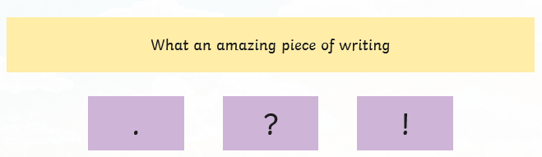
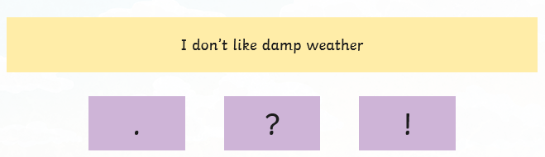

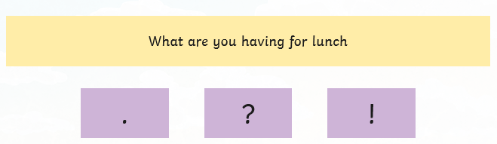

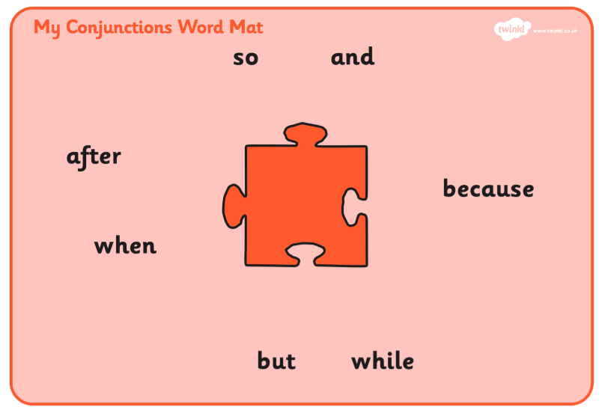

Conjunctions are used to link together different parts of a sentence. and

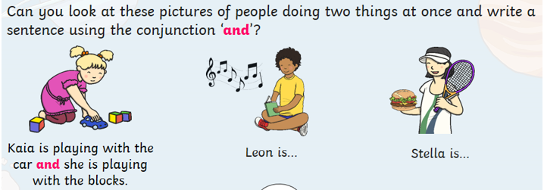

Leon is ____________________________________________________
___________________________________________________________

Stella is ____________________________________________________
___________________________________________________________
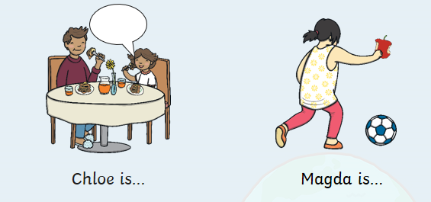

Chloe is ___________________________________________________
___________________________________________________________

Magda is _________________________________________________
___________________________________________________________
or

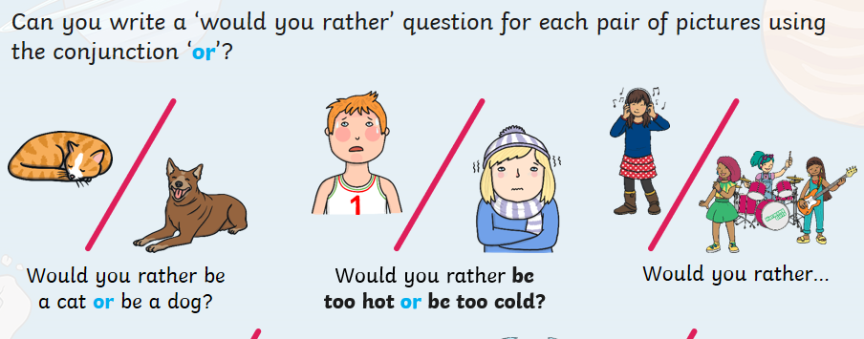

Would you rather ______________________________________________
__________________________________________________________________
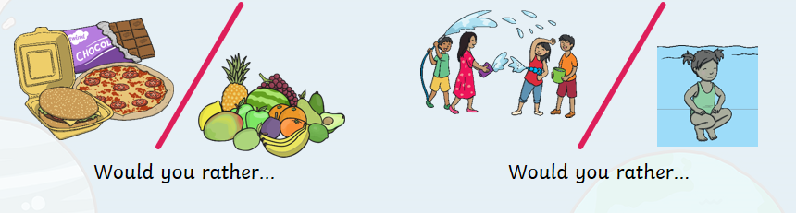

Would you rather ____________________________________________
___________________________________________________________

Would you rather ____________________________________________
___________________________________________________________

but
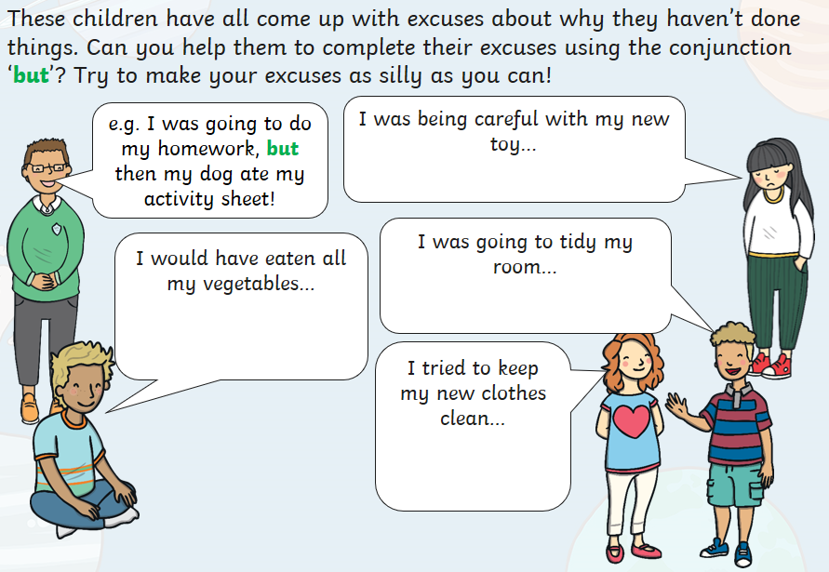
I was being careful with my new toy but____________________
___________________________________________________________

I would have eaten all my vegetables but __________________
___________________________________________________________

I was going to tidy my room but ____________________________
___________________________________________________________

I tried to keep my new clothes clean but ___________________
___________________________________________________________
