Monday 6th July 2020
Questions from myminimaths.co.uk:
20a) 36 x 10 = 20b) 932 x 100 =
20c) 10 x 4.3 = 20d) ____ x 1000 = 196,000
20e) 91 x 100 = 20f) 10 x 771 =
20g) 7711 x ____ = 77110 20h) 65.68 x 100 =
20i) 1000 x 83.52 = 20j) 5356 x 100 =
20k) ___ x 34.16 = 34,160 20l) 5508 x 10 =
20m) 100 x 76.12 = 20n) 21.87 x ___ = 21,870
20o) 10 x 90.01 = 20p) 8.72 x 100 =

Video to help:

https://myminimaths.co.uk/arithmetic-16-practice-question-20/

Answers:
https://myminimaths.co.uk/arithmetic-16-answers-question-20/

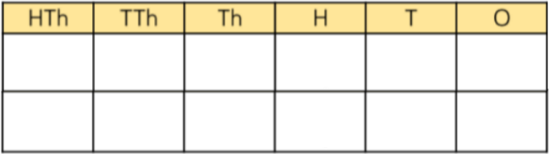
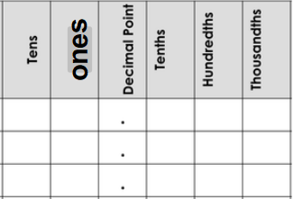

Questions from myminimaths.co.uk:
19a) 0.2 ÷ 100 = 19b) 0.05 ÷ 10 = 19c) 0.8 ÷ 100 =
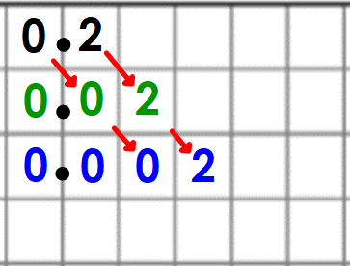
19d) 0.1 ÷ 1000 = 19e) 0.09 ÷ 100 = 19f) 0.04 ÷ 100 =
Video to help:

https://myminimaths.co.uk/arithmetic-16-practice-question-19/

Answers:
https://myminimaths.co.uk/arithmetic-16-answers-question-19/

LO: To multiply decimal numbers by 10, 100 and 1000
Tuesday 7th July 2020
Star words: multiply times lots of groups of
In all product multiplied by area twice

Fluency
When you X 10 you move the counters _____ places to the left. | When you X 100 you move the counters _____ places to the left. |  | When you X 1000 you move the counters _____ places to the left.
1) 3.24 x 10 = X  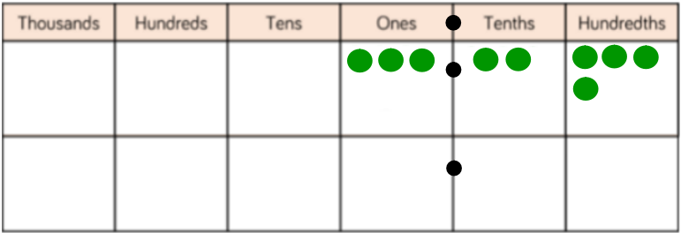 |  | 2) 6.31 x 10 = X  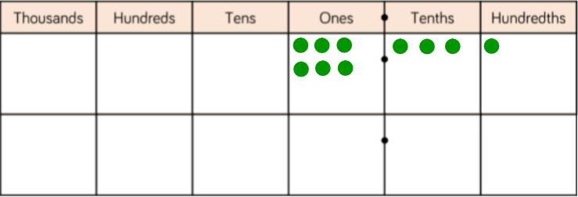
3) 23.04 x 10 =  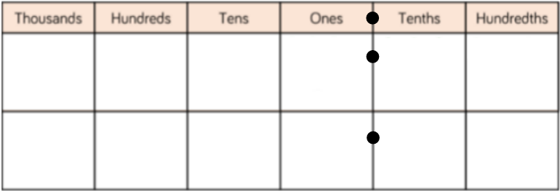 |  | 4) 4.24 x 100 =  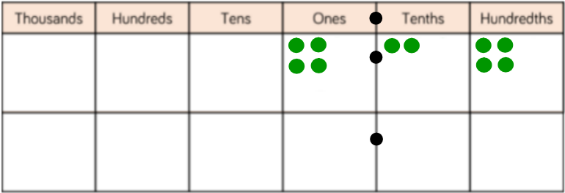
5) 27.37 x 100 = |  | 6) 0.05 x 100 =
7) 5.37 x 1000 =  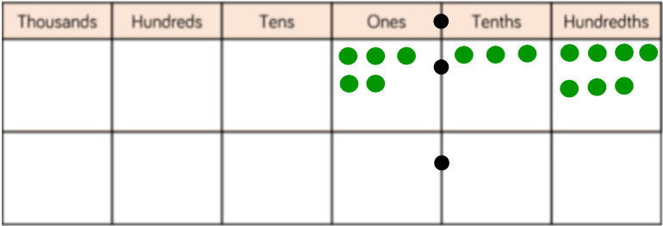 |  | 8) 42.08 x 1000 =  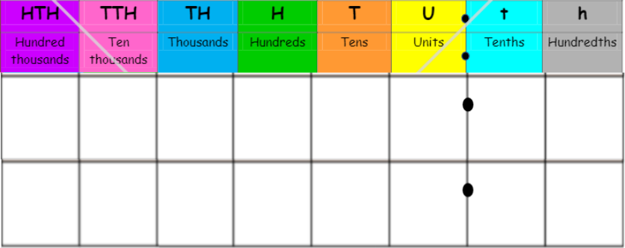
9) 6.2 x 1000 = |  | 10) 501.04 x 100 =
Reasoning
100 x 3.42 = 3420  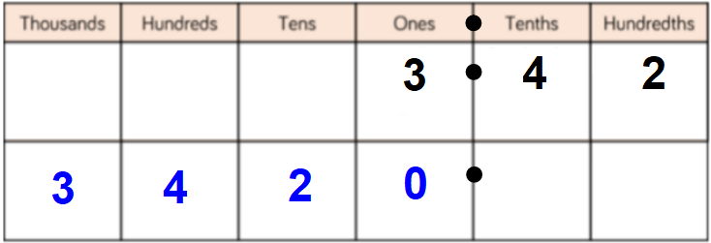  Explain why Mr Needham is wrong. |  | 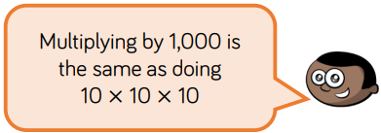  Do you agree with Mo?  Explain your answer
Problem Solving
Mr Orr buys a coffee from Starbucks every morning. It costs £2.05.  How much does he spend on coffees in 10 days?  Can you work out how much he would spend over 100 days? |  | Lisa makes duvets. Each bundle has 100 duvets in it. If one duvet is 4.7 cm thick, how thick is one bundle?
Miss Stonehouse buys a croissant every morning from the Asda. It costs 55p.  How much will she have spent in 1000 days? |  | 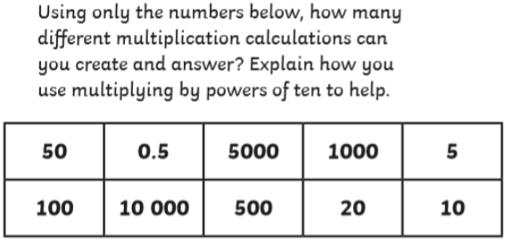

LO: To divide decimal numbers by 10, 100 and 1000
Wednesday 8th July 2020
Star words: division shared equally lots of equal group
divisor dividend split distribute half

Fluency
When you ÷ 10 you move the counters _____ places to the right. | When you ÷ 100 you move the counters _____ places to the right. |  | When you ÷ 1000 you move the counters _____ places to the right.
1) 4.2 ÷ 10 = ÷  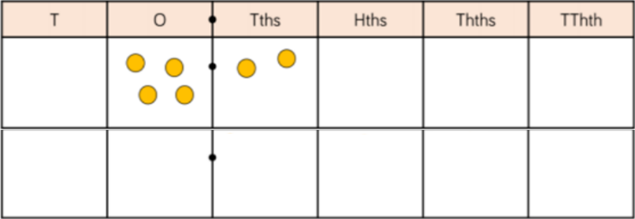 |  | 2) 23.65 ÷ 10 = ÷  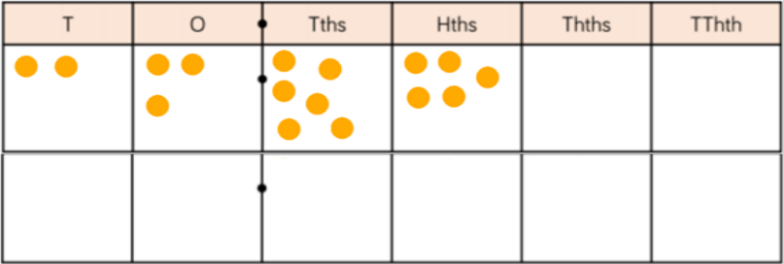
3) 6.432 ÷ 10 =  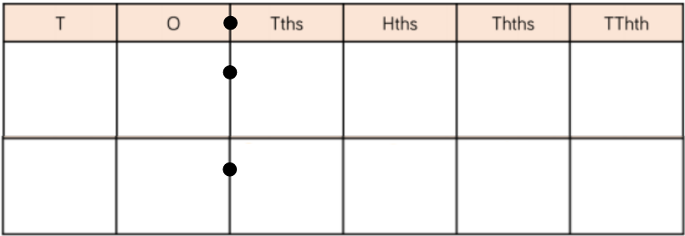 |  | 4) 4.07 ÷ 100 =  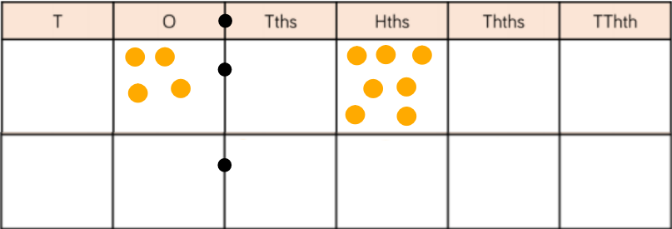
5) 72.4 ÷ 100 = |  | 6) 24.01 ÷ 100 =
7) 5.4 ÷ 1000 =  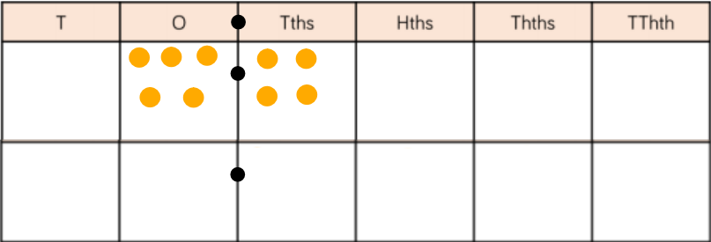 |  | 8) 30.1 ÷ 1000 =
9) 0.9 ÷ 1000 = |  | 10) 0.06 ÷ 100 =
Reasoning
10.2 ÷ 10 = 1.2  Explain what mistake Mr Needham may have made. |  | 5.2 ÷ 1000 is the same as  0.52 ÷ 100  Do you agree?
Problem Solving
10 fidget spinners cost £9.50  What is the price of 1 fidget spinner cost?  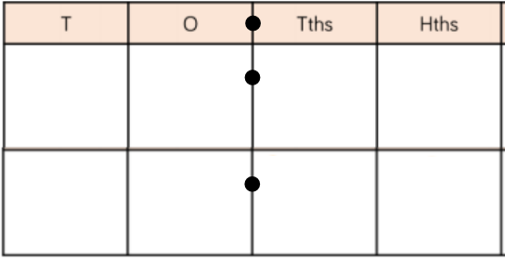 |  | Mr Orr buys a coffee from Starbucks every morning. On the tenth day, he has spent £36.50  a) How much does one coffee cost?  b) How much would 3 coffees cost?  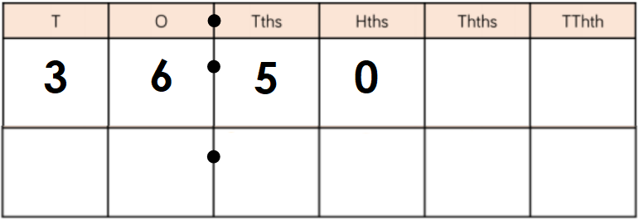
Miss Stonehouse spends £153.50 on 10 football tickets.  What would be the price of two football ticket?  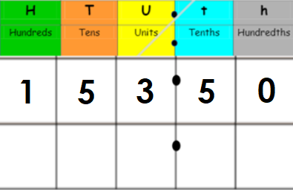 |  | Every morning, Miss Dean goes for a jog. She always runs the same distance. After 100 days, she has run a distance of 535.6 miles.  How far does Miss Dean run each day?  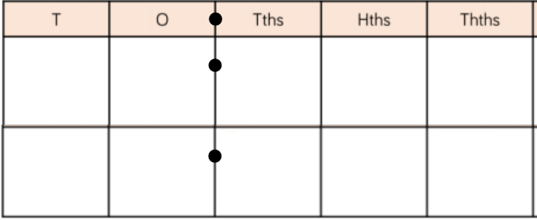

LO: To identify factors and factor pairs.
Thursday 9th July 2020
Star words: multiples factors greatest least
Common product multiply arrays

Fluency –
1) Add the missing factor pairs  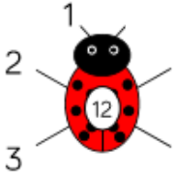  How many factors does 12 have? | 2) Add the missing factor pairs  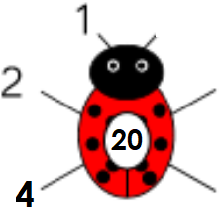  How many factors does 20 have?
3) Add the missing factor pairs  How many factors does 18 have? | 4) Add the missing factor pairs  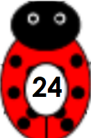  How many factors does 24 have?
5) Add the factor pairs  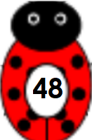  How many factors does 48 have? | 6) Add the factor pairs  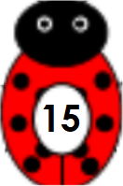  How many factors does 15 have?
7) Circle the factors of 20  1, 4, 7, 14, 5, 15, 20  Which two factors are missing? | 8) Identify the missing common factors of 12 and 18  12 – 1, ___, 3, ___  18 – 1, ___, 3, ___
9) Identify the common factors of 20 and 30  20 – 1,  30 – 1, | 10) Identify the common factors of 12 and 24  12 –  24 –
Reasoning
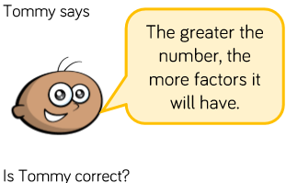  Use the examples and your own to check Tommy’s statement. | 5 is a factor of 7125.  Explain how you know.  Is there a pattern to numbers that 5 is a factor of?
Problem Solving
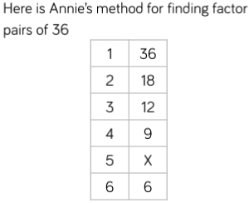  1) When do you put a x next to a number?  2) How many factor pairs does 36 have?  3) How many factors does 36 have?  4) Use Annie’s method to find the factors for 40  1 40  2  3 | Two numbers have common factors of 4 and 9.  What could the numbers be?  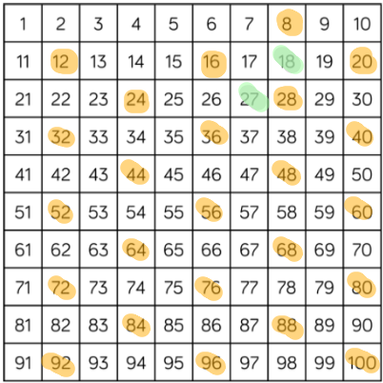

Friday 10th July 2020
Arithmetic
1) 1903 - 10 = | 16) 363 - 18 =
2) 57 x 6 = | 17) 16.04 + 21.87 =
3) 36.2 + 11.9 = | 18) 4 x 3 x 12 =
4) 132 ÷ 12 = | 19) $\frac{4}{7}$ + $\frac{4}{7}$ =
5) 1458 - 889 = | 20) ___ x 80 = 4800
6) 8 x 4 = | 21) 1.423 x 1000 =
7) 417 - 9 = | 22) 3³ ⁼
8) 71.09 + 44.98 = | 23) 40,000 - 700 =
9) 3 x 2 x 12 = | 24) 6300 ÷ 9 =
10) 307 - 10 = | 25) ___ x 120 = 3600
11) 46 x 6 = | 26) 55% of 4500 =
12) 19.6 + 32.5 = | 27) 3.42 x 8 =
13) 36 x 4 = | 28) $\frac{8}{9}$ + $\frac{3}{9}$ =
14) 2908 + 819 = | 29) ___ x 30 = 2100
15) 9 x 7 = | 30) 3.134 x 1000 =

