Monday 13th July 2020

Complete the multiplication grid below and record how long it takes you.
X | 2 | 3 | 4 | 5 | 6 | 7 | 8 | 9 | 11 | 12
12
11
9
8
7
6
4
3
5
2

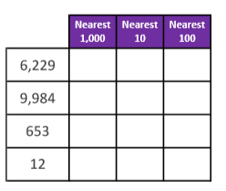
Myminimaths week 15
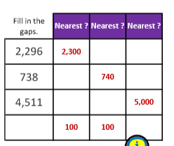
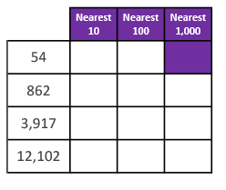

Arithmetic
1. 300 ÷ 4 = 2. 445 x 2 =

- 5,320 + 2,916 = 4. 4,320 – 3,329 =

- 476 ÷ 4 = 6. 218 x 3 =

- 5,539 + 600 = 8. 8,328 – 2,857 =
Date: 14.7.2020
LO: To be able to multiply a 2-digit number by a 1-digit number.
Select Summer term - Week 3 Lesson 1 for the video clip to support your learning https://whiterosemaths.com/homelearning/year-4/

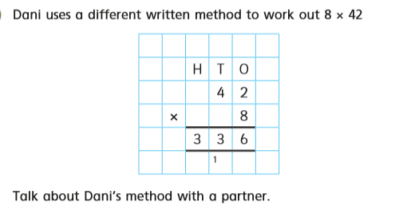

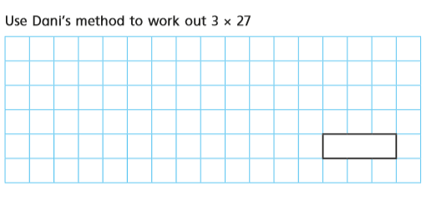

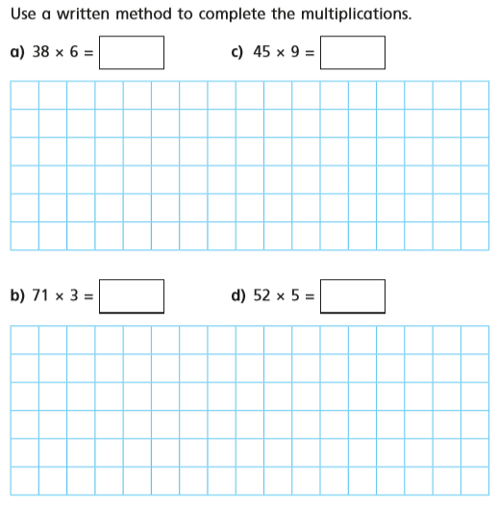

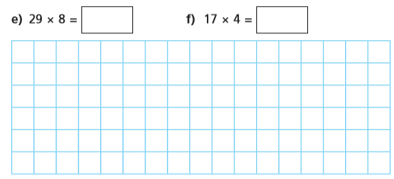

Reasoning and problem solving

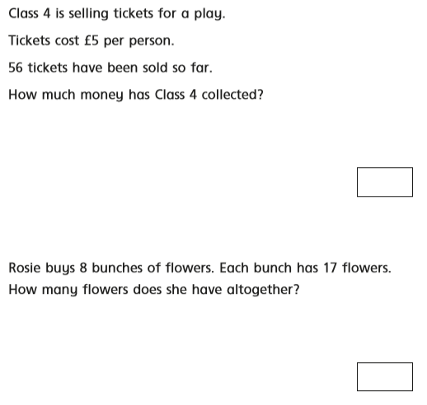

Answers:
https://wrm-13b48.kxcdn.com/wp-content/uploads/2020/05/Y4-Lesson-1-Answers-Multiply-2-digits-by-1-digit-2019.pdf

Date: 15.8.2020
LO: To be able to multiply a 3-digit number by a 1 digit number.
Select Summer term - Week 3 Lesson 2 for the video clip to support your learning https://whiterosemaths.com/homelearning/year-4/

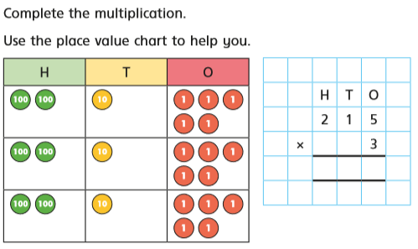

Reasoning and problem solving

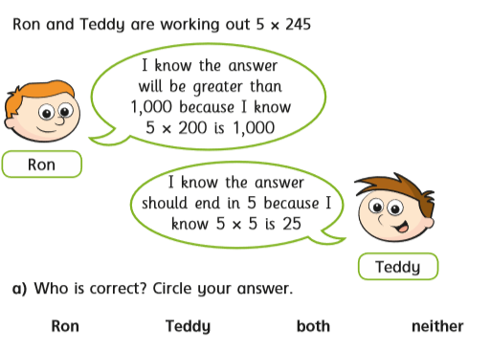

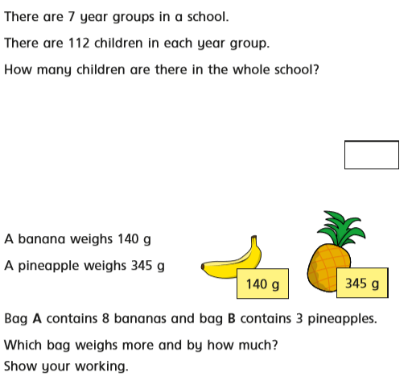

Answers

https://wrm-13b48.kxcdn.com/wp-content/uploads/2020/05/Y4-Lesson-2-Answers-Multiply-3-digits-by-1-digit-2019.pdf

Thursday 16th July 2020.
Complete the multiplication grid below and record how long it takes you. Try and beat your time from Monday.
X | 4 | 9 | 2 | 5 | 11 | 7 | 8 | 3 | 6 | 12
7
11
5
8
12
6
2
3
9
4
Arithmetic

- 424 ÷ 8 = 2. 721 x 5 =

- 946 + 884 = 4. 2,198 – 1,144 =

- 243 ÷ 9 = 6. 882 x 6 =

- 5,433 + 2,885 = 8. 6,540 – 3,228 =

- 238 ÷ 7 = 10. 172 x 6 =

- 8,298 + 7,759 = 12. 302 – 194 =

Friday 17th July 2020.
Watch the video Friday Maths Challenge:
- https://whiterosemaths.com/homelearning/year-4/
Select Summer term - Week 3 Lesson 5 for the video clip to support your learning.
