Year 6 English Week 1
In this week’s English there are four lessons that build up to and prepare for a piece of work on the final day of the week.
In school we code the levels of work for different children as follows:
Green = what is expected of all children. Some children may need support to meet this statement
Amber = many children will also be able to achieve this statement
Red = some children will challenge themselves to achieve this too
Purple = an extension to the required level of work
(Not all lessons will have each of these levels.)
Please get in touch with any questions and to share work if you would like to.
Twitter: @HBMissDean
Email: beth.dean@astreahartleybrook.org
Blog: https://www.hartleybrookprimaryacademy.net/year62019/

Please make sure you read this section carefully!
This week’s English will be slightly different!
You are going to look at a piece of persuasive writing (we’ve looked at persuasion before – it’s a form of non-fiction writing where you have to be careful with your word choices to try to convince the reader to agree with your viewpoint). Here’s a video that should help you to understand: https://www.bbc.co.uk/teach/class-clips-video/english-ks1-ks2-how-to-write-a-persuasive-text/zkcfbdm
At the end of the week, you will design/draw a persuasive poster to stop people cutting down trees in the rainforests. You may also use the information you will read about in this week’s comprehension lessons.
Today, you will look at what a good one looks like and identify the features. On Tuesday, you will revise rhetorical questions to help you be persuasive. On Wednesday, you will gather some emotive language. On Thursday, you will plan your poster, and then you will design/draw your persuasive poster on Friday.

MONDAY 8th June 2020
LO To understand what makes persuasive writing effective
Success Criteria:
I can answer questions and identify features to put in a checklist
I can write a paragraph to explain what makes a piece of persuasive writing effective

Have a look at the following examples of persuasive text. What features can you find that help to make it effective in persuading people to do what it says? Use a highlighter or underline to annotate (write some notes) and see if you found the same features as me (mine is on the next page)
. 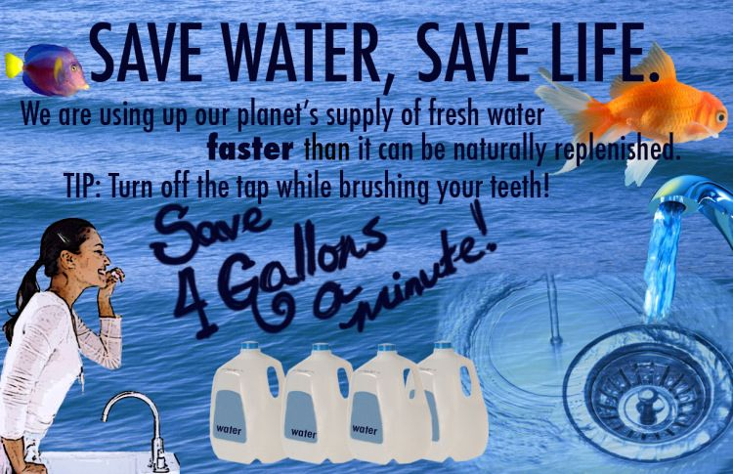
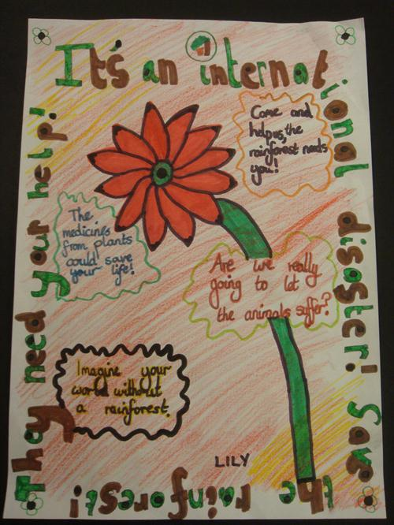

Features of a persuasive poster:
clear, eye catching and snappy title
research/ facts/ figures
present tense verbs
modal verbs
daring the reader to disagree by using a rhetorical question
emotive/ positive language

Now use what you have found to make a checklist of features to use later in the week for your own persuasive poster. Choose around five things that you consider to be most important in making a piece of persuasive text effective.

Features

Now write a paragraph to explain what makes ‘Save Water, Save Life’ an effective piece of persuasive text.

___________________________________________________________________________
___________________________________________________________________________
___________________________________________________________________________
___________________________________________________________________________
___________________________________________________________________________
___________________________________________________________________________

TUESDAY 9th June 2020
LO To recognise and use a rhetorical question
Success Criteria:
I can identify a rhetorical question
I can turn a statement into a rhetorical question
I can write my own rhetorical question
I can explain how a rhetorical question improves a text

Remember: A rhetorical question is a figure of speech in the form of a question. It is a question that is asked in order to make a point: it does not need a reply.
Identify
Tick which of these is a rhetorical question
- Have you ever seen anything as beautiful as that?
- Do you think this is a beautiful place?
- Which team played the best?
- Surely, there hasn’t been as good a match as this one?
- I agree with what other people said about the competition, don’t you?
- Nine out of ten people can’t be wrong, can they?
Controlled Practice
Examples of rhetorical question starters:
Why not…? | How about…?
Who can deny…? | Do you love…?
Who doesn’t want to…? | Are you worried…?
What about…? | Do you want…?
What can you…? | Who would argue that…?
Turn these statements into rhetorical questions:
For example:
You should come to Sheffield.
Why not come to Sheffield?

1 You should visit Alton Towers Theme Park.
2. You must try out the new sporting activities during lunch time.
3. If you love languages, then try the Spanish Film club.

4. You can’t deny that this is the best school ever.
5. Everybody wants to go to Meadow Hall Shopping Centre.

Apply
Write 5 of your own rhetorical questions.

Explain
How does the use of a rhetorical question make the poster more persuasive?
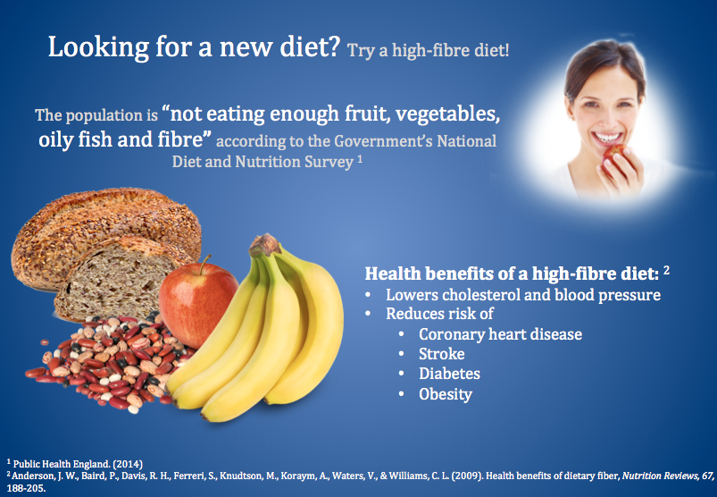

___________________________________________________________________________
___________________________________________________________________________
___________________________________________________________________________
___________________________________________________________________________
___________________________________________________________________________
___________________________________________________________________________

WEDNESDAY 10th June 2020
LO To gather language for writing
Success Criteria:
I can recognise emotive language
I can use emotive phrases

Emotive language is language that is used to create a particular emotional response in the reader. It can create strong feelings and involves the reader in the text.
Remember, you are going to draw a poster to persuade people to stop cutting down trees in the rainforests. How do you want the reader to feel when they look at your poster?
Read this extract and underline all the emotive phrases (phrases which make you think or feel something). One has been done for you. Then think about which of them you could use on your poster.

From childhood, we have heard that trees are our best friend but in practical life, we didn’t see anyone who treats trees as their friends. Although they are the most valuable life source on the earth. They benefit every life form in a direct or indirect way. And the earth is connected to them to maintain a natural balance. Our friends the trees need saving!
They nourish us and protect us in many ways. Also, they keep our environment green and clean. So, it becomes our responsibility to repay them for the things they do for us by saving them. Besides, large trees are more beneficial than small ones because they capture more carbon, capture more water, combat the heat, filter greenhouse gases, gives shelter from heat and sunlight, etc. So, it can be said that we depend on them more rather than they on us.

THURSDAY 11th June 2020
LO To plan a persuasive poster
Success Criteria:
I can use note form and include details from the week’s lessons
I can include knowledge from research
This lesson is not about drawing your design but THINKING about what a good persuasive poster needs to have on it!
Have a look back at the checklist you made in the first lesson and try to include features you identified to help you make your poster effective in persuading the reader to.
Title -
eye catching and snappy
Images to include that I can draw
Images to include that I can
get off the internet
A rhetorical question which dares the reader to disagree
A short sentence using emotive or positive language
A phrase which includes facts/ figures from my research

Read through your comprehension text again to see if you could use any of the facts and figures in that OR spend some time using the internet/reading other texts to support your poster.

FRIDAY 12th June 2020
LO To draw/design a persuasive poster
Success Criteria:
I can use my plan to design my poster
I can think about what makes a poster eye-catching to the reader
I can discuss or write a paragraph to explain what made my writing effective

Today, you are going to draw/design your own poster, which persuades people to stop cutting down trees in the rainforests.
Look at the examples and the check list from the first lesson to remind yourself what a good one looks like. Make sure you think about using a rhetorical question and some emotive language too.
Here are a few design criteria to think about when you are drawing the poster!
Are my images well drawn?
Do the colours work well together?
Is there a good balance of text and images?
Does my message come through clearly?
Do my images support the words?
Is the text neatly laid out, straight and easily read?

Please share your finished work with your teacher by email, Twitter or the blog!

