Monday 22nd June 2020
LO To understand what makes an effective Autobiography
Success Criteria:
I can identify features of an autobiography.
I can make a checklist of features and say why they are important.
This week’s learning is about autobiographies and builds on last week’s work of biographies. An autobiography is a piece of writing about your life written by you whereas a biography is a piece of work written about you by someone else. There are some features that are in both text types as well as some features that are different. Read the autobiography and find the as many features as you can. Use a highlighter/ underline/ write some notes and see if you found the features. (mine is on the following page).
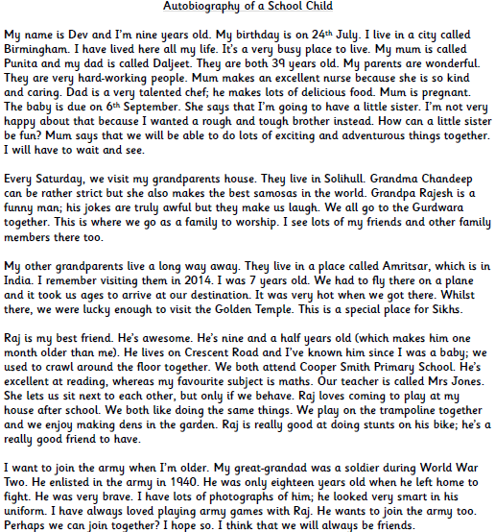

Notes
Now use the features you have found to make a checklist which you will use when you write your own biography. Choose around five things that you consider to be most important in making a good text.
Features

Which feature do you think is most important? Why?

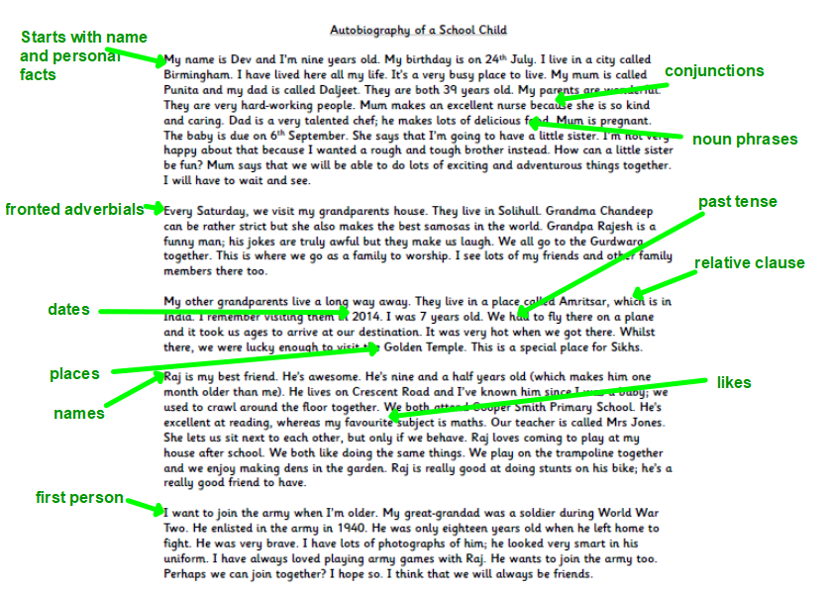

Tuesday 23rd June 2020
LO: To be able to use relative clauses
Success Criteria:
I can identify relative clause.
I can add relative clause.
I can apply my understanding of relative clauses.
I can explain the use of relative clauses.
A comma is used before the relative pronoun if the information added is not essential to the reader.
The children who skateboard in the street are especially noisy in the evening.
Children is non-specific, we don’t know who they are unless we have information in the relative clause, so the information is essential and no comma is used.
Matthew and his sister Jane, who skateboard in the street, are especially noisy in the evening.
Children has been replaced with the names, so the extra information in the relative clause is not essential and a comma is needed.

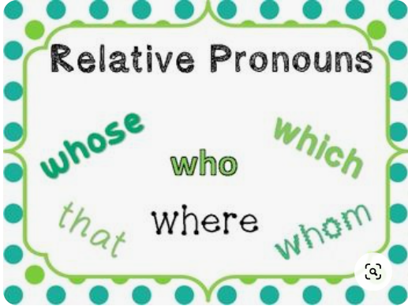
Relative clauses are written next to a noun and start with a relative pronoun. They add extra information about the noun.

Read the introduction to Matilda’s autobiography and find the relative clauses
- Circle the relative pronoun.
- Underline the relative clause
- Put a tick by the comma if there is one.
My Life by Matilda Wormwood
My name is Matilda Wormwood. I used to live with my mummy, who is called Zinnia, and my daddy, who is called Henry. I have a brother called Michael, who is five years older than me. I am extremely thankful that I don’t live with my family because they are really horrible. I live at The Red House, which belongs to a kind lady called Miss Honey. Miss Honey works at the school where Mrs Trunchbull is the head teacher.

The next paragraph of Matilda’s autobiography is about why she doesn’t live with her parents. Add a relative clause (extra information) about the noun in the gaps. Remember to start with a relative pronoun and only use a comma if the information is essential to the meaning.
I don’t live with my parents_______________________________________________ because they were mean and selfish. They never appreciated my wonderful abilities and were too busy thinking about their own lives ___________________________________________________________to notice me.
They thought I was stupid, but I could talk as well as any adult by the age of one and a half! By three years old, I had taught myself to read. By four, I had read all the books in my library __________________________________________________________.
Books helped me enormously; they transported me to other worlds _______________________________________________________________________________.
Write the next paragraph for Matilda’s autobiography and tell the reader what it was like living with Miss Honey. Remember to write the relative clause next to a noun, start with a relative pronoun and only use a comma if the clause is not essential.

Explain if the use of comma is correct.
I enrolled myself into a school where I met lovely Miss Honey.

Wednesday 24th June 2020
LO To gather language for writing
Success Criteria:
I can include information about past using past tense.
I can include dates, names and places
I can include future aspirations using the correct tense.
You are going to gather ideas to write your own biography. Think about different points in your life. Keep it real or add things to make it interesting.
My Autobiography
Early Life
School Life
Future
Facts and figures | Time Adverbials

Thursday 25th June 2020
LO To plan for writing
Success Criteria:
I can write in note form and include details from yesterday’s language gathering
I can include headings, subheadings to organise my ideas in time order.
Have a look back at the checklist you made in the first lesson and try to include the features you identified. Use your planning from yesterday and the SPAG skill you learned on Tuesday to make notes on your plan.
Main Heading

Introduction  - Personal facts about yourself. | _____________________________________________  _____________________________________________  _____________________________________________  _____________________________________________
paragraph 1  - Early Life | _____________________________________________  _____________________________________________  _____________________________________________  _____________________________________________
Paragraph 2  - School Life | _____________________________________________  _____________________________________________  _____________________________________________  _____________________________________________
Paragraph 3  – What you would like to do in the future | _____________________________________________  _____________________________________________  _____________________________________________  _____________________________________________

Friday 26th June 2020
LO To write an autobiography
Success Criteria:
I can use my plan to organise my work in to time order.
I can edit and improve my writing using my checklist
I can write a paragraph to explain why my text is a good autobiography

Today, you are going to your autobiography.
Re-read the example from the first lesson to remind yourself what a good autobiography looks like.
- Start by planning how you will organise your work on paper or use the template included.
- Use your checklist from Monday, work from the relative clause lesson (Tuesday)
- Use the timeline, facts and figures and time adverbials you gathered (Wednesday)
- Use your planning (Thursday)
This will help you be clear and organised about your task.
Remember to use the prompts below to support you.

Please share your writing with your teacher by email, Twitter or the blog!

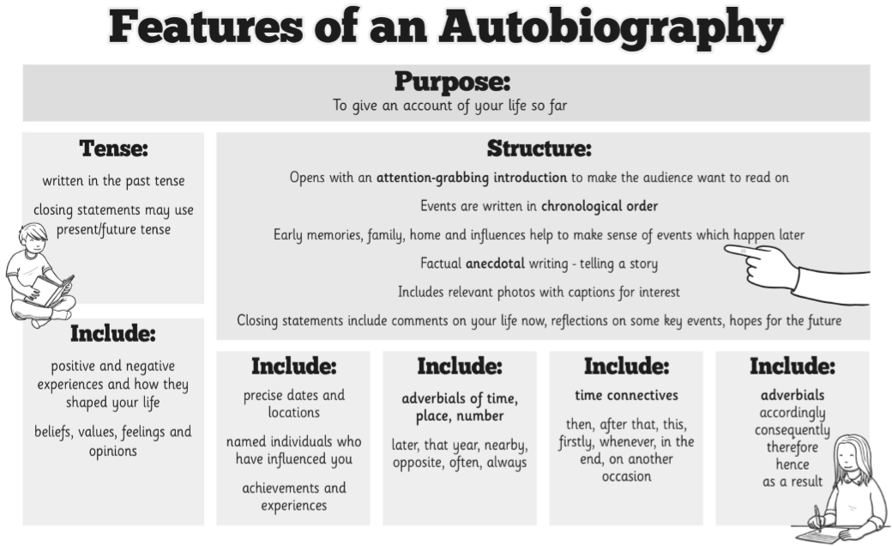

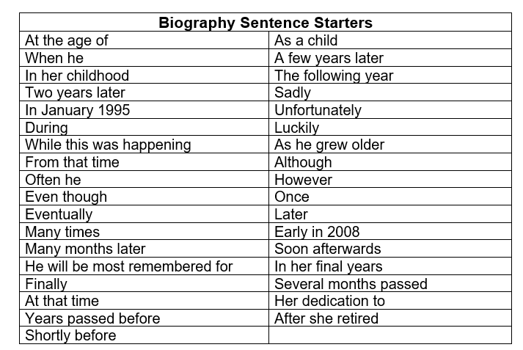
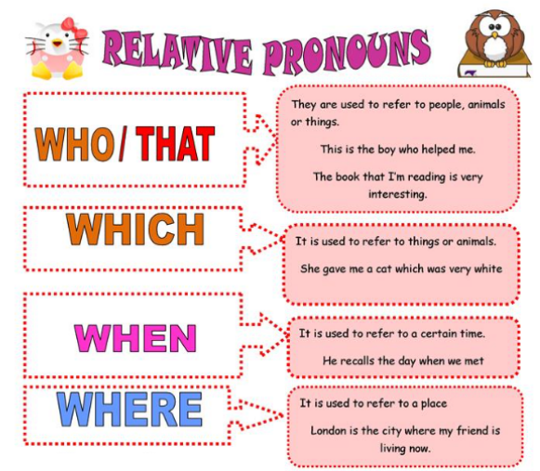
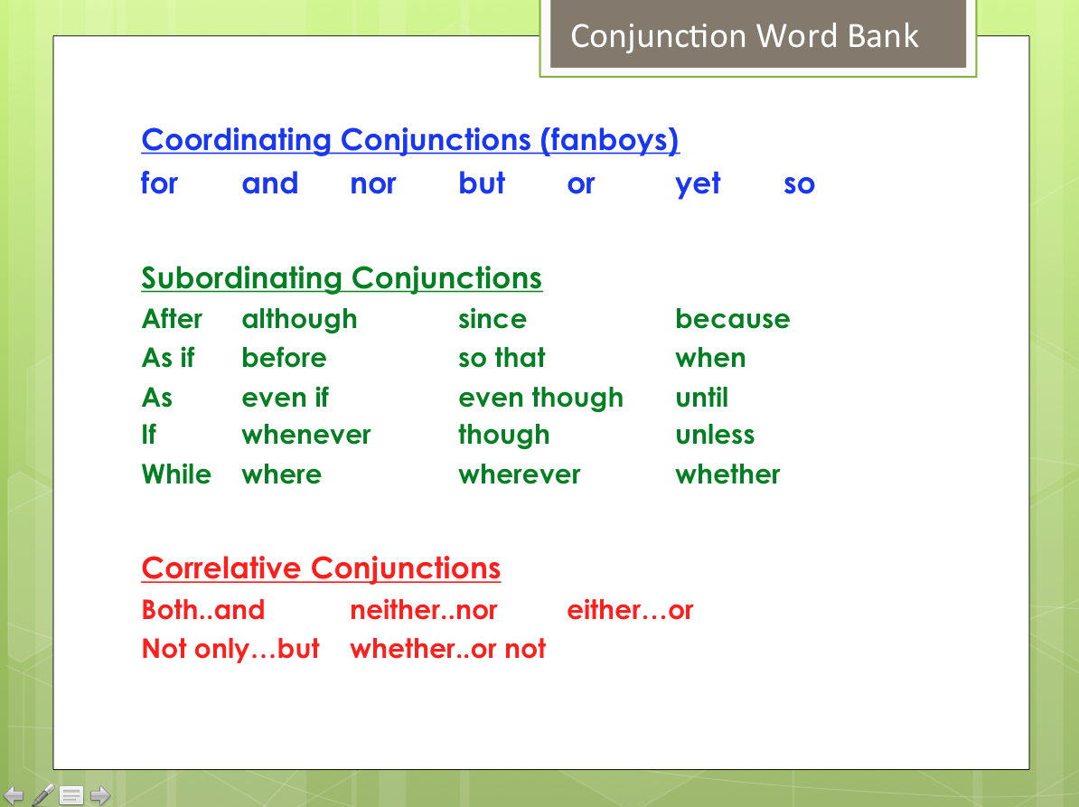

My Autobiography

Introduction
Early life

School life

Future

