Dear Parent/Carers
We know that home learning can be tricky and we’ve tried our best to make home learning as easy and as fun as we possibly can while still teaching your child new things. We would like to thank you for you and your child’s hard work with home learning. It would be great if every week day you could try to do a literacy and maths activity while at some time in the week completing a science and a curriculum task. However, we also appreciate there are so many other ways children can learn so feel free to be as creative as you can in other activities. It would also be great if your child could take part in a physical and a phonics activity too. Below is a list of links to support home learning.
Phonics

Phonics Play
https://new.phonicsplay.co.uk/resources
Phonics play has lots of games and resources to support your child to learn sounds, read tricky words and short sentences. There are even alien words to have a go at!
Read Write Inc Phonics
https://www.youtube.com/channel/UCo7fbLgY2oA_cFCIg9GdxtQ
RWInc has live phonics lessons every week day from 9.30am. There is also story time every Monday, Wednesday and Friday at 2pm. Contact your child’s teacher if you are unsure which set your child is currently working on.
9.30 – Set 1
10.00 – Set 2
As well as phonics activities please reading and asking questions about the story to help their understanding.
Physical
Joe Wicks PE Lesson
https://www.youtube.com/user/thebodycoach1
There is a live PE lesson every morning at 9.00am. Great for burning off some energy.
Yoga
https://www.youtube.com/user/CosmicKidsYoga
Child friendly yoga activities are available on you-tube. Each yoga session has a theme or story. Yoga is great for calming down and mindfulness.
Please don’t forget to share all your home learning on twitter you can find me at @Ms Parker2002. If you wish to contact me directly, need any support, wish to ask questions or simply want to let us know anything please contact me via email on kathy.parker@astreahartleybrook.org and I will get back to you.
Many thanks and keep safe
Ms Parker
Contact details
Hartley Brook Primary Academy
Email – HBenquires@astreahartleybrook.org
Twitter – @HartleyBrookPri

Lesson 1 | I
LO: To learn a poem. | S
This week we are going to be writing a poem, but our first job is to learn it!
The poem is called Handy Work and it is written by Julia Donaldson.

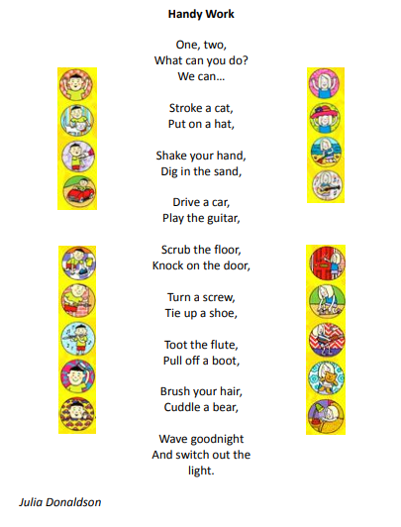
Once you have read the poem a few times, learn some actions to help you remember it! Once you have done that, it’s time to draw a text map! Remember to share it on Twitter!
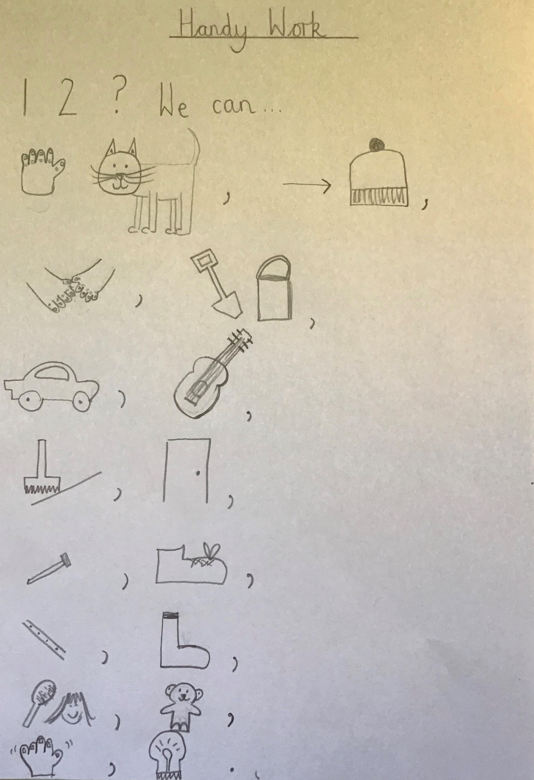
Here is Miss Parkinson’s:
Sunflower Room | I
LO: To identify and write/draw rhymes. | S

Our poem Handy Work is a rhyming poem.
Words that rhyme have the same sound at the end, for example frog and log or peas and cheese. They aren’t always spelt the same way, but they always have the same sound.

In rhyming poems, the last word of every line rhymes.

Job 1:
Listen to the poem again and highlight the words that rhyme.

Job 2:
Can you list words that rhyme with the ones that I have given you?
cap
______ap
______ap
______ap
______ap

hat
_______at
_______at
_______at
_______at

sack
_____ ck
_____ck
_____ck
_____ck

man
______an
______an
______an
______an

Remember rhyming words have the same ending sound but the first sound can change.

Job 3:
Now see if we can write your own rhymes.
The first line has been given to you can you say the second line to make it rhyme with the first? Don’t worry if it’s a silly sentence!
First ideas completed to give a little idea of how silly it could be.
I wanted to climb a tree.

As fast as a bee_____________________________________________

Jim has a golden dog.

________________________________________________________________

I love my red coat.

________________________________________________________________

A pig can jump.

________________________________________________________________

Sunflower Room | I
LO: Understanding verbs and finding them in our poem. | S

Verbs are action words – they tell us what someone or something is doing.

If they are happening in the present they usually end with ing suffix:
For example: shouting, singing, jumping, walking, climbing

If they have happened in the past they usually end with ed suffix:
For example: shouted, singing, jumping, walked, climbed

Job 4 :
There are verbs in each line of the poem. Can you highlight all of them?

Please ensure that your child is forming their numbers and letters correctly.

