Rocket Room calculations (division)

When we divide, we share objects into equal groups. You can practise this at home with any objects you like!
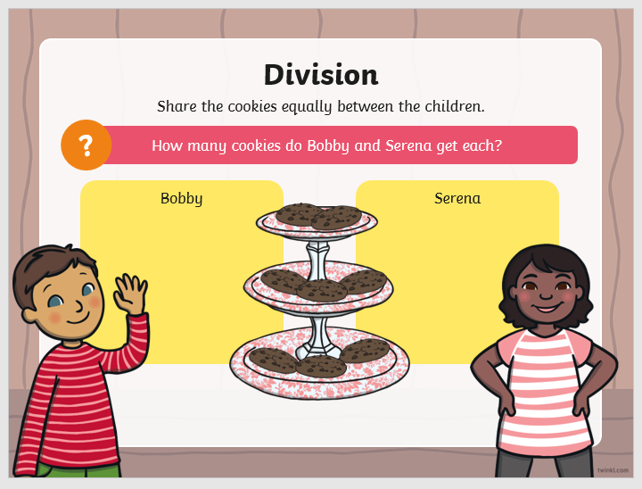
Share 8 objects between 2 people
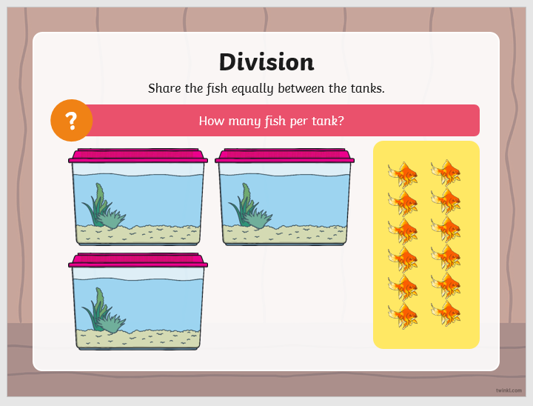
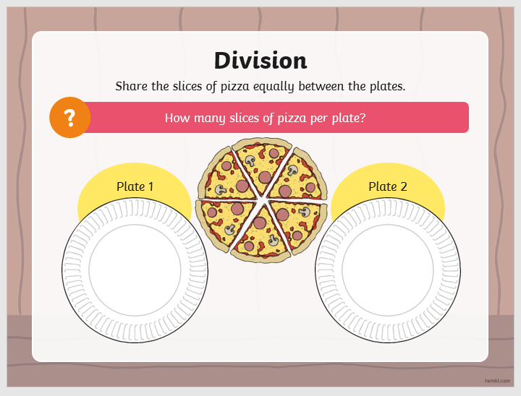
6 ÷ 2 = _____
12 ÷ 3 = _____

8 ÷ 2 = _____

Share 12 objects between 3 people

Share 6 objects between 2 people

How many objects do you need to share?
How many people will share them?
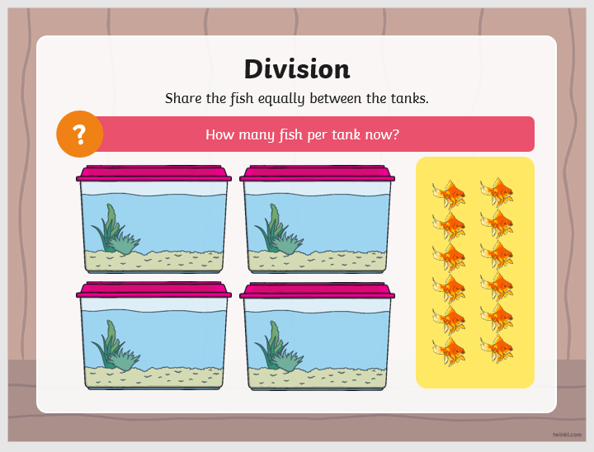
12 ÷ 4 = _____

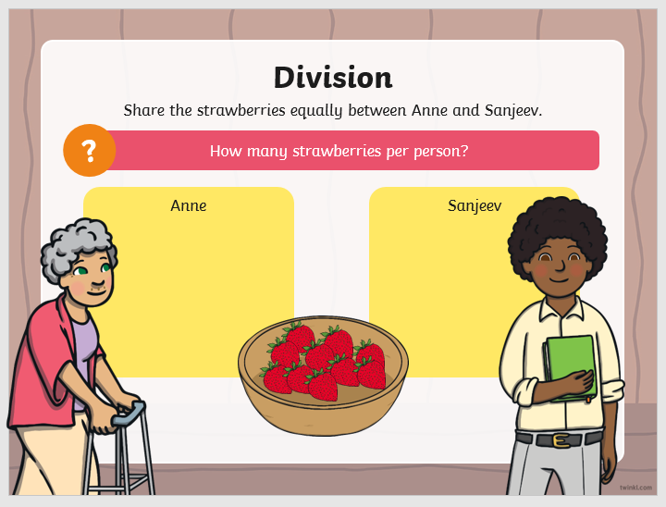

10 ÷ 2 = _____

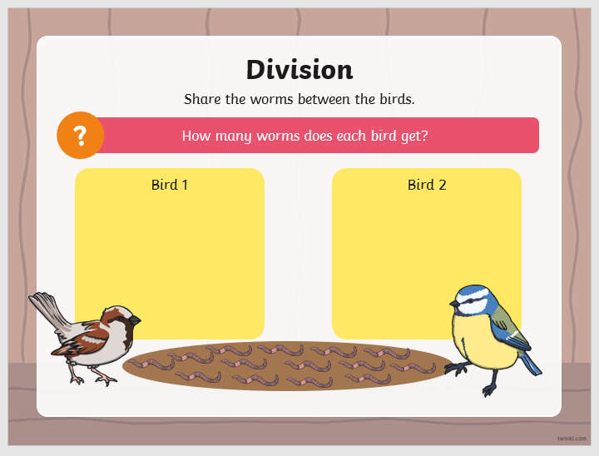
14 ÷ 2 = _____

14 ÷ 2 = _____
Can you write your own calculations?
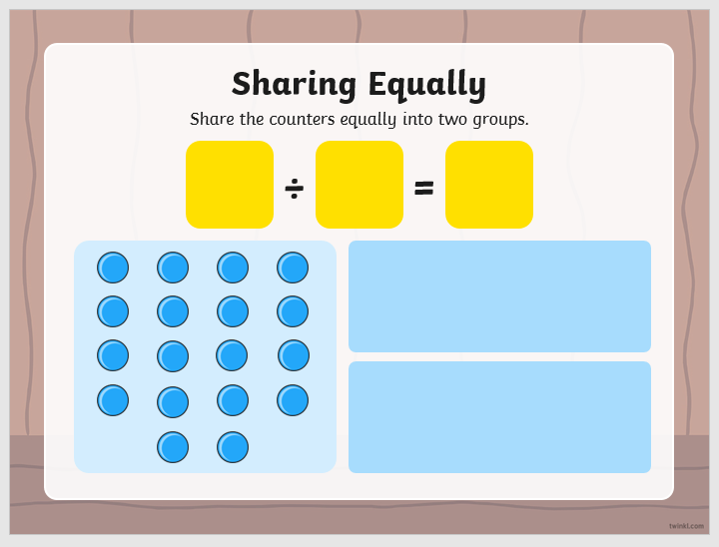

Count the small circles.
How many groups will you share them into?

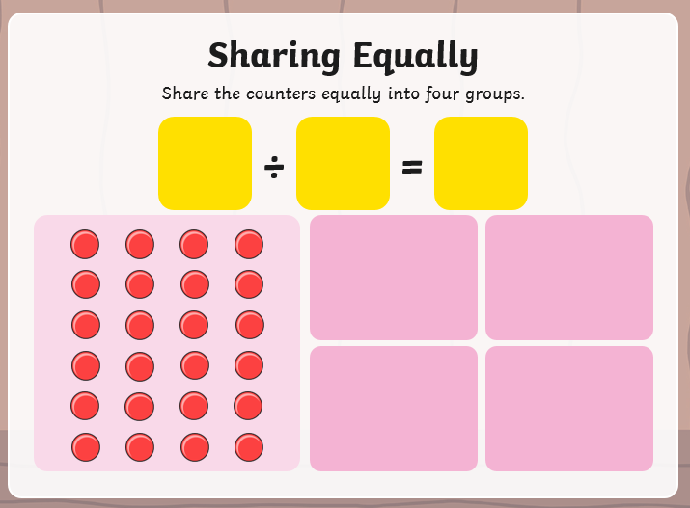

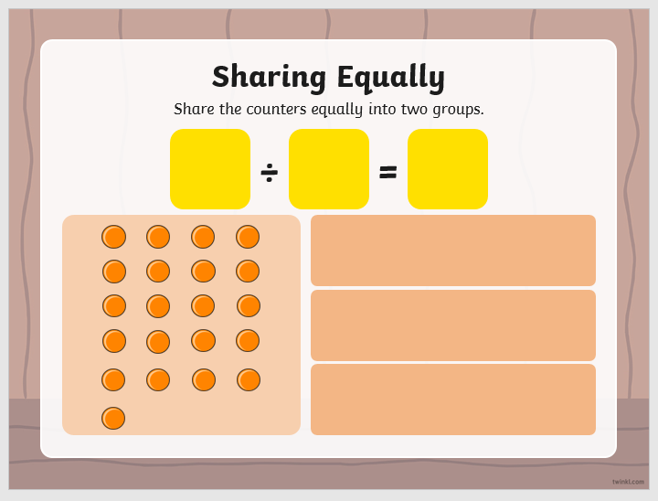

Use the large circles to draw your answers:

15 ÷ 3 = ____

12 ÷ 2 = ____

9 ÷ 3 = ____

16 ÷ 2 = ____

20 ÷ 5 = ____

8 ÷ 1 = ____

16 ÷ 4 =____

10 ÷ 2 = ____

Join the calculations with the correct answer. Draw your
own pictures at the bottom of the page (if you need to)
to find the answers.

21÷ 3 6 4

18 ÷ 2 16 ÷ 4 5

7 9 20 ÷ 4

15 ÷ 3 9 ÷ 1 12 ÷ 2

True or false? Draw your own pictures at the bottom of the page
(if you need to) to find the answers.

25 ÷ 5 = 20 _______ 22 ÷ 2 = 11 ______

16 ÷ 8 = 2 _______ 9 ÷ 3 = 3 ______

18 ÷ 3 = 6 _______ 24 ÷ 4 = 7 ______

20 ÷ 1 = 10 ______ 18 ÷ 6 = ______

Write the calculation for each word problem and find the
answer.
