Dear Parent/Carers

We know that home learning can be tricky and we’ve tried our best to make home learning as easy and as fun as we possibly can. Home Learning for the next few weeks will focus on the topic of The Circle of Life, which would have been this half terms topic at school. It would be great if every week day you could try to do a literacy, maths and creative activity. As well as the activities from the grid it would be beneficial for your child to take part in a physical and a phonics activity too. Below is a list of links to support home learning.
Phonics
Phonics Play
https://new.phonicsplay.co.uk/resources
Phonics play has lots of games and resources to support your child to learn sounds, read tricky words and short sentences. There are even alien words to have a go at!
Read Write Inc Phonics
https://www.youtube.com/channel/UCo7fbLgY2oA_cFCIg9GdxtQ
RWInc has live phonics lessons every week day from 9.30am. There is also storytime every Monday, Wednesday and Friday at 2pm. Contact your child’s teacher if you are unsure which set your child is currently working on.
9.30 – Set 1
10.00 – Set 2
10.30 – Set 3

As well as phonics activities please practise writing your full name everyday.

Physical
Joe Wicks PE Lesson
https://www.youtube.com/user/thebodycoach1
There is a live PE lesson every morning at 9.00am. Great for burning off some energy.
Yoga
https://www.youtube.com/user/CosmicKidsYoga
Child friendly yoga activities are available on youtube. Each yoga session has a theme or story. Yoga is great for calming down and mindfulness.
Dough Disco
https://www.youtube.com/channel/UCj0shfH3pzhrf3dOrSj_pRw
Dough disco is great for building muscles in young children’s hands. It helps to develop fine motor skills which help children to write. All you need is a small piece of play dough and enough room to have a good boogie.

Please don’t forget to share all your home learning on tapestry and twitter. If you do not have a tapestry account please contact Miss Middleton on lauren.middleton@astreahartleybrook.org for a new account log on.

Many thanks and keep safe
Miss Middleton, Miss Wilson and Mrs Brough

Contact details
Miss Middleton
Email - lauren.middleton@astreahartleybrook.org
Twitter - @missmiddletonhb

Mrs Brough
Email – melanie.brough@astreahartleybrook.org
Twitter – @mrsbroughhb

Miss Wilson
Email – Melissa.wilson@astreahartleybrook.org
Twitter - @misswilsonhb

Hartley Brook Primary Academy
Email – HBenquires@astreahartleybrook.org
Twitter – @HartleyBrookPri
Week 9 Daily Activities
 | Literacy | Maths | Curriculum
Monday | Start the week by learning this week’s tricky words (Activity 1). Practise reading, writing and spelling them. You could try to write them in a sentence. Don’t forget to revisit them over the week. | How many mathematical words can you remember that we say when talking about addition? Does the number get bigger (greater) or smaller (fewer) when we are adding? (Activity 6) | Can you draw a picture and label it of something you have done over the weekend? (baking, playing,walking, paddling pool)
Tuesday | Watch the story of Handas surprise on you tube can you remember the key parts of the story?  (Activity 2) | Can you cut out or use cards at home and with a grown up choose two cards 1-9 and add them together?  (Activity 7) | Get creative!
Wednesday | Can you use the pictures from the story to sequence what happened in the story?  (Activity 3) | Can you complete the addition sheets? Challenge yourself to some of the harder equations as well  (Activity 8) | Can you draw or paint a picture of Handa and her basket of fruit?
Thursday | Can you use your sequenced pictures to retell the story to your family without any help?  (Activity 4) | Can you find objects in your house to help you solve the addition equations?  (Activity 9) | Get creative!
Friday | Can you draw your own pictures to tell the story and label or write sentences about them?  (Activity 5) | Can you play the addition games on the links? Try the challenge link as well!  (Activity 10) | On a walk can you take pictures or draw pictures of what you see and put them in a picture?
Challenge | Play Tricky Word Trucks on phonicsplay.co.uk.  How fast can you read the tricky words? | Play maths games on  www.topmarks.co.uk  Let us know which are your favourites on Twitter. | Share all your home learning on twitter or tapestry.

Tricky Words – Activity 1

Please practise reading, writing and spelling this week’s tricky words. You could even have a mini spelling test and let us how you get on, on twitter.
once
the
when
have
she

Activity 2
Can you watch the story of Handas Surprise and talk about happens to your family?
For a challenge you could write about what you thought of the story eg
The story was good.
I did not like the story.
https://www.youtube.com/watch?v=ocnRQi89nK8

Activity 3
Can you cut out and put these pictures from the story in the right order that they happened in the story?

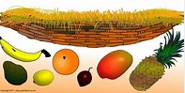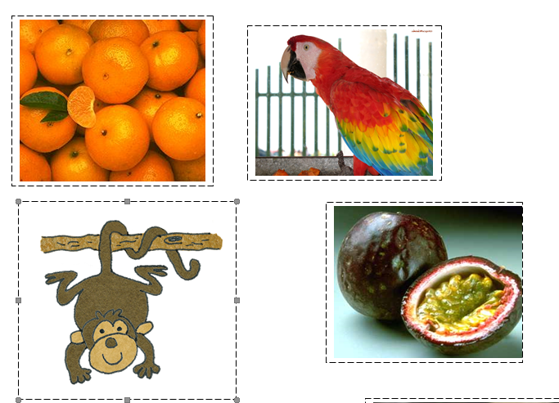
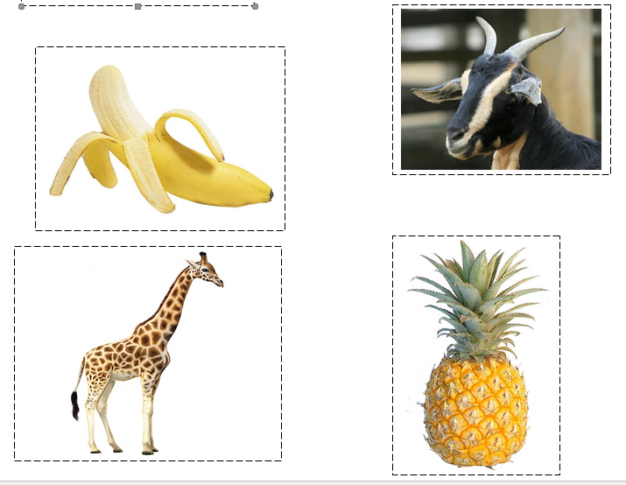

Activity 4
Can you use your sequence of pictures to retell the story of Handas surprise can you think of any actions to support you in remembering how the story goes?

Activity 5
Can you draw pictures from the story and label them or write sentences about your pictures and the story?
Here is my sentence…
Handa had a basket.
She had fruit.

Activity 6
Mathematical words we use when talking about adding
- Add
- Plus
- Greater
- Equal to
When adding the answer will always be greater (bigger).

Activity 7
Can you cut out the cards and choose two and add them together? As a challenge can you write the equation?
7 + 2 = 9

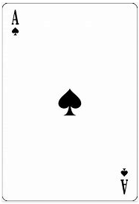
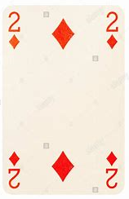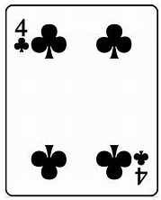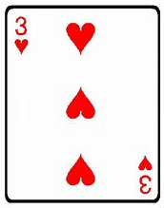
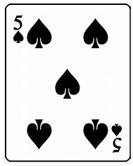
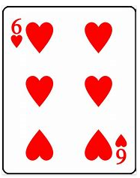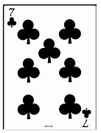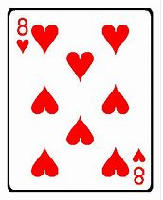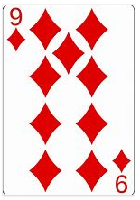

Activity 8
Can you do the addition sheets? Just do the equations you can! As a challenge can you write the equaton?

Sheet1
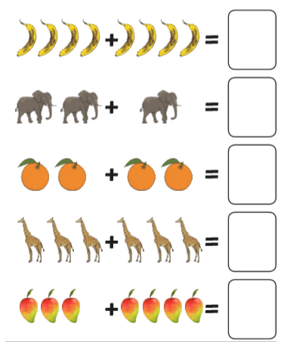

Activity 8 Challenge Sheet 2
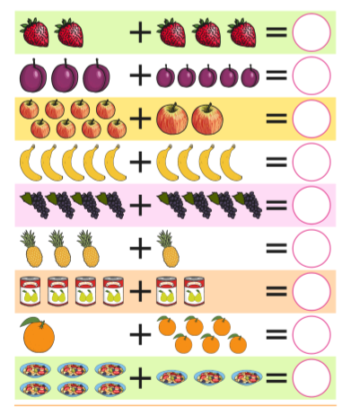

Activity 8 Challenge Sheet 3
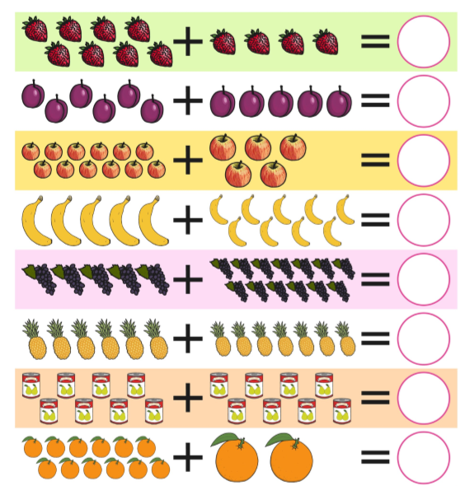

Activity 9
Can you use objects from your house to work out the following equations?
Challenge equations are in purple can you write the equation and answer yourself?

2 + 1 = 8 + 5 =
7 + 4 = 9 + 6 =
5 + 2 = 12 + 3 =
2 + 2 = 6 + 6 =
6 + 3 = 15 + 3 =

Activity 10
Can you do some addition games on line?
https://uk.ixl.com/math/reception/add-with-pictures-sums-up-to-5

https://uk.ixl.com/math/reception/add-with-pictures-sums-up-to-10

https://uk.ixl.com/math/year-1/add-with-pictures-sums-up-to-20

Challenge game
https://www.arcademics.com/games/alien

