Read, Write Inc
ur – nurse with a purse
Word time!
- Show or write the word and ask your child to spot the “special friends”
eg n-ur-se ( sounds like ir)
- Ask children to say the sounds in “Fred talk” and then to read the words.
- Count out the sounds on their fingers. Repeat the word and pinch their fingers as they say the sounds.
- Write the word and pinch their fingers as they say the sounds.
- Tick the word if it is correct or try again.

burn turn spurt nurse purse hurt

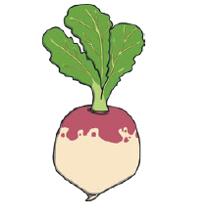
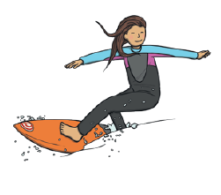
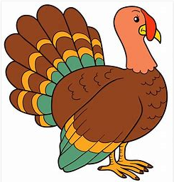

Join the “ur” words to the pictures:
purple turtle turnip surprise surf curl church hurt turkey
Highlight the “ur” words in the story.

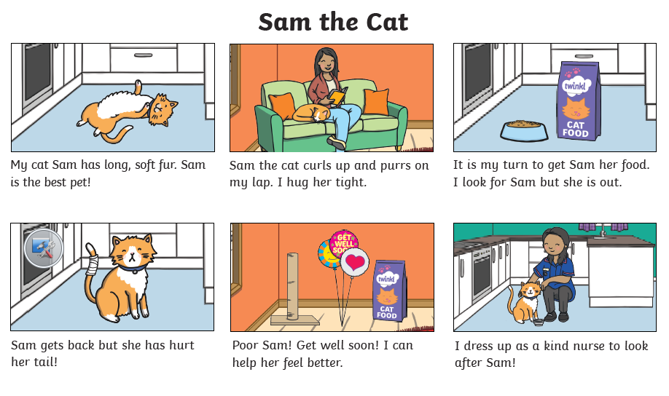

Write or say a sentence for 5 different “ur” words. Make sure your sentence has a capital letter and a full stop.

- _________________________________________________________

- _________________________________________________________

- _________________________________________________________

- _________________________________________________________

- _________________________________________________________
Fill in the correct “ur” word:
Red, blue and __________ are colours.

Take care! Don’t _________ yourself!

Is a __________ bigger than a chicken?

I would love to learn how to _______ in the sea.

Have you ever tried to eat a __________?

Can you spot the alien words?
