Read, Write Inc
ar – start the car
Word time!
- Show or write the word and ask your child to spot the “special friends”
eg start
- Ask children to say the sounds in “Fred talk” and then to read the words Eg s-t-ar-t - start
- Count out the sounds on their fingers. Repeat the word and pinch their fingers as they say the sounds.
- Write the word and pinch their fingers as they say the sounds.
- Underline the special friend “ar”
- Tick the word if it is correct or try again.

car part hard start star sharp
Just add “ar”
Can you match the “ar” word?
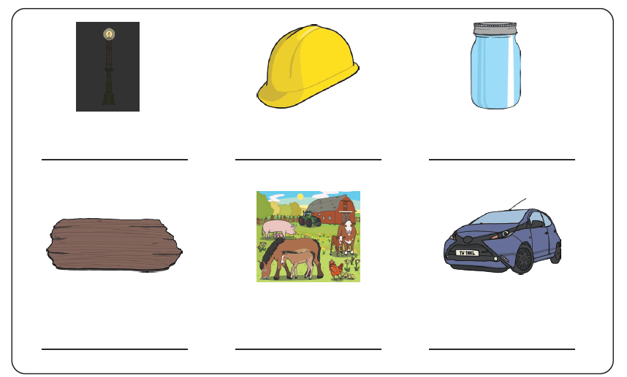

Write or say a sentence for 5 different “ar” words. Make sure your sentence has a capital letter and a full stop.

- _________________________________________________________

- _________________________________________________________

- _________________________________________________________

- _________________________________________________________

- _________________________________________________________

Fill in the correct “ar” word:

Be careful! That is ________.
The opposite to soft is ______.
Have you got a red _______?
Many animals live on a ________.
Look out at night and you will see _______s in the sky.
A ______ is a musical instrument.
When are we going to ______ playing the game?

hard star sharp harp farm car start
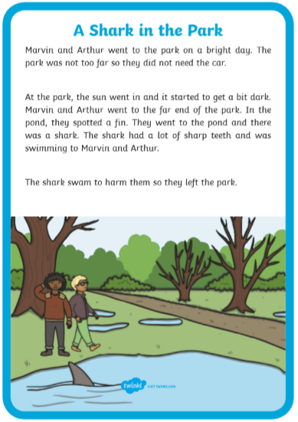
Read the story and highlight all the “ar” word

