Year 4, Summer
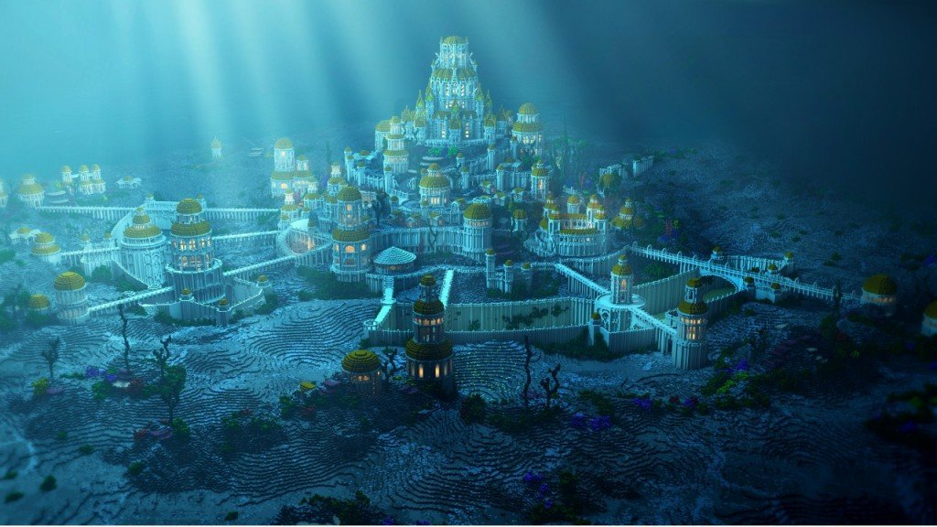
Project Work
Discover Your Own Lost City

You are part of team of discoverers and have heard about a lost city somewhere on Earth. You have decided to find out more about this place and the skills you will need to find it.

In order to visit it, you will need to find out more information before you go by completing the following tasks. Along the way, you will gain a lot of knowledge and hopefully have fun!

Each task will have different ways to complete them and it is entirely up to you how you do it. There will be two tasks per week to complete, resulting in a wonderful project, which will enable you to answer our overarching question. Be imaginative and enjoy working independently! (There are idea sheets for some of the trickier tasks)

Please post any pictures of your completed tasks on the Y4 Twitter page, this will help you to share your ideas and celebrate your hard work.
Overarching Question – How is it possible that cities can disappear?

Contents Page
- Background – What makes a good explorer?
- Roles - Who would you take with you on your discovery?
- Location – Where in the world? Weather, temperature.
- Proposal – How does it look now?
- Prediction – Why has no one discovered it before?
- Proposal – How do you want it to look?
- Discovery – are there any signs of previous civilisation.
- Living animals – food chains/ classification.
- Rivers and Transport
- Mountains & Volcanos
- Religion & beliefs
- Artefacts
- Rulers
- Social Hierarchy
- Architecture including materials to build
- Clothing
- Food
- Tourist attraction & Landmarks – brochure/leaflet
- Sports
- Links – to other civilisation

Task One – Discovery Study
Enquiry Question – What makes a good explorer?
Information
Around the world and over time, many lost cities have been discovered. They were found by people who were curious of what lay beyond the mountains and rivers, underneath the oceans or hidden underneath the lava or within a spilled volcano.
The age of exploration took place between the 15th and 17th centuries. During this time, many countries in Europe sent out explorers to discover new lands, find trade routes, seek treasure and gain territory for their country. As a result, much of the world was mapped and many world civilisations came into contact with each other. Sometimes it is called the Age of Discovery.

Great discoverers from past times include Christopher Columbus, who travelled the world in order to find new land and territory. Some discoverers set out to find trade links to other lands or explore the world for gold and treasure. People such as Charles Darwin were a different type of discoverer who explored places to find new things about Science.

Some discoverers looked to challenge themselves or challenge records. Neil Armstrong, who as part of a big team of astronauts and scientist, discovered a way to travel to the moon.

Many places around the world have been lost over time and unearthed later in civilisation. They show us now how different civilisation would have lived or unearth hidden secrets. Who knows what else has not yet been discovered?

Task
To discover a lost City, you must be an excellent discoverer. Like most great discovers, they have a story to share. Your task is to share your story of how you came to discover a new lost city. You could complete this in many ways, this could be done by writing your own story, biography, newspaper article or internet page. You may want to do it by drawing your own labelled map. Be creative and show why you are a truly great discover!
Research Use the following links to find out more:
https://www.youtube.com/watch?v=vL1UIG_Tcwo
https://www.worldtravelguide.net/features/feature/15-of-the-best-lost-cities/
https://www.roughguides.com/gallery/20-great-lost-cities/
https://www.forbes.com/sites/jimdobson/2016/01/11/move-over-machu-picchu-the-discovery-of-paititi-the-secret-city-of-gold-may-change-peru-forever/#1426b24c5e85A

Task One Ideas – Discovery Study
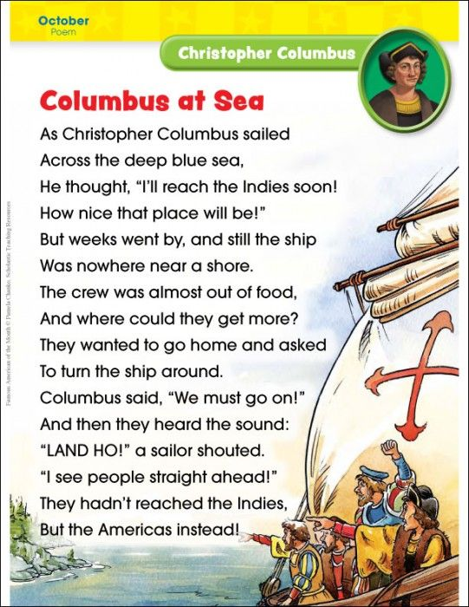
Enquiry Question – What makes a good explorer?

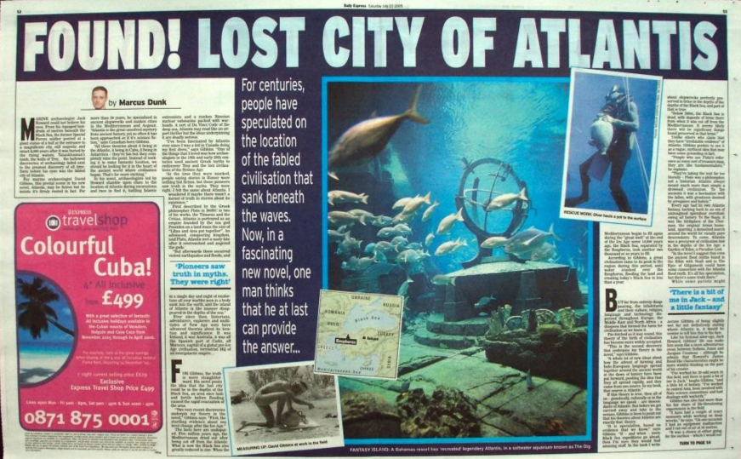
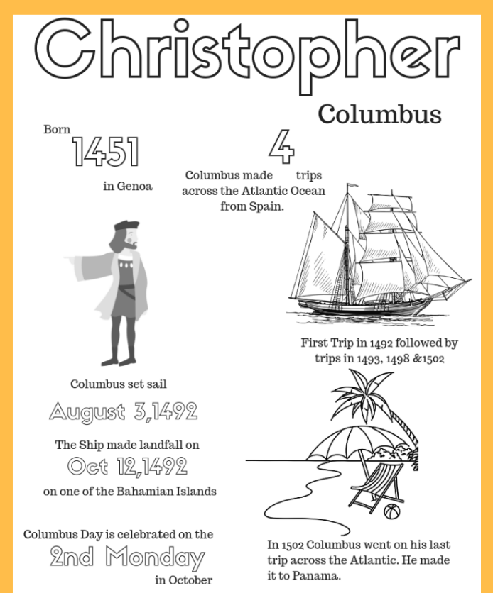

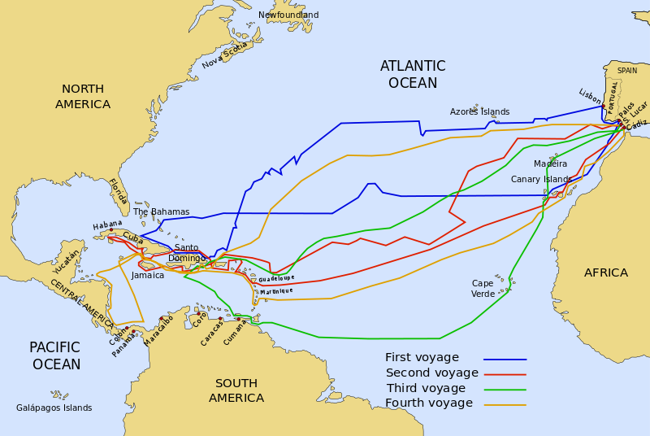

Task Two – Discoverer Study
Enquiry Question – Who would you take on your discovery?
Information
To be a successful discoverer, who explores the world to find new land or unearth hidden cities or treasure, you will need certain skills. Many of the great people who discovered parts of the world, were part of a team. Each person held skills or knowledge that led them to be successful on their journey.

The type of exploration would decide what person or role would be needed in order to be successful on their discovery. Examples of successful discoveries, such as, space and planets, gravity, have impacted on how we see the world today. We have gained knowledge through the finding of fossils and dinosaurs by archaeologists and palaeontologists.

Task
For task 2, we want you to develop your knowledge and understanding of the roles that would be needed to make your discovery successful. You could do this in many different ways. Research about the different types of people who discovered things around the world. Try to keep it to Land or artefacts to link to the overarching question. You could do this by advertising for jobs to be a part of your discovery team, thinking what roles you would need. You may want to complete a fact file about a certain person in history who was successful in discovering land, or a poster or map of different people and where in the world their discoveries took place.
Research Use the following links to find out more:
https://www.ducksters.com/biography/explorers/
https://www.bbc.co.uk/blogs/tv/entries/82eda299-e2ca-37d6-8ffd-00e66303a7b6
https://archaeology.mrdonn.org/
https://kids.britannica.com/kids/article/paleontology/353591

Task Three – Discoverer Study
Enquiry Question – Where in the world is you Lost City located?
Information
From tasks 1 & 2 you should have a good understanding about the type of skills you need to be successful in the discovery of a new lost city. The location that you now decide on as to where the discovery of the lost city is will effect lots of things later on in the task, for example, the climate (weather), animals/food and rivers and mountains.
Continent Country

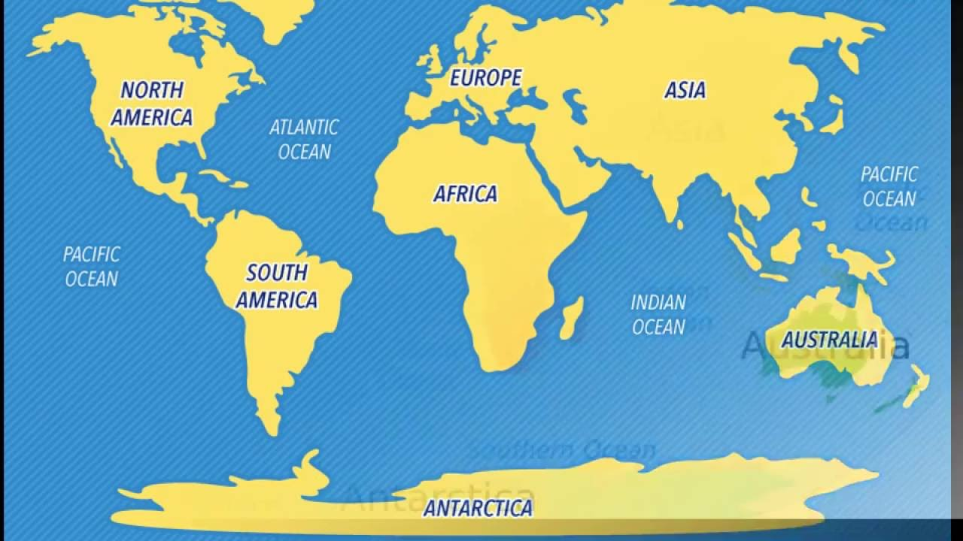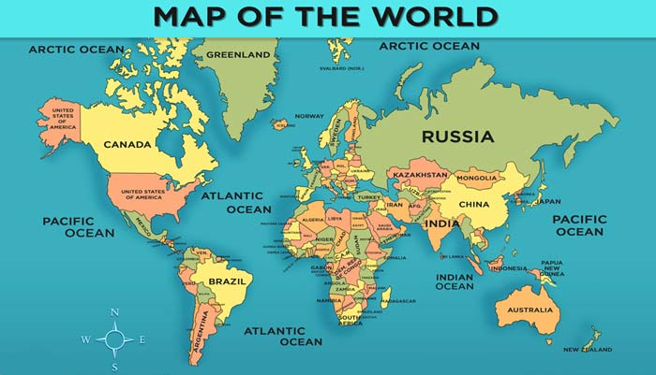
The location of you lost city, for example, could be in Antarctica, where it has been covered over for hundreds or even thousands of years by thick snow and ice. Due to the climate changes, back when your lost city was formed the climate was similar to England and you discover remains of houses similar to the ones we see today.

Task Four – Discoverer Study
Research Use the following links to find out more:
https://www.bbc.co.uk/bitesize/topics/zvsfr82/articles/znm7vk7
https://www.google.co.uk/intl/en_uk/earth/
https://www.bbc.co.uk/bitesize/topics/z849q6f/articles/z7dkhbk
https://www.bbc.co.uk/bitesize/topics/zvsfr82/articles/zdk46v4

Task
Task 3 is all about finding where your lost city will be located. We would like you to create a fact sheet about your city and the country and continent it is located. You could include things like the weather, average temperature in different seasons, what animals currently live there, its population and much more. You can add pictures with detailed labels on if you wish.
Enquiry Question – What does your lost city look like?
Information
Your location is now set! When discoveries take place, often the findings don’t look how they originally did. Over time they may have decayed or broke down due to many reasons. Many lost cities and land that you may have researched in Task 1, would have looked different when they were first formed.

The lost city of Atlanta’s and Pompeii in Italy are some examples of Cities that have changed over time for different reasons. Pompeii was devastated by the eruption of Mount Vesuvius in 79AD. The ash from the eruption was dumped on the city, which preserved it, in the exact same state, for more than 1,500 years. It was rediscovered in 1599, which have provided a fascinating look into the Roman civilisation, capturing the exact moment the City and everything in was set frozen still by the ash. Humans, animals and buildings were frozen in time and their figures can still be seen today!

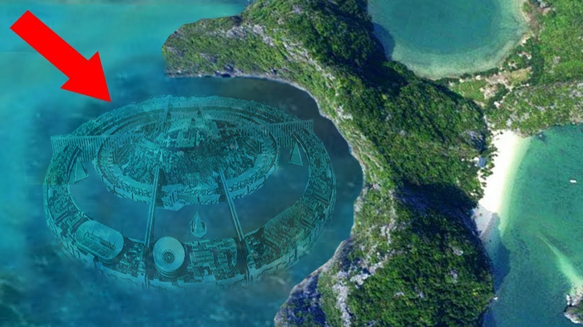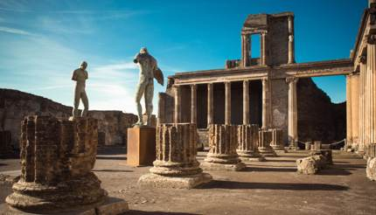

Research Use the following links to find out more:
https://www.persil.com/uk/dirt-is-good/arts-crafts/homemade-clay-for-kids.html
https://www.bing.com/videos/search?q=how+to+draw+ancient+cities+for+children&docid=608022168845814349&mid=81F5A89862D3201DBB2881F5A89862D3201DBB28&view=detail&FORM=VIRE
https://www.youtube.com/watch?v=Y6xL_pFafYI

Task
For task 4, we would like you to recreate what your lost city looks like. This could be drawn and then coloured/painted in a style of your choice or it could be made with clay, play/salt dough or recycled materials.

Task Four Ideas – Discovery Study
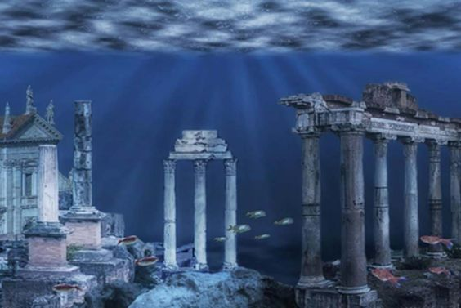
Enquiry Question – What does your lost city look like?
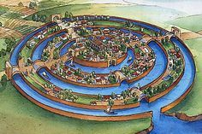
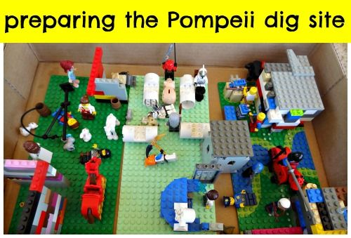
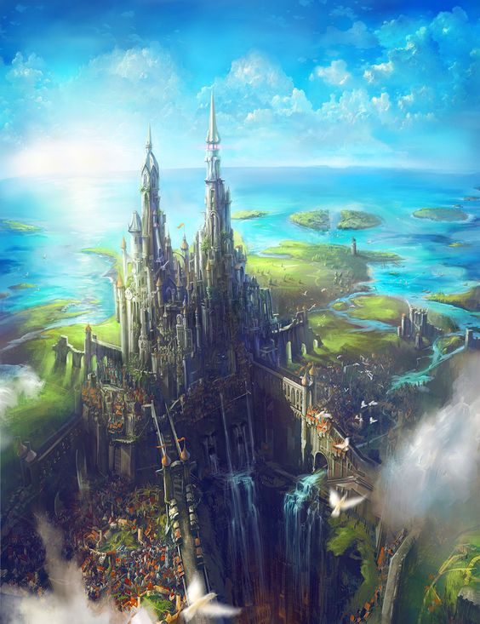

Task Five – Discoverer Study
Enquiry Question – Why has no one discovered it before?

Information
Many cities or landmarks that have been lost or discovered over time were often hidden by something, stopping humans from discovering them. For example, the lost city of Atlantis was said to be submerged within the Atlantic Ocean. There are many stories about these lost cities or mythical stories where creatures live or roam lands.

Mythical creatures are often used within stories or films about creatures who once roamed the earth. Some of these creatures were feared by humans or were seen to be sent from the Gods. Creatures like, Cyclops (the one-eyed giant who captured and ate people), Dragons, who breathed fire, often guarding treasure, Mermaids, which were sea creatures with the head and body of a woman but the tail of a fish. Some of these creatures could have impacted on the discovery of cities, treasure or landmarks.

Research Use the following links to find out more:
https://www.gods-and-monsters.com/list-of-mythical-creatures.html
https://kidskonnect.com/fun/mythical-creatures/
http://www.history-for-kids.com/mythical-creatures.html

Task
For task 5, we want you to show why no one has ever discovered your lost city before now. You could do this by writing a short story, it could be a diary entry of someone who has tried but failed before. If you want to do something creative you could draw part of the lost city that has stopped people from entering, or a creature that lives there.

Task Six – Discoverer Study
Enquiry Question – How do you want it to look?
Task
For this task we want you to think how your lost city will look over time. This could be ways you adapt it for people to live, it could be how you improve it to make it into an attraction or landmark, or to maintain it as it is has started to wear over time.
To do this you could think about how you completed task 4, and make notes next to the model or drawing you did to show the change or you could remake the model or drawing to show the differences. Other ways you could complete this task could be to write a set of instructions or a diary entry on how you or your team will improve or maintain your city.
Some of the examples aren’t of lost cities but of cities which have had massive changes to them, which may help you with your ideas. Try to think about why you are developing things when you plan them, what impact will it have on your city. Think about how you will allow others to travel there, make it safe and be able to provide food and drink to anyone living or travelling to your lost city.

. Think about how you allow others to travel there, make it safe and be able to provide food and drink to anyone living or travelling to your lost city.

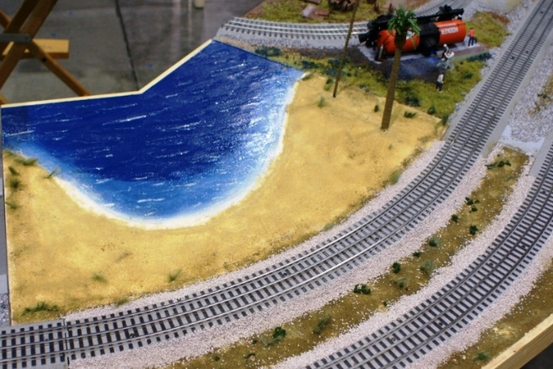
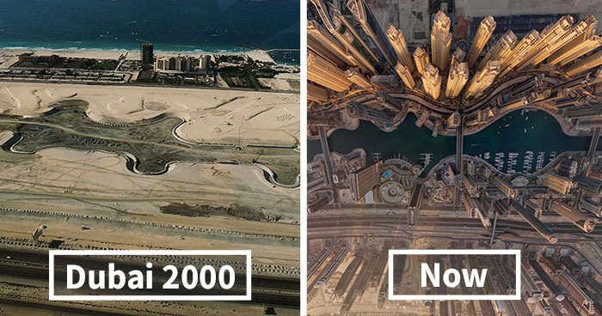

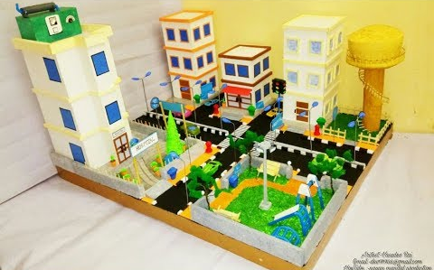
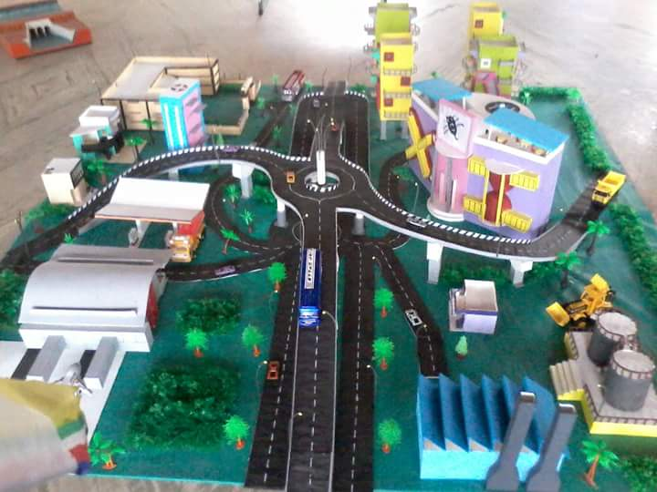

Task Seven – Discoverer Study
Enquiry Question – are there any signs of previous civilisation?
Information
As you will have discovered in previous tasks some lost cities may once have been home to people or living things in the past. Some lost under the ocean, ruined by natural disasters or for many others reasons we may not know about.
We can often tell that there have been signs of previous civilisation (where people lived with many things in place, such as, legal rules, politics and religion) from the things they left behind that are either still there today or are uncovered.
An Archaeologist studies the history of people and their cultures by the analysis of their artefacts, inscriptions, monuments and other remains.

Research Use the following links to find out more:
https://www.bbc.co.uk/bitesize/clips/zwv3cdm
https://www.bbc.co.uk/bitesize/clips/z96hfg8
https://www.bbc.co.uk/bitesize/clips/zdyvr82

Task
After looking at different types of findings from Archaeologists, create your own findings within your lost city that showed evidence of civilisation from a previous civilisation. You could draw a picture of your evidence or create a fact sheet with drawings of different things you have found to suggest there was once people living there.

Task Eight – Discoverer Study
Enquiry Question – What types of animals live in city?
Information
Many different animals only live in certain parts of the world, their habitat. This can be for many reasons, such as, the climate, other animals living in the area and the food chain within that area, and the ecosystems.
An ecosystem is where many plants and animals live together as they rely on one another to survive.
https://www.bbc.co.uk/bitesize/topics/zbnnb9q/articles/z2pqfcw
Depending on where you have located your lost city will have an impact on what animals could live there and the food chains that you will find. Use the video’s below to look at what a food chain is and the types of animals that live in different locations and climates around the world.

Task
Using the information you have gathered from the previous tasks, create a fact file about some of the living animals to your country and the food chains they are a part of. These animals could be ones that live in similar places around the world or animals that have been discovered within your lost city.

Research Use the following links to find out more:
https://www.bbc.co.uk/bitesize/topics/zbnnb9q/articles/zwbtxsg
https://www.bbc.co.uk/bitesize/clips/zjshfg8
https://www.bbc.co.uk/bitesize/topics/zbnnb9q/articles/zsphrwx
https://www.bbc.co.uk/bitesize/topics/zbnnb9q/articles/zcgbjty
https://www.bbc.co.uk/bitesize/topics/zbnnb9q/articles/z93vdxs
https://www.bbc.co.uk/bitesize/clips/zgrvr82

Task Nine – Discoverer Study
Enquiry Question – How are rivers formed and how are they used?
Information
A river is a moving body of water that flows from its source on high ground, across land, and then into another body of water, which could be a lake, the sea, an ocean or even another river.
A river flows along a channel with banks on both sides and a bed at the bottom. If there is lots of rainfall, or snow or ice melting, rivers often rise over the top of their banks and begin to flow onto the floodplains at either side.
Rivers usually begin in upland areas, when rain falls on high ground and begins to flow downhill. They always flow downhill because of gravity.
The water in rivers is “fresh water” that has come from rain, snow and from underground streams. It can usually be drunk safely by people unless it is too dirty because of mud or human pollution. People and animals need fresh water to drink, so they often live by the side of a river.

Research Use the following links to find out more:
https://www.bbc.co.uk/bitesize/topics/z849q6f/articles/z7w8pg8
https://www.bbc.co.uk/bitesize/guides/zyt9q6f/revision/1
https://kids.kiddle.co/River#Using_rivers

Task
Rivers are often used in countries to transport goods, help grow plants or even for leisure or sports activities. Think about the things that you will need in your lost city and where you may get it from. If your lost city is located in a country for example, Egypt, look at what things are already transported by rivers and where they are sent too. Create a fact file about rivers and how they are used within your country or on your map of your lost city you could add on the rivers that pass through and what goods or things they will be used for.

Task Ten – Discoverer Study
Enquiry Question – How are rivers formed and how are they used?
Task
For your task we would like you to have a go at making your own volcano, if you really want to challenge yourself and you have the right materials at home, you could make your volcano erupt. You could make your volcano out of old materials that you don’t need such as cardboard.
The website gives instructions on what you will need to make a DIY erupting volcano.
https://www.instructables.com/id/DIY-Erupting-Volcano/
We would love to see some of your creations so please post them on twitter for us to see and make sure you tag us in your post! Enjoy!

Research Use the following links to find out more:
https://www.bbc.co.uk/bitesize/topics/z849q6f/articles/z4g3qp3
https://www.bbc.co.uk/bitesize/topics/z849q6f/articles/zd9cxyc

Information
Mountains are areas of land that are much higher than the land surrounding them. They are higher and usually steeper than a hill and are generally over 600 metres high. They are often found together in a group called a mountain range.
Some well-known mountain ranges in the four countries that make up the UK include:
- the Cairngorms in Scotland
- the Pennines in England
- the Mourne Mountains in Northern Ireland
- Snowdonia in Wales
The highest mountain ranges are created by tectonic plates pushing together and forcing the ground up where they meet. This is how the mountains of the Himalayas in Asia were formed.
Tectonic plates are also at work under the Atlantic Ocean, but instead of forcing the ground up, the two plates in the middle of the Atlantic Ocean are actually moving apart in opposite directions. This causes lava to erupt out of the gap that is left. As it cools down, the lava creates a long line of mountains - the longest mountain range on Earth.

Task Eleven – Discoverer Study
Enquiry Question – What religions and beliefs are held within your city?
Information
People often use the word religion to mean the worship of a god or gods. But some religions do not believe in gods. One thing that all religions have in common is that they help their followers to find meaning in the world. Many people want to where the world came from or what happens after we die. Most religions offer some sort of answer to these great questions.
Throughout history there have been two main types of religion. One type believes in a single, all powerful god, which include Judaism, Christianity and Islam. In the other main type of religion, followers believe in more than one god, some of which include, Hinduism, Jainism and some Native American religions. Followers of other religions do not focus on worshipping gods, for example, Buddhism. Buddhists search for a higher state of being, which means freedom from suffering.
Non-religious Beliefs
Humanists do not believe in a god. They believe it is possible to live a good and fulfilling life without following a traditional religion. They do not follow a holy book either. Instead, Humanists value traits like reason and rely on science to explain the way things are. Humanists believe that people have one life to live - there is no afterlife. As a result, they focus on being happy and making the most of their life. They also believe they have a duty to support others.

Research Use the following links to find out more:
https://www.bbc.co.uk/bitesize/topics/znk647h/articles/zmqpkmn
https://www.bbc.co.uk/bitesize/subjects/z7hs34j
https://www.bbc.co.uk/teach/ks2-religious-studies/z6pbqp3

Task
Create a fact file of a religion of your choosing. Use the links above to research one of the religious or non-religious beliefs. You could do it as a poster with images or on the computer as a PowerPoint presentation.

Task Twelve – Discoverer Study
Enquiry Question – What do the artefacts found on your lost city tell us about previous civilisation?
Information
Archaeologists look into History or Historical facts to locate things around the world. History is all around us, if we look out of the window, what is the oldest thing you can see?
An artefact is anything made, used, or modified by humans. Artefacts can be portable (they can be moved or collected) like a spear point or clay pot or even a glass bottle. Some artefacts are not portable, for example, remains of ancient fires. Artefacts are important because archaeologists and historians use them as clues to ask and answer questions about what life was like in the past.
People live all over the planet, and where there are people, there are artefacts. They are often found by excavating (uncovering by digging in the ground) abandoned or buried trash piles. Archaeologists collect artefacts and then study them, which can be often found on display in museums. Some artefacts have been discovered underwater from shipwrecks.

Task
Create your own artefact that was discovered upon finding your lost city. You could either draw it or make it out of materials around the house. 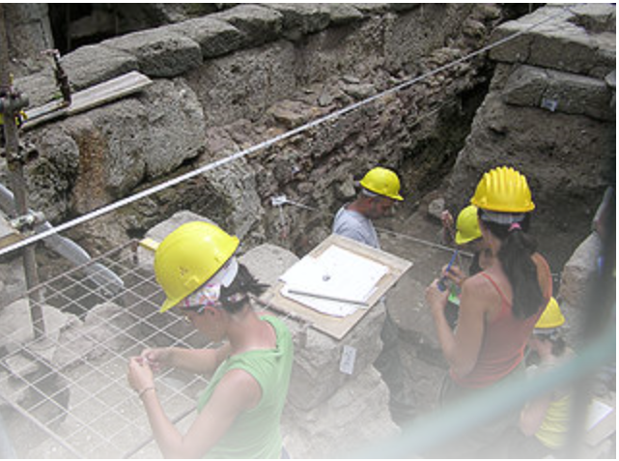 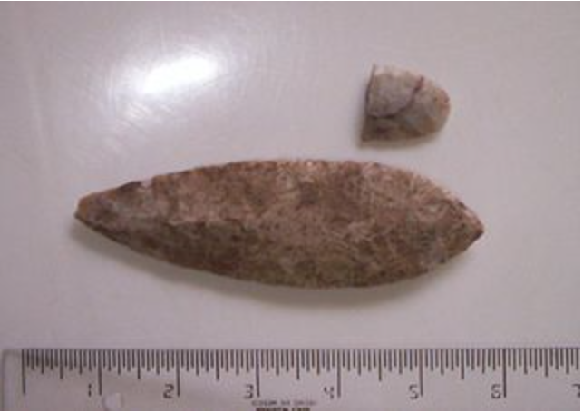

Research Use the following links to find out more:
https://www.bbc.co.uk/cbbc/search?q=artefacts&page=1
https://kids.kiddle.co/Artifact_(archaeology)

