Monday 8th June 2020
Questions from myminimaths.co.uk:
25a) $\frac{4}{6}$ - $\frac{1}{3}$ = 25b) $\frac{3}{10}$ + $\frac{1}{5}$ =
25c) $\frac{1}{3}$ - $\frac{2}{12}$ = 25d) $\frac{3}{8}$ + $\frac{1}{4}$ =
25e) $\frac{12}{15}$ - $\frac{2}{3}$ = 25f) $\frac{1}{4}$ + $\frac{1}{2}$ =
25g) $\frac{35}{50}$ - $\frac{4}{10}$ = 25h) $\frac{4}{6}$ + $\frac{7}{24}$ =
25i) $\frac{15}{18}$ - $\frac{4}{6}$ = 25j) $\frac{51}{100}$ + $\frac{6}{20}$ =
25k) $\frac{17}{25}$ - $\frac{2}{5}$ = 25l) $\frac{3}{4}$ + $\frac{3}{16}$ =
25m) $\frac{10}{13}$ - $\frac{18}{39}$ = 25n) $\frac{4}{7}$ + $\frac{6}{21}$ =
25o) $\frac{65}{72}$ - $\frac{4}{9}$ = 25p) $\frac{19}{48}$ + $\frac{3}{6}$ =

Video to help:

https://myminimaths.co.uk/arithmetic-16-practice-question-25/

Answers:
https://myminimaths.co.uk/arithmetic-16-answers-question-25/

LO: To multiply by an integer.
Tuesday 9th June 2020
Star words: denominator numerator multiply
Simplify factors vinculum proper improper

Fluency
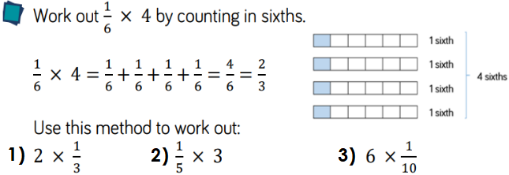
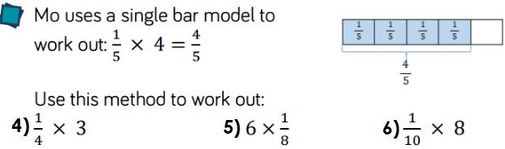
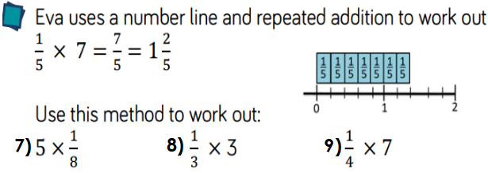

Reasoning
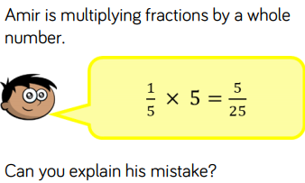 | 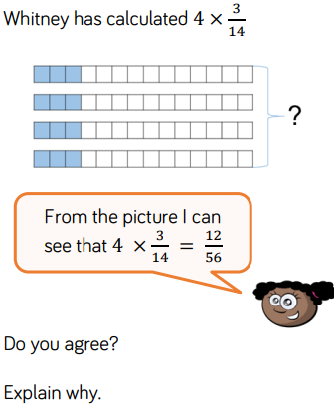

Problem Solving
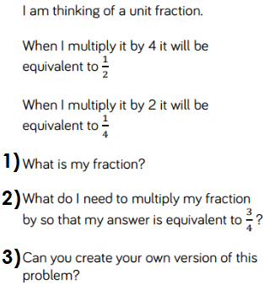 | 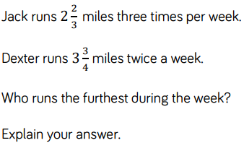

Challenge
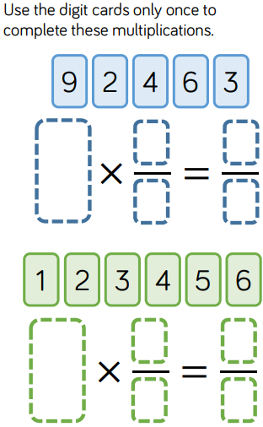

LO: To multiply a mixed number by a whole number.
Wednesday 10th June 2020
Star words: denominator numerator multiply
Simplify factors vinculum proper improper

Fluency
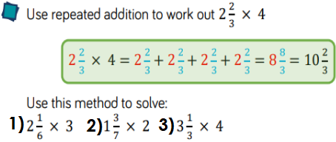
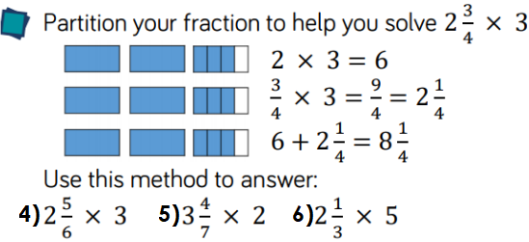
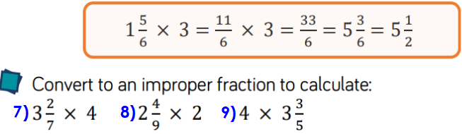
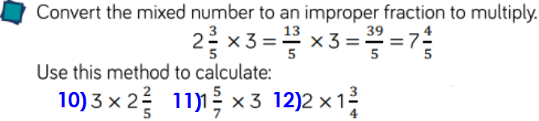

Reasoning
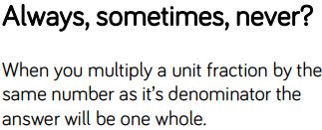 | 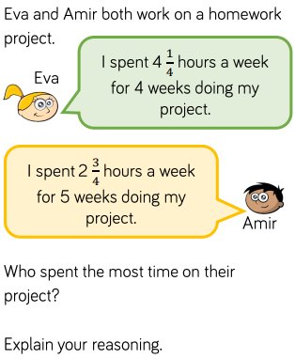

Problem Solving
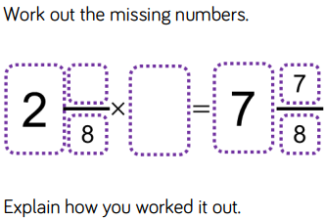 | 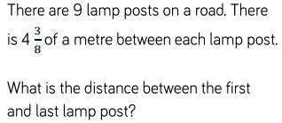

Challenge
Use the pattern blocks. If is equal to 1 whole, work out what fraction the other shapes represent.
Use this to calculate the multiplications.
Give your answers in the simpliest form.
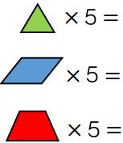

LO: To multiply fractions by fractions.
Thursday 11th June 2020
Star words: denominator numerator multiply
Simplify factors vinculum proper improper

Fluency
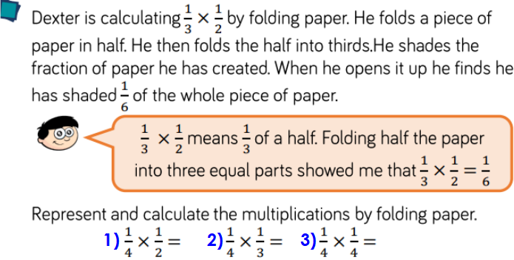
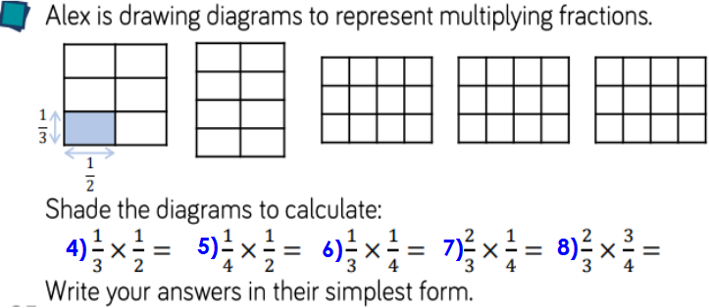

Reasoning
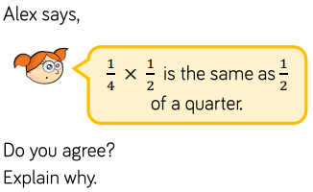 | 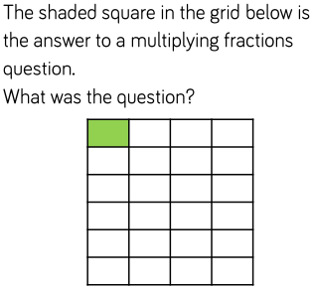

Problem Solving
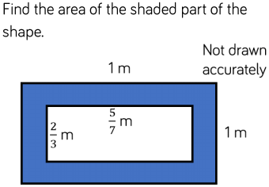 | 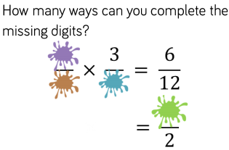
Challenge
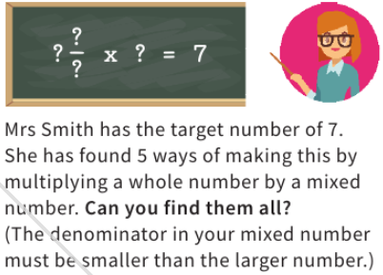

Friday 12th June 2020
Arithmetic
1) 298 + 10 = | 19) $\frac{2}{9}$ + $\frac{3}{9}$ =
2) 46 x 4 = | 20) ___ ÷ 7 = 7
3) 5.5 + 5.5 = | 21) 3.9 ÷ 10 =
4) 78 ÷ 2 = | 22) 7² =
5) 369 + 212 = | 23) 2,900 + 2500 =
6) 64 ÷ 8 = | 24) 490 ÷ 70 =
7) 309 + 7 = | 25) ____ x 20 = 2400
8) 41.09 + 11.2 = | 26) 70 % 3500 =
9) 8 x 3 x 5 = | 27) 5.12 x 3 =
10) 10,361 - 100 = | 28) $\frac{2}{5}$ + $\frac{3}{5}$ =
11) 79 x 4 = | 29) ___ ÷ 8 = 50
12) 6.1 + 7.9 = | 30) 70.6 ÷ 10 =
13) 96 ÷ 2 = | 31) 8² =
14) 486 - 217 = | 32) 1800 + 3300 =
15) 42 ÷ 6 = | 33) 4400 ÷ 44 =
16) 219 + 6 = | 34) ___ x 70 = 4200 =
17) 61.2 + 11.2 = | 35) 60% of 5,500 =
18) 8 x 4 x 5 = | 36) 4.61 x 4 =

