Monday 29th June 2020
Questions from myminimaths.co.uk:
6a) 2.3 + 7.152 = 6b) 3.1 + 1.554 =
6c) 6.54 + 2.3 = 6d) 4.003 + 0.4 =
6e) 7.6 + 4 = 6f) 2.8 + 4.097 =
6g) 9.8 + 0.155 = 6h) 6.24 + 12.41 =
6i) 5.002 + 4.12 = 6j) 7.126 + 2.24 =
6k) 6.5 + 2.318 = 6l) 8.7 + 1.199 =
6m) 5.6 + 3.26 = 6n) 3.756 + 1.2 =
6o) 0.456 + 0.34 = 6p) 0.9 + 17.15 =

Video to help:

https://myminimaths.co.uk/arithmetic-16-practice-question-6/

Answers:
https://myminimaths.co.uk/arithmetic-16-answers-question-6/

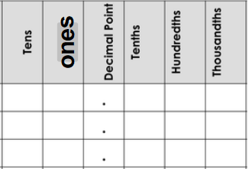
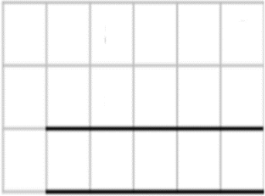
Questions from myminimaths.co.uk:
22a) 8 – 2.27 = 22b) 6 – 4.76 = 22c) 4 – 1.02 =
22d) ___ - 5.35 = 3.65 22e) 1 – 0.7 = 22f) 6 – 1.84 =
Video to help:
https://myminimaths.co.uk/arithmetic-16-practice-question-21/

Answers:
https://myminimaths.co.uk/arithmetic-16-practice-answers-21/

LO: To subtract numbers greater than one with different numbers of decimal places.
Tuesday 30th June 2020
Star words: place value subtraction decimals ones tenths hundredths thousandths difference

Fluency – Identify the decimal numbers and them together.
1)  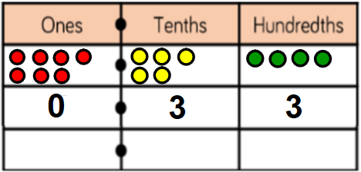 |  | 2)  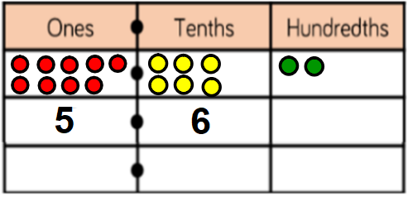
3)  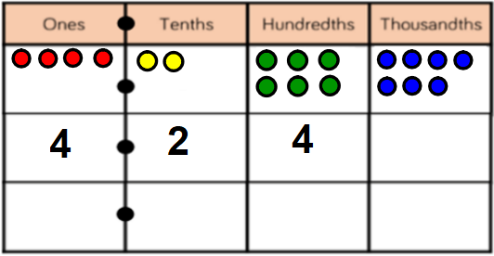 |  | 4) 3.365 – 1.54  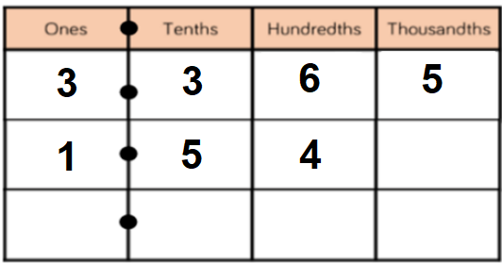
5) 5.765 – 0.965  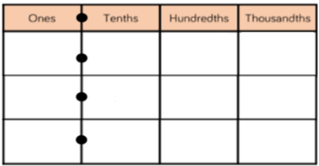 |  | 6) 8.443 – 3.5
7) 5 – 2.581 |  | 8) 13.823 – 6.35
Reasoning
4.9 – 3.85 = 1.15
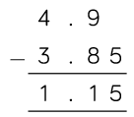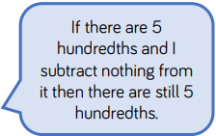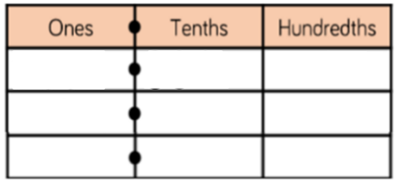
Do you agree with Whitney?
Explain your answer.
In this number pyramid, each number is calculated by adding the two numbers underneath.
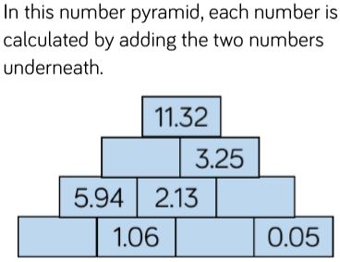
Explain what you need to do to solve the missing numbers. Can you solve the missing numbers?
Problem Solving
Teddy used the calculator to solve 31.4 – 1.408  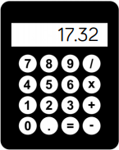  He typed all of the correct digits in.  Can you spot a mistake?  What should the correct answer be? | How much change would I get from £10 if I bought a bag of apples costing £4.27?
How much money does Annie have?

LO: To multiply whole numbers by 10, 100 and 1000
Wednesday 1st July 2020
Star words: multiply times lots of groups of
In all product multiplied by area twice

Fluency
1) 10 x 121 =  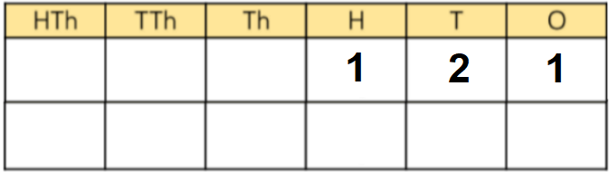 | 2) 10 x 630 =  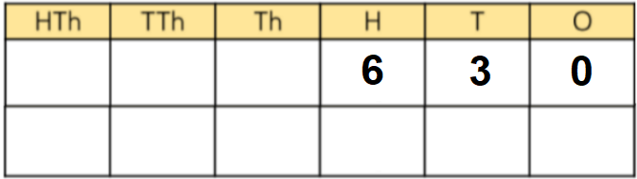
3) 100 x 50 =  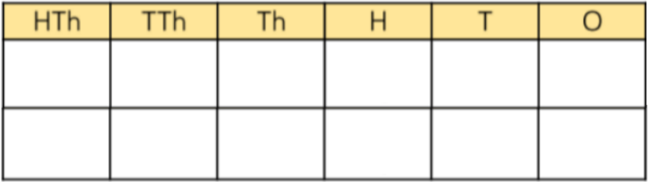 | 4) 6 x 100 =
5) 2030 x 10 = | 6) 100 x 831 =
7) 1000 x 67 = | 8) 966 x 1000 =
9) 7008 x 100 = | 10) 50 x 1000 =
11) 807 x 10 x 10 x 10 | 12) 57 x 100 x 100
Reasoning
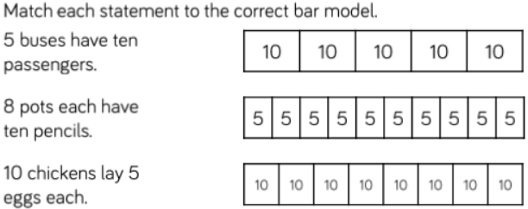 | Mr Needham says 100 x 9 = 9  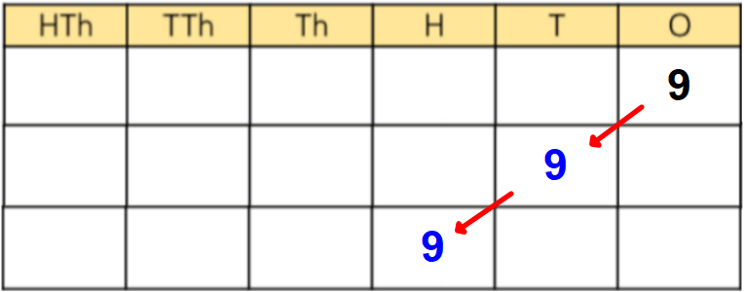  Explain what he has done wrong.
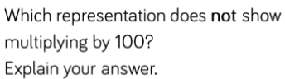
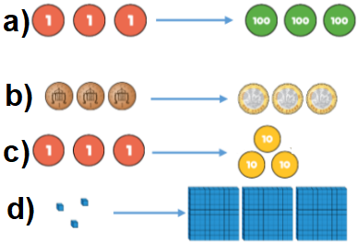
Problem Solving
Rosie has £300 in her bank account.  Tommy has 100 times more than Rosie in his bank.  How much money does Tommy? | 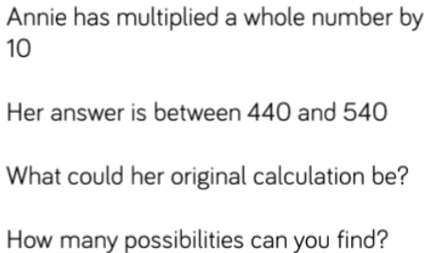  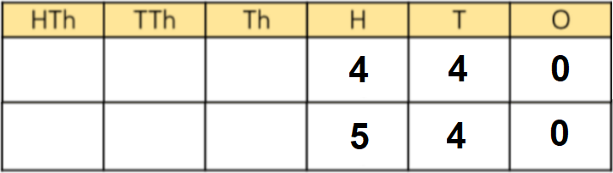
Each week Bob gets £23 spending money. Challenge Question
How much money would Bob save after 10 weeks? Use this to solve 20 weeks.
How much money would Bob save after 100 weeks? Use this to solve 200 weeks.
How much money would Bob save after 1000 weeks? Use this to solve 2000 weeks.

LO: To divide whole numbers by 10, 100 and 1000
Thursday 2nd July 2020
Star words: division shared equally lots of equal group
divisor dividend split distribute half

Fluency
1) 460 ÷ 10 = ÷  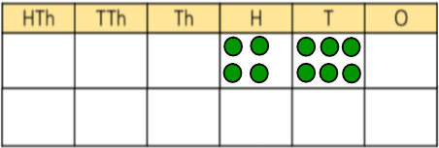 | 2) 1300 ÷ 10 = ÷  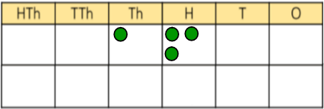
3) 5020 ÷ 10 =  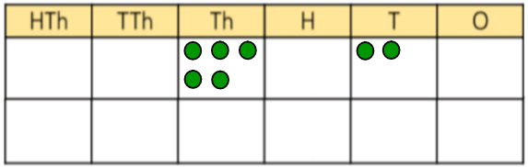 | 4) 600 ÷ 100 =
5) 4000 ÷ 100 = | 6) 80,300 ÷ 100 =
7) 903,000 ÷ 1000 = | 8) 43,000 ÷ 1000 =
9) 3060 ÷ 10 = | 10) 2700 ÷ 100 =
11) 7,800 ÷ 100 = | 12) 52,000 ÷ 1000 =
Reasoning
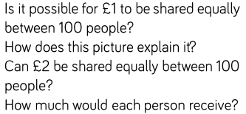
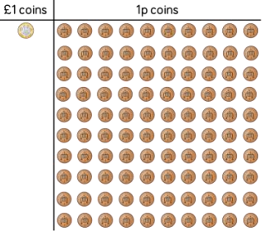
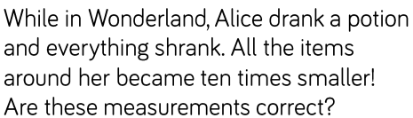
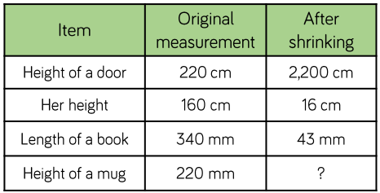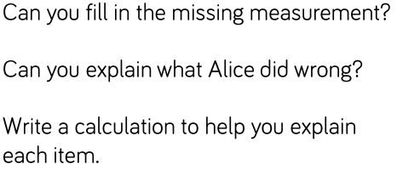
Problem Solving
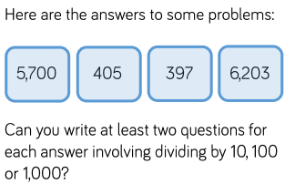
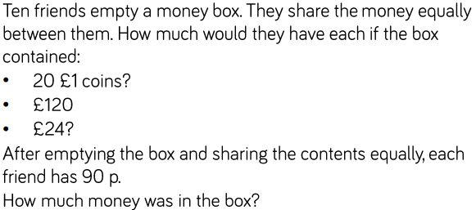

Friday 3rd July 2020
Arithmetic
1) 301 - 10 = | 16) 219 + 8 =
2) 72 x 5 = | 17) 64.17 + 38.19 =
3) 19.6 + 0.9 = | 18) 3 x 12 x 3 =
4) 72 ÷ 3 = | 19) $\frac{5}{7}$ - $\frac{2}{7}$ =
5) 962 - 179 = | 20) ___ x 20 = 140
6) 36 ÷ 12 = | 21) 49.6 ÷ 100 =
7) 363 + 8 = | 22) 1³ ⁼
8) 43.09 + 5.19 = | 23) 28,000 + 6,200 =
9) 8 x 3 x 4 = | 24) 300 x 200 =
10) 12,030 - 100 = | 25) ___ x 80 = 16,000
11) 46 x 6 = | 26) 35% of 1800 =
12) 36.1 + 42.9 = | 27) 7.76 x 6 =
13) 96 ÷ 12 = | 28) $\frac{2}{5}$ - $\frac{1}{5}$ =
14) 842 - 569 = | 29) ___ x 80 = 3200
15) 47 ÷ 6 = | 30) 132.1 x 100 =

