Monday 15th June 2020
Questions from myminimaths.co.uk:
2a) 216 + 1285 = 2b) 334 + 1328 =
2c) 5114 + 297 = 2d) 546 + 2781 =
2e) 737 + 2038 = 2f) 4617 + 632 =
2g) 982 + 6218 = 2h) 7833 + 564 =
2i) 238 + 1590 = 2j) 784 + 8619 =
2k) 3175 + 662 = 2l) 555 + 1485 =
2m) 227 + 1576 = 2n) 3281 + 1285 =
2o) 437 + 2617 = 2p) 1906 + 825 =

Video to help:

https://myminimaths.co.uk/arithmetic-16-practice-question-2/

Answers:
https://myminimaths.co.uk/arithmetic-16-answers-question-2/

Questions from myminimaths.co.uk:
11a) 2553 – 605 = 11b) 448 – ___ = 151
11c) 4466 – 828 = 11d) 8734 – 459 =
11e) 703 – ___ = 2038 11f) 5892 – ___ = 2430
11g) 7839 – 348 = 11h) 2198 – ___ = 1477

Video to help:

https://myminimaths.co.uk/arithmetic-16-practice-question-11/

Answers:
https://myminimaths.co.uk/arithmetic-16-answers-question-11/

LO: To add more than 4-digits – more than one exchange.
Tuesday 16th June 2020
Star words: place value addition greater altogether in total increase by whole

Fluency
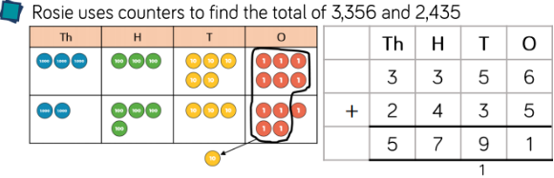
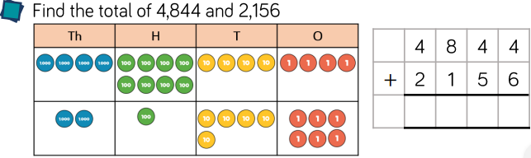
3)  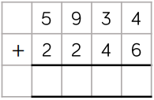 | 4)  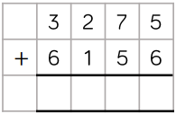 | 5)  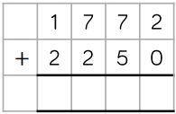
6)  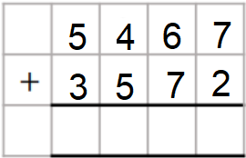 | 7)  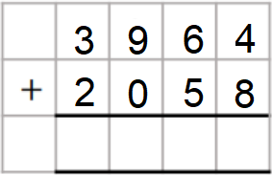 | 8)  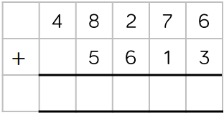

Reasoning
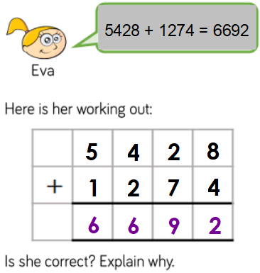 | 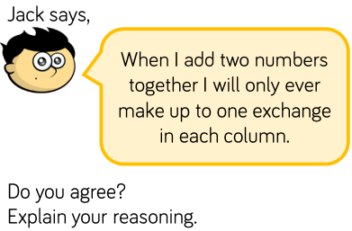

Problem Solving
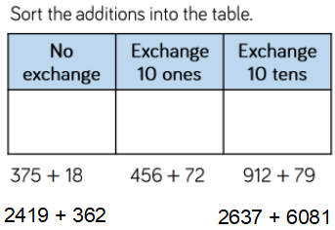 | 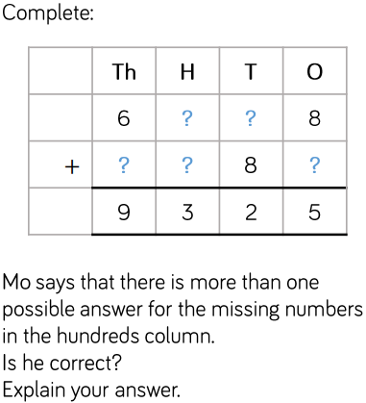
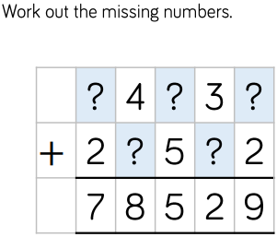

LO: To subtract two numbers with more than 4-digits – with exchanges
Wednesday 17th June 2020
Star words: place value subtraction difference in total decrease by remain how many more

Fluency
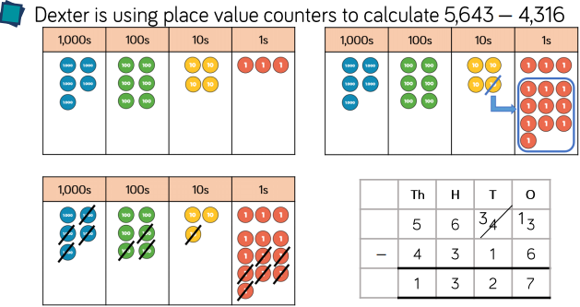
1) 5,783 - 565 = | 1) 2,037 – 1,589 = |  |  | 3) 4,721 - 3,650 =
4) 4,721 - 3,650 = | 5) 4,172 - 3,650 = |  |  | 6) 2,541 – 1,829 =
7) 2,499 -1,829 = | 8) 6,063 - 4238 = |  |  | 9) 8,030 - 3,355 =
Reasoning
Find the missing 4-digit numbers.  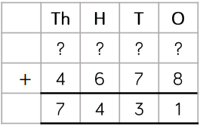 |  | Rosie completes this subtraction incorrectly.  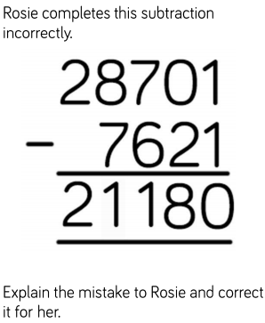  Explain the mistake to Rosie and correct it for her.
Problem Solving
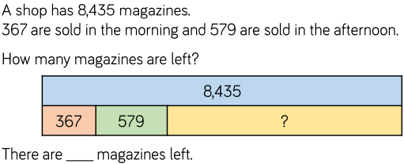

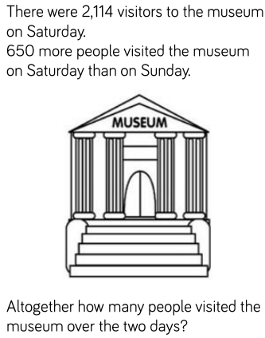 |  |  | 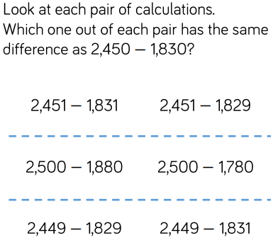

LO: To estimate and check answers.
Thursday 18th June 2020
Star words: Addition subtraction difference estimation inverse how many

Fluency
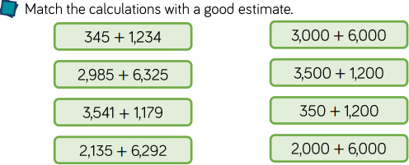
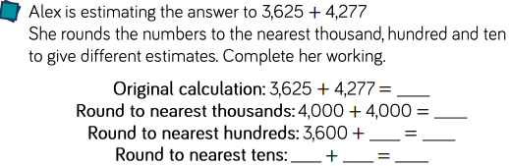
Decide whether to round to the nearest 10,100 or 1000 and estimate the answers to the calculations.
3) 4623 + 3421 = | 4) 9732 + 6489 = |  |  |  | 5) 8934 + 1187 =
2300 + 4560 = 6860  Use subtraction to check the anser to the addition.  Is there more than one subtraction we can do to check the answer?  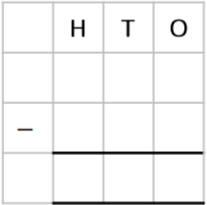 |  | 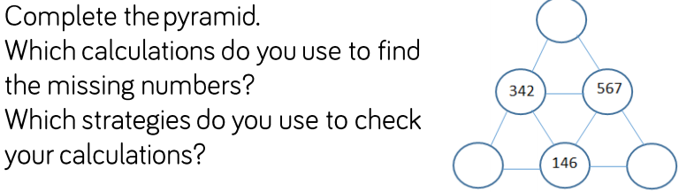
Reasoning
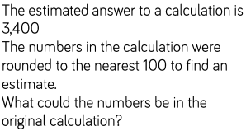 |  |  | 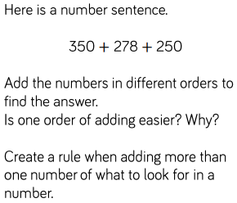
Problem Solving
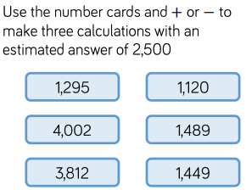 |  |  |  | 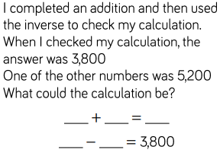  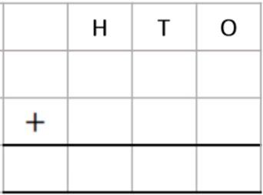

Friday 19th June 2020
Arithmetic
1) 2042 - 100 = | 16) 362 -7 =
2) 263 x 4 = | 17) 50.09 – 9.97 =
3) 9.6 + 0.8 = | 18) 3 x 5 x 6 =
4) 32 ÷ 2 = | 19) $\frac{3}{6}$ + $\frac{1}{6}$ =
5) 1432 + 614 = | 20) ___ x 5 = 450
6) 9 x 6 = | 21) 3.21 x 100 =
7) 403 + 9 = | 22) 9²
8) 49.14 + 49.14 = | 23) 39,200 + 9,500
9) 2 x 5 x 12 = | 24) 720 ÷ 90
10) 201 - 10 = | 25) ___ x 80 = 6400
11) 69 x 4 = | 26) 20% of 8500
12) 12.6 + 16.8 = | 27) 9.12 x 6 =
13) 48 ÷ 2 = | 28) $\frac{3}{5}$ + $\frac{1}{5}$ =
14) 2608 + 319 = | 29) ___ x 4 = 360
15) 12 x 4 = | 30) 4.63 x 100 =

