Monday 15th June 2020
Questions from myminimaths.co.uk – Week 9:
Circle the largest number in each set of values below.
- 138 or 147
- 401 or 388
- 76, 100 or 81
- 410, 366 or 404

Write each set of numbers in order, starting with the smallest.
- 520, 513, 564, 550
- 27, 111, 49, 58
- 1205, 1198, 1677, 1280

Write each set of numbers in order, starting with the largest.
- 3500, 3369, 3602, 3448
- 99, 399, 199, 1099, 799 Challenge
- 603, 609, 601, 621, 617
- 431, 4031, 41, 444, 4134
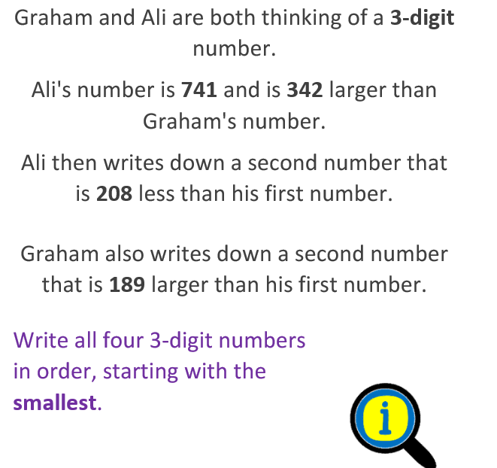
- 836, 1086, 937, 1093, 879
- 2780, 2820, 2078, 2280

Video to help:
https://myminimaths.co.uk/year-4-week-9-order-and-compare-numbers-beyond-1000-monday/
Answers:
https://myminimaths.co.uk/year-4-home-learning-week-9-order-and-compare-numbers-beyond-1000-answers/
Date: 16-06-20
LO: To be able to represent hundredths on a place value grid.
Fluency - https://whiterosemaths.com/homelearning/year-4/

Select Week 2 Lesson 4 at the bottom of the page for the video clip to support your learning.

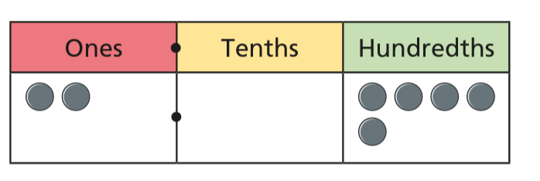
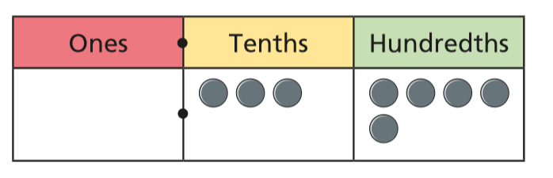
Write the decimal that is represented in each place value chart.
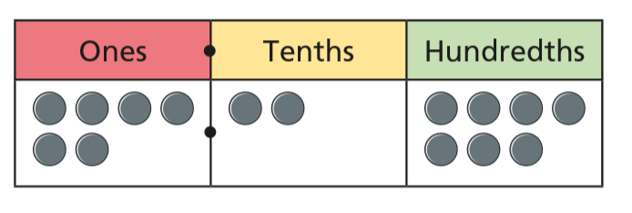
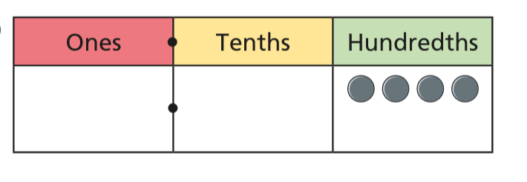
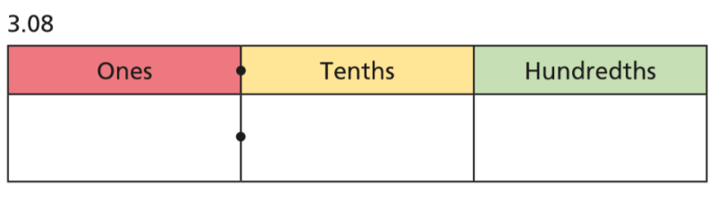
Use place value counters to make each number. Draw your answers on the place value charts.
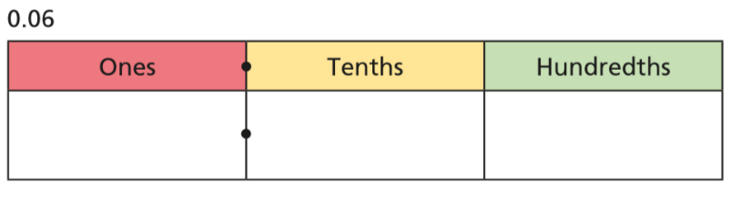
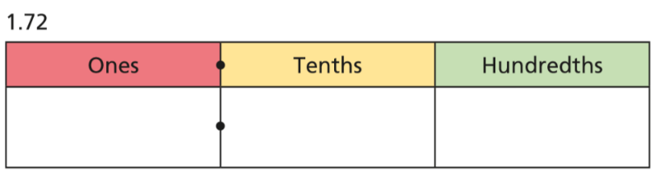
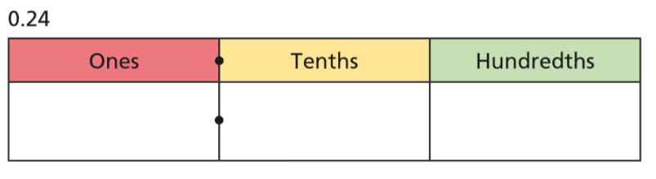

Reasoning and problem solving

Complete the part-whole models.
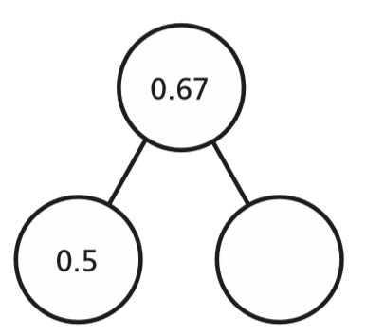
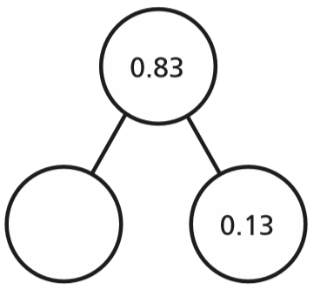

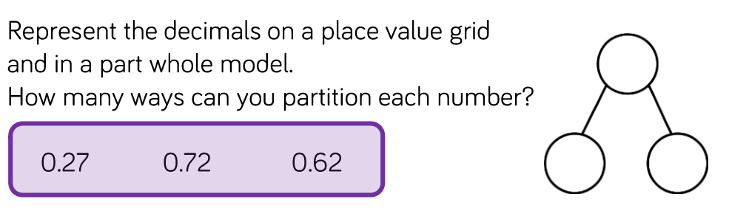

Date: 17-06-20
LO: To be able to divide 1 and 2 digits by a hundred.
Fluency - Select Week 2 Lesson 5 at the bottom of the page for the video clip to support your learning.
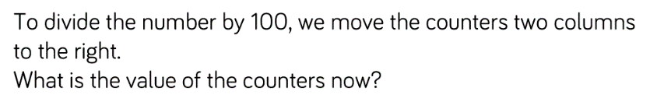
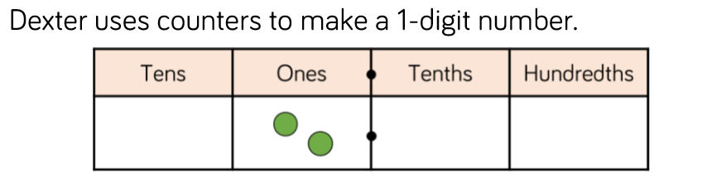

Use this method to solve the following:

4 ÷ 100 =
5 ÷ 100 =
6 ÷ 100 =

Use the same method to solve the following 2 digit numbers:

72 ÷ 100 =
82 ÷ 100 =

___ ÷ 100 = 0.23

___ ÷ 100 = 0.56

Complete the sentence.

When dividing by 100, you move the counters place to the ____________________.

Reasoning and problem solving

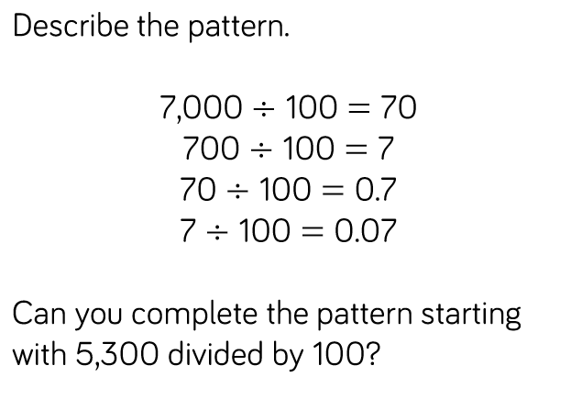

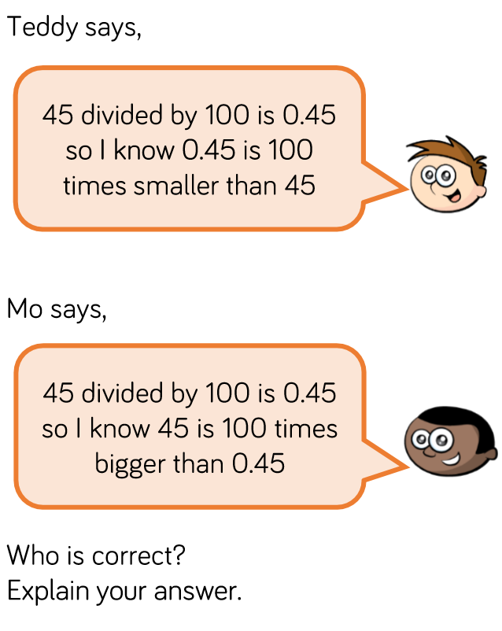

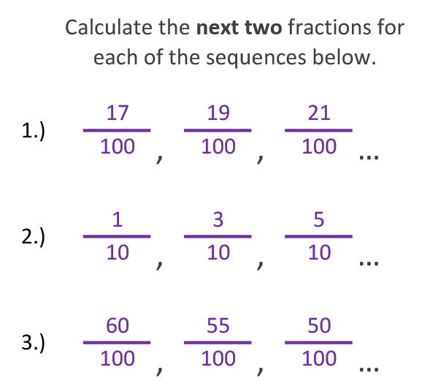
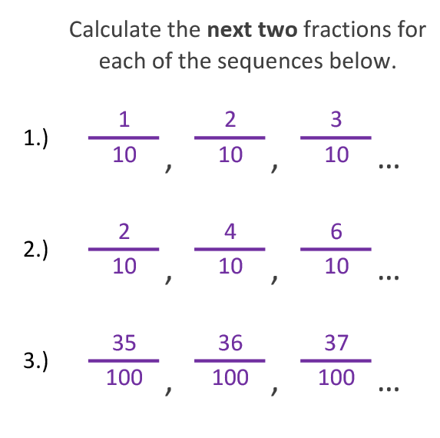
Questions from myminimaths.co.uk – Week 10:

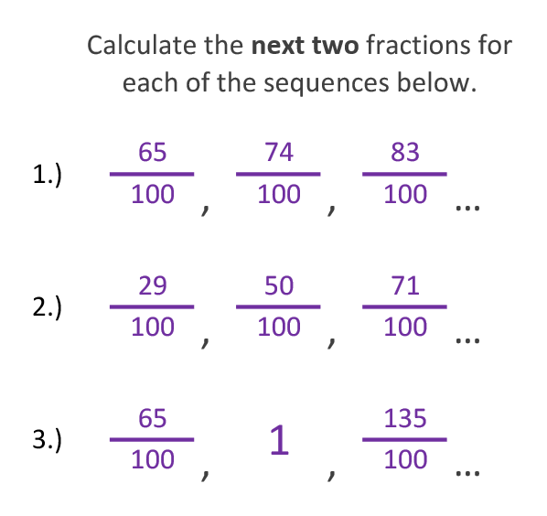
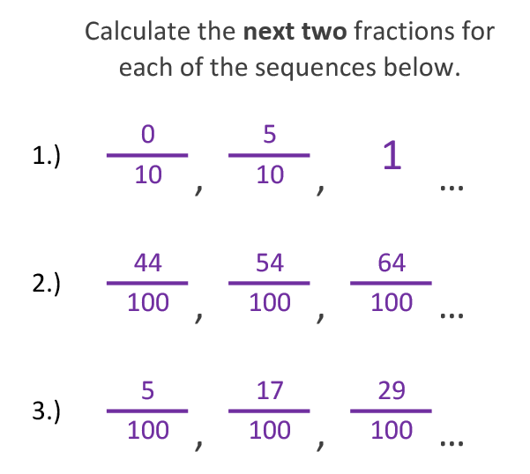

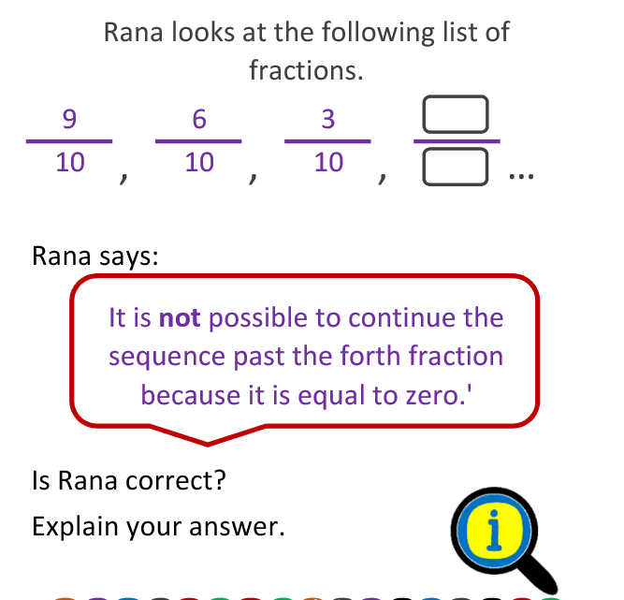

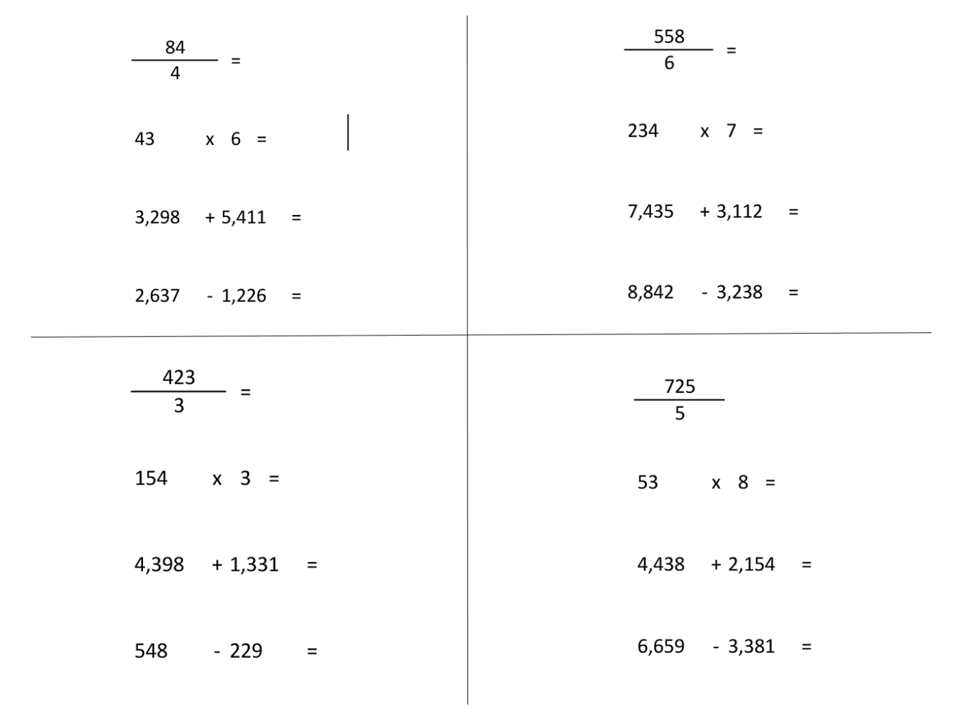
Arithmetic Questions:

Challenge:
