Monday 22nd June 2020
Questions from myminimaths.co.uk – Week 10:
Complete the multiplication grid below and record how long it takes you.
X | 2 | 3 | 4 | 5 | 6 | 7 | 8 | 9 | 11 | 12
12
11
9
8
7
6
4
3
5
2

Arithmetic:
- 639 ÷ 3 =
- 345 x 5 =
- 1,234 + 345 =
- 4,234 – 134 =
- 488 ÷ 2 =
- 344 x 4 =
- 3,765 + 644 =
- 2,678 – 396 =

Date: 23-06-20
LO: To be able to make a whole.
Fluency - https://whiterosemaths.com/homelearning/year-4/

Select Summer term - Week 1 Lesson 1 for the video clip to support your learning.
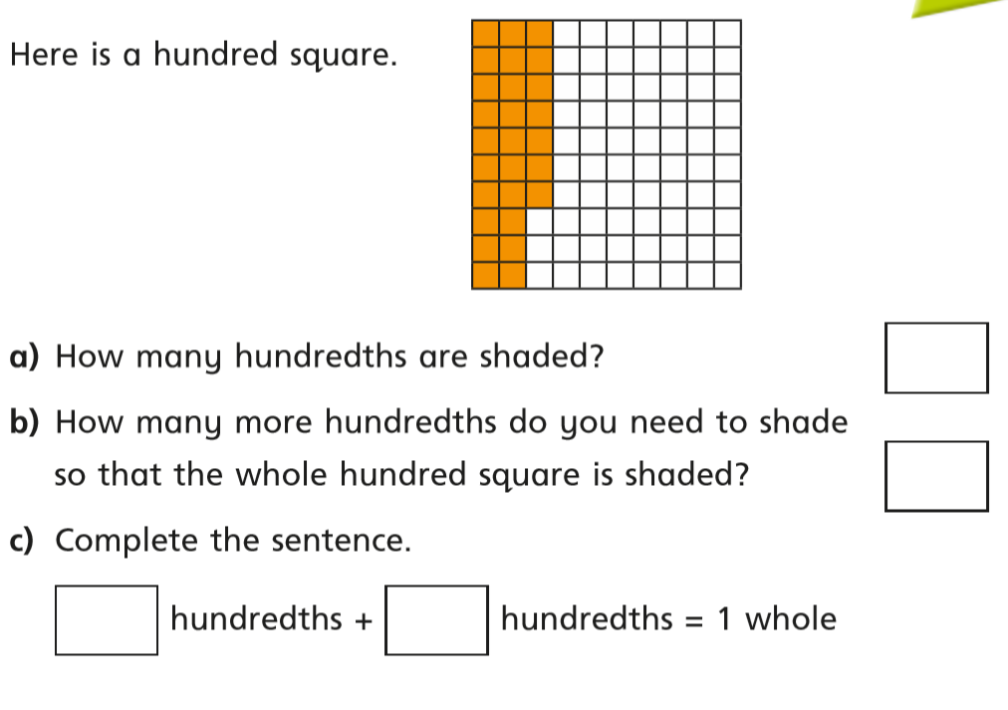

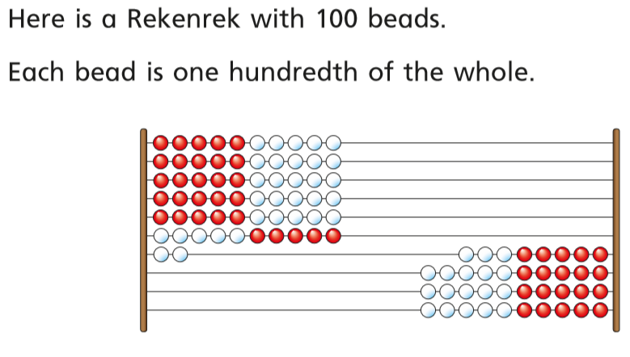

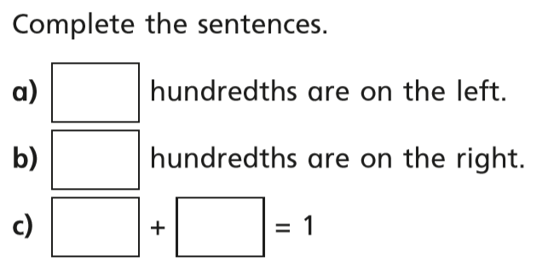

Use the Rekenrek and beads above to try and think of different ways you could split 100 beads to make a whole.

How many different ways can you make a whole?
Reasoning and problem solving
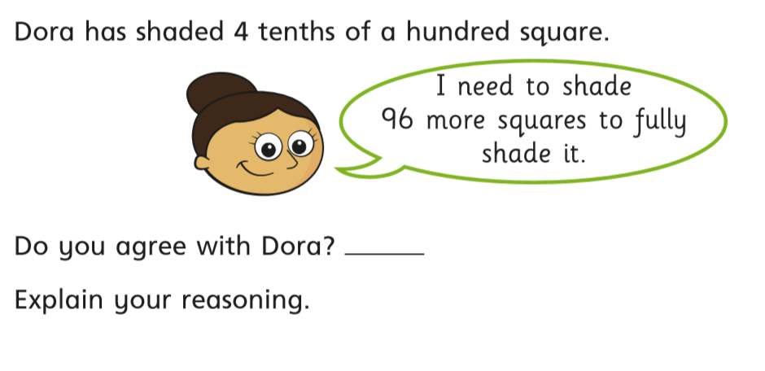

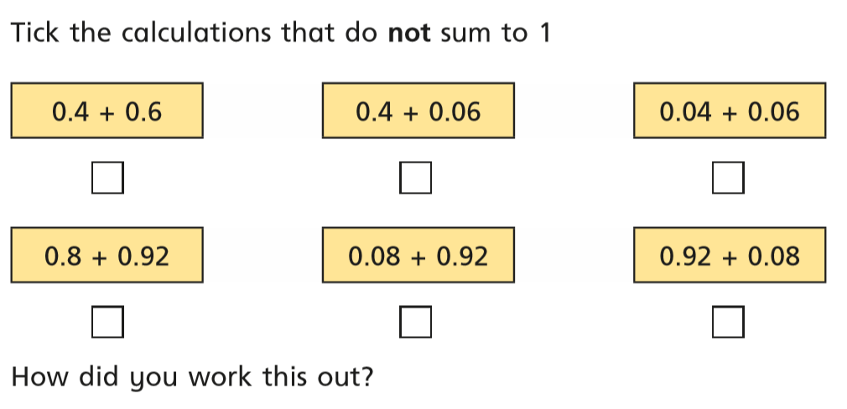

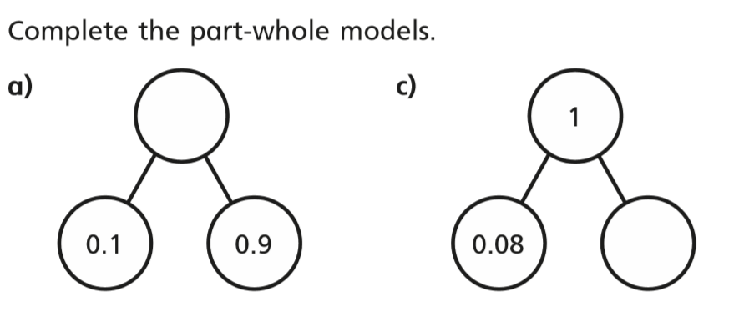

Answers:
https://wrm-13b48.kxcdn.com/wp-content/uploads/2020/homelearning/year-4/Lesson-1-Y4-Summer-Block-1-ANS1-Make-a-whole-2020.pdf

Date: 24-06-20
LO: To be able to write decimal numbers.
Select Summer term - Week 1 Lesson 2 for the video clip to support your learning.
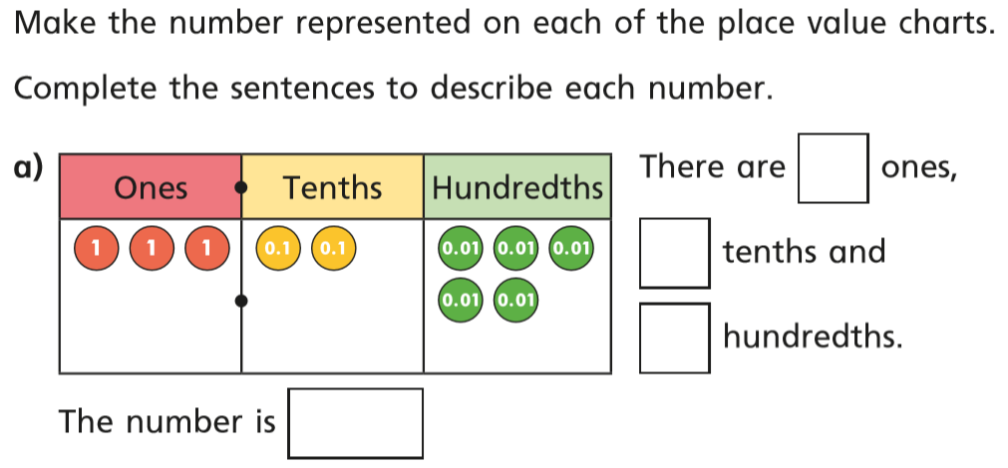

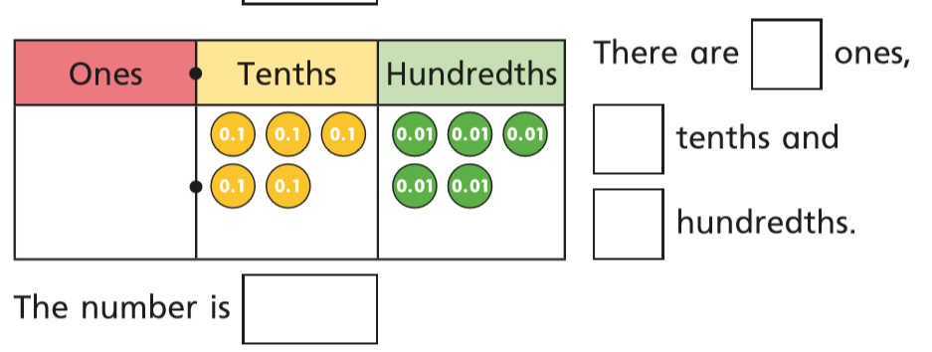

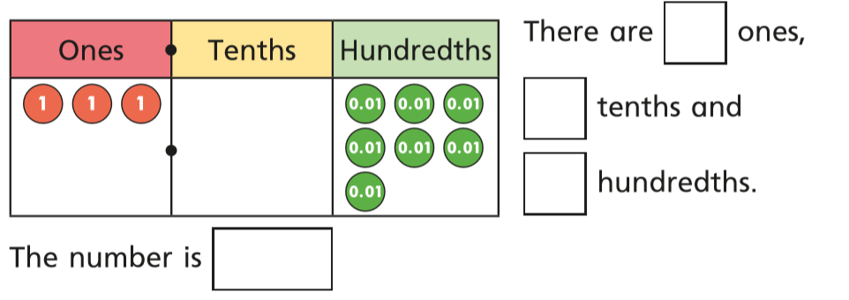

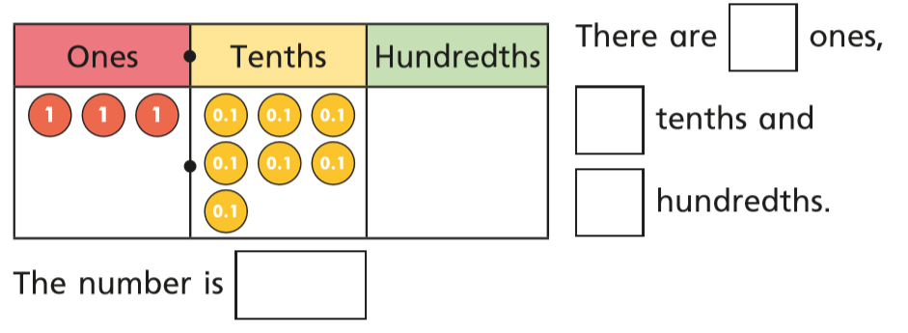

Reasoning and problem solving
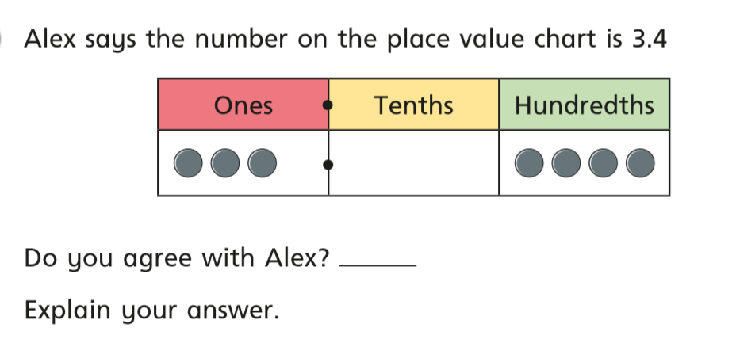

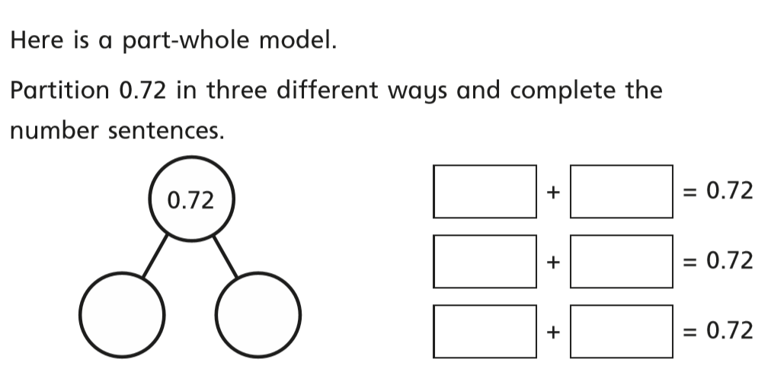

Thursday 25th June 2020.
Complete the multiplication grid below and record how long it takes you. Try and beat your time from Monday.
X | 2 | 3 | 4 | 5 | 6 | 7 | 8 | 9 | 11 | 12
12
11
9
8
7
6
4
3
5
2

Arithmetic:
- 484 ÷ 4 =
- 578 x 3 =
- 5,672 + 242 =
- 3,334 – 142 =
- 155 ÷ 5 =
- 324 x 6 =
- 4,234 + 844 =
- 4,211 – 410 =

Friday 26th June 2020.
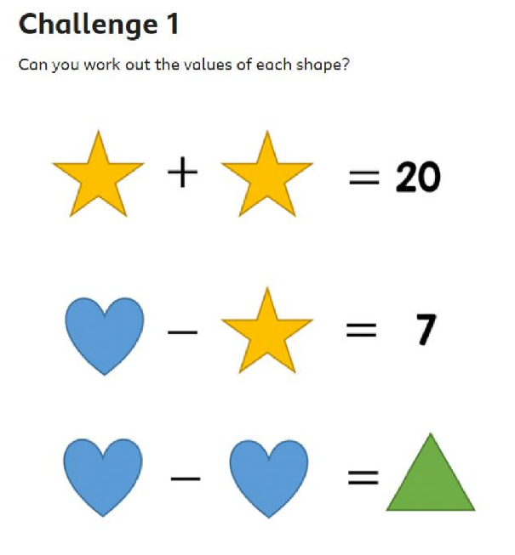
Friday Maths Challenge:

Can you think of your own challenge using different shapes and numbers?
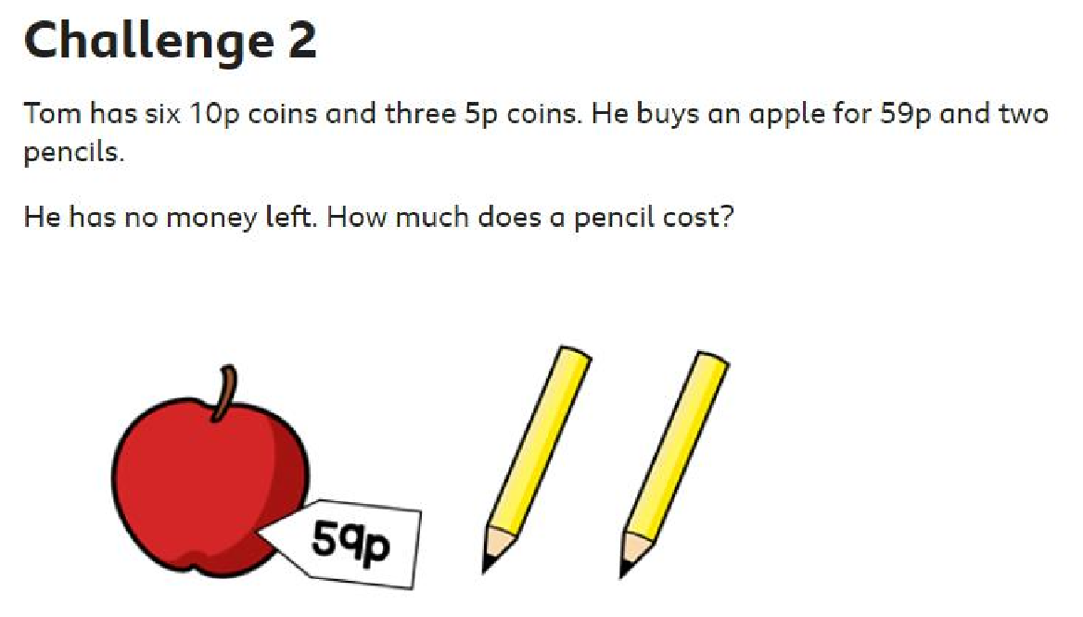

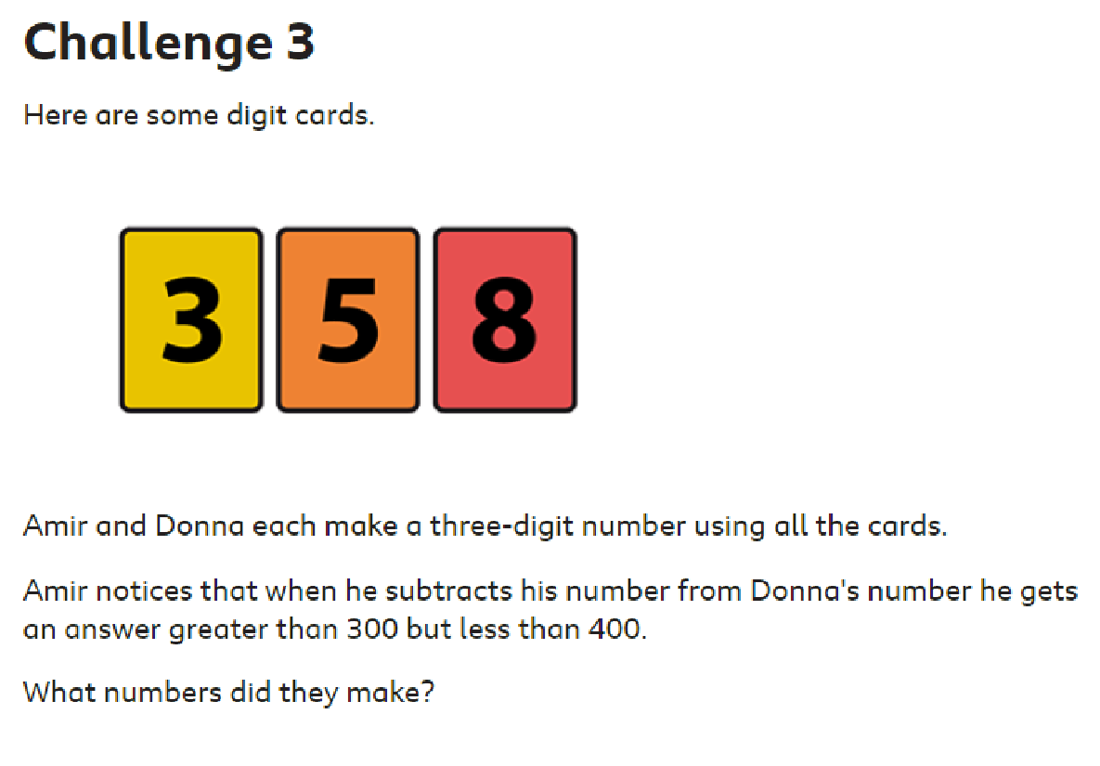

Answers:
https://wrm-13b48.kxcdn.com/wp-content/uploads/2020/04/Answers-Week-1.pdf

