|  |  |
| --- | --- |
| **Fluency** | |
| **Problem Solving** | **Reasoning** |

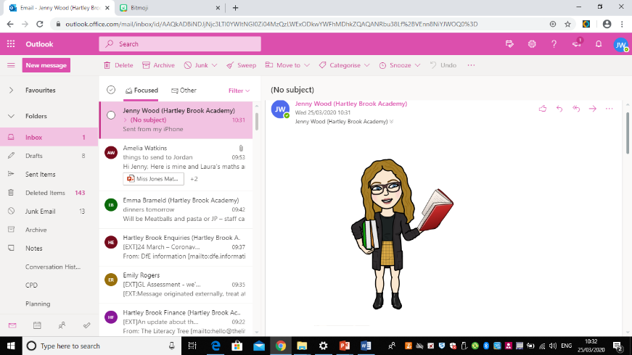**Monday – Miss Wood Y3**

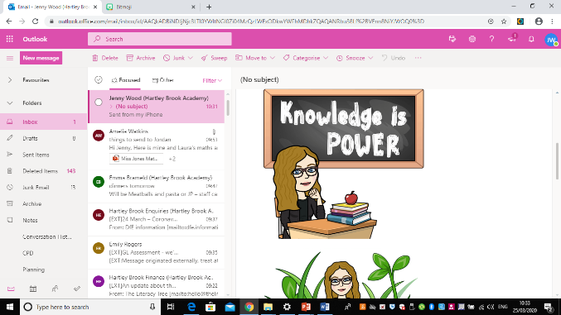**Tuesday – Miss Wood Y3**

|  |  |
| --- | --- |
| **Fluency** | |
| **Problem Solving** | **Reasoning** |

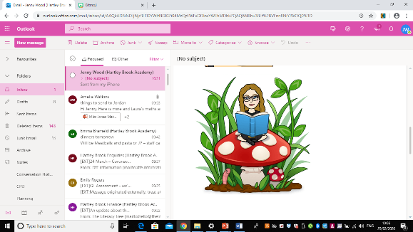**Wednesday– Miss Wood Y3**

|  |  |
| --- | --- |
| **Fluency** | |
| **Problem Solving** | **Reasoning** |

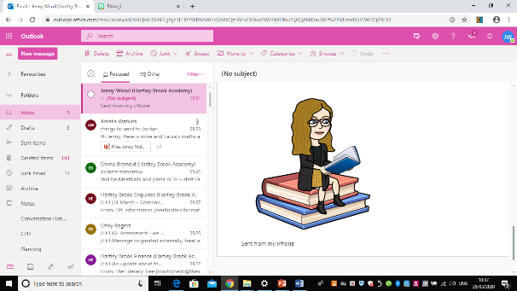**Thursday– Miss Wood Y3**

|  |  |
| --- | --- |
| **Fluency** | |
| **Problem Solving** | **Reasoning** |

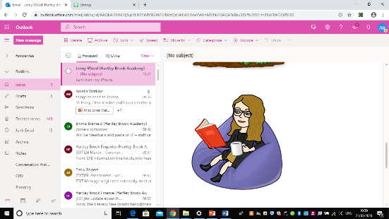**Friday – Miss Wood Y3**

