Lesson 1-Circles
LO: To explore difference by comparing measures of length and volume.
compare, capacity, more, less,
full, empty, volume, litres.

Time for another game. Today you will need 2 containers full of water, 2 empty containers and 2 cups. You will also need another player and a measuring jug.

Both players should start with a cup and a full container on a line together. Further away should be 2 empty buckets.

You have 1 minutes to use your cup to get as much water from your full bucket to the empty bucket as you can, using your cup.

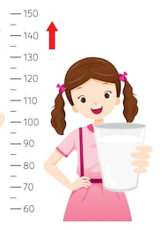
Can you tell how much is in the container just by looking? No. Then let’s measure if using your jug to see who has got the most.

Let us know who won on twitter. Have fun and always ask an adult before using the equipment.

compare, capacity, greatest, smallest,
full, empty, fewer.

Lesson 2- Circles
LO: To explore difference by comparing measures of length and volume.

Today we are going to play the same game as yesterday. But this time we are going to find the different between your container at the end and the second person.
The difference is how many jumps between the two numbers.
If partner 1 had 1 litre but you had 6 litres in your container there are 5 jumps between the two numbers meaning the difference is 5 litres.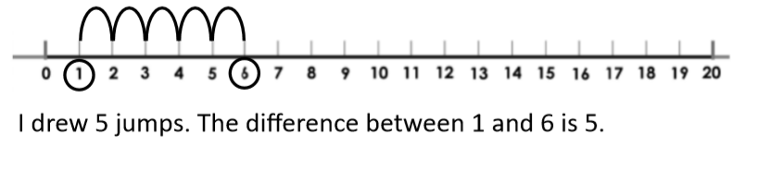
Use one of the number lines below to work out the difference after you have played your game.

The difference between the two containers is _________________________.

volume, mass, length, weight,
ingredients, recipe, instructions,

Lesson 3- Circles
LO: To apply understanding of measurement in a real life context.

So far we have learnt about length, mass, weight and now volume. Let’s use this to bake. Below are a few links to baking different things. With an adult follow the recipie making sure you measure the ingredients properly. Discuss the mass, weight and volume with your adult.
Which ingredients has the heviest mass?
Which ingredients has the least mass?
What equipment do you use?
Which piece of equipment was the longest and the shortest?

Gingerbread men: https://www.bbc.co.uk/food/recipes/gingerbread_men_99096
Cookies: https://www.bbcgoodfood.com/recipes/collection/cookie
Scones: https://www.bbcgoodfood.com/recipes/classic-scones-jam-clotted-cream
Butterfly cakes: https://www.bbcgoodfood.com/recipes/butterfly-cakes

Don’t forget: Talking is the most important part for this task.
Take lots of pictures and post them on twitter so we can see your recipes and creations.

volume, mass, length, weight,
ingredients, recipe, instructions,

Lesson 4- Circles
LO: To apply understanding of measurement in a real life context.

After following a recipe yesterday, you should have discussed, weight, mass, length and volume. Now see if you can answer these questions.
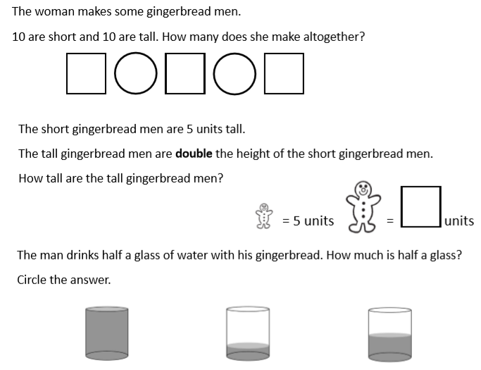
Lesson 5- Circles
LO: To apply understanding of measurement in a real life context.
volume, mass, length, weight,
ingredients, recipe, instructions,

Today you will need any plastic container and lots of water. You will also need your feet as this will be your unit of measurement to measure length today.

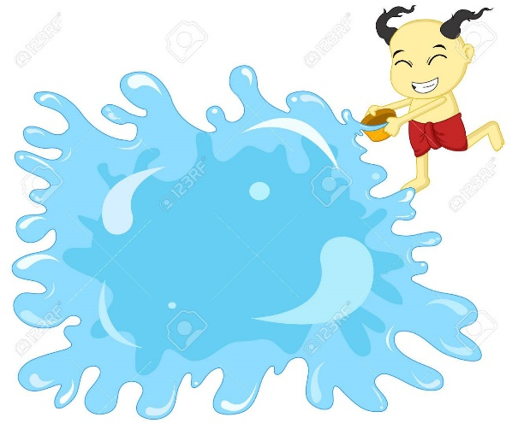
You are going to fill your container with water and throw it as far as you can. Then measure how far you through it with your feet like we have done in class before. Do this 5 times to see your different results and record them in the table.
throws | Footprint units.
1
2
3
4
5

Throw ________ measured the longest.
Throw ________ measured the shortest.

