Miss Dean’s Reading and SPaG Group

Week 9
18.05.20 – 22.05.20
Includes:
Reading
Writing
SPaG

Reading: Monday 18th May 2020
Read through the text: Pet Care of a Hamster. Go through the text very carefully and underline words you are unsure of, just like we did in class. Use the internet or a dictionary to find the definitions of these words. It may help to write down these definitions in case you need to refer to them in your answers.
Reading: Tuesday 19th May 2020
When answering your questions, always go back to the text to ensure you have the right answer, never guess!
- What do hamsters eat and drink?
- Why do you think hamsters store food in their burrows?
- What do hamster cages need to be like?
- How are hamsters different to people when thinking about when they are awake and asleep?
Reading: Wednesday 20th May 2020
When answering your questions, always go back to the text to ensure you have the right answer, never guess!
- How long do hamsters usually live?
- What part of a hamster carries on growing?
- Why do hamsters have ‘well developed senses’?
- Should hamsters be given grapes? Explain why?
- What might happen if a hamster is out of its cage and not watched carefully?

Reading: Thursday 21st May 2020
Would you want a hamster? Explain your thoughts.
________________________________________________________________________________________________________________________________________________________________________________________________________________________________________________________________________________________________________________________________________________________________________________________________________________________________________________________________________________________________________________________________________________________________________________________________________________________________________________________________________________________________________________________________________________________________________________________________________________________________________________________________________________________________________________________________________________________________________

Why not try writing your own guide on how to keep a different pet? It could be a cat, dog or even a made up animal!
Writing Task – Friday 22nd May 2020
Perfect Picture!
Imagine you have just turned invisible. Can you draw the first thing you would do?

Question time!
Why is today the most important day of his life? What is supposed to be happening?
Who is ‘he’?
What has happened to him? When did it happen?
What caused him to finally realise what happened?
How will he find help?
Why is he wearing gloves? What will he do next?

Story Starter!
Just minutes before, everything had been completely normal. He had sat eating his breakfast at the kitchen table, as he did every day of his life.
It was only when he looked in the mirror that he realised something was wrong. For several seconds he had panicked, and a sick feeling grew in his stomach. His mouth felt dry and he started to sweat as he sprinted from room to room, trying in vain to find a reflection.
How could this have happened? Of all days, why did it have to be today? This was the most important day of his life. He had to find help…

SPaG - 18.05.20 – 22.05.20
Determiners
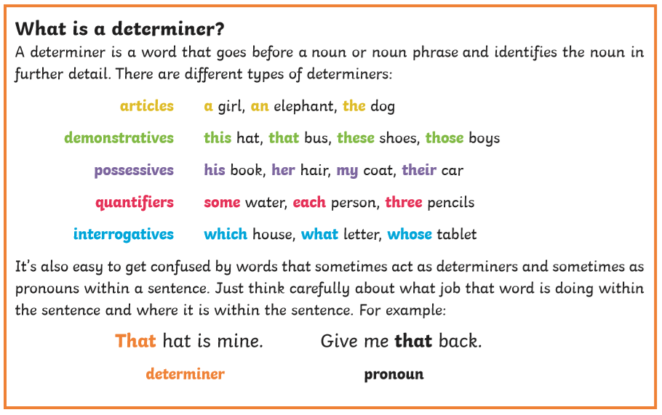
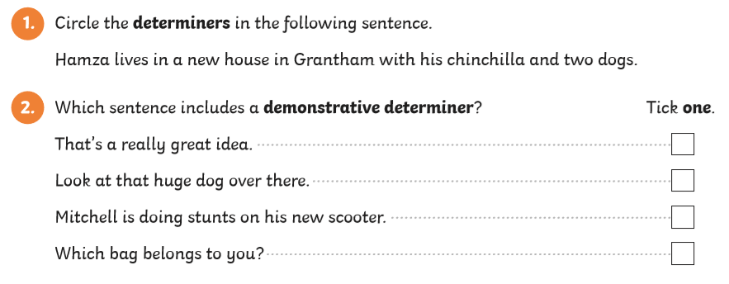
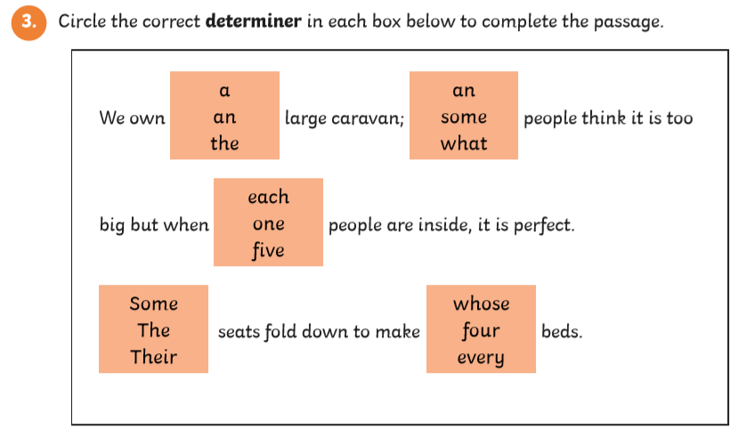
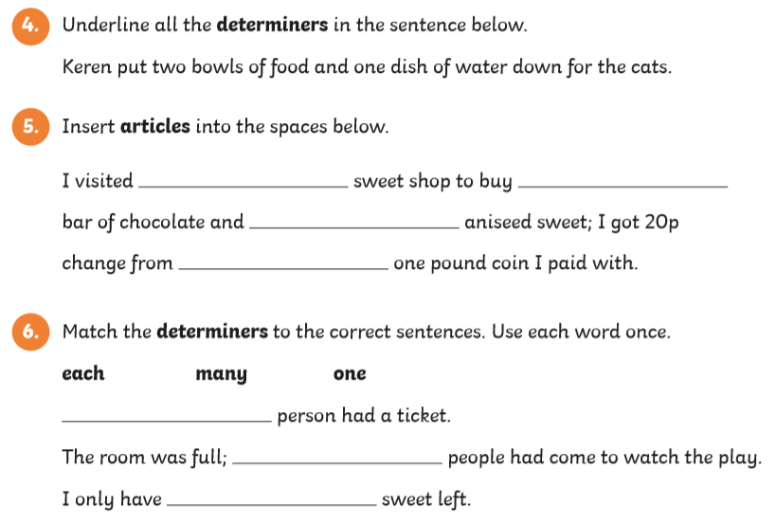

Prepositions
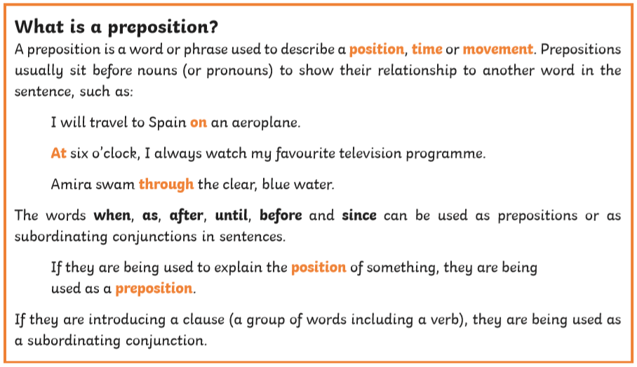
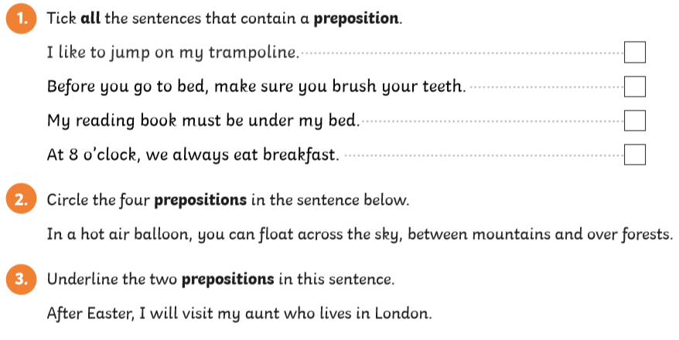
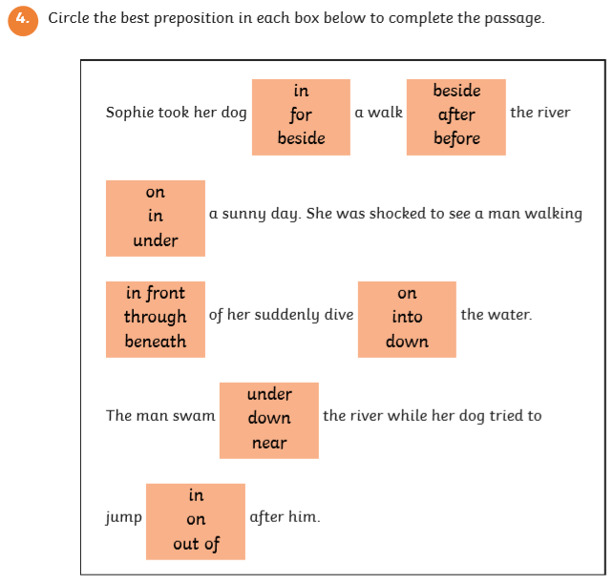
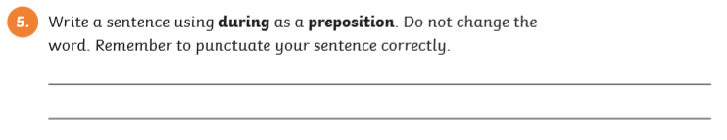
Example: He fell asleep during the film.

