Year 3, Summer 1
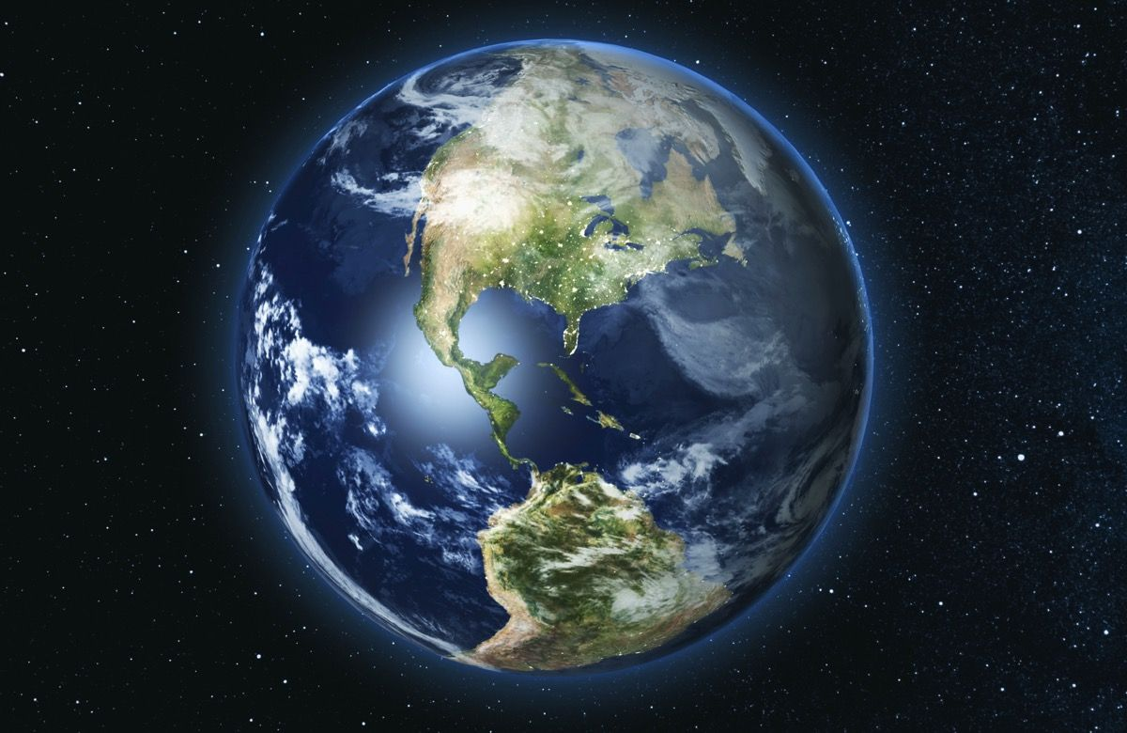
Project Work

The Most Dangerous Animal on Earth
Week beginning: 18.5.20
Tasks 7 - 9

This week your activities will focus on why it is our responsibility to look after the planet and how we can do this.

Remember, each week more activities will be sent out to complete. These will help you towards the final task which will be creating an information leaflet to advise people how to help save the planet.

Remember to post any work you complete and want to share on twitter and tag:
@HartleyBrookPri
@HBMissWood
@HBMissJones1
@MissWatkinsG

Overarching Question –What destruction are we causing to Earth and how can we help to stop it and protect our amazing planet?

Task 4 – Deforestation
Task 1 – Find out about recycling.
Enquiry question – Why is it our responsibility to look after the planet?
Information
Recycling means making rubbish into something new. Every time you throw something away it gets sent to a landfill. More and more rubbish is piled on top until it is too big and the landfill has to be closed.
The great thing is that most things can be recycled. Every day, clever scientists come up with new ways to make use of things we usually consider rubbish. But what exactly do they do with the recycling?

Task
Read the information given about recycling from recycling week, then answer the questions given. This should give you lots of information about how you can look after our planet that you will be able to use to create your leaflet at the end of the project. Remember to keep all your work safe as you will need it at the end of the project to create your leaflet.

Research
Use the following link to find out more:
https://www.youtube.com/watch?v=7UuUeoyYmxI

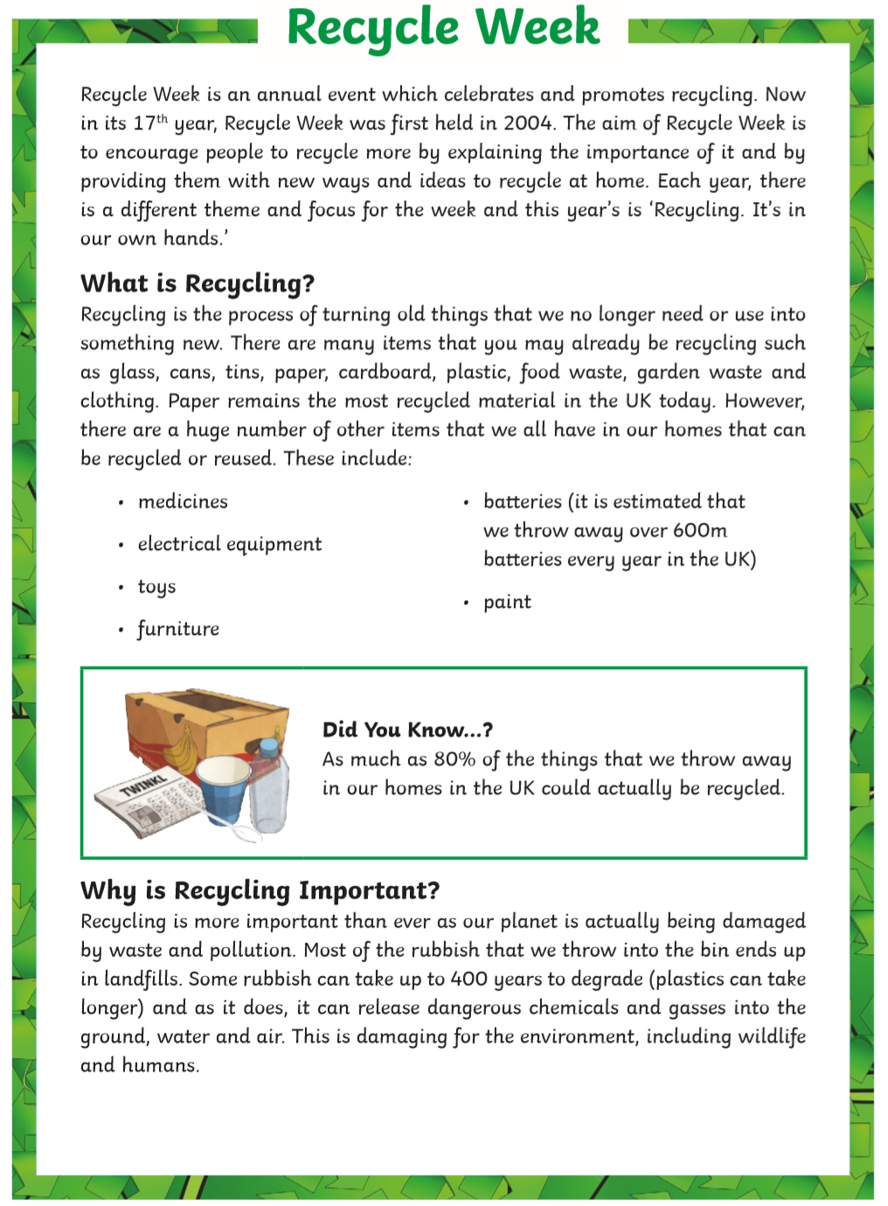

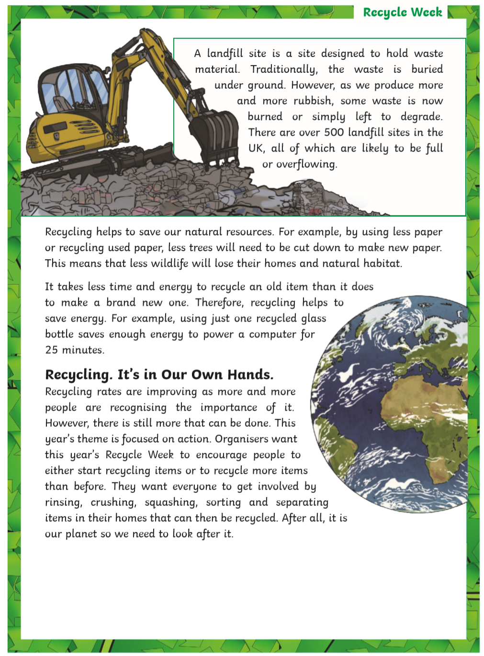

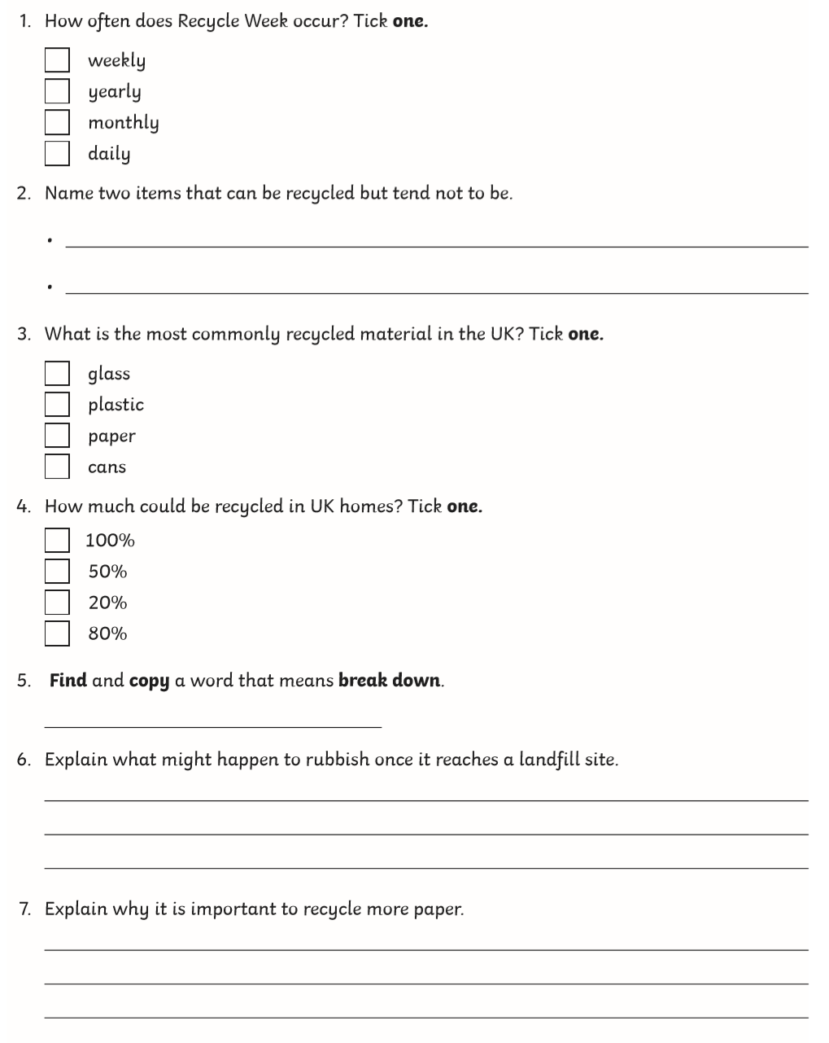

Task 8 – Household recycling
Enquiry question – Which objects can be recycled?
Information
We are told which materials we can recycle and which we cannot. Your domestic recycling is collected and taken to a Materials Recovery Facility (MRF).If you have two separate containers for recycling, your collection vehicle will have two compartments so the recycling does not need to be sorted again. At the Materials Recovery Facility the recyclable materials are sorted into various categories: metal, glass, plastic, paper and cardboard. The materials will be sorted by people, machines or a mix of both. In each case, the rubbish goes through the facility on a long conveyor belt.

Task
Your job is to walk round your house and identify which objects can be recycled in each room. Look closely to see what material things are made out of as this will determine whether they can be recycled or not. Can some parts of objects be recycled and others not?
In the four boxes draw and label any items which could be recycled. For a challenge explain to a member of your family why a certain object can be recycled and write a sentence.
How many recyclable items can you find in your home? Make sure you use the information sheet below to help you identify the recyclable items.

Research Use the following links to find out more:
https://www.bbc.co.uk/bitesize/clips/zwywmnb
https://www.bbc.co.uk/bitesize/topics/ztv4q6f/articles/zvn3gwx
Bathroom | Bedroom
Living room | Kitchen

Fact Sheet
What is recycling?
Recycling is a way to take rubbish and turn it into new products. There are a number of different recycling processes that allow materials to be used more than once.
What can be recycled?
All sorts of materials can be recycled. Some of the most common processes in use today involve recycling plastic, glass, metals, paper, electronics, and textiles (clothes). Typical used items made of these materials include pop cans, plastic milk cartons, newspapers, old computers, and cardboard boxes.
How does recycling work?
Recycling is a complicated process and is different for each type of material.
Aluminum cans - Aluminum cans were one of the first items to be heavily recycled. The process isn't quite as complicated as it is for some other materials. The cans are first shredded and then melted. From there, the aluminum can be used to make new cans and other aluminum items.
Plastic bottles - There are a lot of types of plastics and each type is made from a different combination of chemicals. As a result, plastic bottles are first sorted into their various chemical types. Then they are cleaned to get rid of any leftover food or other waste. Next, the bottles are crushed or shredded into fine plastic chips. Then the chips can be melted down to create new plastic or turned into a fiber used for making carpets or clothing.
Paper - Paper starts its recycling process by being mixed with water and other chemicals to break it down. It then gets shredded and heated up. This process eventually turns the paper into a pulp or slurry. The pulp gets strained in order to remove any glues or plastics. After that, it gets cleaned and bleached to remove any left over inks or dyes. Now the pulp is ready to be made into new paper.
Computers and Batteries - Computers and batteries are usually recycled in order to remove harmful chemicals as well as to recover, or salvage, some valuable materials such as gold from electronics boards.

Task 9 – The recycling symbol
Enquiry question – How is recycling recognised around the world?
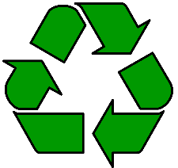
Information
The recycling symbol, or loop, has three arrows. Each arrow represents a different step in the recycling process. These steps are:
- Collecting recyclable materials, like aluminum cans and plastic bottles.
- Processing the old materials and making new items.
- Buying items made from recycled materials.
The recycling symbol is one of the most recognisable international logos. It was designed in 1970 by Gary Anderson for a competition held in America to raise awareness of environmental issues.
Reduce, Reuse, Recycle!

Task
Your job is to design your own recycling symbol which could be used in your leaflet. It needs to be a bold symbol with an appropriate meaning. Similar to the three arrows in the recycling loop representing the three steps of the recycling process.
Remember to use your imagination and think creatively. Make sure that your design in eye catching and would stand out clearly on a product.

Research Use the following links to find out more
https://www.bbc.co.uk/cbbc/quizzes/bp-are-you-a-recycling-master
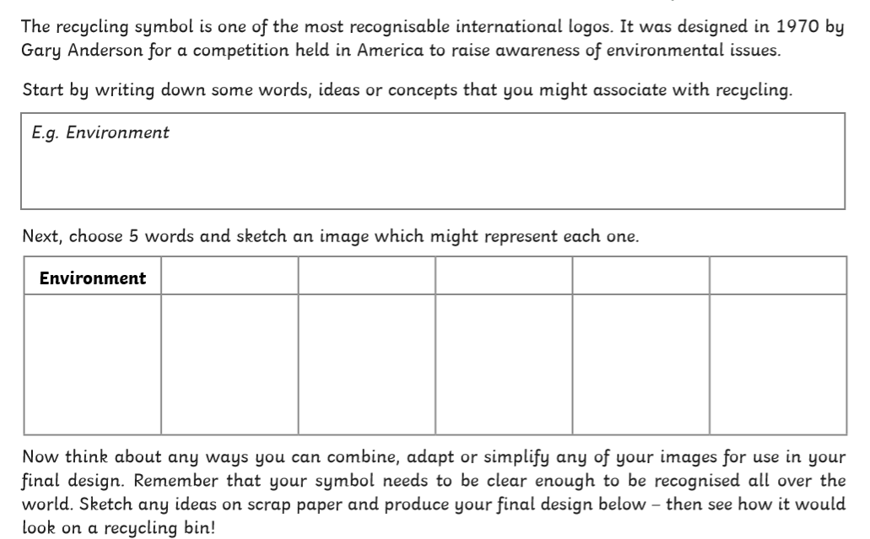
My design | What my design would look like in use
 | 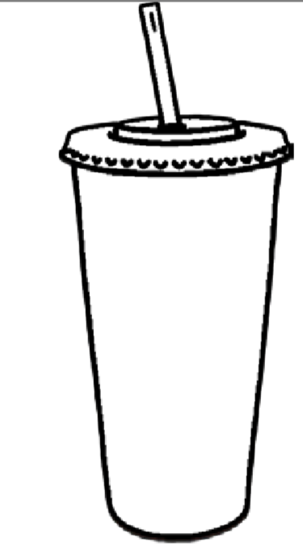
Extra activities about recycling!

On the next few pages are some extra activities linked to recycling. Completing these will help you with your end project in a few weeks’ time.

Remember they do not need to be on the sheet provided, if you would rather complete on a blank sheet of paper or in your workbook that is fine .

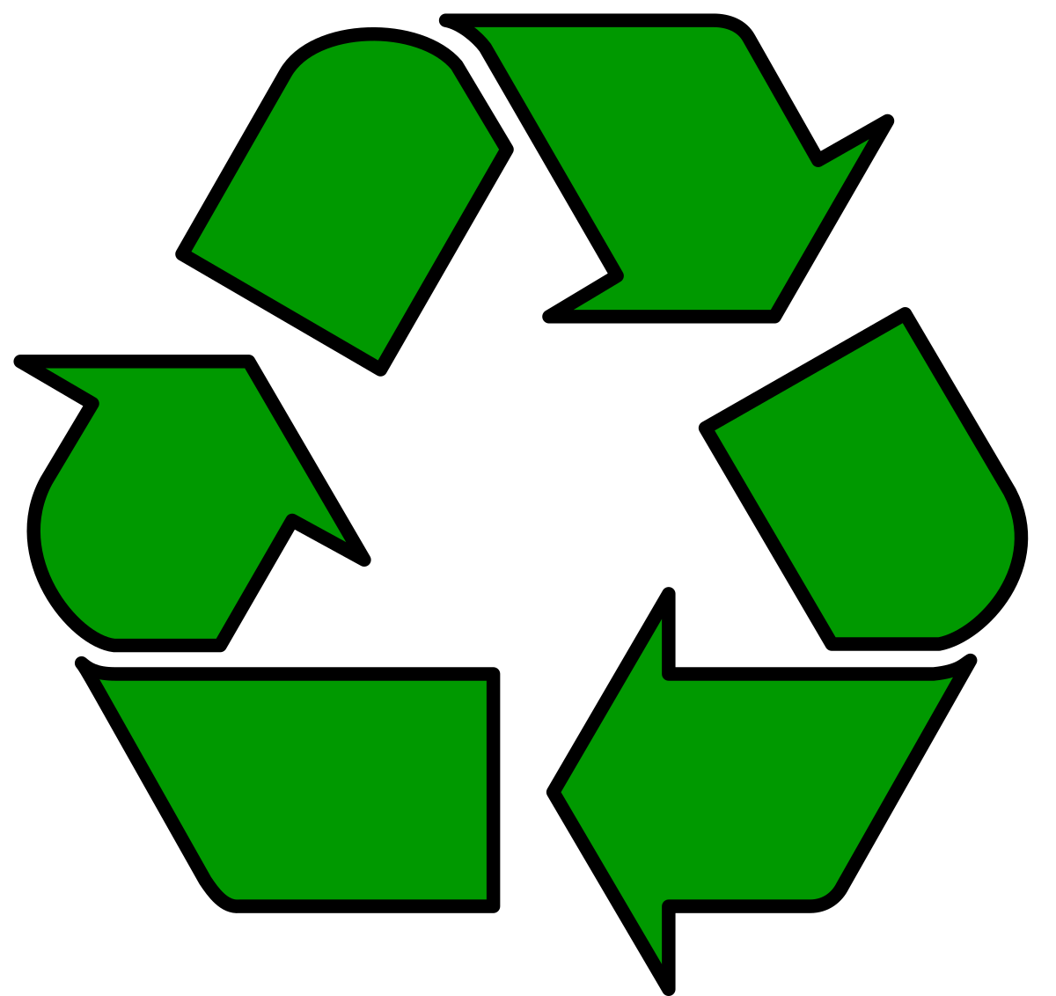

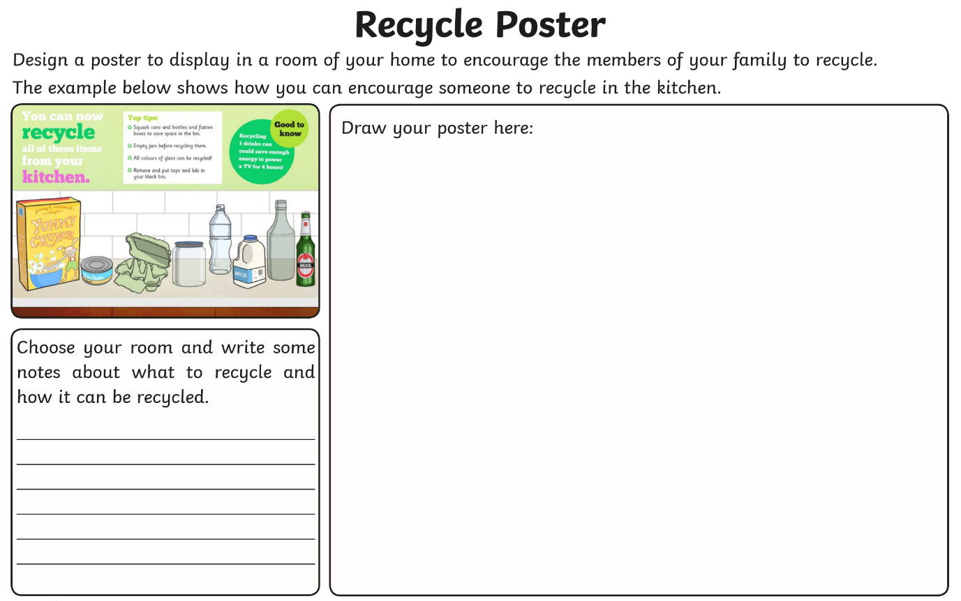
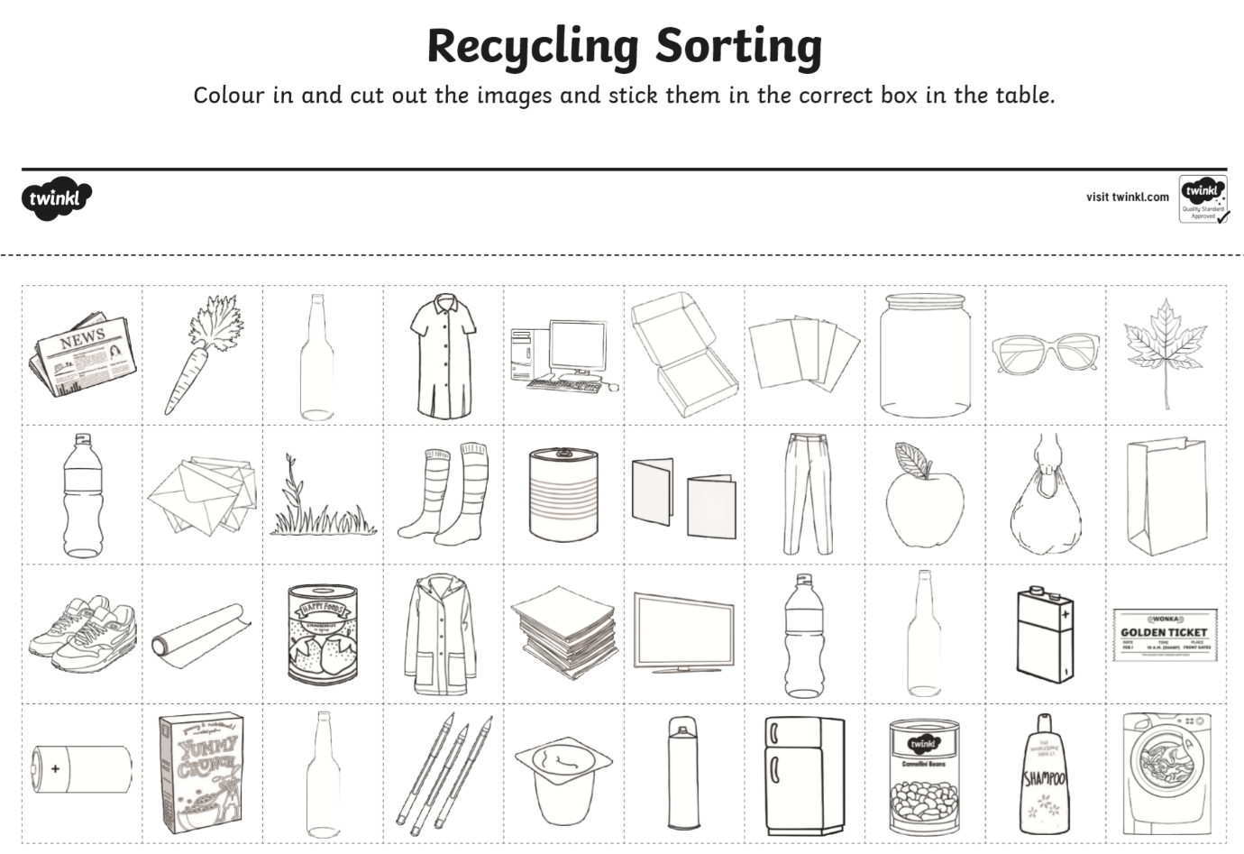
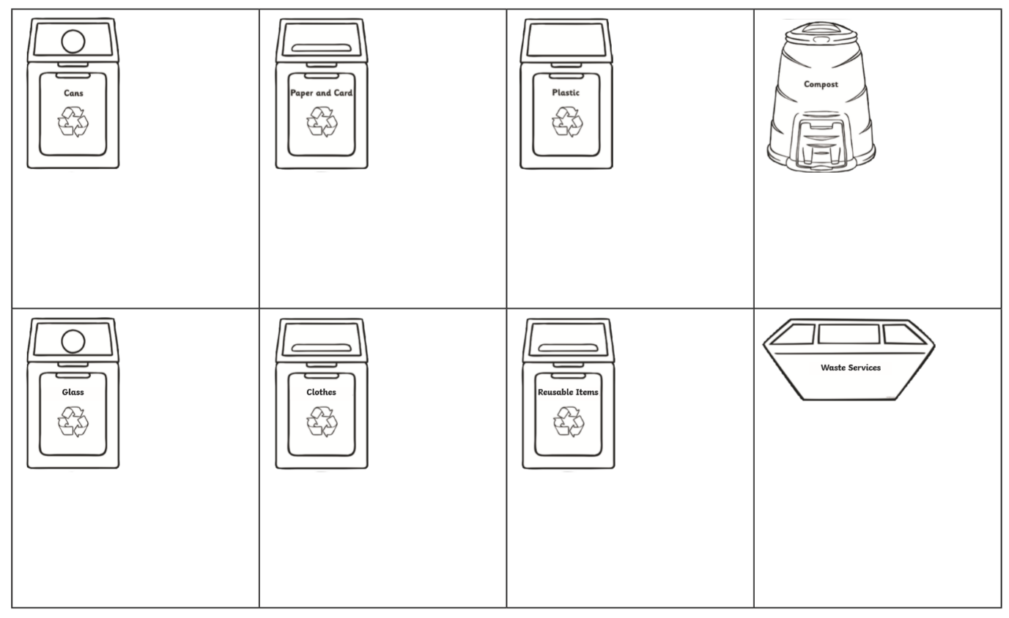
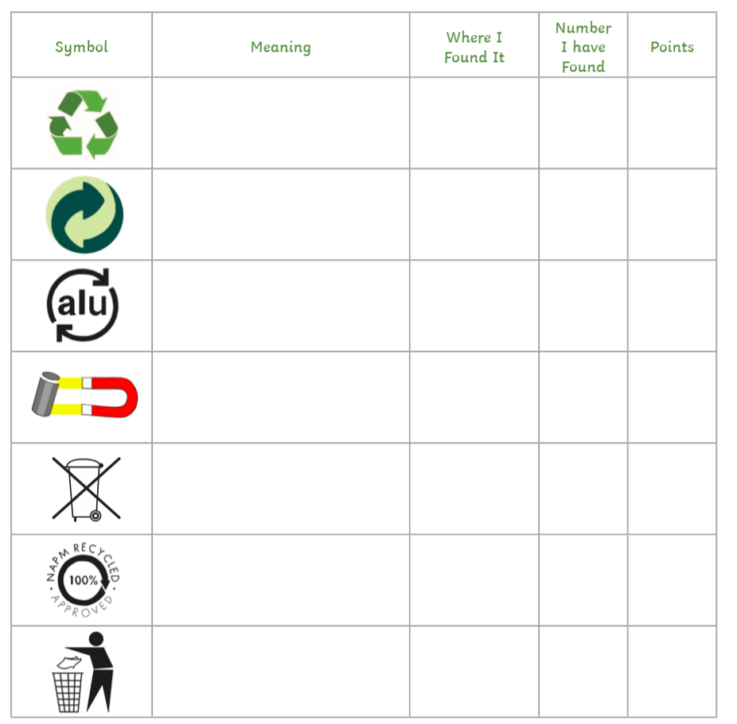
Name of item
Have a close look at some of the symbols you see on the products you buy in your home. Look carefully at the table below and see which ones you can find! When you find a symbol write down the name of the item you have found it on, where you have found it and how many you have found. Give yourself 2 points for each item you find. These symbols may not be on all labels, you may need to look on the actual container (maybe on the bottom). Good luck!
Make sure you ask an adult to help you!

