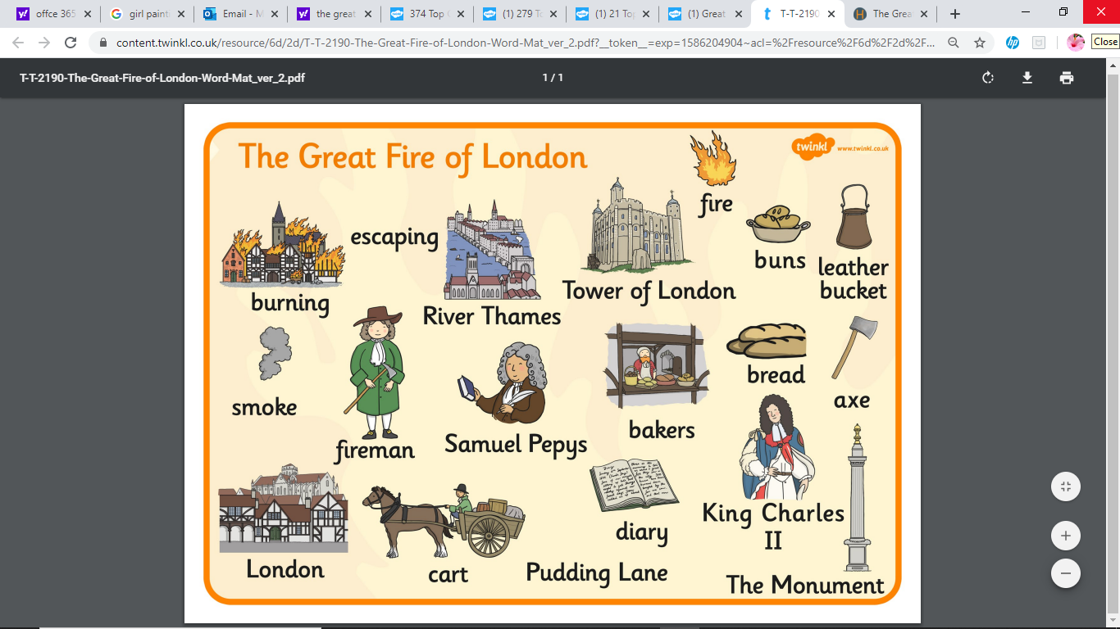
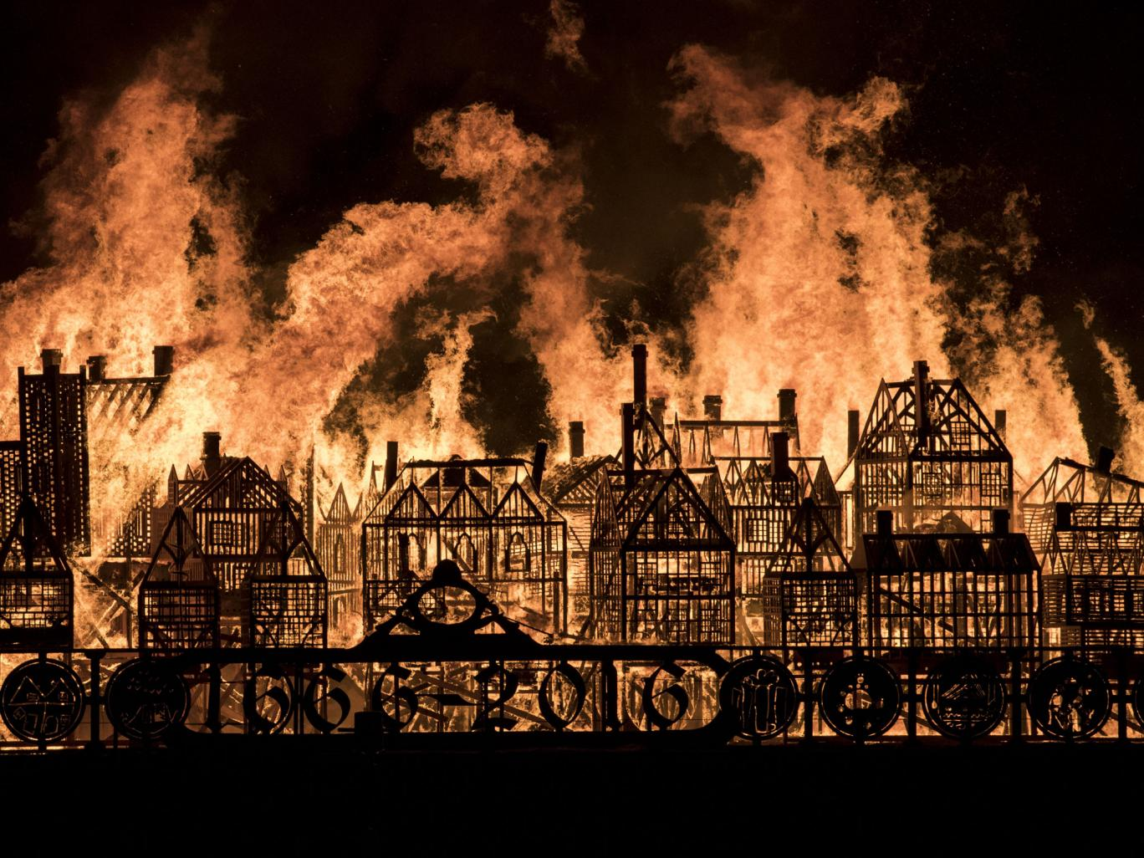
New topic: The Great Fire of London

Please don’t forget to share all your home learning on twitter you can find us at @mrstravishb, @hbmissrose, @hbmissparkinson, @hbmisskhan, @hbmissclayton, @hbmissdarwin. If you wish to contact us directly, need any support, wish to ask questions or simply want to let us know anything please contact us via email on rebecca.travis@astreahartleybrook.org megan.rose@astreahartleybrook.org Fiona.parkinson@astreahartleybrook.org and we will get back to you.

Many thanks and keep safe
Mrs Travis, Miss Rose and Miss Parkinson

Contact details
Mrs Travis
Email - rebecca.travis@astreahartleybrook.org
Twitter - @mrstravishb

Miss Rose
Email – megan.rose@astreahartleybrook.org
Twitter – @hbmissrose

Miss Parkinson
Email – Fiona.parkinson@astreahartleybrook.org
Twitter - @hbmissparkinson

Hartley Brook Primary Academy
Email – HBenquires@astreahartleybrook.org
Twitter – @HartleyBrookPri

Date: WB 11th May 2020
LO: write a diary
Today we would like you to play this game:
http://www.fireoflondon.org.uk/game/
After you have played it we would like you to pretend you lived in 1666 in London at the time of the fire, just like the boy in the game!
After, we would like you to write a diary about the Great Fire.
Don’t forget, a diary is a piece of writing written by you and to look back and remind you of what happened at a certain time in your life.
Answer these questions to help you think of ideas for your diary, remember to try and answer why:
How would you feel if you lived in London whilst it was on fire?
______________________________________________________________________________________________________________________________________________________
What is the first thing you would do if the fire was near your house?
______________________________________________________________________________________________________________________________________________________
Make a list of 4 things you would try to save (remember there’s NO Play Station’s or Xbox’s in 1666!! They had wooden dolls, board games, hoops and books… if you were lucky! Think about what people would really need or miss if it got burnt in 1666)
- ______________________________________________
- ______________________________________________
- ______________________________________________
- ______________________________________________
What are your neighbours/ community doing to stop the fire? Does it stop?
______________________________________________________________________________________________________________________________________________________
How do you feel when it is all over? Has anything you own been burnt? What will you do next?
______________________________________________________________________________________________________________________________________________________

Now let’s write your diary! Don’t forget to start it with ‘Dear Diary’. (Grown up’s if you want to tea stain and burn corners of a piece of paper for your child to write on instead… this is fine!)
Don’t forget to sign your name at the bottom.
Please send us your finished diaries to read!!!!!! We want to see your beautiful work! (twitter or email!)

