Dear Parent/Carers

We know that home learning can be tricky and we’ve tried our best to make home learning as easy and as fun as we possibly can while still teaching your child new things. We would like to thank you for you and your child’s hard work with home learning. It would be great if every week day you could try to do a literacy and maths activity while at some time in the week completing a science and a curriculum task. However, we also appreciate there are so many other ways children can learn so feel free to be as creative as you can in other activities. It would also be great if your child could take part in a physical and a phonics activity too. Below is a list of links to support home learning.
Phonics
Phonics Play
https://new.phonicsplay.co.uk/resources
Phonics play has lots of games and resources to support your child to learn sounds, read tricky words and short sentences. There are even alien words to have a go at!
Read Write Inc Phonics
https://www.youtube.com/channel/UCo7fbLgY2oA_cFCIg9GdxtQ
RWInc has live phonics lessons every week day from 9.30am. There is also story time every Monday, Wednesday and Friday at 2pm. Contact your child’s teacher if you are unsure which set your child is currently working on.
9.30 – Set 1
10.00 – Set 2
10.30 – Set 3

As well as phonics activities please reading and asking questions about the story to help their understanding.

Physical
Joe Wicks PE Lesson
https://www.youtube.com/user/thebodycoach1
There is a live PE lesson every morning at 9.00am. Great for burning off some energy.
Yoga
https://www.youtube.com/user/CosmicKidsYoga
Child friendly yoga activities are available on youtube. Each yoga session has a theme or story. Yoga is great for calming down and mindfulness.

Please don’t forget to share all your home learning on twitter you can find us at @mrstravishb, @hbmissrose, @hbmissparkinson, @hbmisskhan, @hbmissclayton, @hbmissdarwin. If you wish to contact us directly, need any support, wish to ask questions or simply want to let us know anything please contact us via email on rebecca.travis@astreahartleybrook.org megan.rose@astreahartleybrook.org Fiona.parkinson@astreahartleybrook.org and we will get back to you.

Many thanks and keep safe
Mrs Travis, Miss Rose and Miss Parkinson

Contact details
Mrs Travis
Email - rebecca.travis@astreahartleybrook.org
Twitter - @mrstravishb

Miss Rose
Email – megan.rose@astreahartleybrook.org
Twitter – @hbmissrose

Miss Parkinson
Email – Fiona.parkinson@astreahartleybrook.org
Twitter - @hbmissparkinson

Hartley Brook Primary Academy
Email – HBenquires@astreahartleybrook.org
Twitter – @HartleyBrookPri
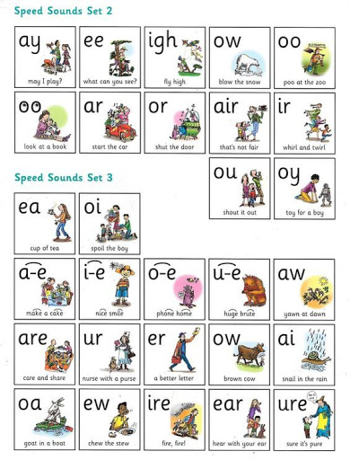
The spellings are repeated 2x over 2 weeks.

Lesson 1 | I
To learn the story | S

The Gingerbread Man

Once upon a time lived Goldilocks and three bears.
One day Goldilocks went for a walk in the deep dark forest and found a house. She opened the door and went inside.
On the table were three bowls of hot porridge. Goldilocks felt very hungry so she decided to have some.
First she tasted some from the biggest bowl. “This porridge is too salty” said Goldilocks.
Next she tried some from the smaller bowl. “This porridge is too sweet” said Goldilocks.
Then she tried some from the smallest bowl. “This porridge is just right” and she ate it all up.

After that Goldilocks found three chairs.
First she sat in the largest chair. “This chair is too big” cried Goldilocks.
Next she sat in the medium sized chair. “This chair is too big too” cried Goldilocks.
Then she sat in the smallest chair. “This chair is just right” and she smiled.

Suddenly the chair broke! Goldilocks was very tired now so she went upstairs to find a bed to sleep in.
First she laid down on the biggest bed. “This bed is too hard” said Goldilocks.
Next she laid on the smaller bed. “This bed is too soft” said Goldilocks.
Then she laid on the smallest bed. “This bed is just right” and soon she fell asleep.

Just then the three bears came home. “Someone’s been eating my porridge” said Daddy.
“Someone’s been eating my porridge too” said Mummy.
“Someone’s been eating my porridge and it’s all gone!” cried Baby bear.

“Someone’s been sitting in my chair” called Daddy.
“Someone’s been sitting in my chair too” called Mummy.
“Someone’s been sitting in my chair and it’s broken!” cried Baby bear.

Finally the bears climbed upstairs. “Someone’s been sleeping in my bed” shouted Daddy.
“Someone’s been sleeping in my bed too” shouted Mummy.
“Someone’s been sleeping in my bed and she is still there!” cried Baby bear.

Suddenly Goldilocks woke up and screamed “help!”. She ran and ran all the way home. Goldilocks never went into the deep dark forest again.

The end.

Discuss the following questions.
- Who are the characters in the story?
- Why do you think The Gingerbread Man ran away?
- Who were the characters that chased The Gingerbread Man? Why do you think they were chasing him?
- Did you expect the fox to do what he did? Why?
- Did you like the story? What was your favourite part? Why?
- If you found a runaway Gingerbread Man what would you do? Why?

When we learn stories at school, we usually add actions to them as well to help us remember. Try and come up with your own actions for The Gingerbread Man. Share them on Twitter: @HartleyBrookPri @HBMissParkinson @MrsTravishb @HBMissRose
Lesson 2 | I
LO: To draw a story map. | S

Story Map and labels
Look at Miss Rose’s story map above. Can you make your own story map to help you retell the story? Remember you only need pictures for the important parts. As an extra challenge you could add labels to your story map like I have done.

The Gingerbread Man, My Story Map
_______________________________________________________________________________________________________________________________________________________________________________________________________________________________________________________________________________________________________________________________________________________________________________________________________________________________________________________________________________________________________________________________________________________________________________________________________________________________________________________________________________________________________________________________________________________________________________________________
Lesson 3 | I
To use an adjective | S

Last week we did a character description, where we described the Gingerbread man.
I bet you used lots of good describing words to tell your grown up what he looked like!
These words are called adjectives.
They tell people what things;
Feel like
Look like
Taste like
Smell like

Have a look at these things from the story. Can you use an adjective to describe them? Can you put them into a sentence?
Top tip: have a look at the colour of the objects caption. This will tell you what the adjective should describe what the object is like.

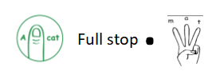
CL

Write the adjective on the line. Put it in a sentence.
Mummy bear’s bed
__________

________________________________________________________________
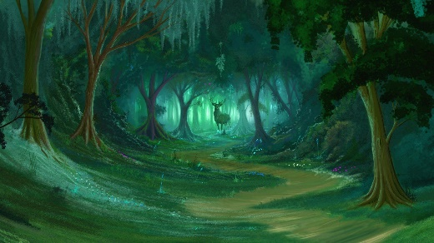
The forest
_____________

________________________________________________________________
Mummy bear’s porridge
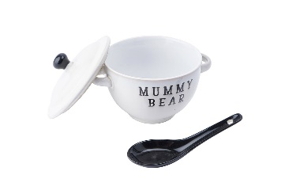
_____________

________________________________________________________________
Lesson 4 | I
LO: to write part of a story | S

Use your text map to help you write the story. I have broken it down using mine to help you!
Goldilocks ____________ Three Bears

Once upon a time there lived Goldilocks and the three ____________.

One day Goldilocks went for a walk in the ___________ dark forest.

She knocked on the door and went inside__ On the table were three bowls of ______________

Goldilocks was hungry so she decided to eat some__

____________ she ate some from the bigger bowl. “It’s too salty!” Said ______________.
Next she ate some from the smaller bowl. “Too __________!” Said Goldilocks. Then she ate some from the smallest bowl “___________________” Said Goldilocks and she ate it all _______.
After that Goldilocks saw three ________. First she sat on the largest chair. “_________________” said Goldilocks.

Next she sat on the medium sized chair. “That is too big too” She said. Then she ________ on the smallest chair. “________________” said Goldilocks.
Suddenly the chair broke! Goldilocks felt very tired so she climbed the stairs to find a ________.

First she tried the biggest ____________, “too hard” Cried Goldilocks. Next she tried the smaller bed “__________________”
cried Goldilocks.

Lesson 5 | I
LO: to write part of a story | S
The she tried the smallest bed. “___________________” said Goldilocks and soon she fell to _____________.

Just then the three bears came __________

“Someone’s been eating all my porridge!” Said _________ bear. “Someone’s been ____________ all my porridge!” Said ___________ bear.

“Someone’s been eating my porridge and it’s all gone!” Cried baby __________
“Someone’s been sitting in my _________” said Daddy bear. “Someone’s been sitting in my ___________” said _____________.
“Someone’s been sitting in my chair and it’s _____________!” cried baby bear.
_______________ the three bears went upstairs. “Someone’s been sleeping in my _____________” said Daddy bear.
“Someone’s ___________________________”
said Mummy bear. “Someone’s been sleeping in my bed and she’s still there!” Cried baby bear.
Suddenly, Goldilocks jumped up and __________ all the way home. Goldilocks never went to the _________ dark woods ever again.

