Nursery week 8

Hello Everyone
This weeks home learning is all about Little Red Riding Hood. Work through the different activities on the grid. You can also join Joe Wicks for PE everymoring at 9.00am and Dough Disco at 9.30am over on the spread the happiness chanel on Youtube.

Rememeber to add observations to tapestry and share your learning on twitter. Don’t forget to tag school (@HartleyBrookPri) and Miss Middleton (@missmiddletonhb). If you have any questions please email me lauren.middleton@astreahartleybrook.org and I’ll try my best to help.

Have fun and keep safe!
Miss Middleton

Activity 1 – Story  Watch the video or read the story of The Very Hungry Caterpillar. Put the cards in the right order and retell the story. | Activity 2 – Drawing  Can you make your very own butterfly. Don’t forget to use lots of bright colours. | Activity 3 – Favourite food  Can you draw a picture of your favourite food?You could even have a go at writing some labels. Why is it your favourite?
Activity 4 – Number match  Cut out the numbers and match them to the numbers on the caterpillar. | Activity 5 – Sound of the week.  Follow the link and watch the video. Now practise writing and reading t. | Activity 6 – Counting  Can you count the circles that make up the caterpillars body and record the answers?
Activity 7 – Bug Hunt  Go on a bug hunt in your garden or the park. Can you take photos or draw the bugs you find? | Activity 8 – Number of the week  Follow the link and watch the video. Now practse writing and reading 4. Can you spot the number one on your daily walk. | Activity 9 – Phonics  Log on to phonicsplay.co.uk and play a phonics game from the phase 1 tab. You can log on for free  Username: march20  Password: home
Number of the week
https://www.youtube.com/watch?v=xsYWsYPA4fE
Sound of the week
https://www.youtube.com/watch?v=WDjlIdI_Wdc&list=PLlG8Y2sj2t1FUbf8GD6r0XT7iITaKVUrV&index=7
Activity 1 – The Very Hungry Caterpillar
Watch the video of the story The Very Hungry Caterpillar, or read the story if you have the book at home. Then put the pictures in order and retell the story.

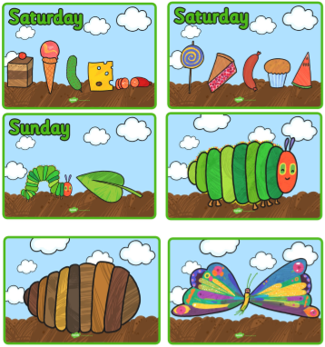
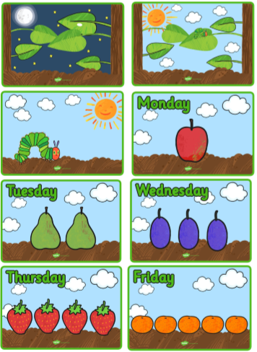
Activity 3 – The hungry caterpillar likes lots of food. Can you draw your favourite food? Why is it your favourite?
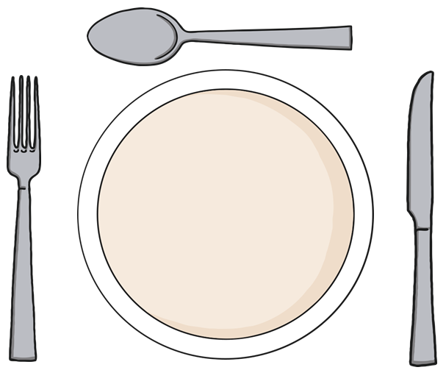

Activity 4 – Can you cut out the numbers and match them to the numbers on thecaterpillar?
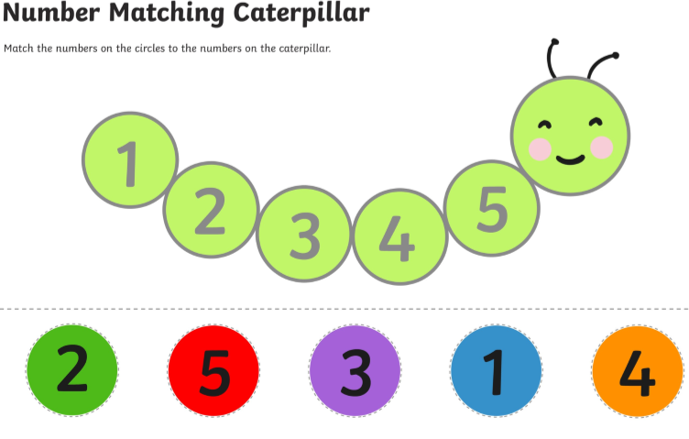
Activity 5 – Practise writing t
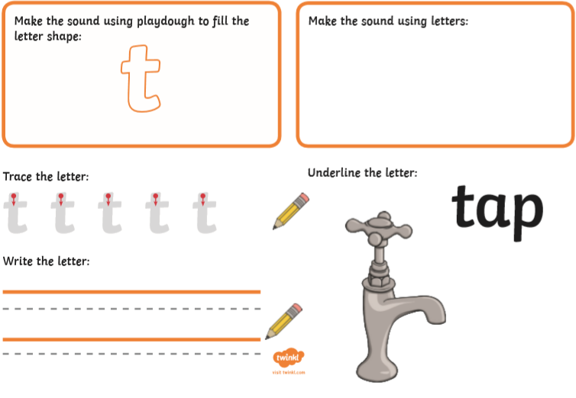
Activity 6 – Counting
Can you count how many circles make up the caterpillars body?

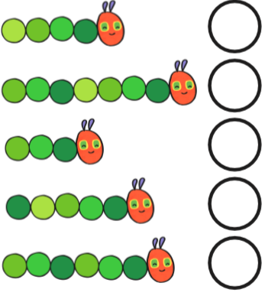

Activity 7 – Go on a Bug Hunt! Use the sheet to tick off all theb ugs you find.

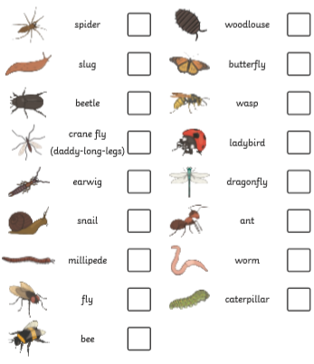

Which is your favourite minibeast? Can you make your favourite out of junk modelling or play dough?

Activity 8 – Number of the week
