L.O. How can we identify living things by looking at their characteristics?
Scientific Vocabulary – species characteristics
invertebrates mini-beasts classification habitat backbone

In this week’s science, we are learning about living things in different habitats and classifying them.
- Use the PowerPoint to find out about classification.
- Complete the Woodland Habitat Classification Sheet using the PowerPoint.
- Fill in the Urban Habitat Classification Sheet using the animals on the next sheet.
- Cut out the questions and yes / no answers. Create a classification key for animals that live in an urban habitat. Remember to check that it works for each animal.
- If you want to challenge yourself, create a classification key for living things in a different habitat e.g. the desert or sea. Start by listing the living things you want to include, then create your questions to sort them. Make your classification key and remember to check it works for each living thing.
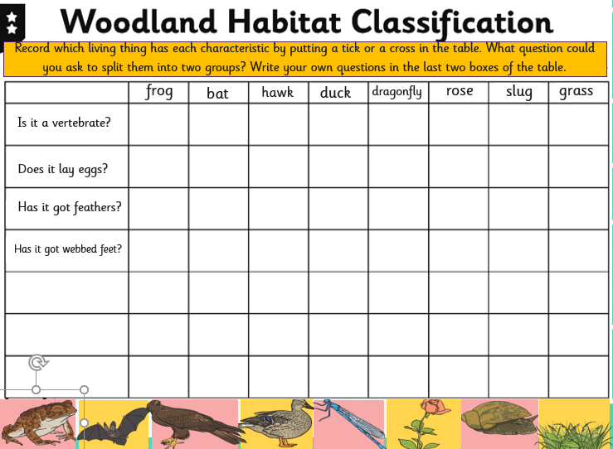

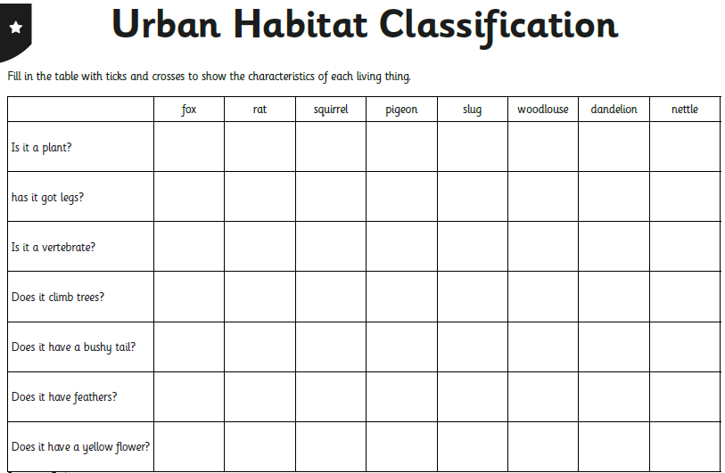

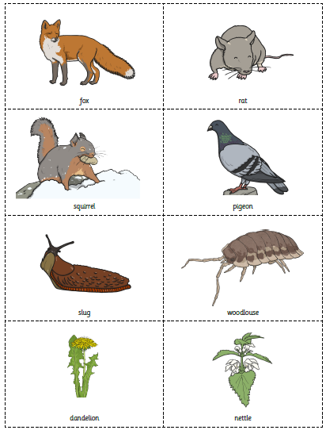

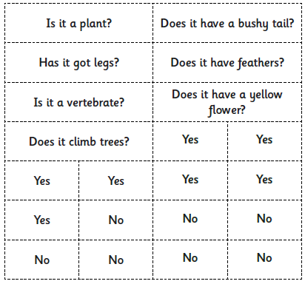

My Urban Classification Key

