Sunflower Room WC 11th May 2020 | I
How do our diets put us in groups? | S
Identify, describe, sort, omnivore, herbivore, carnivore, ven diagram

We eat many different things. Some humans do not eat meat, other eat meat and veg. This is also like other animals.
Watch the link below if you can if not I have written a little to help give you some information. https://www.youtube.com/watch?v=3yrikH2QEFA
Herbivores-only eat plants. They do not eat meat at all. 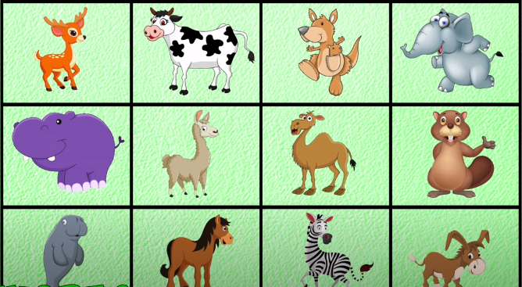
Carnivores- only eat meat. They do not eat plants at all.
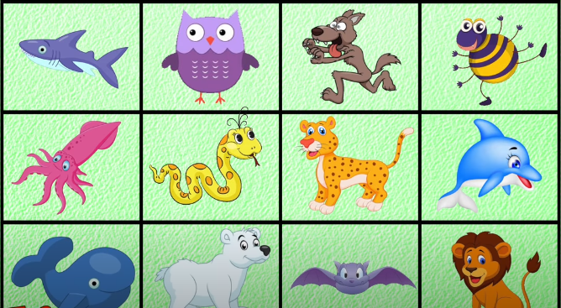
Omnivores – eat both plants and meat. They eat everything.
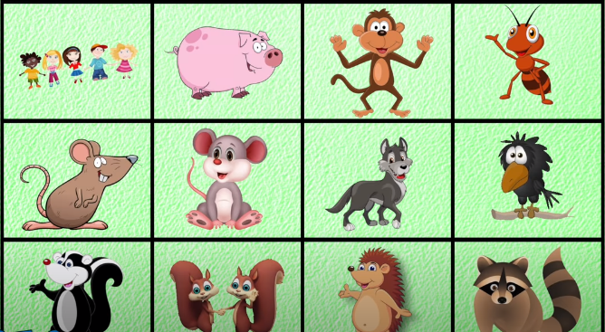

Below is a ven diagram. It has three parts. Carnivore, herbivore and omnivore. Omnivore is in the middle because these animals eat both meat and plants. Can you cut the animals out and stick them in the correct category?

Carnivore

Omnivore

Herbivore

Sunflower Room WC 11th May 2020 | I
Do you know they difference between Carnivore and herbivore teeth? | S

Rip tear pierce
Crush grind

Have a look at the shape of the teeth, and think about what foods they might eat. What would there teeth do to the food?

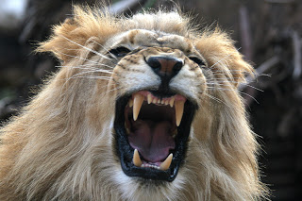
Why do you think the carnivore and herbivore have different teeth?

Ask someone to help you write your answer.

____________________________________________________________________________________________________________________________________________________________________________________________________________________________________________________________________________________________________________________________________________________________________________________________________________________________________________________________________________________________________________________________________________________________________________________

