Dear Parent/Carers

We know that home learning can be tricky and we’ve tried our best to make home learning as easy and as fun as we possibly can. Home Learning for the next few weeks will focus on the topping of Giants, which would have been this half terms topic at school. It would be great if every week day you could try to do a literacy, maths and creative activity. As well as the activities from the grid it would be beneficial for your child to take part in a physical and a phonics activity too. Below is a list of links to support home learning.
Phonics
Phonics Play
https://new.phonicsplay.co.uk/resources
Phonics play has lots of games and resources to support your child to learn sounds, read tricky words and short sentences. There are even alien words to have a go at!
Read Write Inc Phonics
https://www.youtube.com/channel/UCo7fbLgY2oA_cFCIg9GdxtQ
RWInc has live phonics lessons every week day from 9.30am. There is also storytime every Monday, Wednesday and Friday at 2pm. Contact your child’s teacher if you are unsure which set your child is currently working on.
9.30 – Set 1
10.00 – Set 2
10.30 – Set 3

As well as phonics activities please practise writing your full name everyday.

Physical
Joe Wicks PE Lesson
https://www.youtube.com/user/thebodycoach1
There is a live PE lesson every morning at 9.00am. Great for burning off some energy.
Yoga
https://www.youtube.com/user/CosmicKidsYoga
Child friendly yoga activities are available on youtube. Each yoga session has a theme or story. Yoga is great for calming down and mindfulness.
Dough Disco
https://www.youtube.com/channel/UCj0shfH3pzhrf3dOrSj_pRw
Dough disco is great for building muscles in young children’s hands. It helps to develop fine motor skills which help children to write. All you need is a small piece of play dough and enough room to have a good boogie.

Please don’t forget to share all your home learning on tapestry and twitter. If you do not have a tapestry account please contact Miss Middleton on lauren.middleton@astreahartleybrook.org for a new account log on.

Many thanks and keep safe
Miss Middleton, Miss Wilson and Mrs Brough

Contact details
Miss Middleton
Email - lauren.middleton@astreahartleybrook.org
Twitter - @missmiddletonhb

Mrs Brough
Email – melanie.brough@astreahartleybrook.org
Twitter – @mrsbroughhb

Miss Wilson
Email – Melissa.wilson@astreahartleybrook.org
Twitter - @misswilsonhb

Hartley Brook Primary Academy
Email – HBenquires@astreahartleybrook.org
Twitter – @HartleyBrookPri
Week 8 Daily Activities
 | Literacy | Maths | Curriculum
Monday | Start the week by learning this week’s tricky words (Activity 1). Practise reading, writing and spelling them. You could try to write them in a sentence. Don’t forget to revisit them over the week. | Can you use the star words to describe the height and length of objects in your house?  (Activity 6) | Draw a picture of a beanstalk and use leaves from outside for the stalk (Activity 11)
Tuesday | Can you describe the characters from Jack and the beanstalk to people in your household thinking about some really good adjectives. (See activity 2) | Can you find out who is the tallest and shortest in your house? Can you order put people in order from shortest to tallest? Can you order 5 of your toys in height order?  (Activity 7). | Get creative!
Wednesday | Can you draw and label the giant from the story using the adjectives you used to describe the characters to the people in your house. As a challenge you could write a sentence to describe him. (Activity 3). | Can you play the height order game from twinkl? (Activity 8). | Can you write your plant diary for this week?  (Activity 12)
Thursday | Can you describe Jack and write about him? (Activity 4) | Can you cut out and order the beanstalks starting from tallest to shortest? (Activity 9). | Get creative!
Friday | Look at the picture of Jack and the castle (Activity 5). Can you write about the picture? You can mark make, write labels, a caption or sentences. | Would you use height or length vocabulary to describe the objects? (Activity 10). | Can you learn the Debbie and Friends Jack and the Beanstalk song from you tube and sing to your family? (13)
Challenge | Play Tricky Word Trucks on phonicsplay.co.uk.  How fast can you read the tricky words? | Can you measure your garden’s length and your bedroom’s length using non-standard measure – footsteps? Which is the longest? | Share all your home learning on twitter or tapestry.

Tricky Words – Activity 1

Please practise reading, writing and spelling this week’s tricky words. You could even have a mini spelling test and let us how you get on, on twitter.
come
we
what
have
like
Use the link to practise reading tricky words. How fast can you read all the words?
https://new.phonicsplay.co.uk/resources/phase/2/tricky-word-trucks
Jack and the Beanstalk – Activity 2
Can you describe the characters to people in your house?

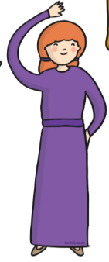

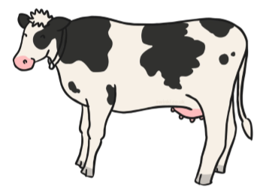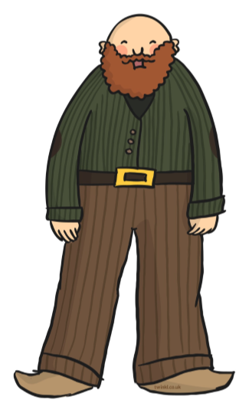
Caring rude happy beautiful friendly

rude angry sly evil clever

handsome kind honest nasty gentle

wicked pretty cross enormous tall

short shy scary mean helpful bold brave cunning

Can you draw and label the Giant?
Activity 3

Can you describe Jack? – Activity 4

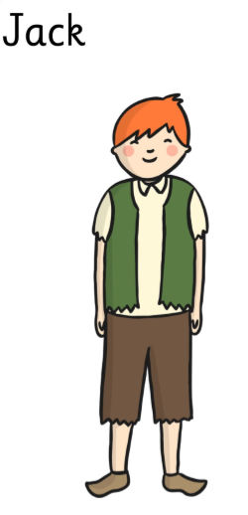

__________________________________________________________________________________________

Labels/Captions/sentences – Activity 5
Can you write about the picture?
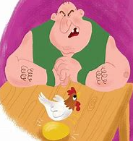

__________________________________________________________________________________________

Can you use the star words to describe the length of objects in your house – Activity 6
long | short
longer | shorter
longest | shortest

An example would be the sofa is longer than the cluedo box.

Can you find out who is the shortest and tallest – Activity 7
Can you find out who is the tallest and shortest in your house?
Can you put them in order from shortest to tallest?
Can you put your toys in height order and share with us on twitter?
tall | short
taller | shorter
tallest | shortest
You can use cut out the star words and label the objects and people.

Can you play the height order game? – Activity 8
Can you use the link and play the height order game from twinkl?
https://www.twinkl.co.uk/resource/tg-ga-75-beanstalk-height-ordering-game

Height order of beanstalks – Activity 9
Can you cut out the different beanstalks and put them in height order?
Can you use Tallest, taller, shorter, shortest and same to describe the beanstalks?

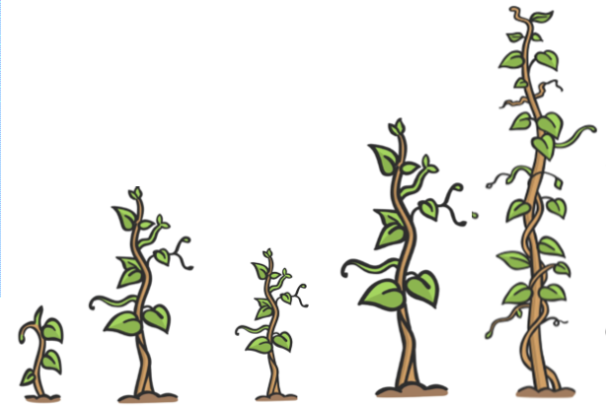

Length or height? – Activity 10
Would you use length or height vocabulary to describe the following objects?
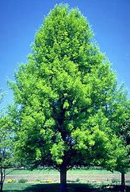
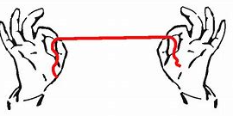
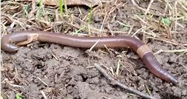

What could you use to measure the length of objects?

Beanstalk picture - Activity 11
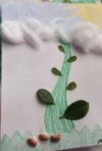

Can you draw a picture of a beanstalk and use leaves and other things from the garden?

Plant diary - Activity 12
Week 2

Draw a picture of what your plant looks like?

What has happened?
____________________________________________________________________________________
_
Activity 13 Can you learn the Debbie and Friends Jack and the Beanstalk song?

https://www.youtube.com/watch?v=pf9cVnfyhjM

Below is a list of end of reception expectations to look out for in your child’s maths and English. These will help improve your child’s maths work and writing which will move their learning forward.
English
- Check for capital letters
- Full stops
- Finger spaces
- Can you read what you have written to someone in your house?
- Check your writing makes sense and you haven’t missed any words from your sentence.
- Could you add an adjective to extend your sentence (a word to help describe something in your sentence)? Example- The frog had a bright green head.
- Can you add a conjunction to your sentence to extend it further (a word like and, so, because)?
Example – I am getting dressed so that I can go for a walk.
- Are all your letters formed properly and on the lines– are they the right way round.
- If you are struggling with forming letters practise writing the letter on some paper remembering where the letter starts etc here is a good page for you to look at.
http://resources.hwb.wales.gov.uk/VTC/ngfl/ngfl-
Maths
- When adding numbers together can you add a two-digit number and a single digit number together? Can you write the equation yourself?
13 + 5 =
- When subtracting can you subtract a single digit from a two-digit number? Remember which number must come first. Can you write the equation?
- Can you count on from the first number to find the answer when doing addition equations?
- Can you count back to find the answer when subtracting?
- Recognising numbers – can you recognise numbers to 50?
- Can you write number ensuring they are all facing the right way?
- Can you weigh and measure the lengths of objects using standard (ruler, digital weighing scales, tape measure etc) and non-standard measure (cubes to measure, footsteps, balancing scales)? Find attached a page to help describe standard and non-standard measure - https://www.theschoolrun.com/what-are-standard-and-non-standard-units
- Can you find patterns in your house and describe them to people in your house?
- Can you estimate different amounts when cooking pasta or other objects – does A have more or less than B?
Estimate which is heavier is the orange, grape or plum heavier than the apple? Can you write down your predictions of the order and then check to see who was right or the closest?

