Read, Write Inc
Oy – toy for a boy
Word time!
- Show or write the word and ask your child to spot the “special friends”
eg boy
- Ask children to say the sounds in “Fred talk” and then to read the words eg b-oy - boy
- Count out the sounds on their fingers. Repeat the word and pinch their fingers as they say the sounds.
- Write the word and pinch their fingers as they say the sounds.
- Underline the special friend “oy”
- Tick the word if it is correct or try again.

toy boy enjoy annoyed joy destroy loyal voyage

Can you match the “oy” word?

oyster royal voyage destroy

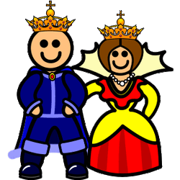
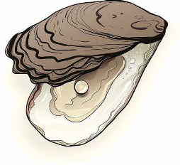
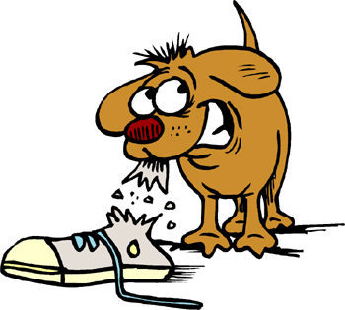

Write or say a sentence for 5 different “oy” words. Make sure your sentence has a capital letter and a full stop. Can you write a question?

- _________________________________________________________

- _________________________________________________________

- _________________________________________________________

- _________________________________________________________

- _________________________________________________________

Fill in the correct “oy” word:
I went on a long __________ across the world.
Half my class are girls and half my class are _________.
I got a lot of ________ from playing with my baby sister.
It was raining on my holiday so I was ___________.
My friends are very ________.
Would you like a new _______ for your birthday?
Don’t ___________ your painting!

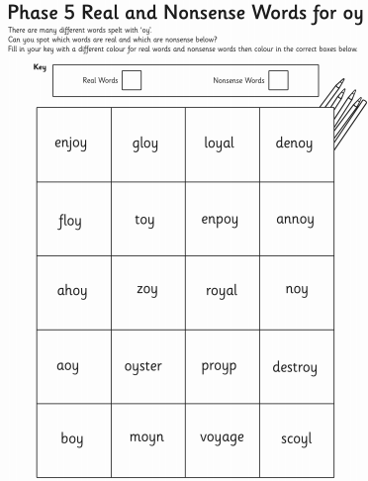

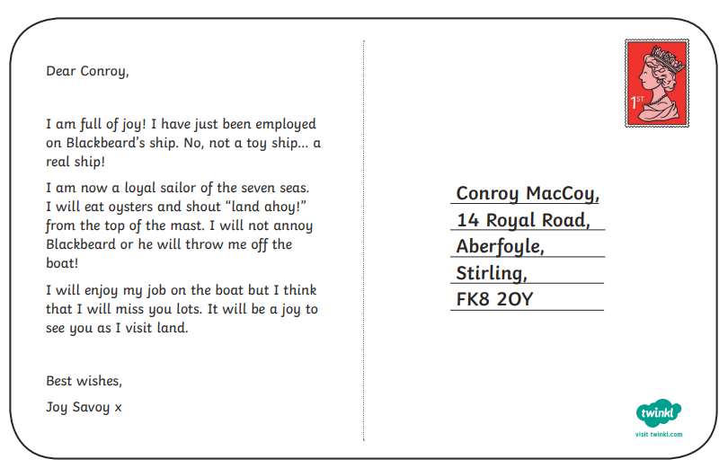

Can you highlight all the “oy” words?

