Monday 18th May 2020
Questions from myminimaths.co.uk:
5a) _____ = 54 - 33
5b) _____ = 856 - 241
5c) 83 - 25 = _____
5d) 759 - 78 = _____
5e) _____ = 82 - 44
5f) 156 – 117 = _____
5g) _____ = 533 - 370
5h) 97 – 46 = _____
5i) _____ = 984 - 239
5j) 423 – 6 = _____
5k) _____ = 57 - 32
5l) _____ = 903 - 61
5m) 855 – 522 = _____
5n) _____ = 26 - 17
5o) 93 – 55 = _____
5p) _____ = 82 - 25

Video to help:
https://myminimaths.co.uk/arithmetic-16-practice-question-5/
Answers: https://myminimaths.co.uk/arithmetic-16-answers-question-5/

LO: To identify common factors
Tuesday 19th May 2020
Star words: multiples factors greatest least
common product multiply arrays

Fluency
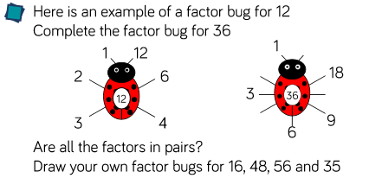
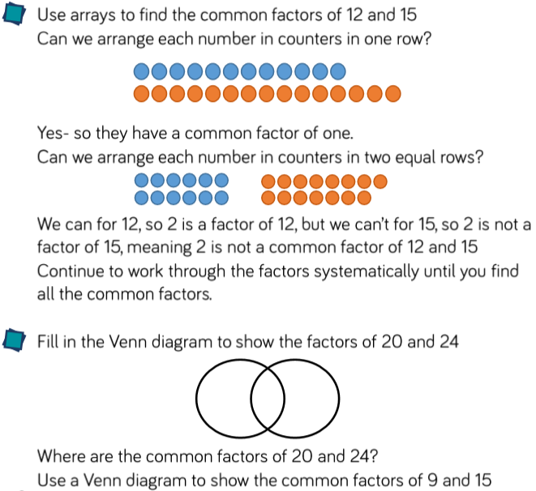

Reasoning
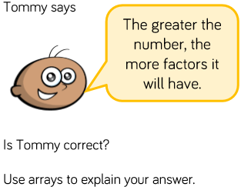 | 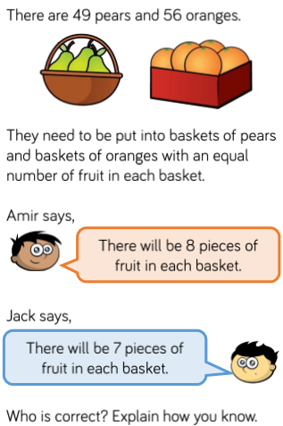
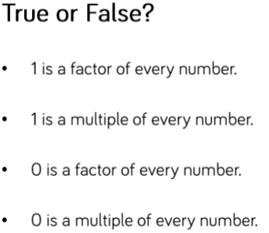

Problem Solving
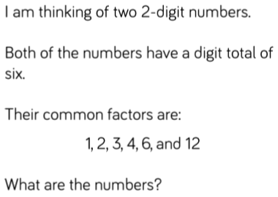 | 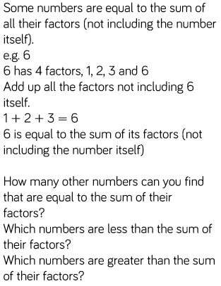
Miss Dean has 60 sweets that she gives away to her friends.

She shares them equally between her friends.

How many friends could Miss Dean have?

Challenges
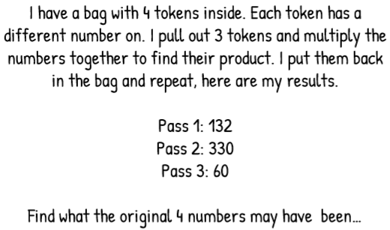

LO: To identify common multiples.
Wednesday 20th May 2020
Star words: multiples factors greatest least
common product multiply arrays

Fluency
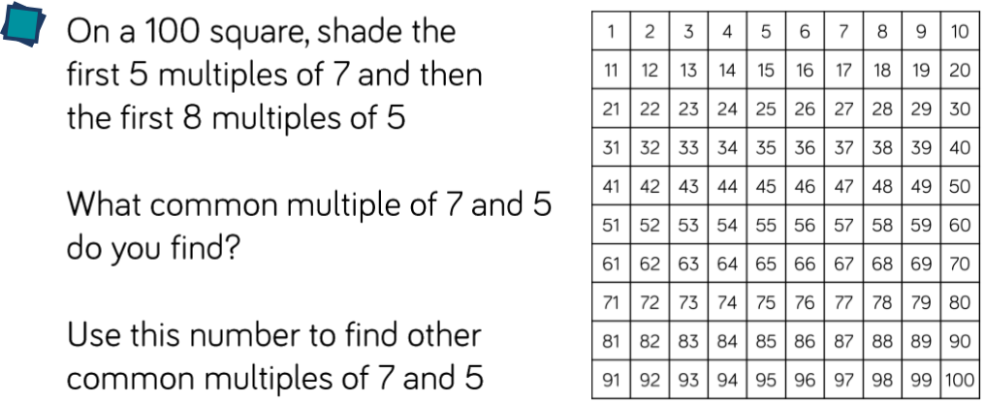
List 5 common multiples of…
1) 3 and 4 2) 4 and 8
3) 3 and 6 4) 2 and 6
5) 5 and 10 6) 4 and 6

Reasoning
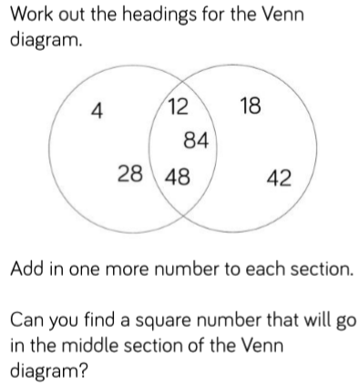 |  | 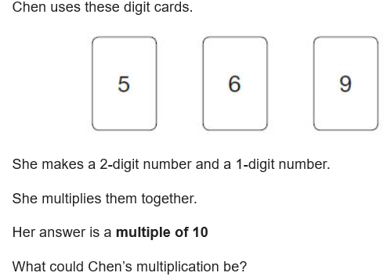
Problem Solving
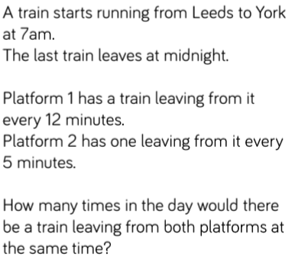 | A man smiles at her wife every 3 seconds while the wife smiles back every 6 seconds. When will both husband and wife smile at each other at the same time?
A manager at a restaurant can buy hamburger buns in packages of 8 and hamburger patties in packages of 6. Suppose the manager cannot buy part of a packages. What is the least number of packages of each product he can buy to have an equal number of hamburger patties and buns?
Challenges
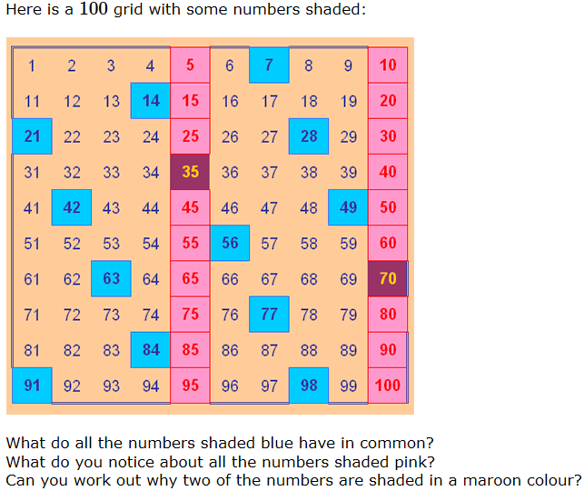

LO: To identify prime numbers.
Thursday 21st May 2020
Star words: prime factors multiples prime factor lowest common factor highest common factor
Fluency
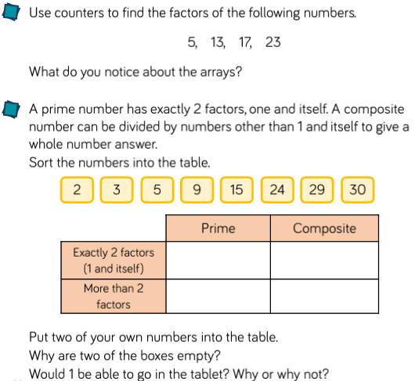

Reasoning
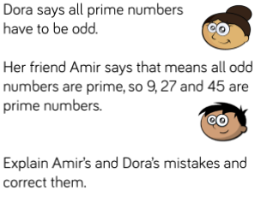 | 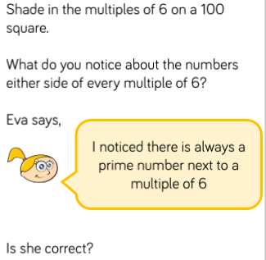

Problem Solving
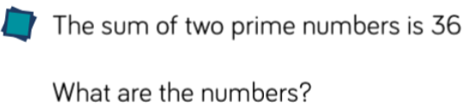 | 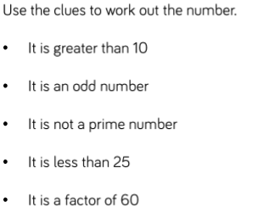

Challenge
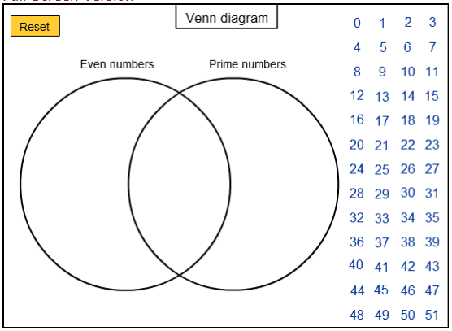

Friday 22nd May 2020
Arithmetic
1) 934 + 100 | 10) $\frac{7}{12}$ - $\frac{4}{12}$
2) 345 x 4 | 11) 216 ÷ 8
3) 8.6 + 0.6 | 12) 5.98 x 100
4) 29 x 5 | 13) 8²
5) 2,452 + 573 | 14) 30,000 - 700
6) 63 ÷ 7 | 15) 1000 x 60
7) 846 - 9 | 16) 720 ÷ 9
8) 8.3 + 0.08 | 17) 40% of 1,700
9) 5 x 6 x 2 | 18) 3.59 x 4

