Monday 1st June 2020
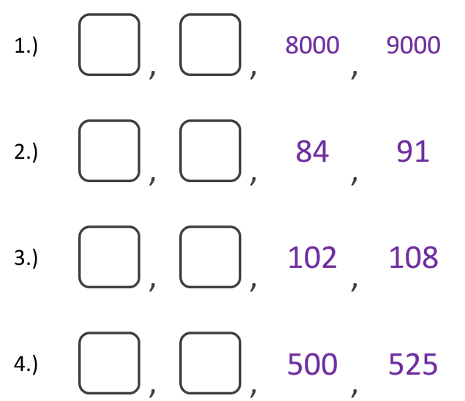
Questions from myminimaths.co.uk:
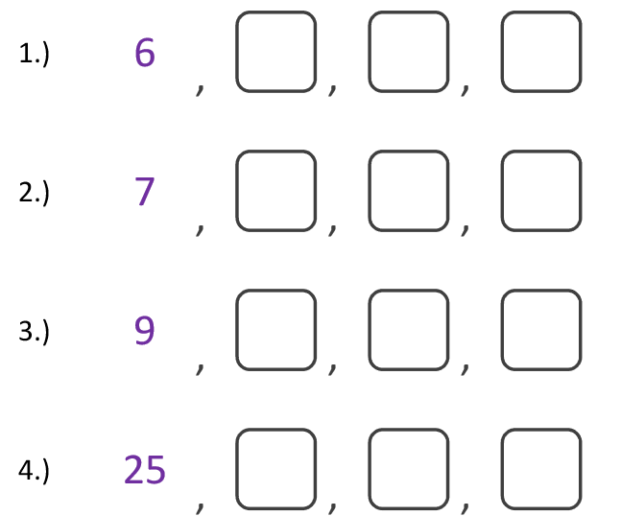

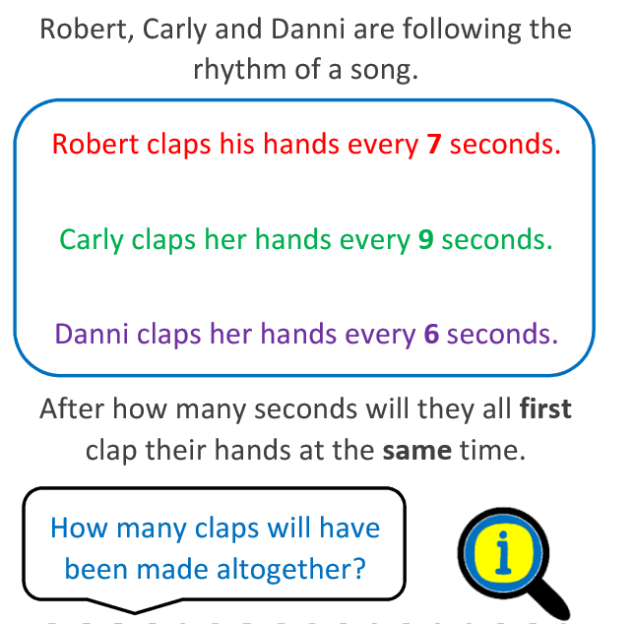
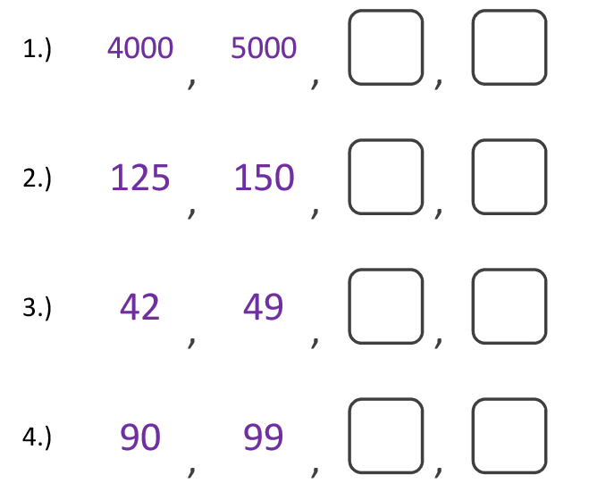

Video to help:
https://myminimaths.co.uk/year-4-week-7-recognise-any-given-digit-in-a-4-digit-number-monday/
Answers:
https://myminimaths.co.uk/year-4-home-learning-week-6-count-and-identify-multiples-of-6-7-9-25-and-1000-answers/

Date: 02-06-20
LO: To be able to recognise tenths and hundredths
Fluency - https://whiterosemaths.com/homelearning/year-4/

Select Week 1 Lesson 1 at the bottom of the page for the video clip to support your learning.

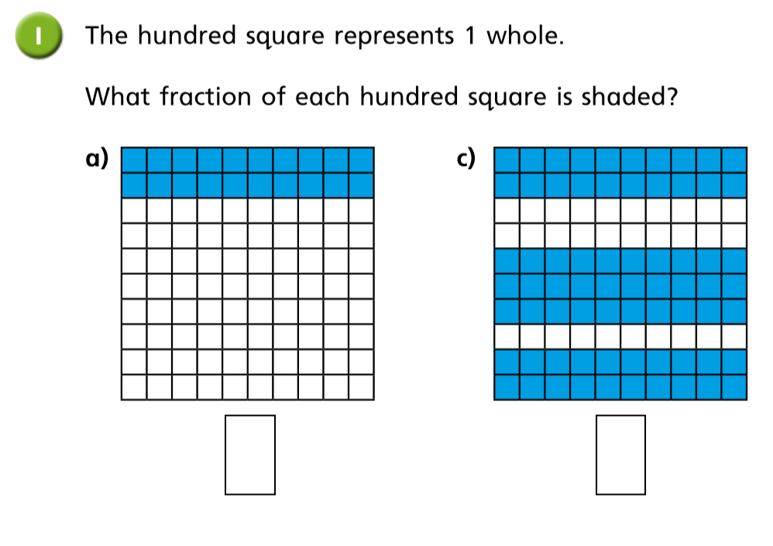

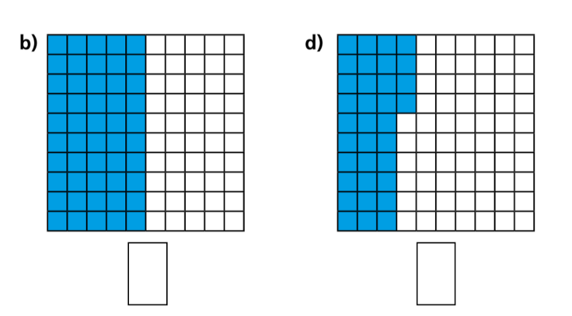

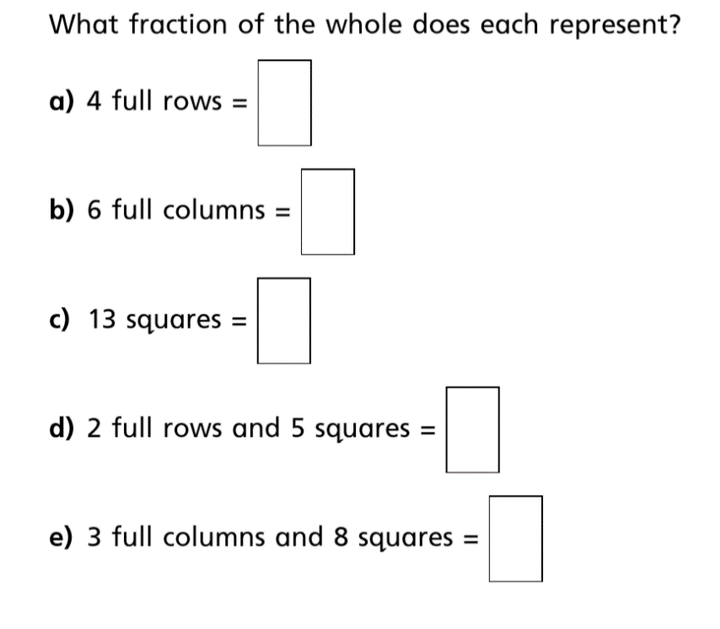
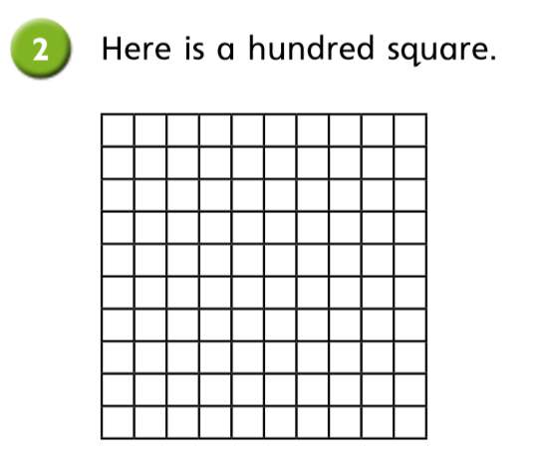

Reasoning and problem solving
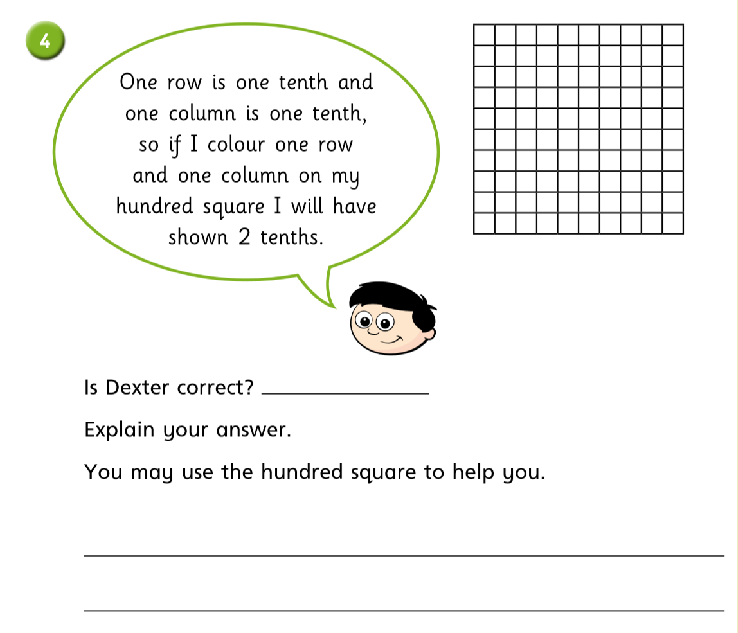

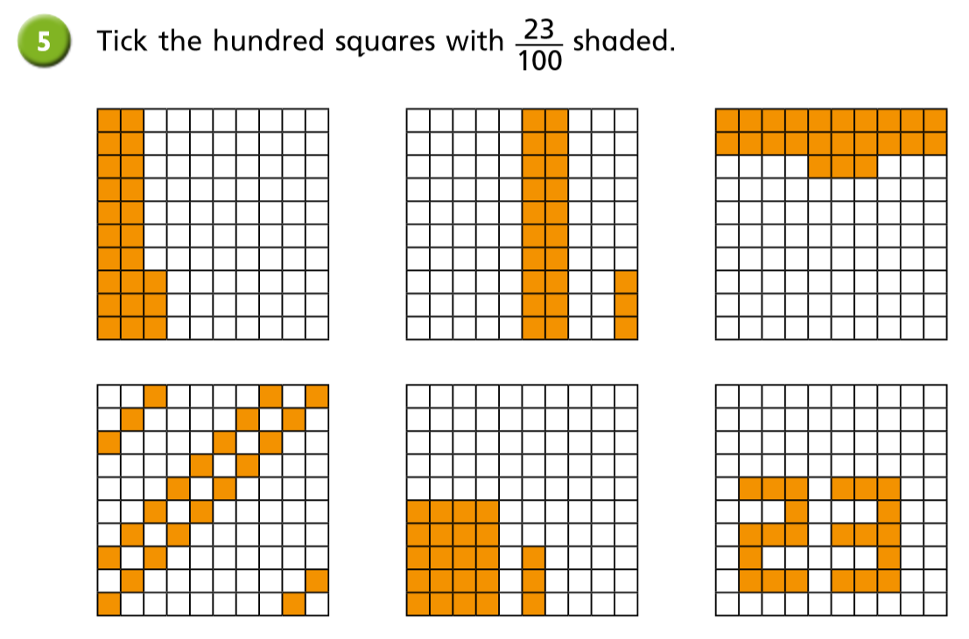

Date: 03-06-20
LO: To be able to find tenths as a decimal.
Fluency - Select Week 1 Lesson 2 at the bottom of the page for the video clip to support your learning.

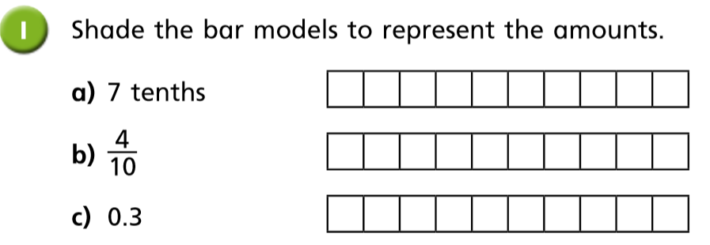

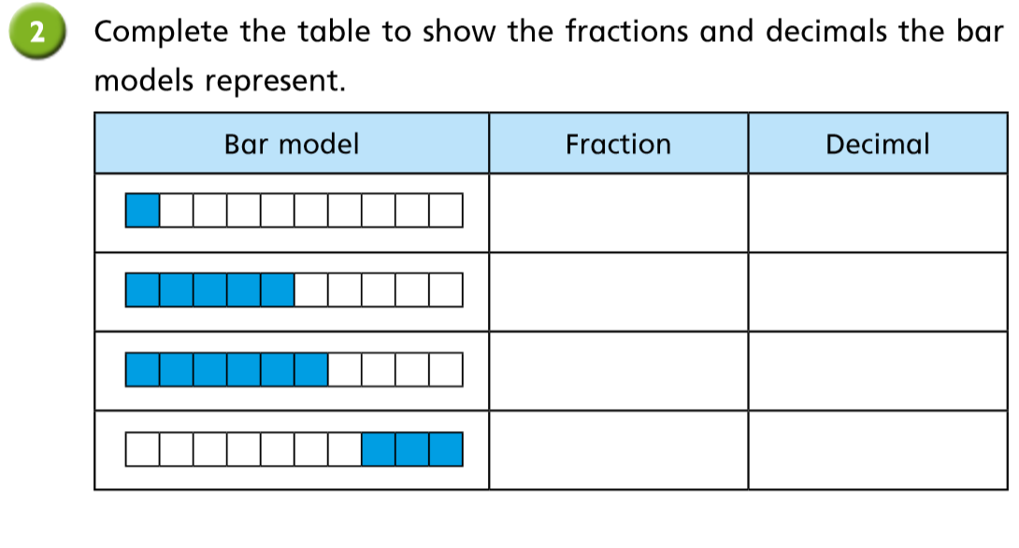

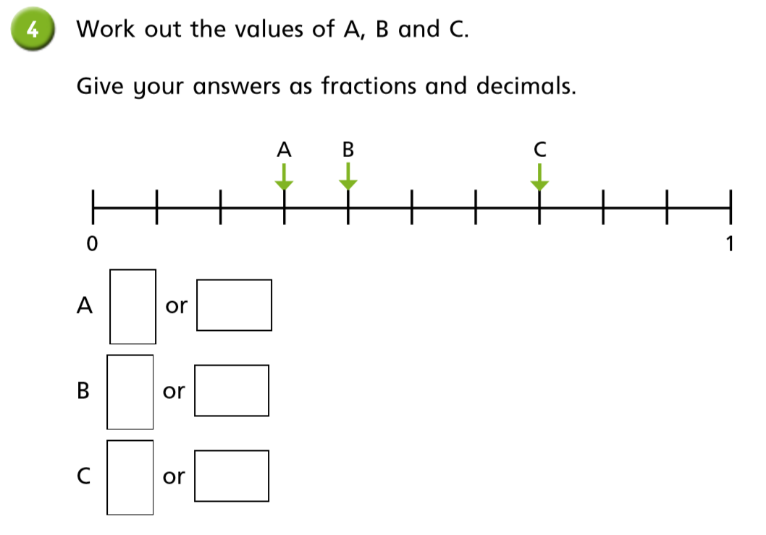

Reasoning and problem solving
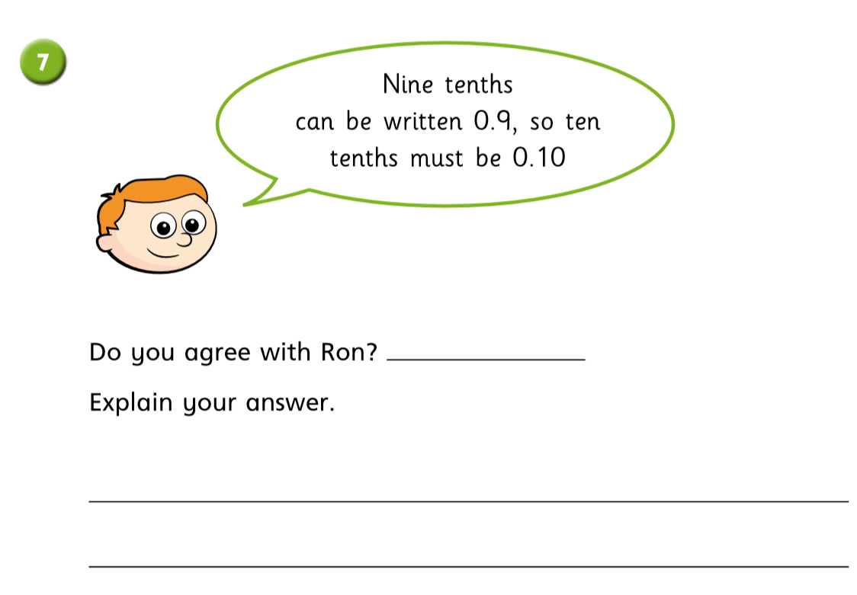

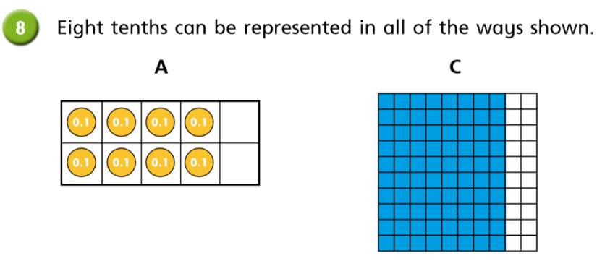
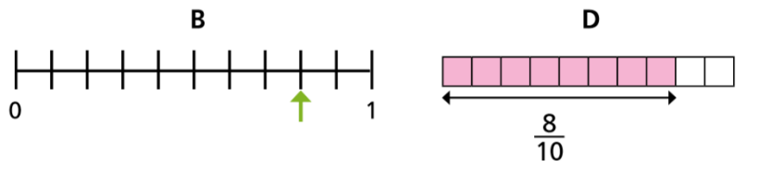

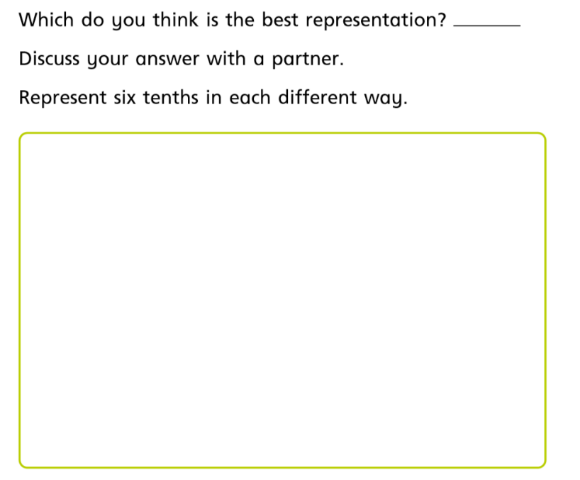

Date: 04-06-20
LO: To be able to represent tenths on a place value grid.
Fluency - Select Week 1 Lesson 3 at the bottom of the page for the video clip to support your learning.
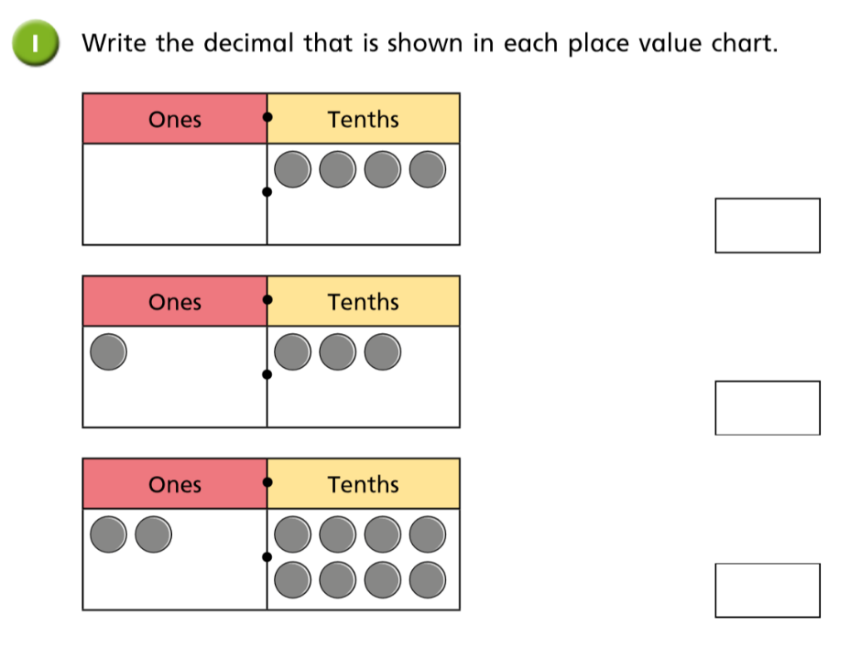

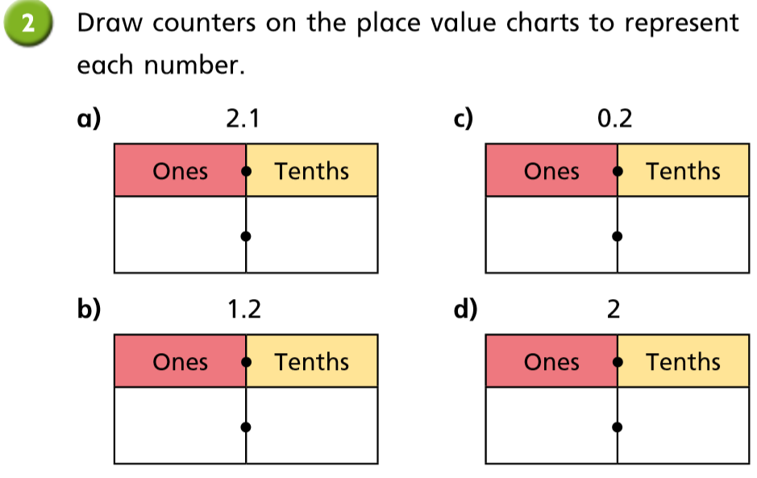

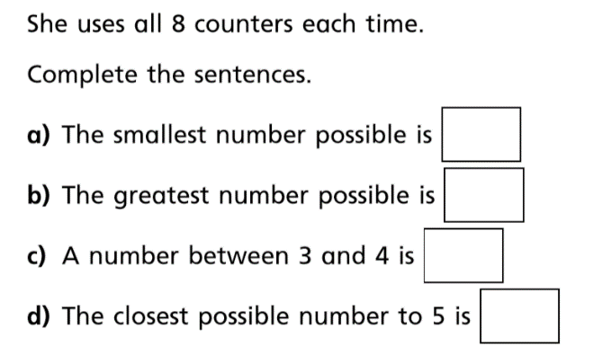
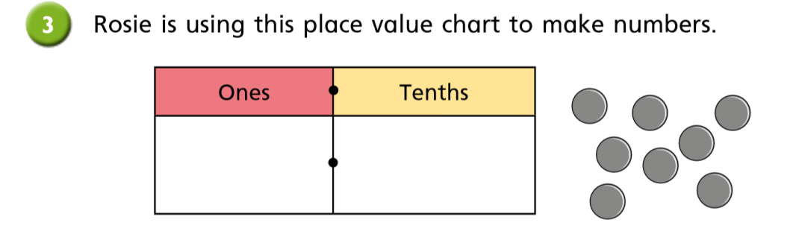

Reasoning and problem solving
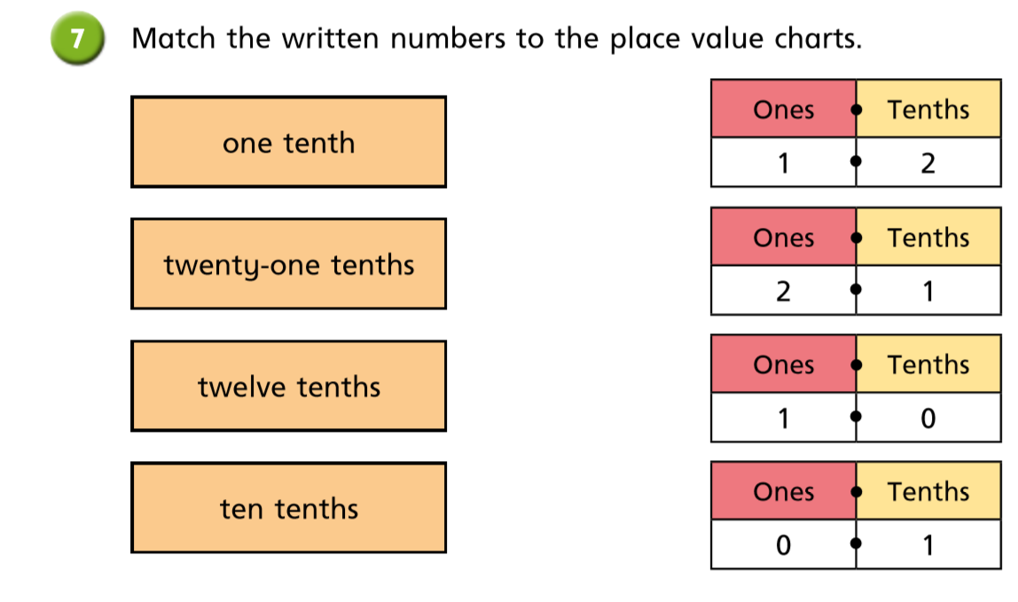

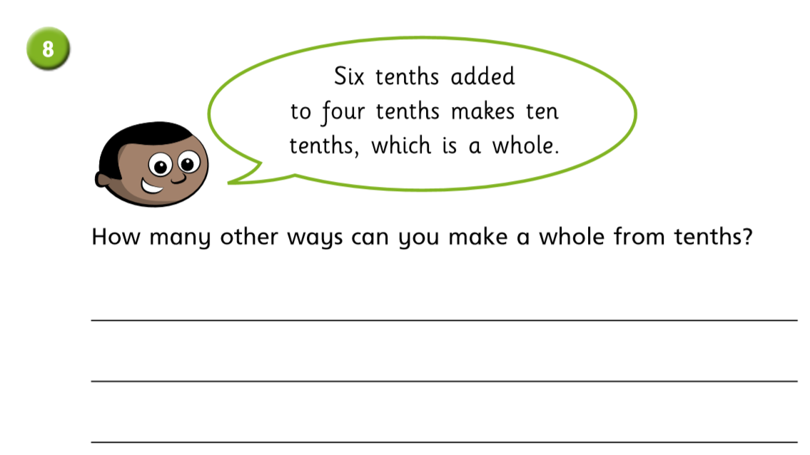

Date: 05-06-20
LO: To be able to represent tenths on a number line.
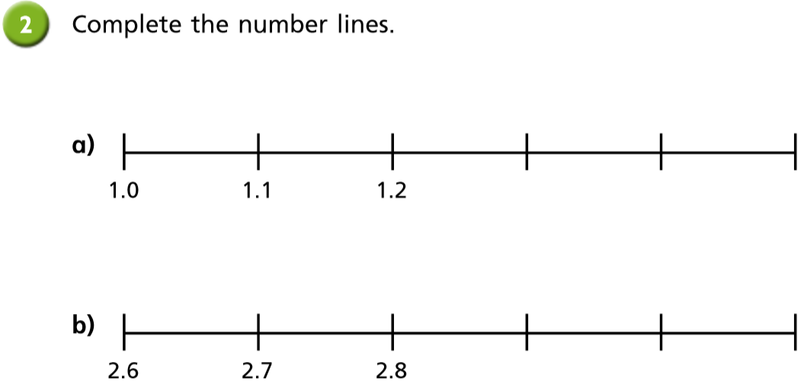

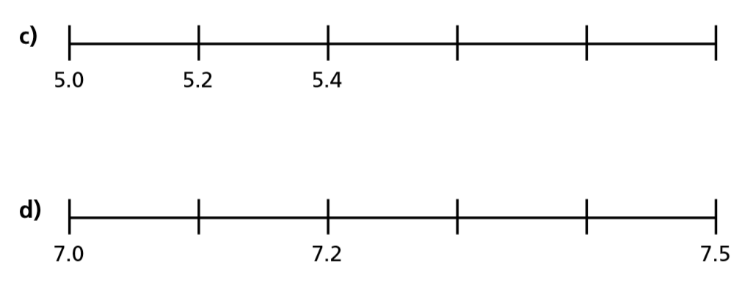

Reasoning and problem solving
