COPY THE PICTURE USING THE GRID

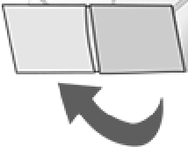
X

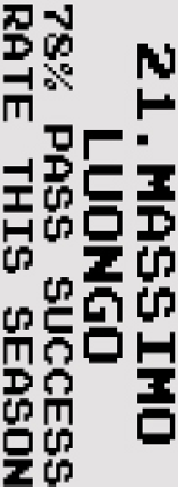
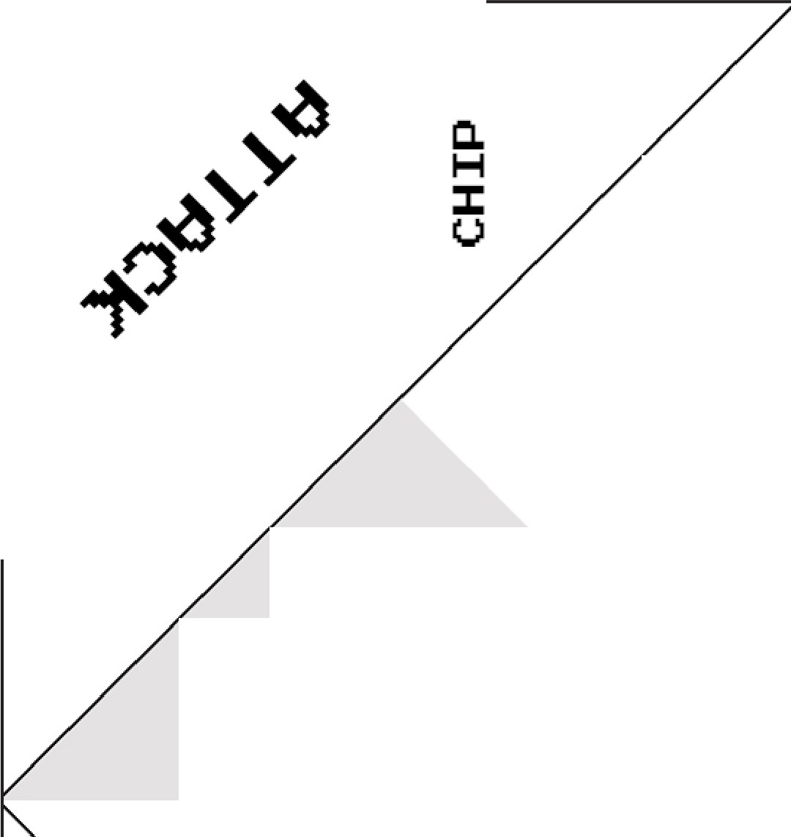::c IT1 D C IT1
0cn
z
:L>LJ LLJ en
z
cc
::CH
1-1-1-
LLJ u::c
SHOOT
cn LLJ en
- ...J .J
Cl"I LL. 25
45.
FERNANDO FORESTIERI
"'
l'4')
-I
20 KEY PASSES THIS
SEASON
;it'I

PASS

7.KADEEM
HARRIS

19 SHOTS ON TARGET THIS SEASON

NOStJ3S SIH.l NOStJ3S
oz

SNOild3 31NI £ SIHl S3H llj
XO.:I NOS Mt'01
Nt'9HOH"£ N0 3Wt'::>"£iZ
Cll ()

1-4
::J::
I-
r

m:1::1-
:D IT1 •

37>1::>t'l
a^{E}:
t3z z (J".I _ii::: 3nt'S
LLJ uo Dc,n -Im

t-1 E zcn c.i, ::z: E t-1
a: cca:: :tl
...J ...J o o
Cl! LU z-1om
- cccn
z N C.LU Cl)c z

g. <v

.u..J
-t
::J:: (")

+c :z
0
"111":f'
+6
1-4 D
-I
(")

::c

I-
::c

.•.
I • • ' ••
· "". '. 1.J ·. . .

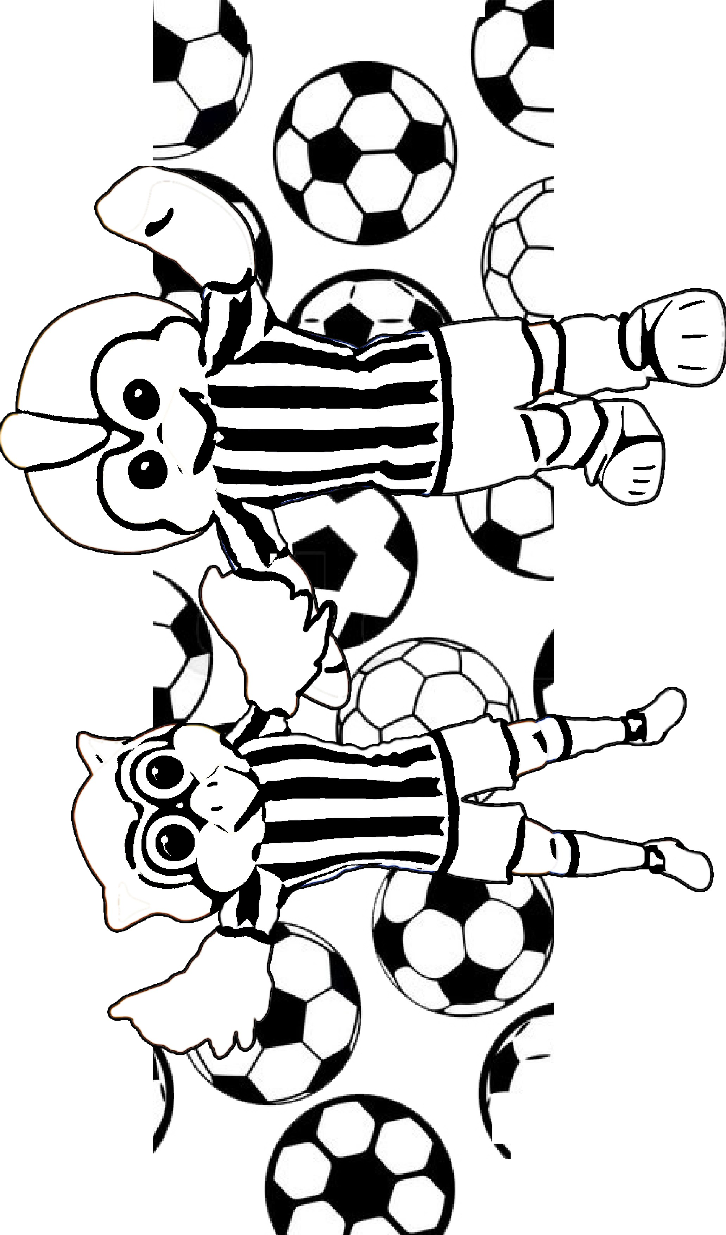

. \-•
.

f..

'
CAMERON
DAWSON

I

'

-====-
-

:. .

==---==
-
·'·I';·tu.

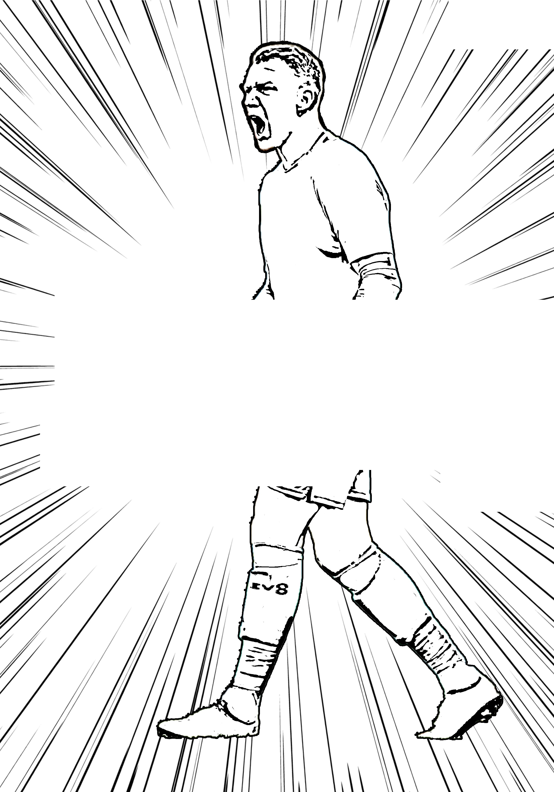' . , 7
I'_
/ · ,

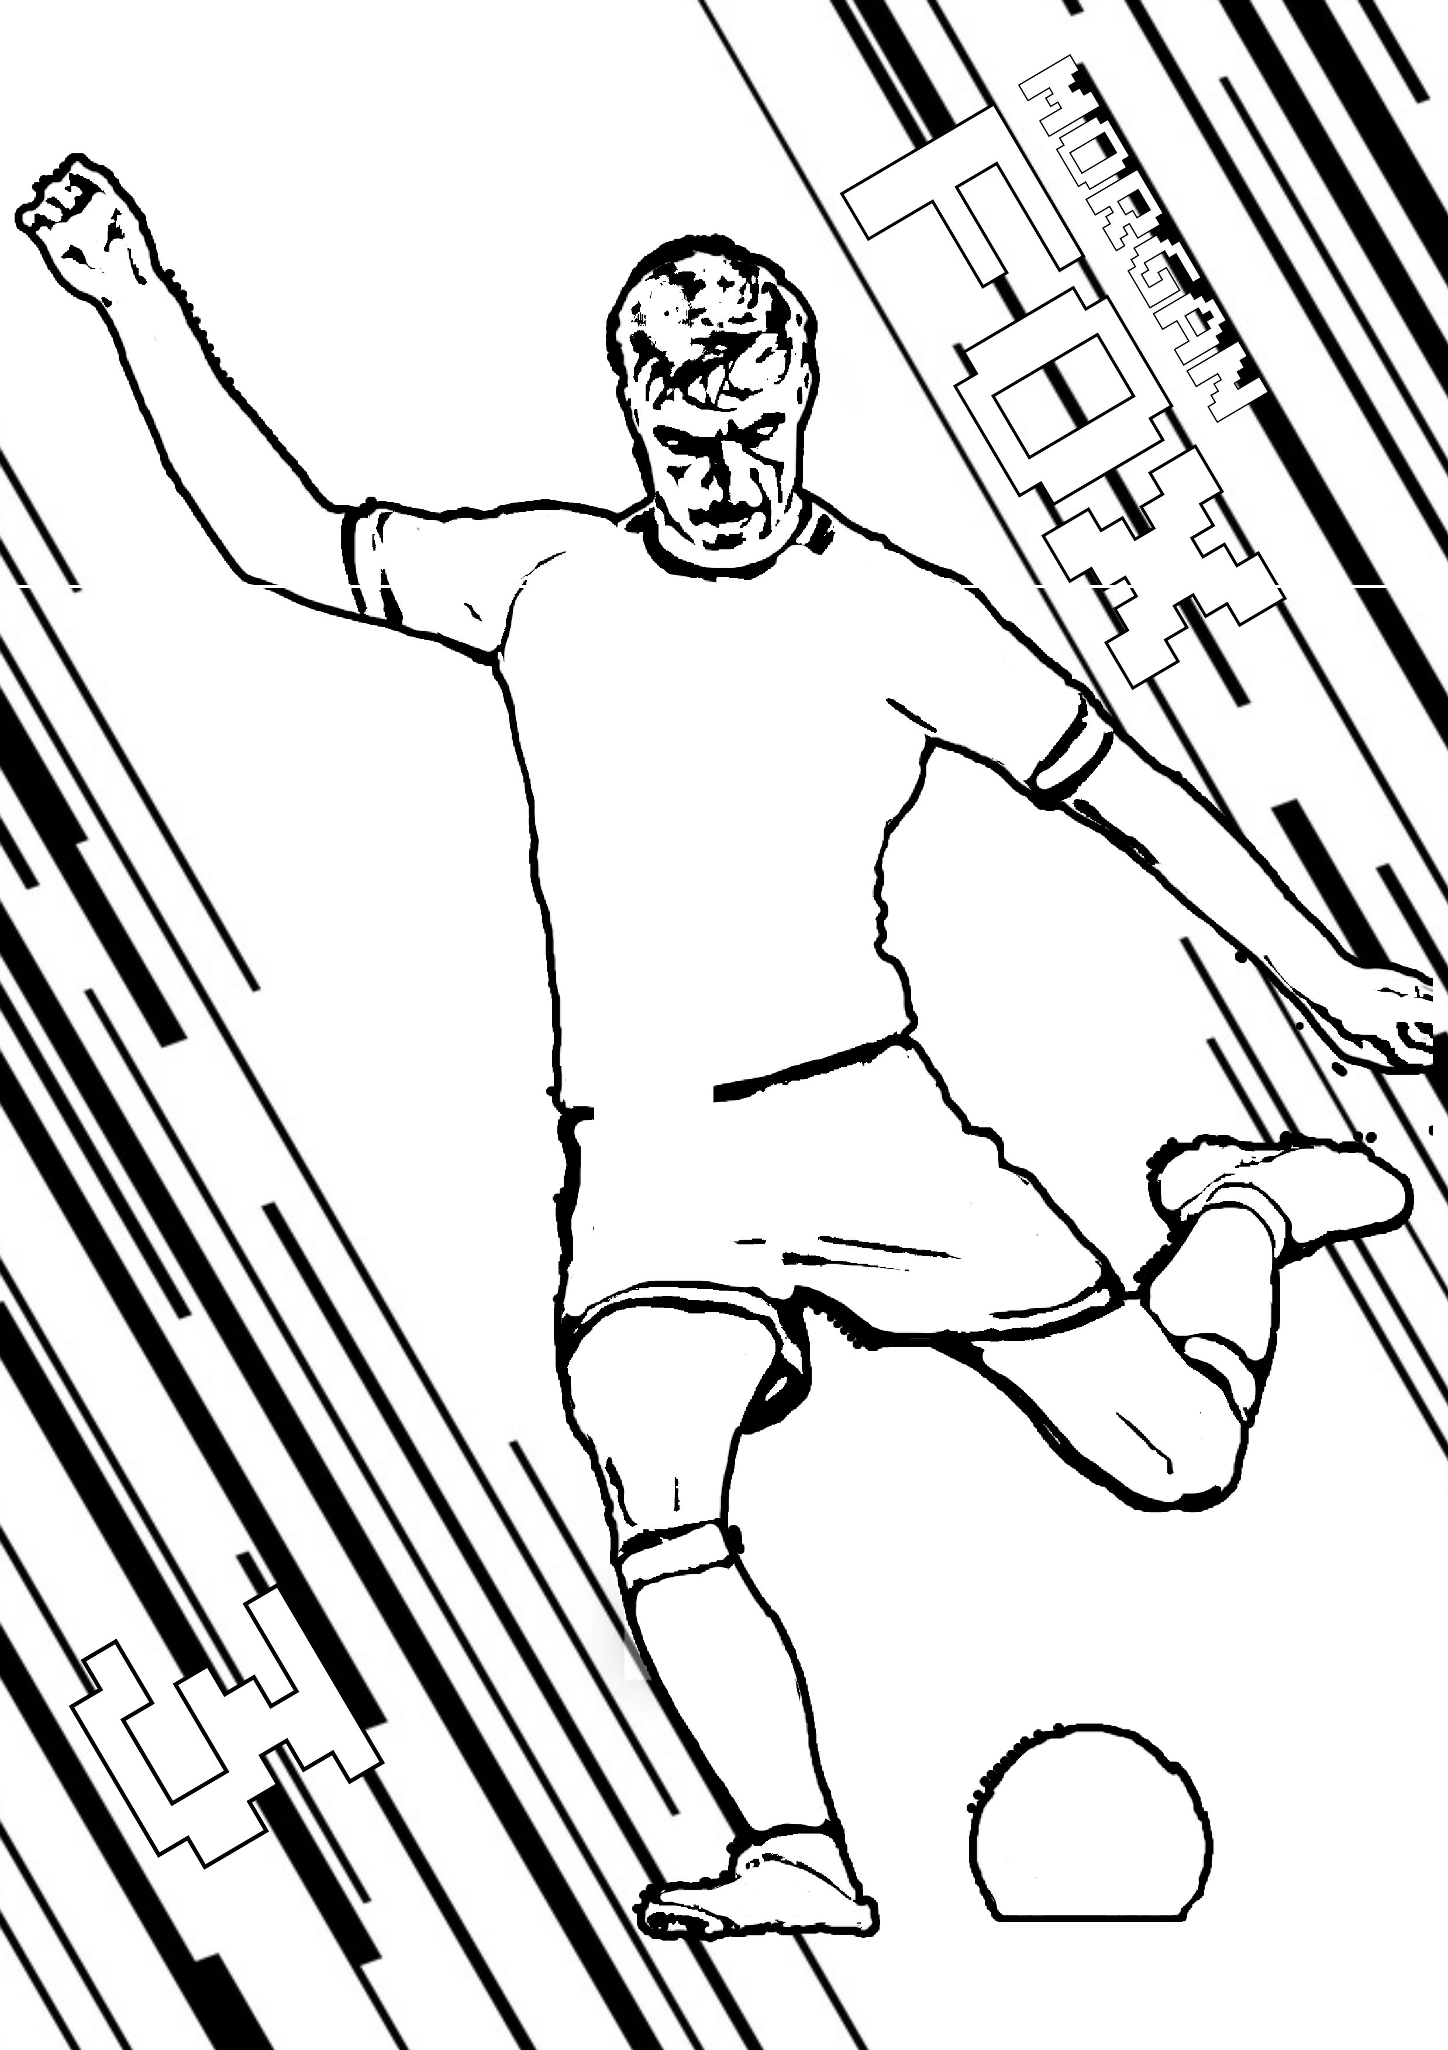

,----

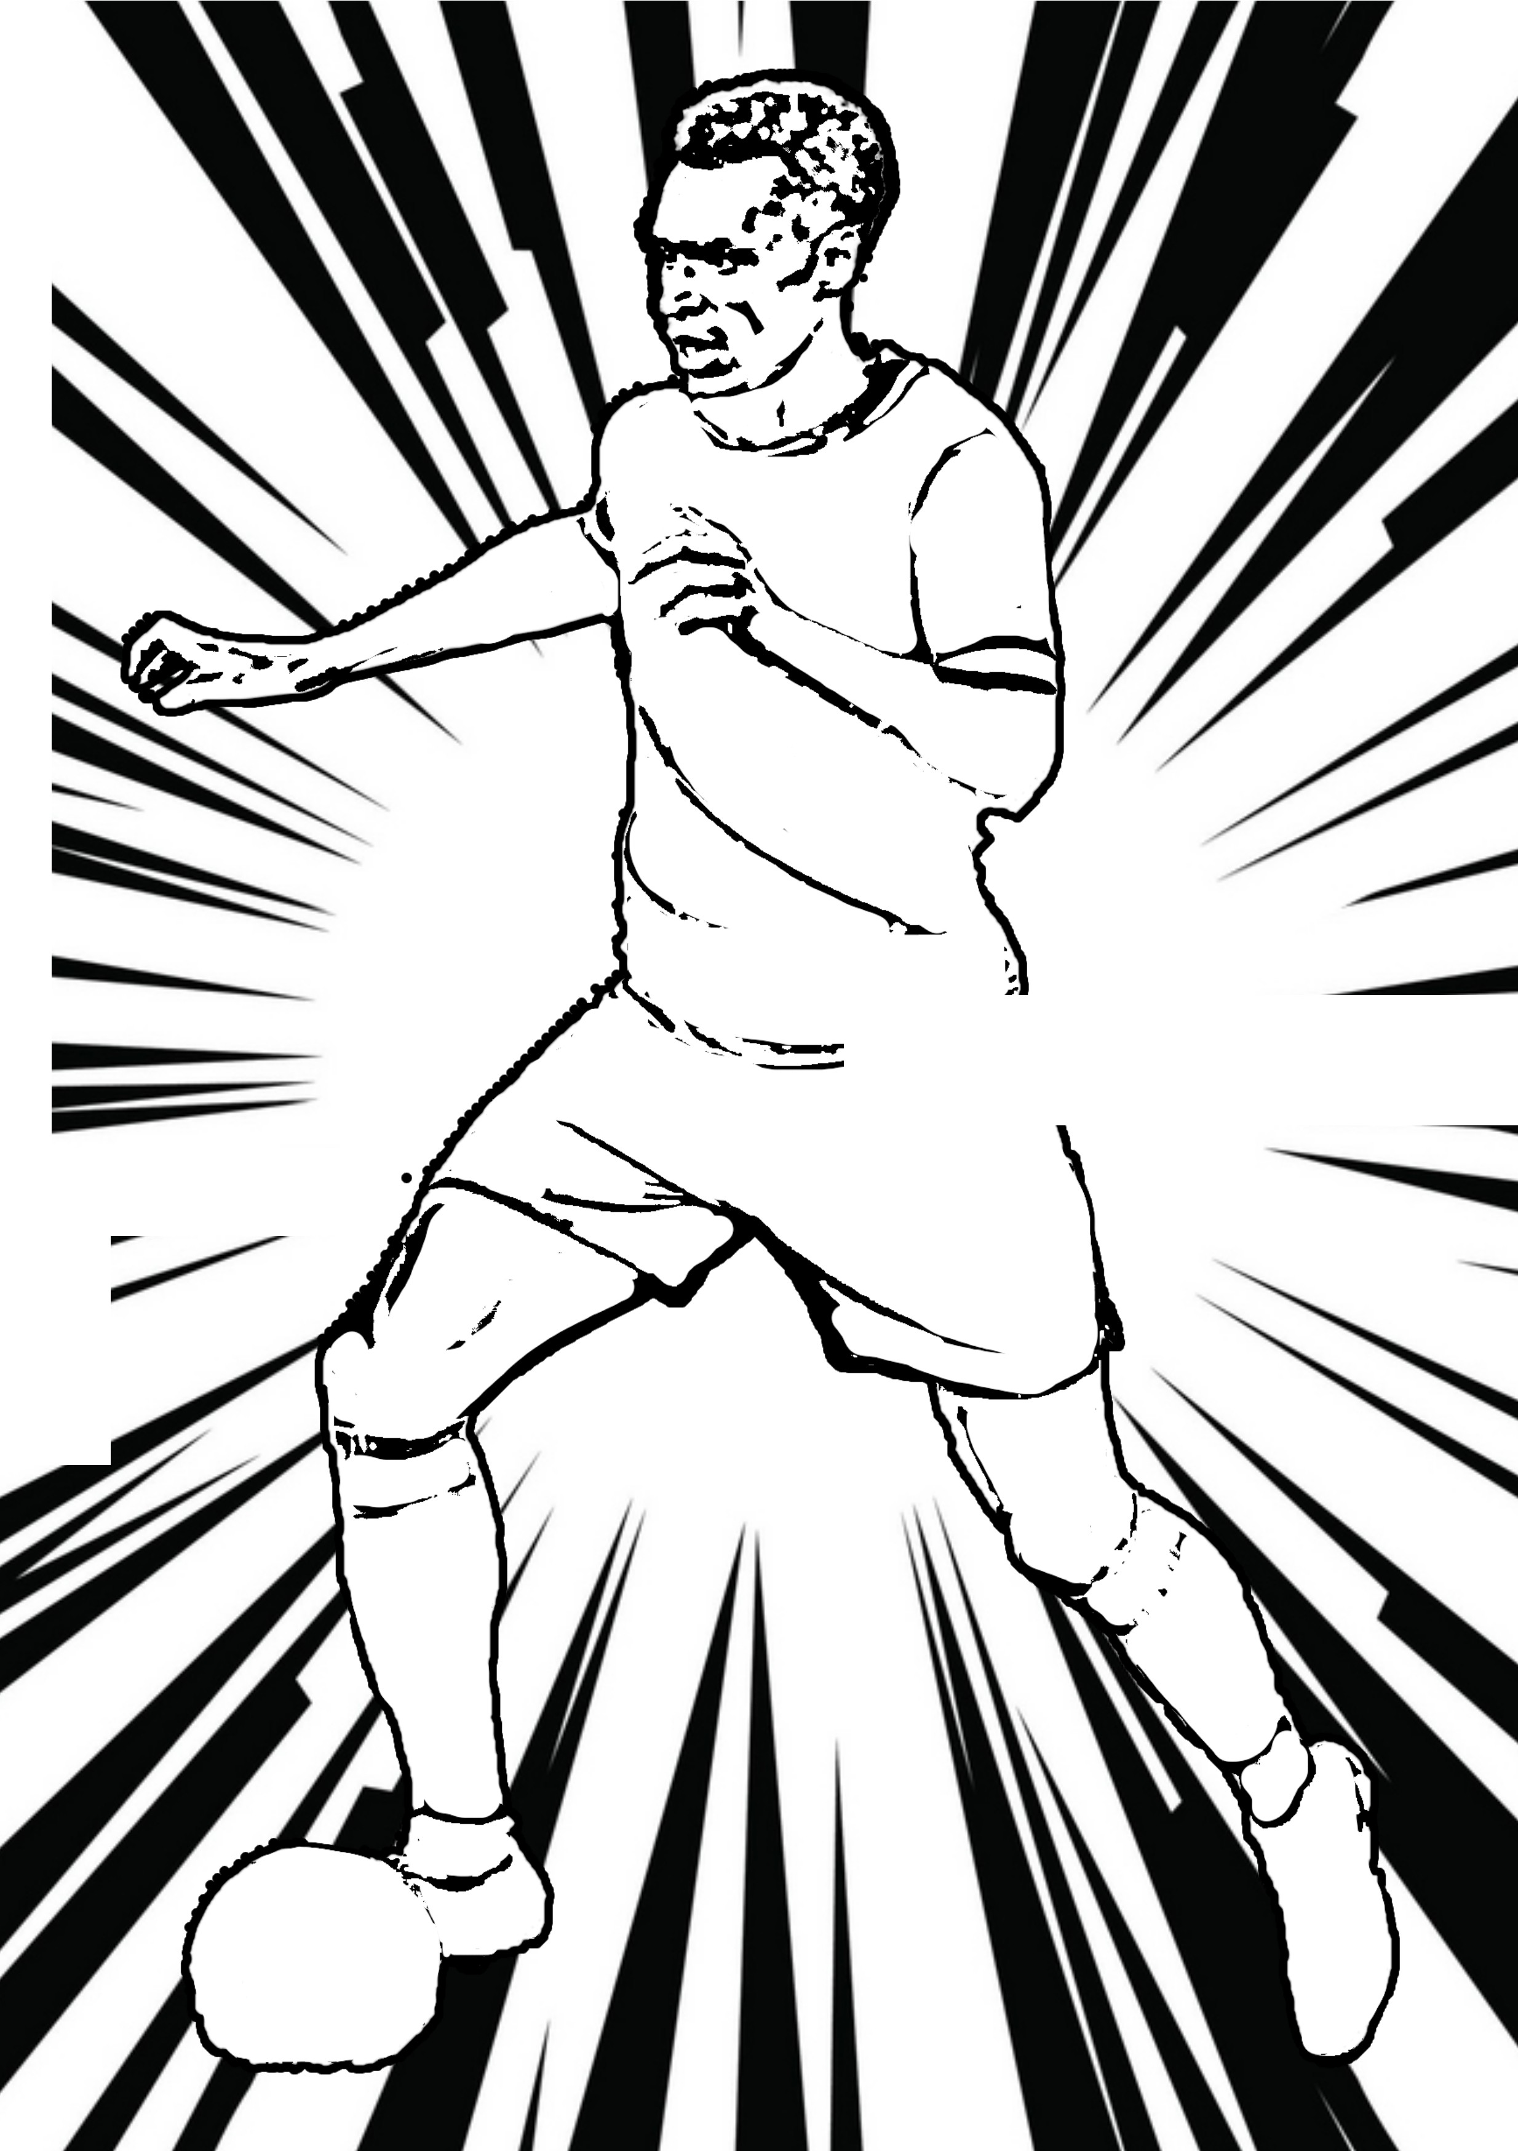

I

---;.,/
- -

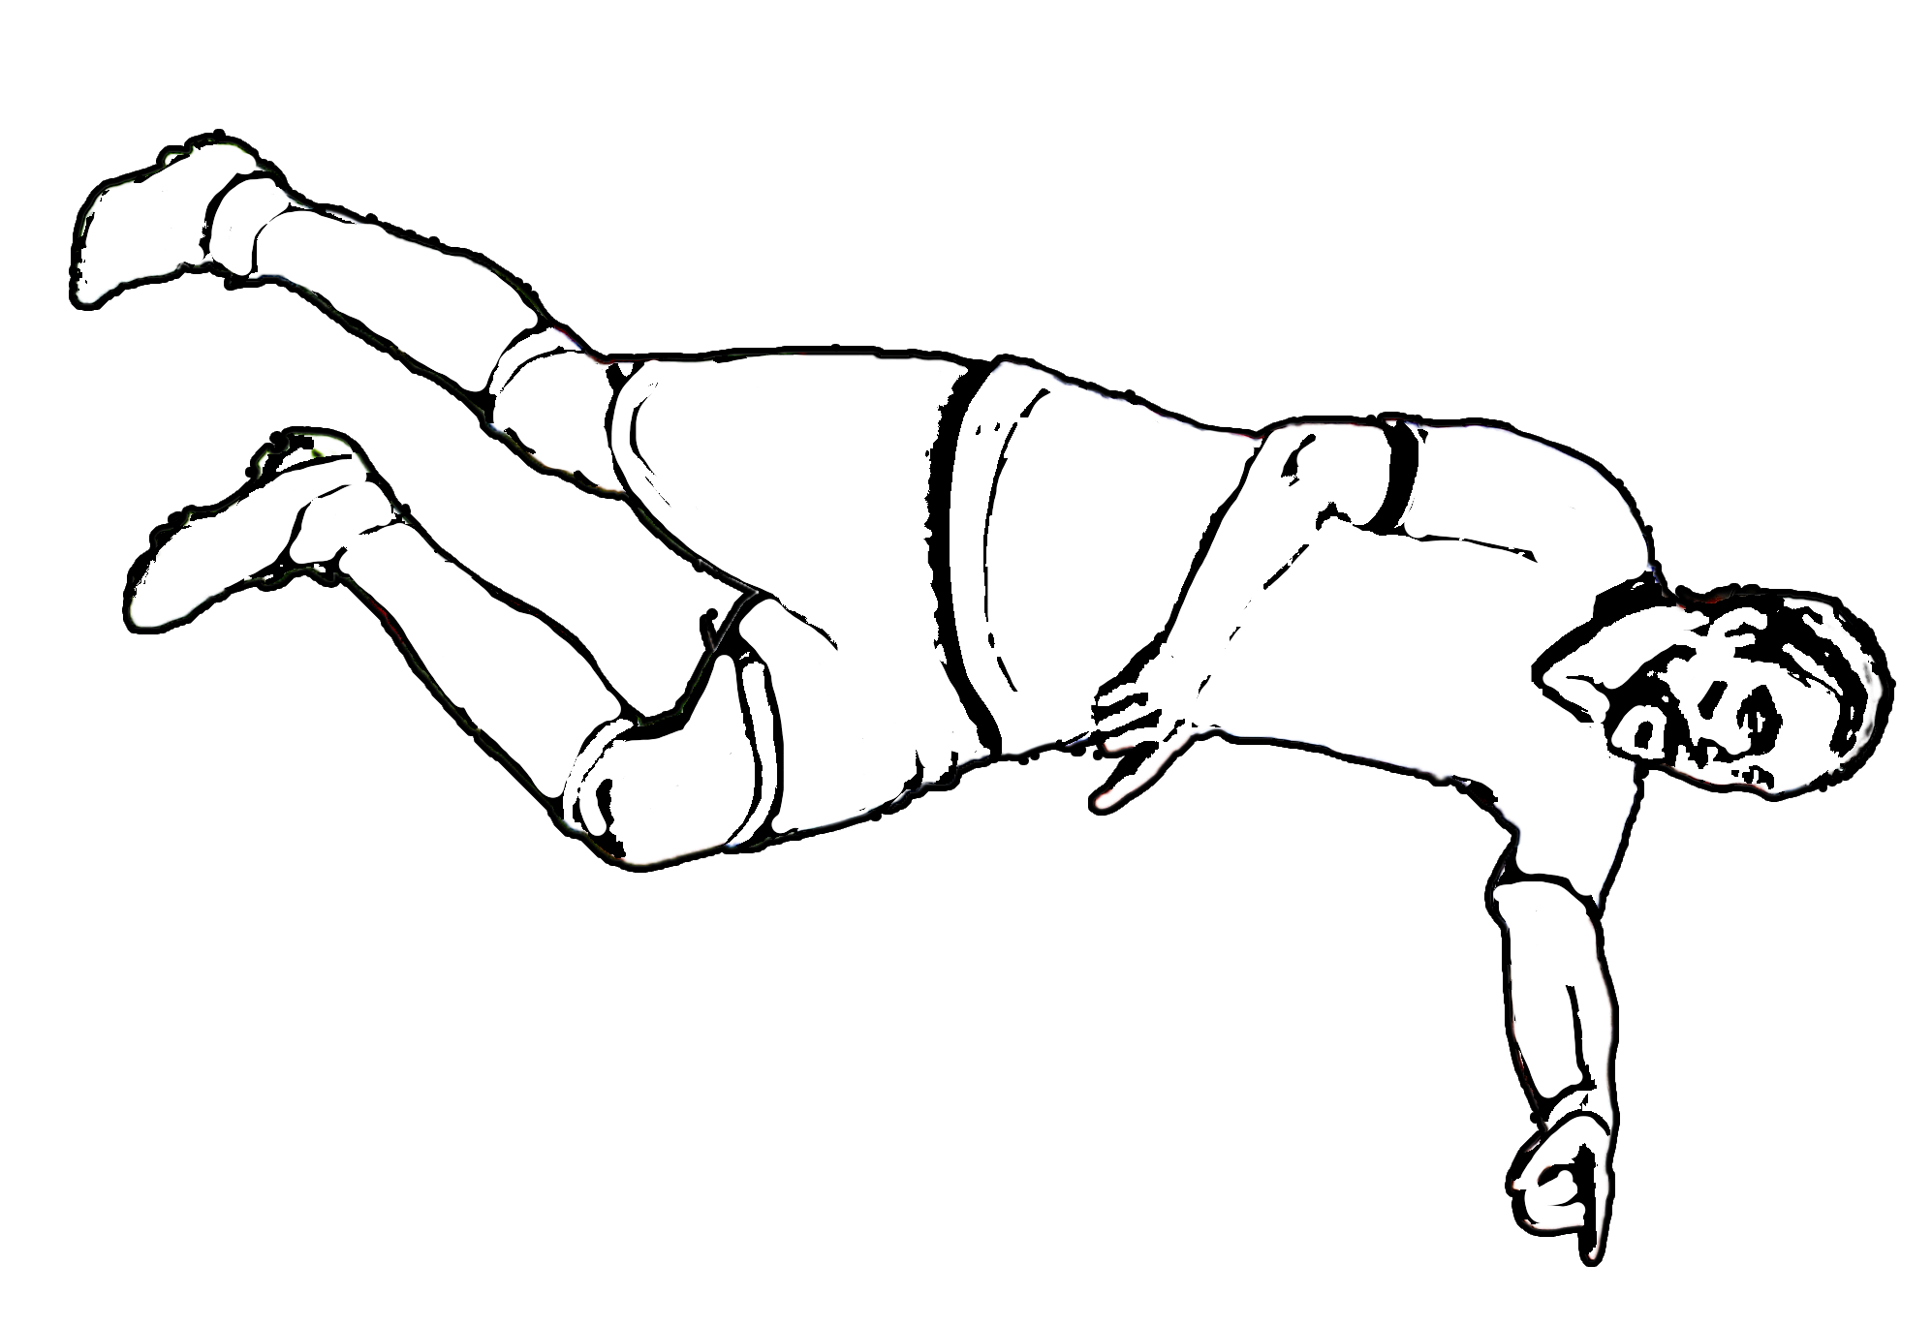
17

ATDHE
NUHIU

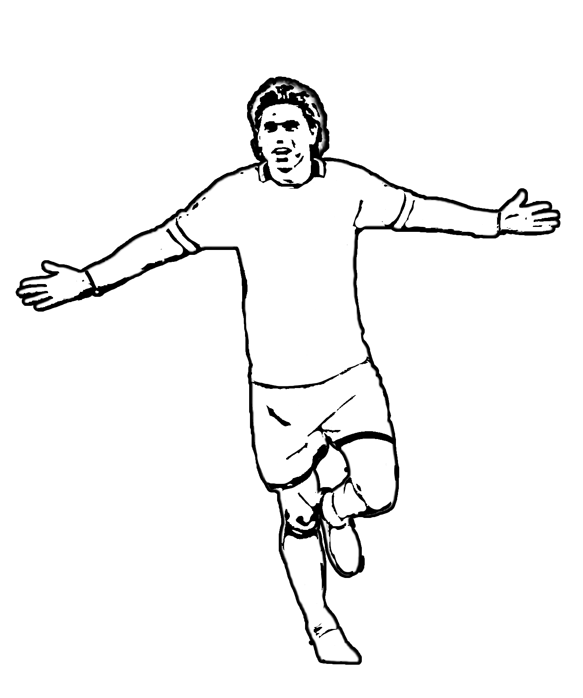

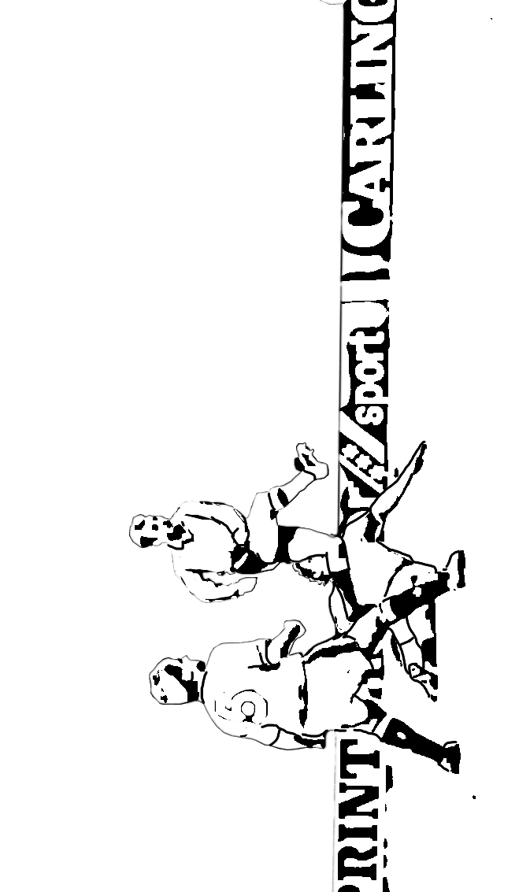

MY DREAM TEAM
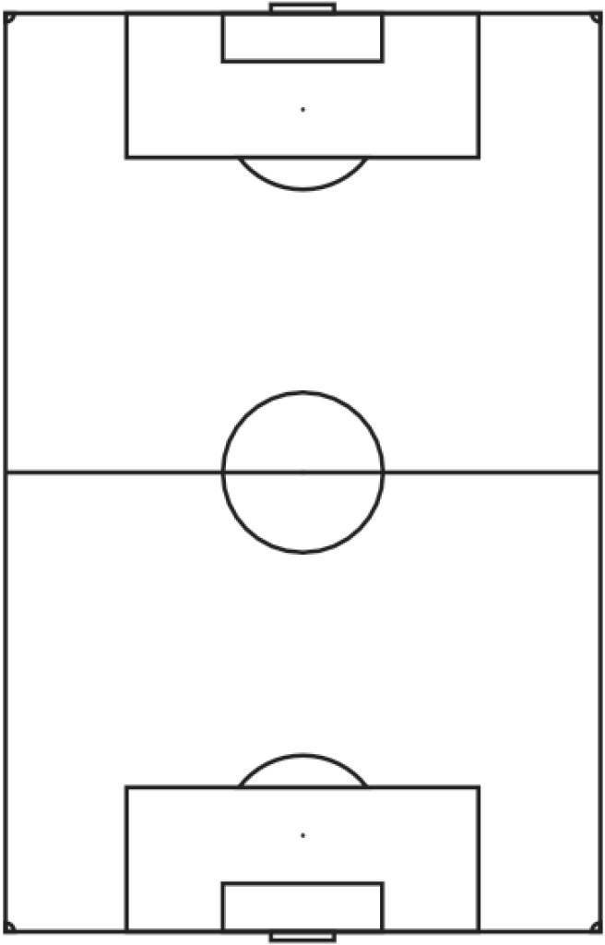

1
2

'I ..-
'

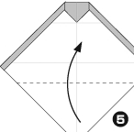
0 E)

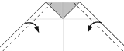
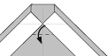

0
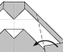
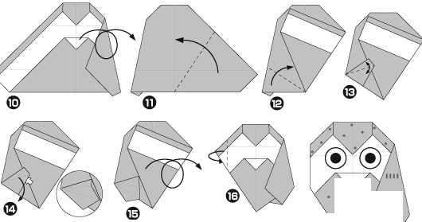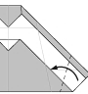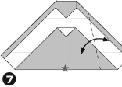 0
.
1111
•
.
(u
.
1111
.
•
1111

•

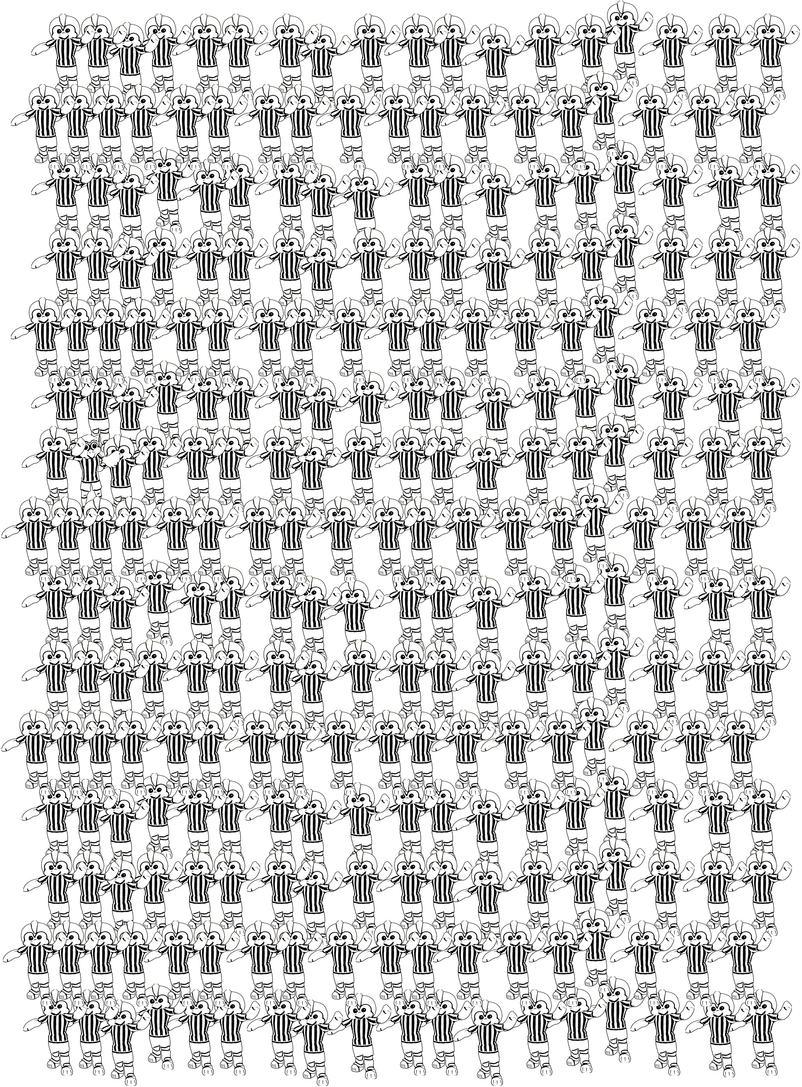
Where’s Barney?

Cool Tricks!
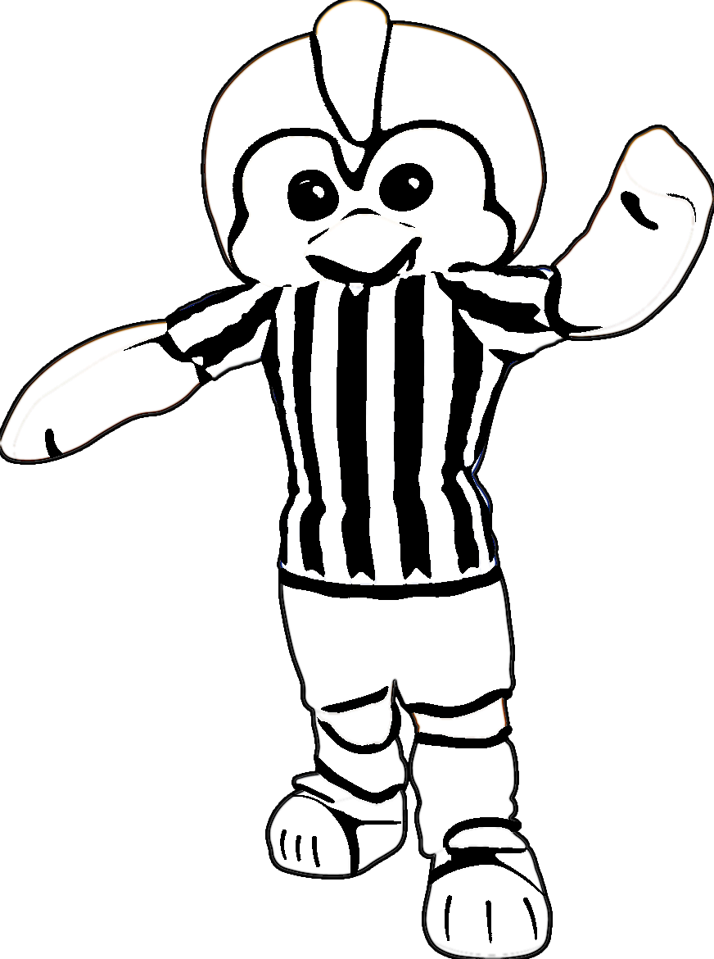
1. Think of a number
2. Multiply it by 3
3. Add 6
4. Divide by 3
5. Subtract the number chosen in step 1, from the answer in step 4

The answer is hidden in the ‘Where’s Barney’ page

I

:J@J
(e] -
3
8@@
@
-a
f\nO

is r,:;::::::::_=--- ---. -- D
Do
..;::;::::;::-..:;:::::::-..:::;:::;::-
§] ----....... - ¥"""'111,,,. , u-u
; z

NEW Impossible Maze
Can you escape in 60 seconds?

Start
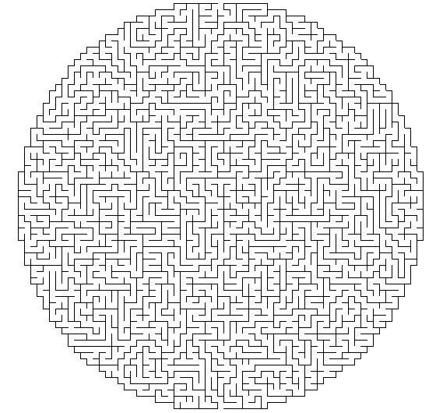
Finish

Sheffield Wednesday Crossword
10
- Sheffield Wednesday nickname (4) 6. What do the players kick
- Tries to stop other team from scoring 7. When you are a reserve on the bench
- The man wearing black, in charge 8. The last name of our Scottish Striker
- If the ball goes in the net, you ***** a goal 9. What you win if you win the final
- If you make a bad tackle 10. Wednesday stripes are white and ****
W

1 O

2
L
3

Goalkeeper Foul
7
S
Referee
Score Fletcher Blue Substitute Trophy Football
4
5

6

8

9

Colour in the Stadium

