Year 6, Summer 1
Project Work
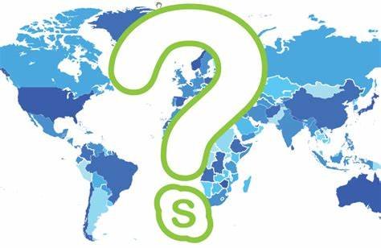

Design Your Own Country

You are a great explorer and have stumbled across an undiscovered country. You have decided to claim it as your own and set up a civilisation.

In order to create your own country, you will need to work through all the following tasks, gaining knowledge and having fun along the way!

How you complete each task is completely up to you and there is no specified amount of time you should spend on each one, however, the project should be completed by the 22nd May 2020 (that’s 6 weeks to complete 20 tasks….easy-peasy ). Be imaginative and enjoy working independently! (There are idea sheets for some of the trickier tasks)

Post pictures of your completed tasks on the Year 6 Twitter page, this will help you to share your ideas and celebrate your hard work.
Overarching Question –Which component of a civilisation makes it the most prosperous?

Contents Page
- Explorer Study – who can you be compared to?
- Location – weather, daylight hours, time zone, influences & alliances
- Topography- Rivers, mountains & forestry
- Population
- Animals
- National Flower
- Religion
- Flag
- Language
- National Anthem
- Currency
- Landmarks
- Leaders
- Food
- Clothing
- Sports
- Transport
- Trade
- Tourism
- Model
Task One – Explorer Study
Enquiry Question – What makes great explorers GREAT?
Research Use the following links to find out more:
https://www.dkfindout.com/uk/history/explorers/
https://www.bbc.co.uk/teach/class-clips-video/ks2-explorers/zjh8bdm
https://explorers.mrdonn.org/

Information
Throughout history people have always wondered what was beyond the next mountain, ocean, river, or even planet.
The age of exploration took place between the 15th and 17th centuries. During this time many countries in Europe sent out explorers to discover new lands, find trade routes, seek treasure and gain territory for their country. During this time much of the world was mapped and many world civilisations came into contact with each other. Sometimes it is called the Age of Discovery.
The reasons for exploration varied. Most explorers certainly liked the adventure of going to new places, meeting new people and cultures or taking on new challenges but there was often a more specific task, such as, increasing trading links (like Vasco da Gama and Christopher Columbus), plundering gold (The Conquistadors), understanding science (Charles Darwin) or relocating to new lands.
Some explorers however, simply wanted a challenge! They wanted to test their personal limits and be the first in the world to do something. These types of explorers included the men who raced to be the first to the North and South Poles, the top of Mount Everest and to the Moon!!!
Task
To have discovered a brand new country you yourself must be an excellent explorer and as you have already found out, all great explorers have a GREAT story to share. Your first task is to share the story of why and how you discovered your new country. Some ways you might complete this written task are as a biography, fact card, story, poem, newspaper article, diary entry, annotated map or Wikipedia page. Let your imagination go wild! Try to get your readers to truly believe that you are the great, adventurous explorer that you know inside you could be.

Task One Ideas – Explorer Study
Enquiry Question – What makes great explorers GREAT?
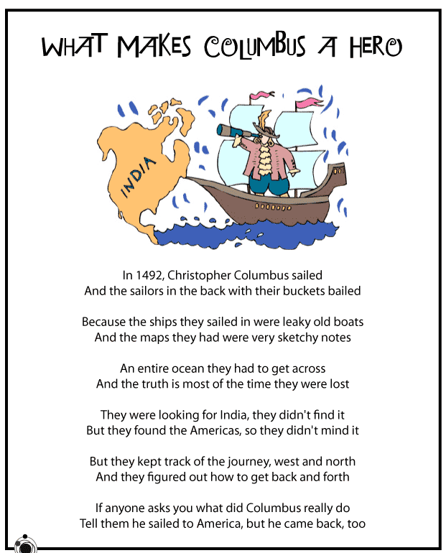
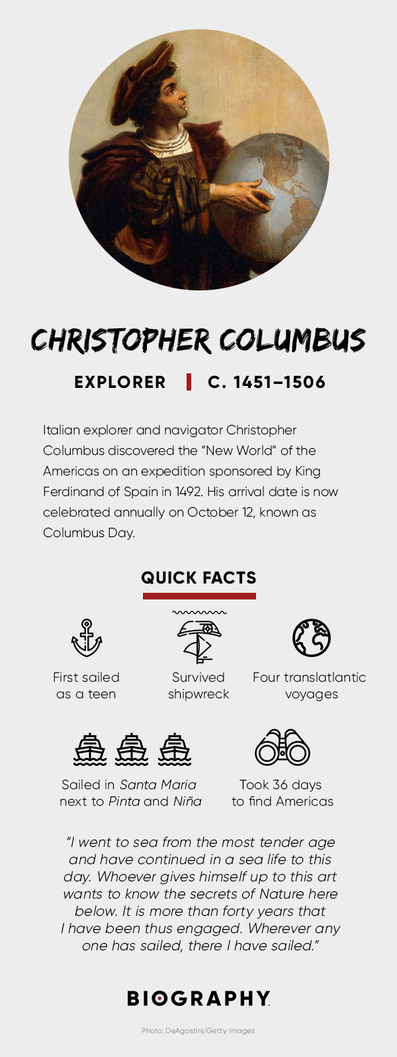

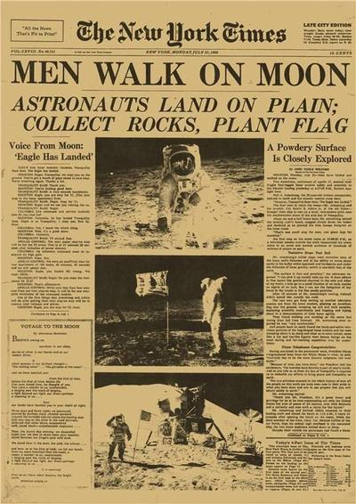

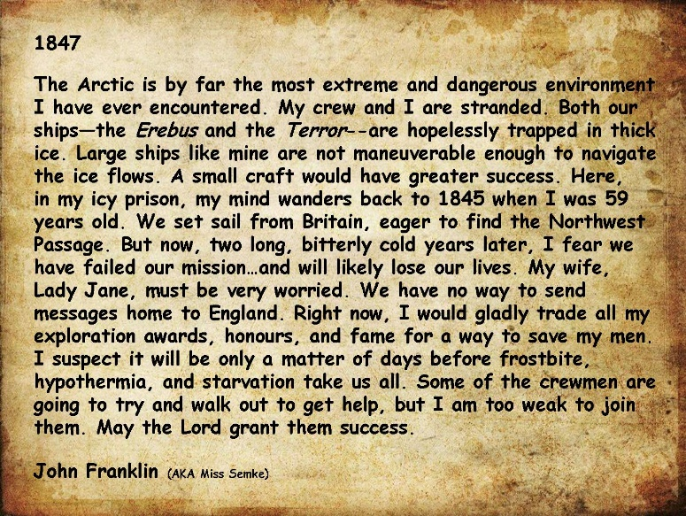

Task Two – Location
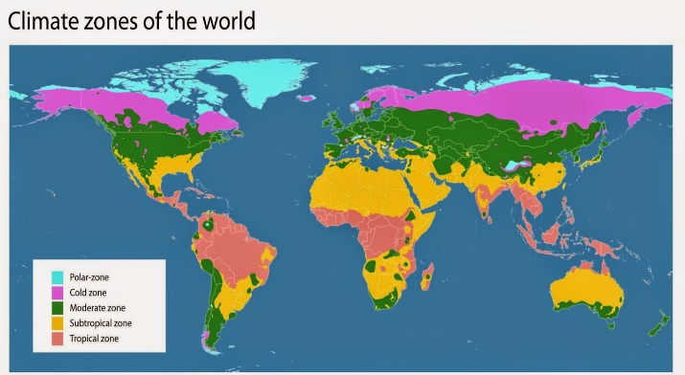
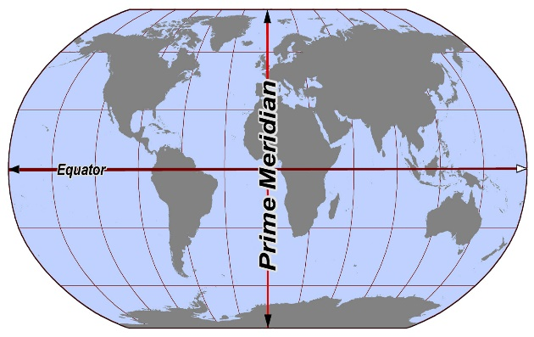
Enquiry Question – How does location effect a country’s: weather, daylight hours, influences & alliances.
Information
Weather and daylight (Latitude) – Countries that are closer to the equator are warmer than countries near the poles, they also have more hours of daylight.

Time Zones (Longitude) – Countries across the world are in different time zones depending on how close they are to the Prime Meridian.
If you study any country, there is often evidence of different influences from other countries amongst its civilisation. These influences can often come from the surrounding countries or people who have relocated to the country, and can impact things such as, food, religion, trade, language, architecture, names of cities, monarchy etc.
A country’s history and location can also affect their alliances. An alliance means an agreement/partnership between two or more countries. A country can have alliances in terms of military, unions, sport, trade etc.

Research Use the following links to find out more:
https://www.bbc.co.uk/bitesize/subjects/zbkw2hv
https://www.natgeokids.com/uk/

Task
If you did not already do so for Task 1, look at a world map and decide where your country is going to be located. Once you have done this, research the surrounding countries in order to help you create a fact sheet that tells the reader about your country’s: weather, daylight hours, time zone, influences & alliances (you can also add any other fun facts). This could be done as a map, in boxes, as a poster, a paragraph of writing, annotated drawings etc.

Task Three – Topography
Enquiry Question – How is the topography of your country
similar and different to the topography of England?
Research Use the following links to find out more:
https://www.bbc.co.uk/bitesize/topics/z3fycdm
https://www.bbc.co.uk/bitesize/topics/z849q6f/articles/z4g3qp3
https://www.bbc.co.uk/bitesize/topics/z849q6f/articles/z7w8pg8
Information
Topography describes the physical features of an area of land. These features typically include natural formations such as mountains, rivers, lakes, and valleys. Manmade features such as roads, dams, and cities may also be included. Topography often records the various elevations of an area using a topographical map.
Some Topographical Facts about England
England's topography is low in elevation but, except in the east, rarely flat. Much of it consists of rolling hillsides, with the highest elevations found in the north, northwest, and southwest.
England is an island; therefore, it has many beautiful coastlines.
England’s tallest mountain is Scafell Pike at an elevation of 978 metres (3,209 ft) above sea level. It is located in the Lake District National Park, in Cumbria, and is part of the Southern Fells.
England’s longest river is the River Thames with a distance of 215 miles (346km). While it is best known for flowing through London, the river Thames also flows alongside other towns and cities, including Oxford, Reading, Henley-on-Thames, and Windsor. It has 45 locks and is home to over 25 species of fish. The River Severn is the longest river in the United Kingdom, it runs through both Wales and England.

Task
Topography is most commonly shown on a topographic map. Your task is to create a topographic map for your country. This could be drawn and then coloured/painted in a style of your choice or it could be made with clay, play/salt dough or recycled materials. Whichever format you choose; ensure you have annotated/labelled the map with its key features.
Top Tip: Refer back to Task 2 and use the location of your country and its surrounding countries to help you.
Task Three Ideas – Topography
Enquiry Question – How is the topography of your country
similar and different to the topography of England?
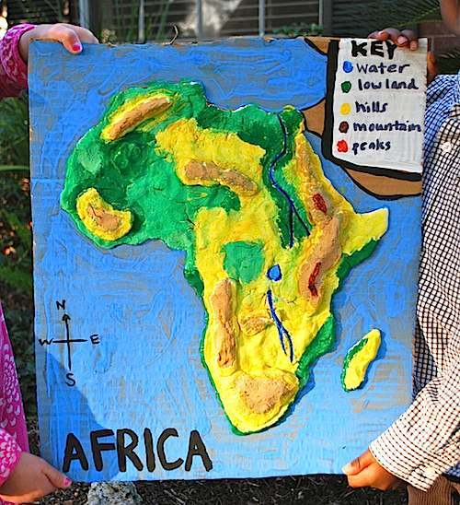
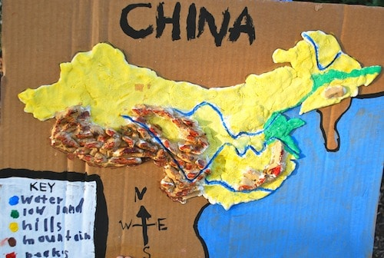

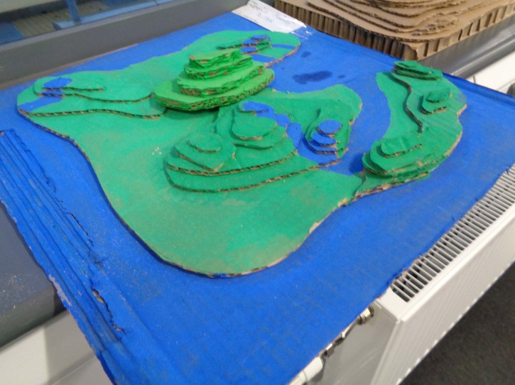

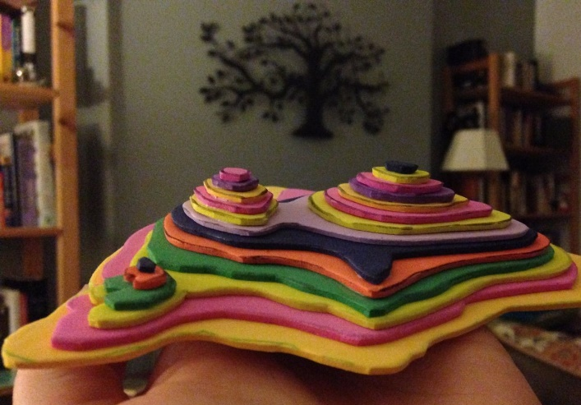

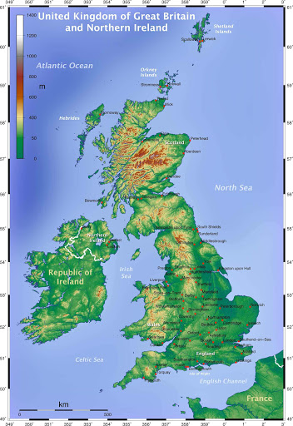
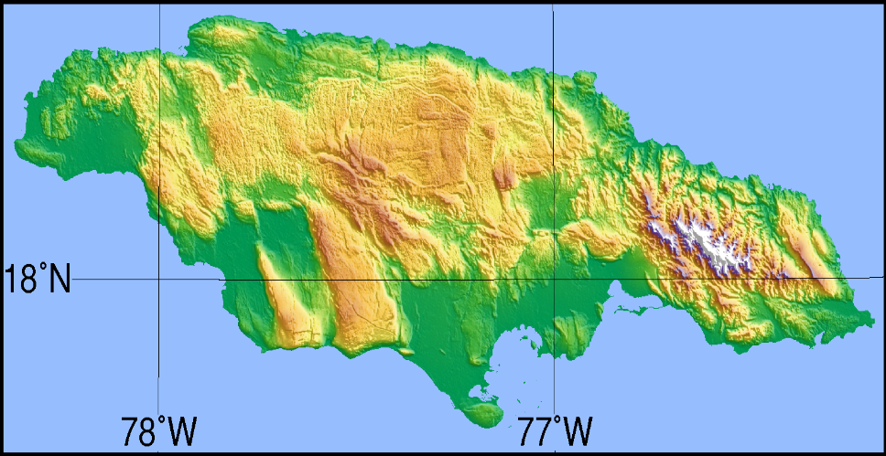

Task Four- Population
Enquiry Question – Why did China implement the one child policy in 1980?
Task
After researching populations of countries similar to your country and population trends, create a fact sheet or population density map for your country.
Research Use the following links to find out more:
https://www.3dgeography.co.uk/population
https://easyscienceforkids.com/all-about-population-growth/
https://www.kids-world-travel-guide.com/
Information
A population is the number of living things that live together in the same place. A city's population is the number of people living in that city. These people are called inhabitants or residents. The population includes all individuals who live in that certain area.
Population density is the average number of people in a place. Urban areas such as big cities have a high population density. People there live close to each other. In areas with a low population density, people usually live far away from each other, such as in rural areas out in the countryside. There are also counties (islands) which have large areas of inhabited land around its coastline but sparsely populated land in the middle.
The maximum population that can be supported in an area is called the carrying capacity.
Population growth is the rate at which a population grows or expands. For example, if a population increased from 100 to 110 in a year, then it would have had a population growth of 10% per year.

Task Four Ideas- Population
Enquiry Question – Why did China implement the one child policy in 1980?
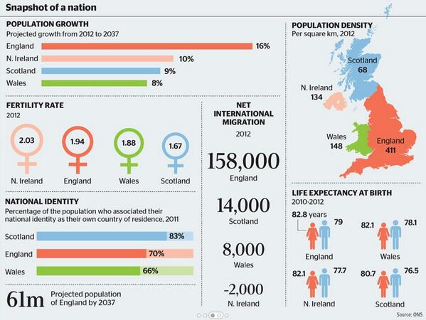

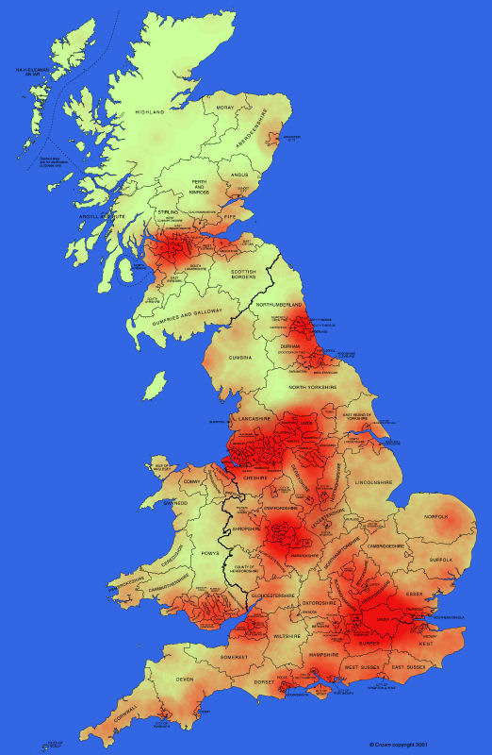
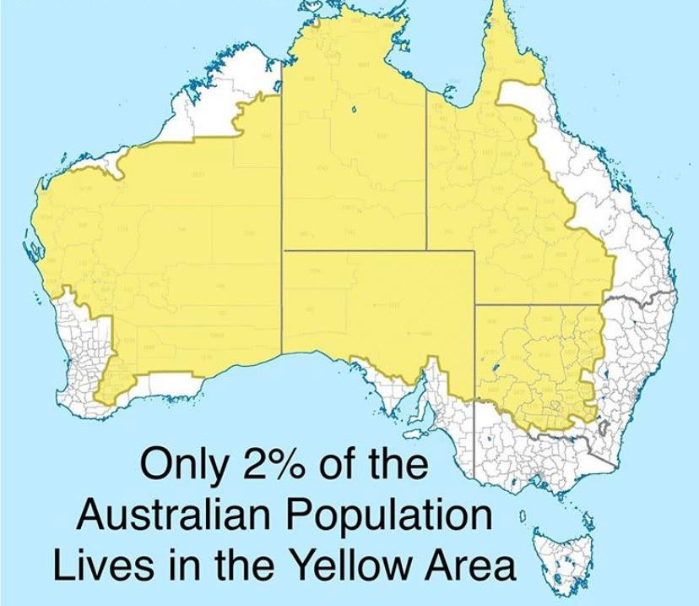

Task Five – Animals
Enquiry Question – Why are some animals indigenous to specific countries?
Task
Consider the climate, topography and population density of your country (previous tasks) and create 3 fact files on 3 different native animals to your country. These can be animals that already live in other places in the world or they can be newly discovered animals which are native to your country only (you can use your imagination to create a new animal).
Research Use the following links to find out more:
https://animalfactguide.com/animal-facts/
https://www.chesterzoo.org/schools/resources/
https://www.treehugger.com/animals/21-animals-only-found-one-place-world.html

Information
Native animals are sometimes referred to as indigenous animals. Native animals are described as the type of creatures that have existed in a particular place over a given period. Native animals of Britain are defined as those animals that either colonised the British Isles during the Ice Age or those species that were found in Britain when the English Channel was being created. A few examples of native UK animals are: the red squirrel, the little owl, the Scottish wildcat and the grey seal.
Animals thrive in countries that provide the right habitat, climate and food sources for them. Animal existence in a certain place is also dependent on the predators that are also there.
For example, 150,000 years ago, brown bears living in the Arctic gradually evolved into polar bears. Their fur became thicker and blubber (fat) became deposited under the skin to keep them warm and enable them to stay without food for a long time. There was no rich vegetation in the Arctic, so they had to survive on seals. That is where the polar bears remained, because they did not feel the need to travel elsewhere. Thus, still to this day, these animals are only present in the Arctic countries such as Russia, Norway, Canada, Greenland and the USA (Alaska).

Task Five Ideas - Animals
Enquiry Question – Why are some animals indigenous to specific countries?
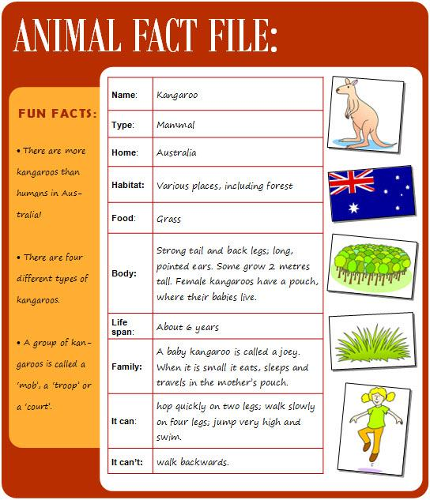

Enquiry Question –
Task –

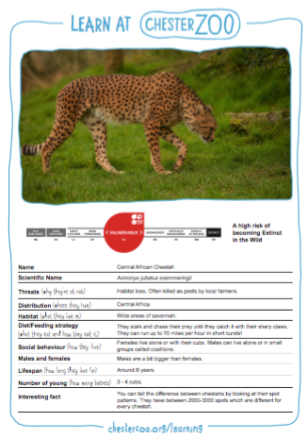

Task Six- National Flower
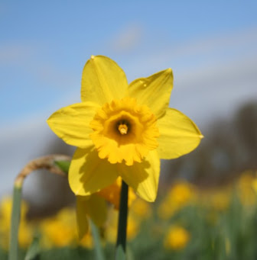
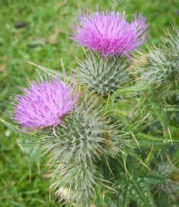
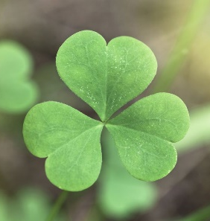
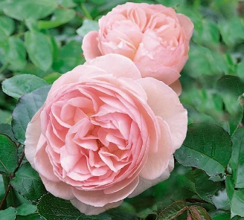
Enquiry Question – Why does the UK have more than one national flower?
Task
Draw a detailed sketch of your country’s national flower and name it.
Research Use the following links to find out more:
https://www.flowerglossary.com/national-flowers-by-country/
https://www.interflora.com.au/blog/post/national-flower-by-country
https://gardenerdy.com/complete-list-of-national-flowers-by-country

Information
National flowers are symbols representing a country. Some national flowers have cultural or religious roots that go back hundreds or even thousands of years and may or may not have been officially adopted.
For example, the United Kingdom is comprised of four countries, each of these countries has its own national flower. The Tudor rose (also known as an English rose) is the traditional emblem of England and takes its name and origins from the Tudor dynasty. The shamrock, a three-leafed old white clover, is an unofficial symbol of Northern Ireland. Shamrocks are said to bring good luck and also used as a badge for sports teams, state organisations, and troops abroad from Ireland. On the other hand, the thistle - a prickly-leaved purple flower - is the national flower of Scotland, and is featured in many Scottish symbols and logos. The thistle was first used in the fifteenth century as a symbol of defence. The daffodil is the national flower of Wales, where it is traditional to wear a daffodil on Saint David's Day.
Task Seven – Religion
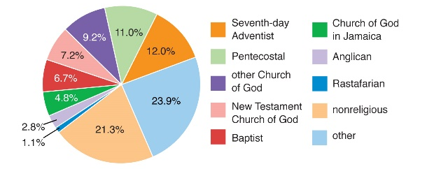
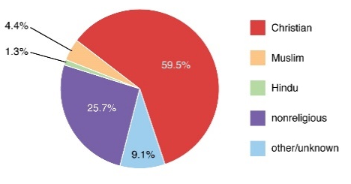
Enquiry Question – How is a Humanist similar, and different, to a religious person?
Task
Create a graph that shows the religions practised in your country (a pie chart or a bar chart are the simplest ones to try), you could draw it or do it on a computer.
For example, UK (2011) Jamaica (2011)
Research Use the following links to find out more:
https://www.bbc.co.uk/bitesize/subjects/z7hs34j
https://www.bbc.co.uk/teach/ks2-religious-studies/z6pbqp3
Information
A religion is a set of beliefs that is held by a group of people. There are many different religions, each with a different set of beliefs. The beliefs are about the world and the people in it, about how they came into being, and what their purpose is. These beliefs are often linked to supernatural beings such as God, a number of gods or spirits. They may also be linked to an idea such as a path that the spirit of each person should take towards goodness, truth and duty. This is called spirituality. Each religion has different ideas about these things. Each religion also has a "moral code" which is a set of beliefs about how humans should act. Each religion usually has their own type of "devotions" - when people worship or pray. They often have rituals (special things that are always done in the same way) for certain times of the year or certain times of a person's life. The largest religions are Christianity, Islam, Hinduism, Buddhism, Taoism, Sikhism and Judaism. There are many other religions.
Non-religious Beliefs
Humanists do not believe in a god. They believe it is possible to live a good and fulfilling life without following a traditional religion. They do not follow a holy book either. Instead, Humanists value traits like reason and rely on science to explain the way things are. Humanists believe that people have one life to live - there is no afterlife. As a result, they focus on being happy and making the most of their life. They also believe they have a duty to support others.
Task Eight – Flag
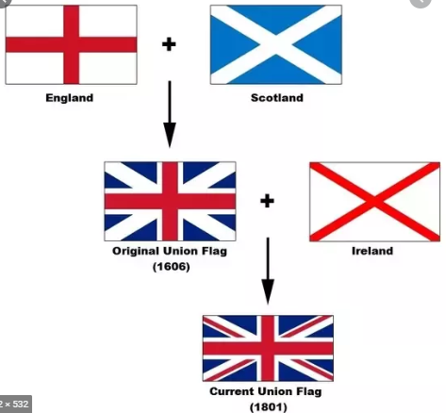
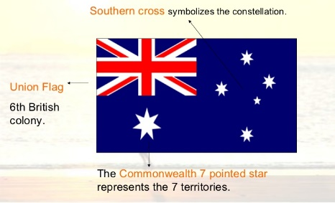
Enquiry Question – Why did Neil Armstrong put an American flag on the Moon?
Information
Flags show that we belong to a community, organisation or nation and that we share beliefs, goals, rules and regulations.
Flags are national symbols. Every country has got a specific flag as their national symbol. The first flags were flown in the 18th century to tell others that a piece of land was owned ('proclaim a possession') and the people and land were ruled over ('proclaim sovereignty').
World Flags show different sets of colours and symbols, like the sun or the moon and some cultural symbols, like their national bird or flower.
Most flags contain primary colours (red, blue or yellow) and/or secondary colours, especially green. Gold is also used in many flags as the colour is associated with the sun and is often considered as the colour of kings. Colours can have different meanings in different cultures. A flag can also contain other flags within its design, showing an allegiance with the country.

e.g The Australian Flag The Union Jack Flag

Research Use the following links to find out more:
https://www.bbc.co.uk/newsround/26530974
https://allthatsinteresting.com/world-flags-infographhic
Task
Draw your country’s flag and add colour (in any way you wish). Think carefully about the previous tasks you have completed when adding significant colours, shapes and symbols to your design. Annotate your flag once you have completed it.

Task Nine – Language
Enquiry Question – Why don’t we all speak the same language?
Task
Create a page of useful language translations for anyone who may wish to visit your country (This can be a language that already exists elsewhere in the world or a new language you have discovered). If your country is an English speaking country, create a translation page for your slang words.
Research Use the following links to find out more:
https://www.youtube.com/watch?v=mzBtusg05i4

Information
Did you know there are about 7000 languages in the world today? That’s a lot! Scientists who study languages are called linguists. They don’t know exactly when people began inventing words instead of just using a few sounds or body movements, like many animals do. But they know that human migration, moving from one place to another, played a big role in making so many languages.
Over thousands of years, humans split off into groups that migrated in different directions. As that happened, one language could turn into many. People had to learn to live in very different places: hot deserts, freezing mountains, steamy rainforests. Each place had different kinds of weather, plants, and animals. Having new words to talk about these new things helped people adapt (change) to their new home and survive (live). After a while, new words and ways of living helped lead to totally new languages.
Once a group of people settled in a place, they were often isolated (apart) from other groups. When people didn’t mix much, their words didn’t either. On the other hand, people did sometimes learn and borrow some words from other groups. For example, people speaking different languages might meet to trade, or were forced to leave home and move closer to another group because of war. Over long periods of time, then, both things—isolation and a little mixing—helped create so many languages.

Task Nine – Language
Enquiry Question – Why don’t we all speak the same language?
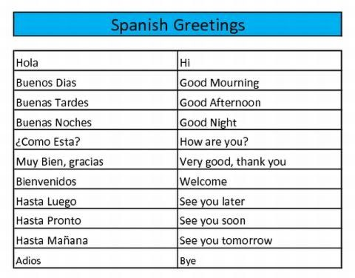
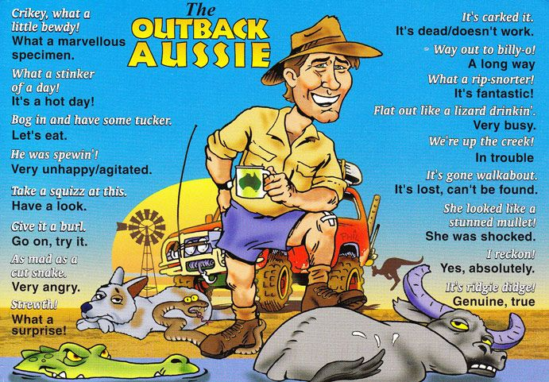

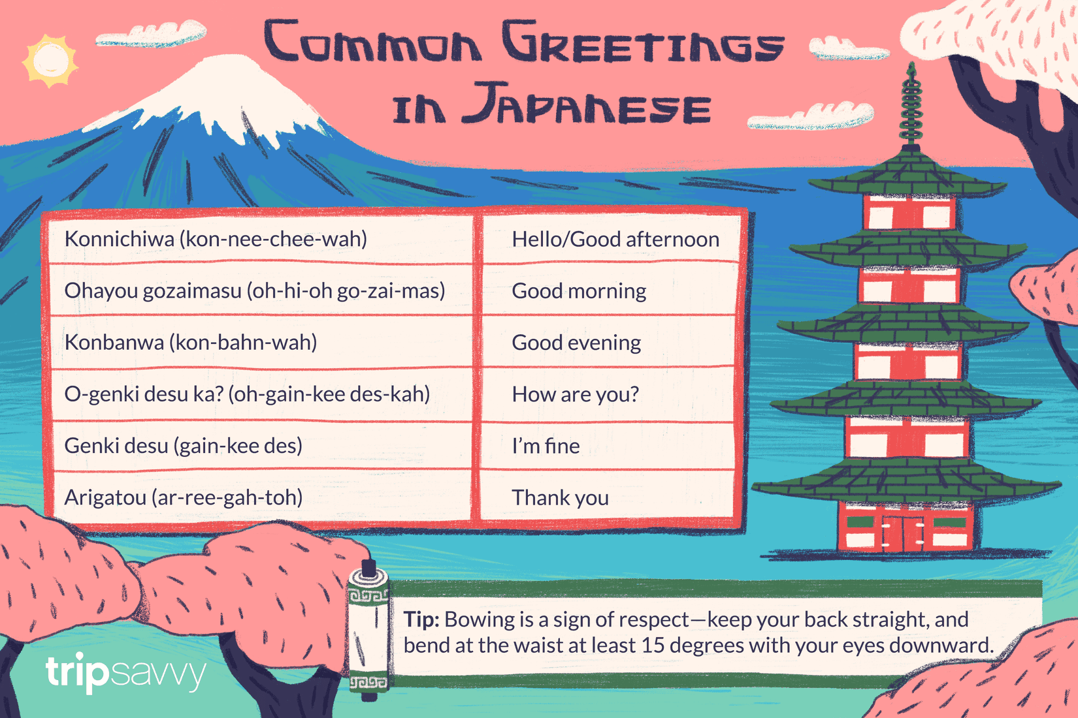
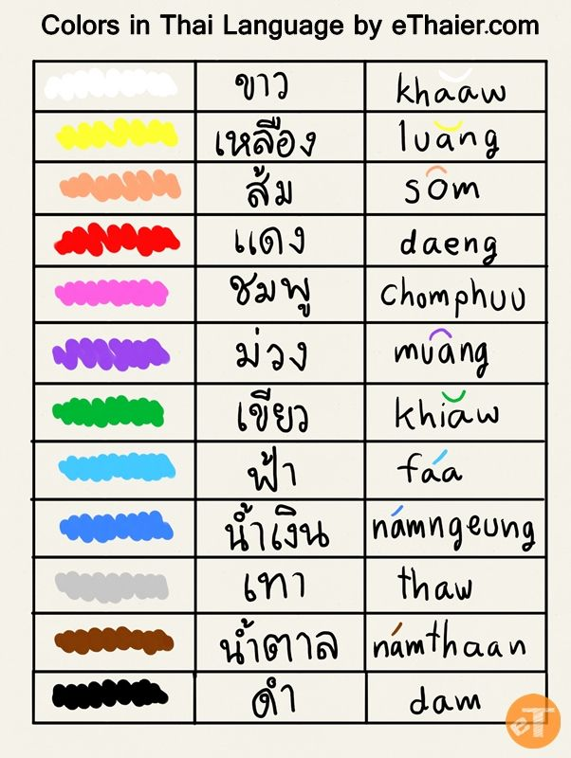

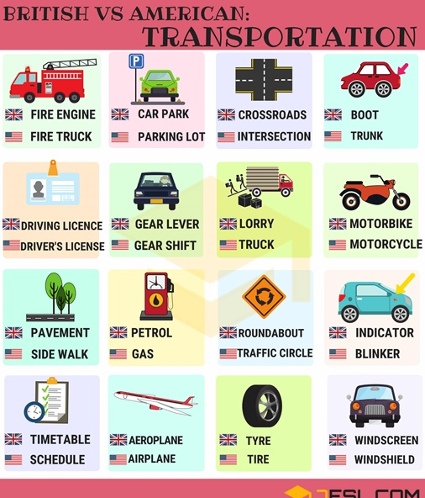
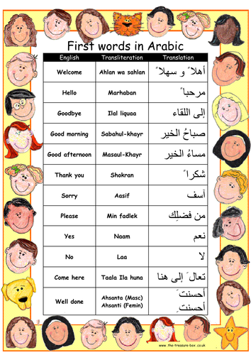

Task Ten – National Anthem
Enquiry Question – Why do people often get emotional when they sing/hear their national anthem?
Task
After listening to a range of national anthems, try to create a national anthem for your country.
This could be written down, recorded as an audio clip (of it being sung) or you could even try and be really brave, and record a video. If you are struggling, try to use the tune of an existing national anthem and adapt it to fit your country.
Research Use the following links to find out more:
http://kinooze.com/all-about-national-anthems/
https://kids.britannica.com/kids/article/national-anthem/353518
Information
Do you know what a national anthem is? A national anthem is a patriotic musical composition that praises the people and traditions of a country. In most countries, the national anthem is played on national holidays and festivals. It is also sometimes played at the beginning or the end of the sporting event. During the Olympic Games, the national anthem of the country winning the gold medal is played while the winner is on the podium. The playing of a national anthem in another country is a mark of international recognition and respect towards that country. In some countries, the national anthem is played to students each day at the start of school.
Particular etiquettes are often involved in the playing of a country’s anthem. These usually involve standing up, standing straight and removing headwear.
Many countries, where people may follow different cultures and languages, have national anthems in mixed languages. New Zealand’s national anthem is a mix of Maori and English. In South Africa, where there are 11 national languages, the national anthem is musical mix of five different languages.
National anthems often mention the history and struggle of the nation. The oldest national anthem is the Wilhelmus, the Dutch anthem, written in the late 15th century during the Dutch Revolt.

Task Eleven – Currency
Enquiry Question – If I exchange 5 pounds for 5 euros, will this be a fair exchange?
Information
All around the world different countries use different types of money. Many countries have their own money. This money is backed by the government and is usually called "legal tender." Legal tender is money that must be accepted as a form of payment in that country.
Major World Currencies
Although there are many different types of money throughout the world, there are some major world currencies that are accepted or used in several different regions and countries. Some of these are described below:
British Pound Sterling- The British pound is the official currency of the United Kingdom. It is currently the fourth most traded currency in the world. Prior to 1944, it was considered the world reference for currency.
U.S. Dollar - The U.S. dollar is the official currency of the United States. It is the most used currency in international transactions.
European Euro - The Euro is the official currency of the European Union. Many of the countries in the European Union use the Euro as their official currency.
Japanese Yen - The Japanese Yen is the official currency of Japan. It is the third most traded currency in the world.
Exchange Rates
When you go to another country, you will usually want to get some cash. You can do this by exchanging your money for some of that country's money. This is done by using exchange rates. For example, if you went to Europe and wanted to trade U.S. dollars for 100 Euros and the exchange rate was 1 Euro equals 1.3 U.S. dollars, then you would have to give them 130 U.S. dollars to get 100 Euros.

You can look on the internet to see the latest exchange rates between different world currencies. However, exchange rates will vary slightly depending on where you go. Different banks or institutions may have different fees and rates for making the exchange.
Task
Design one note of your country’s currency and workout the exchange rates for the 3 major world currencies listed in red above. You can base this on the £ exchange rate to make it easier, you will need to use the internet to find the current rate. For example, today, the exchange rate for a note worth £5 = 5.71 Euros. You could simply then just replace the pounds with the name of your currency.

Research Use the following links to find out more:
https://www.bbc.co.uk/bitesize/topics/z8yv4wx/articles/z8nn8mn
https://kids.kiddle.co/Currency
https://www.mathsisfun.com/money/currency.html
Task Twelve – Landmarks
Enquiry Question – What is the difference between a human-made and a natural landmark?
Task
Think about the landscape of your country and decide if it is going to have a human-made or natural landmark. Once you have decided, sketch out what you think it will look like. You will then be ready to draw or create a model of your landmark. Once you have completed it, make sure you have named it and recorded some information about its size, location and significance etc.
Research Use the following links to find out more:
https://www.kids-world-travel-guide.com/top-10-famous-landmarks.html
https://study.com/academy/lesson/lesson-for-kids-what-is-a-landmark-definition-facts.html#lesson
https://kids.britannica.com/kids/article/landmarks-at-a-glance/608620
Information
Landmarks are features of the land or structures that are notable or unique.
Human-made landmarks are impressive structures that were built by humans. These can include recent achievements in engineering as well as the remains of ancient cities and architecture.
Natural landmarks include rivers, lakes, mountains, and deserts. Some natural landmarks are so impressive that in order to ensure that they are preserved for generations to come, they are protected in national parks.
The top 5 landmarks in the world are:
1. Eiffel Tower
2. Great Wall of China
3. Kremlin
4. Leaning Tower of Pisa
5. Pyramid of Giza

Task Thirteen – Leaders
Enquiry Question – Why is Nelson Mandela known as a great world leader?
Research Use the following links to find out more:
https://www.ducksters.com/biography/world_leaders/
https://kids.britannica.com/kids/article/world-leaders-at-a-glance/608622
Task
Create a biography for the world leader of your country (you could base this on a real person or someone you have made up).
Use this checklist to help you write the biography.
★ An introduction to say why the person is a good world leader.
★ Write in chronological (time) order.
★ Use dates and ages for key points in their life.
★ Include quotations.
★ Use the third person – he/she
★ A conclusion evaluating the person’s life and their impact on the world.
Information
Throughout history, world leaders can be identified from as far back as the early pharaohs and kings up to modern day prime ministers/presidents and dictators.
Great world leaders are leaders who have been the most powerful and influential leaders of a country.
For example, the current world leaders of the United Kingdom are Queen Elizabeth II and Boris Johnson.
Her Majesty Queen Elizabeth II is the Head of State; she ascended the throne in 1952 on the death of her father, George VI. She is the longest serving head of state, reigning over 16 independent countries including Canada and Australia.

Boris Johnson (in full Alexander Boris de Pfeffel Johnson) was born on June 19, 1964 in New York City. He became Prime Minister of the United Kingdom in July 2019 after serving as the Mayor of London (2008–16) and as Secretary of State for Foreign Affairs (2016–18) under Prime Minister Theresa May.

Task Fourteen – Food
Enquiry Question – Why are the national dishes of England and Japan not the same?
Task
Create a recipe for your country’s national dish, you could write it down or film yourself making it, like a cooking tutorial (you can pretend to be making it). It may be your favourite dish that already exists or a brand new recipe, just make sure that the main ingredients of your recipe are available in your country (Task 2) and it is appropriate for any religious beliefs which people in your country may have (Task 7).
Research Use the following links to find out more:
https://www.easy-kids-recipes.com/international-recipes.html
https://www.kids-world-travel-guide.com/food-facts-for-kids.html
https://www.nationalgeographic.com/travel/top-10/national-food-dishes/

Information
Food is different around the world because latitude differs from place to place. As we know from Task 2, latitude effects a country’s climate and daylight hours, this then effects what foods will grow there. In the present day food can be quite easily imported (shipped or flown in from other countries), making food that isn’t produced or grown in the country you live in available to buy in the shops, however, this was not always the case.
Most countries have a favourite or national dish which is popular with residents and often forms part of that country’s identity. These dishes have normally been part of the country’s history for a long time, and therefore use ingredients that are produced or grown within the country.
Not only do people around the world eat different types of food, they also differ in the way they eat it (In parts of India people only eat with their hands, in Japan chop-sticks are used and here in the UK, we use a knife and folk). Some countries also have their meals at certain times whereas in other countries people eat at any time.

Task Fourteen Ideas – Food
Enquiry Question – Why are the national dishes of England and Japan not the same?
Ye Ole English Fish and Chips
2 pounds cod fillets (thawed if frozen)
1 cup all-purpose flour
1/2 teaspoon sea salt
1 1/2 tablespoons baking powder
1 cup water
vegetable oil
2 medium potatoes, washed and peeled

In a large bowl combine flour, salt, baking powder and water and mix until smooth. Make your batter the night before and refrigerate overnight.
Cut potatoes into thin circles like cottage fries and place in a pot of boiling hot water and cook for only a few minutes (they must still be firm).
Drain and let potatoes cool.
Dust fish fillets in flour and shake off excess. Dip each fillet one at a time in your batter, letting excess batter drip off.
Deep fry fillets a few at a time. Drain fish on paper towels.
Once all the fish is cooked, add potatoes to the pan and fry. The potatoes will "soak" up the fish flavour and make it extra delicious. Serve fish and chips while hot.
Mexican Creamy Chicken Enchiladas
2 cans cream of chicken soup
1 package of sour cream mix
3 chicken breasts, cubed or 1 can of cooked chicken
1 small can of green chilies or 4 fresh green chilies
8 corn tortillas
1 cup of cheddar cheese

Mix all the ingredients together in a medium saucepan and cook over medium heat for about 15 minutes, stirring constantly.
Next pour the mixture into each tortilla and roll the tortillas. Then place them in a row of a 9 X 13inch casserole dish. Pour the remaining mixture over the tortillas. Shred the cheese and sprinkle on top.
Bake in a 350F degree (175C degree) oven until cheese on top is melted.
Serve with a green salad or with guacamole.
Serves 2.

Vietnamese Coconut Rice Dessert
1 cup white rice
3 cups coconut milk
2 teaspoons salt
1/4 cup brown sugar
1/2 cup water

Rinse and drain rice then place in a saucepan. Add salt and coconut milk. Bring to a boil, then turn heat down, place lid over rice and cook for about five minutes. Let cool.
Spoon rice onto greased baking pan and place in the refrigerator overnight. Cut into slices.
Make a syrup by heating brown sugar over low heat in a small saucepan. Add water as needed and stir until a syrup forms. Next drizzle syrup over rice squares and serve.

Task Fifteen – Clothing
Enquiry Question – What can national clothing tell you about a country?
Research Use the following links to find out more:
https://www.roughguides.com/gallery/traditional-dress/
https://study.com/academy/lesson/traditional-clothing-around-the-world.html#lesson
Information
From the Indian sari to the Vietnamese conical hat, the world is full of different varieties of traditional dress. Some colourful, some immersed in history and specific to the country’s culture and others due to circumstance or status – they are almost always eye-catching. Learning about them gains you an insight into the country they’re part of!
Examples
Beads are used in African culture to represent a person's wealth. The colours and sizes of the beads symbolise a person's social status. Bigger, brighter beads are a sign of wealth and every colour represents something different.
The people who reside in the Arctic (Inuit people) simply had to dress for the elements. Traditionally, their jackets, hats, and boots were all made of animal skins and down feathers to keep the wind and snow out and the warmth in.
The modern day Scottish kilt barely resembles the original. They began as battle attire and have evolved into more formal clothing. They had the sole purpose of keeping a soldier warm in the cold climate of Scotland.
Clogs, which originated in the Netherlands, served two very different purposes - protection for miners and dance shoes for the everyday civilian. These wooden shoes were adorned with images representing stories, a style common in many cultures.
The traditional clothing of Mexico is made with extremely vibrant colours. The fabric available to each region was used for making the dress. The intricate designs used in every article of clothing represented some sort of story or icon of Mexican history.
Task
Design your country’s national clothing and write a short description (like the ones above), stating why it is significant.

Task Sixteen – Sport
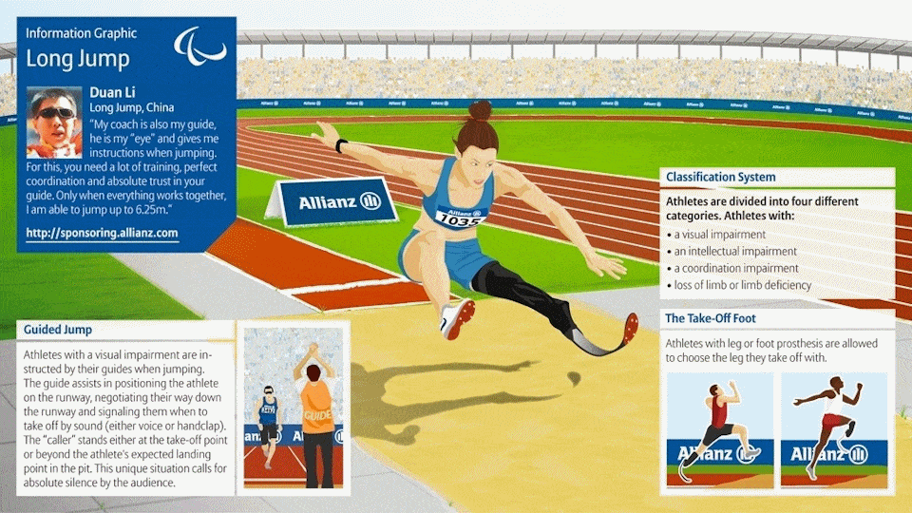
Enquiry Question – Why is England’s national sport cricket and not football?
Task
Decide what your county’s national sport is and write an explanation of the sport - adding a picture often makes writing the explanation much easier and shorter.
Examples:
Research Use the following links to find out more:
https://sportycious.com/list-national-sports-all-countries-91082
Information
Not only are different nations identified by their flag, their national anthem, their national flower and animal, their national dress, their national food, their national language, but also … their national sport.

A national sport is a sport or game that is considered to be an essential part of the culture of a nation. Some sports are national sports as established by the law of the country, while others are just popularly accepted as national sports.
The national sport is not necessarily (and not usually) the most popular sport in that country, but they are sports or pastimes that are important historically or culturally significant to the country.
The national sport of a country not only defines the culture and traditional ideas and beliefs of that nation but it also represents its people in a major way. Over thousands of years of human culture and civilisation, numerous sports have evolved in different parts of the world.
Task Seventeen – Transport
Enquiry Question – Why were India’s original rickshaws pulled by man power?
Information
When people travel to a new destination, for either work or pleasure, they are often interested in the local transport. Unique modes of transport found around the world can be a really exciting way to travel around and see the sights. For example, you may get to use the double-decker trolley in Dubai, tuk-tuks in Thailand, reindeer sleds in Finland, the high-speed Bullet Train in Japan or a dog sled in Alaska.
Transport in each country has to be suitable for the climate and topography. A country’s unique form of transport may resemble everyday transport such as, buses, taxis and trains, but sometimes the form they take isn’t so familiar!

Research Use the following links to find out more:
https://kids.britannica.com/kids/article/transportation/399628
https://livinglocal.triip.me/30-unique-types-of-transport-around-the-world/

Task
Create a new, unique form of transport that is only found in your country. As mentioned above, this could resemble a current form of transport but be adapted. Try to make the adaptions fit in with your country’s climate and topography. You could draw it, adapt an existing transport drawing, make it or simply draw a transport map.
Examples
India’s Rickshaw Thailand’s Tuk-tuk Model Japan’s Bullet Train Map
Drawing

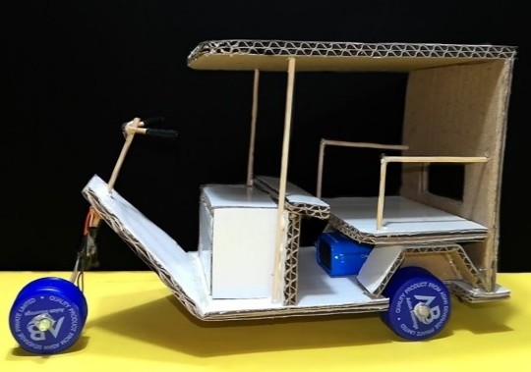
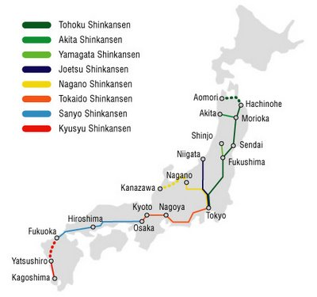
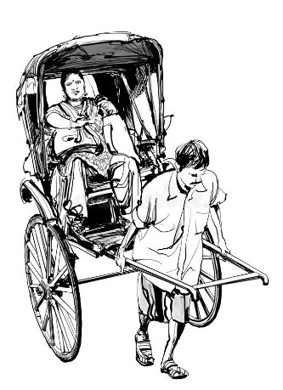

Task Eighteen – Trade
Enquiry Question – Why is trade significant?
Task
Think about all the tasks that you have completed so far and consider which products your country is already producing themselves (therefore which they are able to export) and which products they do not have (therefore need to import). Once you have jotted down your ideas, create a simple table that puts all the products you can think of into two columns - Import and Export. If you are unsure, research existing countries that have a similar location, population and topography to yours and investigate what products they import and export. Give your table a title and if you are drawing it, don’t forget to use a ruler!
Research Use the following links to find out more:
https://www.bbc.co.uk/bitesize/topics/zx72pv4/articles/zk4rmfr
https://kids.britannica.com/kids/article/trade/353871
https://schools.fairtrade.org.uk/resource/adventure/
Information
Buying and selling things is called trade. Trade is an important way for countries to make money and has been happening across the world for thousands of years. Today, goods are carried around the world in container ships from port to port and by aeroplane.
Export and import
People sell the things that they make or grow to people in other countries. This might be because those countries can’t make or grow the things themselves or because they are cheaper or better quality. Sending goods like this to other countries is called export.
Import is when goods are brought into a country, for example, bananas and oranges - which are hard to grow in the UK - are transported from abroad to be sold in supermarkets.
The UK
Sometimes countries need experts from abroad such as engineers, scientists or teachers. These experts can sell their services to people around the world and this is called a service industry. The service industry is the UK's main industry today and we import more goods than we export.
Task Eighteen Ideas – Trade
Enquiry Question – Why is trade significant?

If you are struggling to imagine what the table will look like, you can use the template below.

Trade in __________________________
Export  (goods or services your country sends to another country for sale) | Import  (goods or services your country brings in from abroad for sale)

Task Nineteen – Tourism
Enquiry Question – How have modern communication systems, such as the internet, impacted on tourism?
Research Use the following links to find out more:
https://kids.britannica.com/kids/article/tourism/476327
https://www.kids-world-travel-guide.com/
https://www.lonelyplanet.com/places

Information
People travel for many different reasons, such as business, visiting family or friends and for pleasure. When people travel for pleasure they are called tourists. Tourism is the business of encouraging and supporting tourists. Many people go on holiday because they want a break from their everyday lives, or to experience a warmer climate. Others enjoy learning about different cultures, tasting new food, and observing different lifestyles.
Since the late 1900s tourism has grown and become an important part of economies all over the world. This growth has happened because in More Economically Developed Countries (MEDCs) people’s lifestyles have changed. They have more money and there are many more opportunities to travel than there were in the past. The cost of travel has also become cheaper with the rise of low-cost airlines.

Task
For this task you could create a one-page travel guide, or a front cover for your country’s travel guide (make sure you refer back to the previous tasks), or alternatively you could create a mind map of the positive and negative impacts of tourism on your country.

Task Nineteen Ideas – Tourism
Enquiry Question – How have modern communication systems, such as the internet, impacted on tourism?
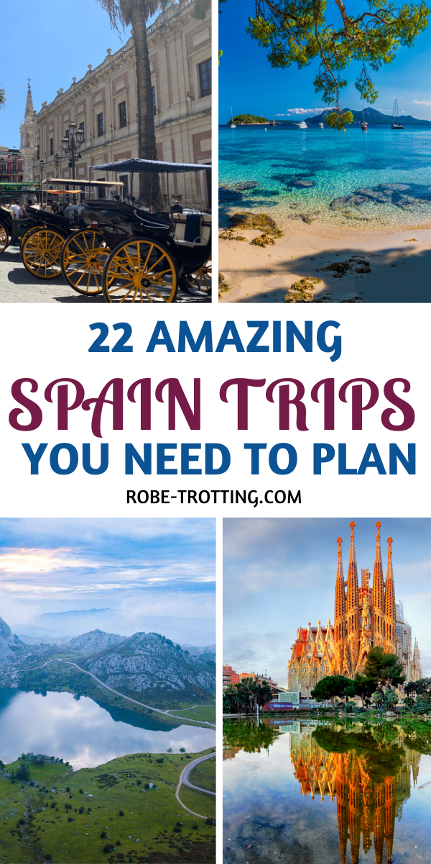
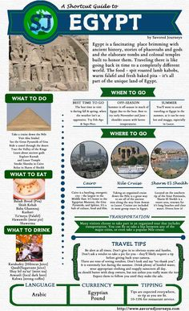

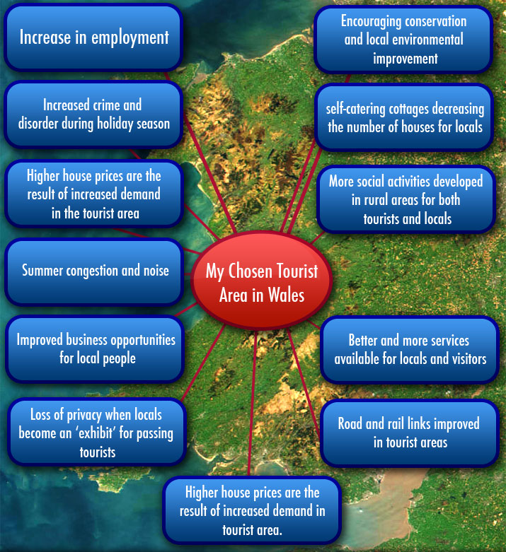

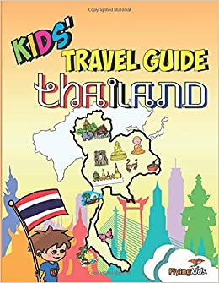

Task Twenty – Model
Task
Your final task is to create a detailed model of a city or town in your country. It could be a built-up city or a rural/coastal town…the choice is yours. You could make the model using paper mache, recycled materials, or building kits and props you may already own (such as building blocks, a train track or toy cars). You may even decide to use a mixture of all of them.

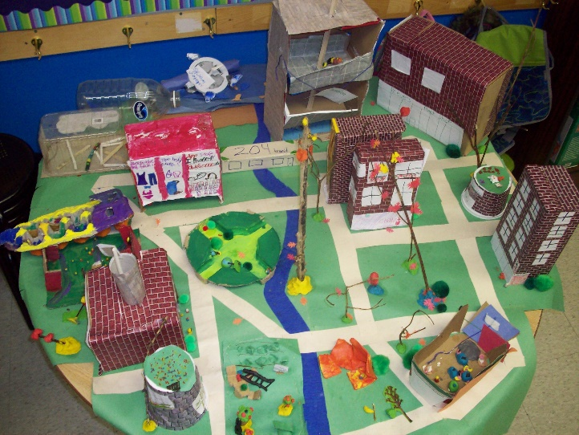
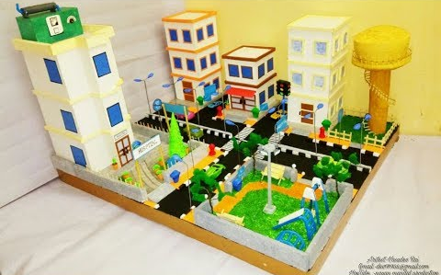
Ideas
