Y6 Work
Summer 1 Week 4
04.05.20 – 08.05.20
Includes:
Reading
Writing
SPaG

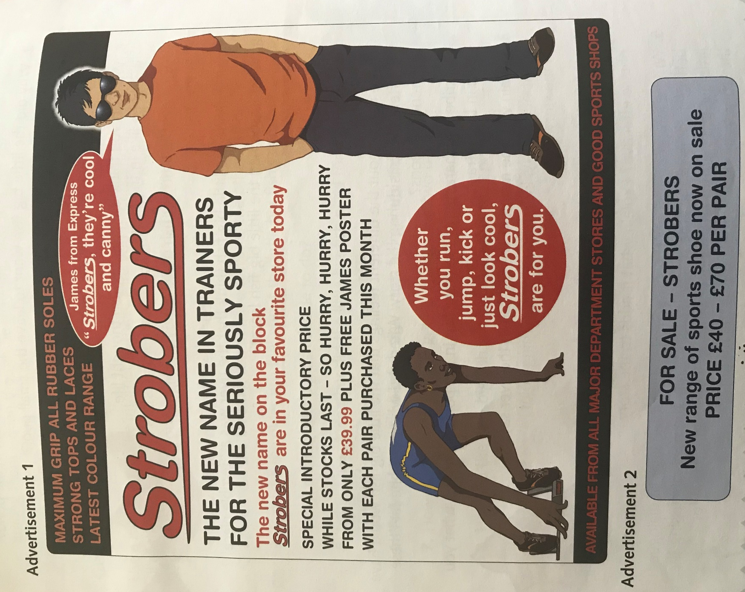
Reading Text for the Week:

Reading: Monday 4th May 2020
Get started
Use a dictionary or the internet to make sure you understand and can explain all of the words in the advert. Make a list of all the words.
Then write sentences to answer each question. Refer to the advertisements in your answer, and use quotes when you can.
- What kind of product are both of these adverts promoting?
- What is the brand name of the product?
- Where can you buy the product?
- What features does the product have?
Reading: Tuesday 5th May 2020
Get started
Use a dictionary or the internet to make sure you understand and can explain all of the words in the play script. Then write sentences to answer each question. Refer to the text in your answer, and use quotes when you can.
- What does James from Express say?
- According to the adverts, who might want to buy Strobers?
- How much do they cost?
- What colours are used on each of the adverts?
Reading: Wednesday 6th May 2020
Try these
Write sentences to answer each question in your own words. Explain your answer as fully as you can.
- James from Express is a pop star. Why has a celebrity been used in advert 1?
- Why might fans of James want to buy Strobers? Give two reasons.
- Why do you think Advert 1 tells the reader to ‘HURRY HURRY HURRY’?
- What makes the word ‘Strobers’ more memorable on Advert 1 than on Advert 2?

Try these
Write sentences to answer each question in your own words. Explain your answer as fully as you can.
- Why does Advert 1 use different fonts and different colours?
- Which advert’s pricing is more likely to attract customers?
- Why might the image of an athlete have been used on Advert 1?
- Which advert do you think is more effective?
Reading: Thursday 7th May 2020
Now try these
Imagine you are a child who has seen Advert 1 and wants to persuade their parents to buy them some Strobers trainers. Write a short letter as this child, giving all the details about the trainers you think will be most effective. How much opinion and persuasive language will you need to use?
Imagine you have been asked to improve Advert 2. Write about what parts of the advert are effective and what parts could be made better or re draw the advert with your improvements.

Draw a chart, like the one shown below, with two columns: ‘Facts’ and ‘Opinions’. Write at least three things found on Advert 1 into each column of your table.
Explain why the opinions in your chart have been included on Advert 1.

- In your own words, explain the difference between a fact and an opinion.
- Draw a chart, like the one shown below, with two columns: ‘Facts’ and ‘Opinions’. Write at least three things found on Advert 1 into each column of your table.

Week 4 Writing Task – Friday 8th May 2020 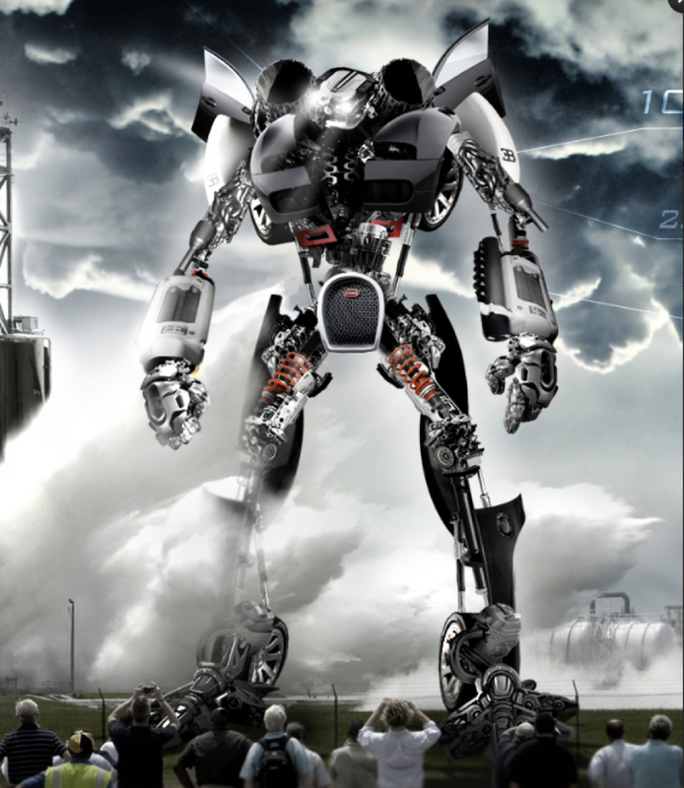
Question time!
Who do you think is controlling the robot?
Does it have a mind of its own?
Where has the robot come from?
Are the people in danger?
Can you think of a good name for the robot?
Is there a chance that robots will become part of our society in the future?

Perfect Picture!
Imagine your job is to design a robot. Draw or describe what your robot would look like, and what it could do.

Sentence Challenge!

A preposition is a word that shows the relationship between one thing and another. It may tell you where a thing is in relation to something else. E.g. The silver, shining giant stood on the car. It may tell you when something is in relation to another event. E.g. The crowd watched until the giant departed. Is it possible to begin a sentence with a preposition? Can you end a sentence with a preposition? What about trying to start and end a sentence with a preposition?

Story Starter!
Snap…Snap…Click…The sound of a hundred cameras filled the air.
Craning their necks to the skies to see the enormous specimen, the crowd all let out gasps and moans in unison as the figure took its first steps.
Standing over 50 metres tall, the metal beast cast a foreboding shadow over the gathering, transfixed spectators. No-one knew why it was here. No-one knew where it had come from. No-one knew whose side it was on. However, its intentions were about to be made clear…

Week 3 SPaG - 27.04.20 – 01.05.20
Using the Subjunctive
The subjunctive form of verbs refers to what someone imagines, wishes or hopes will happen. We usually use it in formal writing rather than everyday speech.
- The head teacher suggested that the boys stop playing football.
- I wish the house were closer to the park.
Get Started
Copy out these sentences, underlining the subjunctive verb in each. One has been done for you.
- Mum wishes that my brother would keep his room tidy, but of course he disagrees.
- It is important that Ruchi practises netball if she wants to become good enough for the county team.
- I suggested that Pippa come to the cinema, as I haven’t seen her for months.
- On the day of the school play, Ms Cox insisted we be at school early.
- The teacher recommends that we write carefully during our exam, so the marker can read it.
- We’ve packed a huge picnic – the day would be ruined if it were raining!
- Liam demanded that our project include his name on the title page.
Try These
Copy and complete each subjunctive sentence by choosing a suitable verb. One has been done for you.
- I wish it _________ true, but I know you’re making it up!
- I wish it were true, but I know you’re making it up!
- My baby sister demands that I ______ with her, otherwise she cries.
- It is important that we _____ our teeth daily to keep them healthy.
- Suppose he ______ feeling better this afternoon, he might get up.
- The princess requests that you ______ the ball at the palace tonight.
- The French teacher insisted that Dean _____ harder with his vocabulary.
- Is it really necessary that we _____ there at seven o’clock?
- Dad recommended that Amara ______ a school club to help her make friends.
Now Try These
Copy and complete these sentences, using a subjunctive verb in each one.
- Ravi proposed that…
- I suggest very strongly that…
- It is vital that…
- Mr Henderson says it’s important that…
- They all urge that you…
- It is an odd request, that…

