Nursery week 7

Hello Everyone
This weeks home learning is all about Little Red Riding Hood. Work through the different activities on the grid. You can also join Joe Wicks for PE everymoring at 9.00am and Dough Disco at 9.30am over on the spread the happiness chanel on Youtube.

Rememeber to add observations to tapestry and share your learning on twitter. Don’t forget to tag school (@HartleyBrookPri) and Miss Middleton (@missmiddletonhb). If you have any questions please email me lauren.middleton@astreahartleybrook.org and I’ll try my best to help.

Have fun and keep safe!
Miss Middleton

Activity 1 – Story  Read or listen to the story of Little Red Riding Hood. Ask your child to retell you the story and talk about their favourite part. | Activity 2 – Drawing  Can you draw your favourite character or part of the story? Why is it your favourite? | Activity 3 – Woodland Walk  Go for a walk in Wolley Woods as part of your daily exercise. Draw, write or take pictures of what you see.
Activity 4 - Map  Follow the map to help Little Red get to Grandma’s house. | Activity 5 – Sound of the week.  Follow the link and watch the video. Now practise writing and reading a. | Activity 6 – Addition  Can you add the groups together to find the totol? You could make your own additon problem using objects from your house.
Activity 7 – Biscuits  Follow the recipe to make some biscuits for a family member or neighbour.. | Activity 8 – Number of the week  Follow the link and watch the video. Now practse writing and reading 3. Can you spot the number one on your daily walk. | Activity 9 – Phonics  Log on to phonicsplay.co.uk and play a phonics game from the phase 1 tab. You can log on for free  Username: march20  Password: home

Number of the week
https://www.youtube.com/watch?v=1DLqZOujkCM
Sound of the week
https://www.youtube.com/watch?v=stMIusugnvk
Activity 1 – The Three Little Pigs

Little Red Riding Hood lived in a wood with her mother. One day Little Red Riding Hood went to visit her granny. She had a nice cake in her basket.
On her way Little Red Riding Hood met a wolf. ‘Hello!’ said the wolf. ‘Where are you going?’
‘I’m going to see my grandmother. She lives in a house behind those trees.’
The wolf ran to Granny’s house and ate Granny up. He got into Granny’s bed. A little later, Little Red Riding Hood reached the house. She looked at the wolf.
‘Granny, what big eyes you have!’ ‘All the better to see you with!’ said the wolf.
‘Granny, what big ears you have!’ ‘All the better to hear you with!’ said the wolf.
‘Granny, what a big nose you have!’ ‘All the better to smell you with!’ said the wolf.
‘Granny, what big teeth you have!’ ‘All the better to eat you with!’ shouted the wolf.
A woodcutter was in the wood. He heard a loud scream and ran to the house.
The woodcutter hit the wolf over the head. The wolf opened his mouth wide and shouted and Granny jumped out.
The wolf ran away and Little Red Riding Hood never saw the wolf again.

Listen to the story https://learnenglishkids.britishcouncil.org/short-stories/little-red-riding-hood

Activity 2 – Can you draw your favourite character or part of the story? Why is it your favourite?

Activity 4 – Can you help Little Red Riding Hoodget to Grandma’s? Follow the map with a pencil.
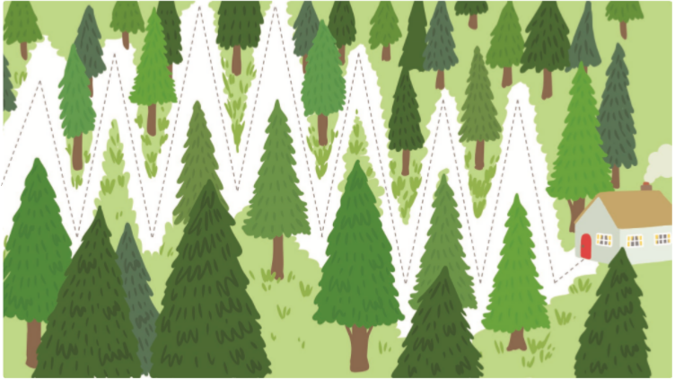
Activity 5 – Practise writing a
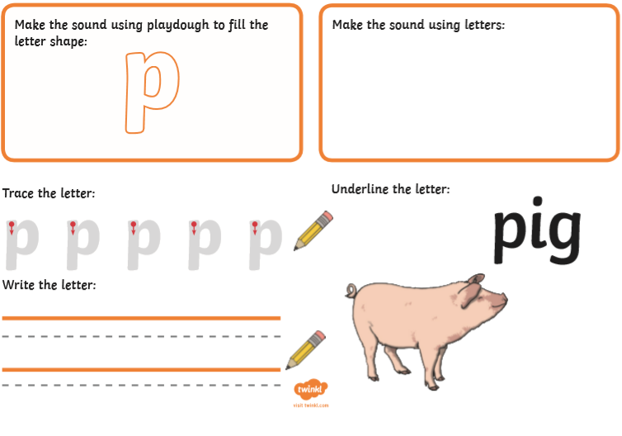

Activity 6 – Addition
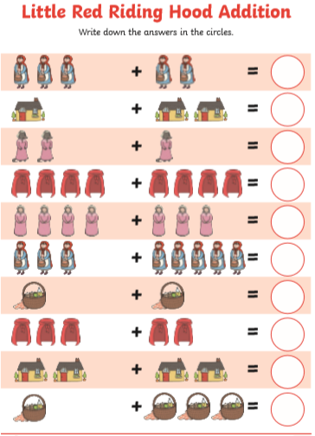
Activity 7 – Biscuist
Ingredients
- 200g Unsalted butter, softened
- 200g Caster Sugar
- 1 large egg
- ½ tsp vanilla extract
- 400g plain flour

Method
- Heat oven to 200C/180C fan/gas 6 and line a baking sheet with baking parchment. Put the butter in a bowl and beat it with electric beaters until soft and creamy. Beat in the sugar, then the egg and vanilla, and finally the flour to make a dough. If the dough feels a bit sticky, add a little bit more flour and knead it in.

- Pull pieces off the dough and roll them out to about the thickness of two £1 coins on a floured surface. The easiest way to do this with small children is to roll the mixture out on a baking mat. Cut out shapes using a 9cm biscuit cutter, or a use the rim of a small glass and peel away the leftover dough around the edges. Press some clean toys gently into the biscuits, making sure you make enough of a mark without going all the way through. Re-roll off-cuts and repeat.

- Transfer the whole mat or the individual biscuits to the baking sheet and bake for 8-10 mins or until the edges are just brown. Leave to cool for 5 mins, then serve. Will keep for three days in a biscuit tin.

Activity 8 – Number of the week
