Monday 27th April 2020
Questions
https://myminimaths.co.uk/year-4-home-learning-week-1-adding-using-formal-written-methods-full-week/

Video’s to help
https://myminimaths.co.uk/year-4-week-1-addition-using-formal-written-methods-monday/

https://myminimaths.co.uk/year-4-week-1-addition-using-formal-written-methods-wednesday/

Answers
https://myminimaths.co.uk/year-4-home-learning-week-1-adding-using-formal-written-methods-answers/

Tuesday
Date: 28-04-20
LO: To be able to multiply by 3,6 & 9.
STAR WORDS: multiple, times by, inverse, division.
Work out the calculations for each question using an appropriate method.
- 34 x 3 6) 34 x 6
- 16 x 3 7) 16 x 6
- 36 x 3 8) 36 x 6
- 19 x 3 9) 19 x 9
- 24 x 3 10) 24 x 9
Reasoning and problem solving.
- What have you noticed about the calculations above?
- If 27 x 3 = 81. What do you know 27 x 6 and 27 x 3 will be?
Always, Sometimes, Never?
When you multiply and whole number by 6 it will always be an even number.
Explain your answer.

Always, Sometimes, Never?

All multiples of 9 have digits that have a sum of 9.
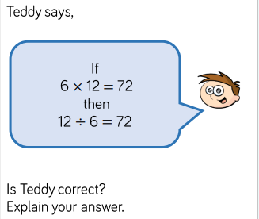

Date: 29-04-20
LO: To be able to multiply by 4 & 8.
STAR WORDS: multiple, times by, inverse, division.
Wednesday

Work out the calculations for each question using an appropriate method.
- 18 x 4 6) 32 x 8
- 13 x 4 7) 16 x 8
- 22 x 4 8) 26 x 8
- 15 x 4 9) 19 x 8
- 21 x 4 10) 24 x 8
Reasoning and problem solving.
Circle the calculation that has a different answer to the other three.
4 x 2 = 8 x 1 = 64 ÷ 8 = 8 x 8 =

The numbers in this sequence decrease in equal steps.
Write the missing numbers in the sequence.

40 36 24 20

Boris completes this calculation.
72 ÷ 8 = 9
Tick the inverse of Boris’s calculation.
72 ÷ 9 =
9 x 8 =
72 x 8 =
9 ÷ 8 =

Date: 30-04-20
LO: To be able to multiply by 9.
STAR WORDS: multiple, times by, inverse, division.
Work out the calculations for each question using an appropriate method.
- 13 x 9 6) 51 x 9
- 16 x 9 7) 33 x 9
- 19 x 9 8) 18 x 9
- 23 x 9 9) 32x 9
- 25 x 9 10) 26 x 9
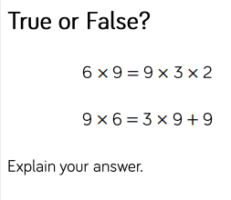
Reasoning and problem solving.

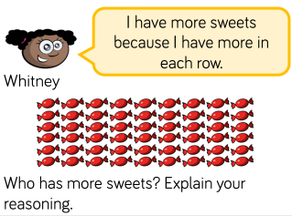
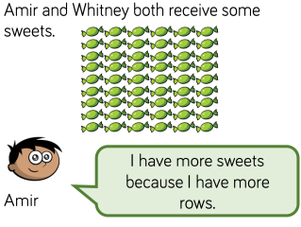

Date: 01-05-20
LO: To be able to multiply by 7.
STAR WORDS: multiple, times by, inverse, division.

Work out the calculations for each question using an appropriate method.
- 13 x 7 6) 22 x 7
- 16 x 7 7) 33 x 7
- 17 x 7 8) 28 x 7
- 20 x 7 7) 32x 7
- 18 x 7 10) 24 x 7
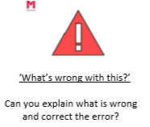
Reasoning and problem solving.

