Reading
Monday
1. The small pool as described as a “still muddy pool, stony and weedy, and surrounded by scraggy trees and bushes” (1 mark)
2. The little big fish “kept himself to himself. He was aloof and haughty whenever the others came near him“ (1 mark)
3. The older fish “was becoming irritated by the big fish’s constant gripes” (1 mark)
4. The little big fish decided he would allow himself “to be swept down into the big river and out of this little pool” (1 mark)
Tuesday
1. The little big fish needed rain and floods for his plan work (1 mark)
2. When he reached this river, the little big fish sighed “with anticipation of the good life that lay ahead” (1 mark)
3. The little big fish got away from the black and white fish by wedging himself “into a crevice in the bank, just out of their reach” (1 mark)
4. The little big fish got back to the small pond “with a leap…. into the expanse of flood-water that was surging past him” and then by swimming “against the swirling torrent” (1 mark)
Wednesday (possible answers could include)
1. The little big fish liked to be by himself. He prefers his own company.
“He kept himself to himself”
“He was aloof and haughty” (2 marks)
2. The little big fish wants to leave the pond because he thinks he is bigger and better than the rest of the fish there.
“this prompted the big fish to think further on how much too big and important he was to be living in such a small pool” (2 marks)
3. The little big fish thought the older fish was his friend.
“My friend is quite right, he thought” (2 marks)
4. No the little big fish doesn’t know that the older fish is annoyed by his constant moaning and that he uses sarcasm when he tells him to go and find a better place to live.
“who was becoming irritated by the big fish’s constant gripes”
“I wonder why a beautiful creature like you doesn’t go off to the big river and mix with other big and important fish, he added sarcastically” (2 marks)
Thursday (possible answers could include)
1. I think he thought it would be a good, happy life with fish like himself.
“I should be far happier if I lived among fish of my own size, beauty and intelligence”
(2 marks)
2. The little big fish annoyed the fish in the river because he was in their way.
“Out of the way, little fellow! Don’t you know this is our hunting ground?’ they exclaimed harshly” (2 marks)
3. He thought the river was a terrible place because no one was friendly, in fact they tried to eat him.
“Presently two large black and white fish came rushing straight for him with their fearful jaws open wide” (2 marks)
4. He learned that it is better to be a little big fish in a small pond than be a little big fish in a strange river full of even bigger fish! He realised that being safe is an important part of where and with whom you are living.
“If only I could get back to my little pool I would never grumble again”
Friday (possible answers could include)
1. At first the big little fish was quite rude about the other fish. He thought he was better than them. He had bigger ambitions and wanted to leave the others behind. When he arrived at the river, he was happy but then the reality of being there set in. He was actually confused about what to do and where to go, and he felt nervous in front of the other fish. He was then frightened about his decision to return to the small pond but he was determined and didn’t give up, even when it became a struggle. At the end when he was back where he had started, he felt relieved.
2. The older fish were irritated by the big little fish’s attitude to where they lived and they used sarcasm to show this when talking to him. The older fish manipulated the big little fish into thinking his idea of leaving was a good one. They perhaps thought he needed to be taught a lesson and they didn’t warn him about the dangers of leaving the safety of the small pond.
3. This is the moment when the big little fish realises his mistake and begins to doubt the decision he made.
4. The author shows how hard the big little fish’s return journey is. He uses phrases like “struggled”, “force” and “swirling torrent” to show that the journey was very difficult and that it would have been easy for the big little fish to give up, but he didn’t. It shows how desperate yet determined the little big fish is to get home.
5. This is an open ended question

SPaG
Monday (other answers are possible)
1. The king had returned from a long journey and consumed his welcome-home feast quickly.
2. The beautiful, wild hawk balanced high in the branches of an old, oak tree.
3. The graceful ballerina danced beautifully across the stage in her bright pink costume.
Tuesday (other answers are possible)
1. It was only by the smallest chance that the charmed rabbit got away from the fox.
2. I wanted some of the mushroom pizza, but there was only a meagre bit left!
3. Three, large gentle cows with black spots stood devouring grass in the field.
4. Caroline held onto her puppy’s lead firmly, so he couldn’t run off.
Wednesday (other answers are possible)
1. Dan was active in his hunt for the missing money.
2. Dan wavered in his attitude towards his daily fitness programme.
3. Dan was unworried about his written answers for his spelling test.
4. Dan was dissatisfied with the bed he had to stay in at his friend’s house.
5. Dan was content with the breakfast he had when staying at his friend’s house.
6. Dan thought the new boy was a little surly when he first met him.
7. Dan thought the new boy was short for his age.
8. Dan found the hidden treasure in a clear corner of the attic.
Thursday and Friday (other answers are possible)
1. upbeat/ optimistic
cheerless/uncertain
Although the film was upbeat, the viewers felt the ending was a little uncertain.
2. outdated/obsolete
modern/fresh
Despite the house having some modern features, most of it was rather outdated in its style.
3. fiery/scorching
nippy/sub-zero
In the morning the classroom was scorching but by the afternoon the temperature had dropped to sub-zero.
4. cull/reject
employ/keep
Whilst most of the applicants were rejected for the job, two were successfully employed.
5. appalling/loathsome
pleasing/agreeable
It was pleasing to sit in the sunshine however the chilly wind soon made it a loathsome pastime.
6. clamorous/ noisy
calm/tranquil
At night the city was tranquil but as the sun rose the clamorous noise of the traffic began again.
Maths – Mr Needham and Miss Dean
LO: To multiply decimals by integers
TUESDAY
Star words: Ones tenths hundredths decimals integers Place value digits

Fluency
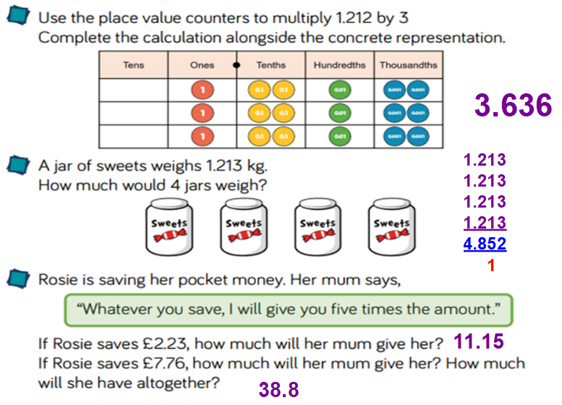

Reasoning
Mr Needham says 2 x £2.60 = £5.20  Explain how he could use this to solve 4 x £2.60.  If you double 2 you get 4.  We could double (x2) £5,20  2x £5,20 = £10.40 | 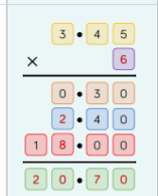

Problem Solving
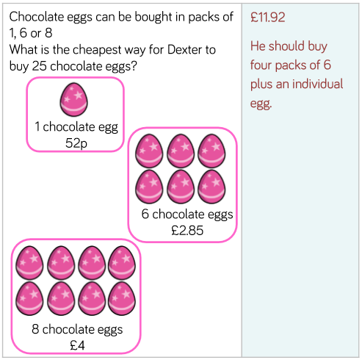
Tip:
25 x 1 = 25
3 x 8 = 24 (+ how many more eggs to make 25?)
4 x 6 = 24 (+ how many more eggs to make 25?)

LO: To round to the nearest 10
WEDNESDAY
Star words: Rounding place value digits tens

Fluency
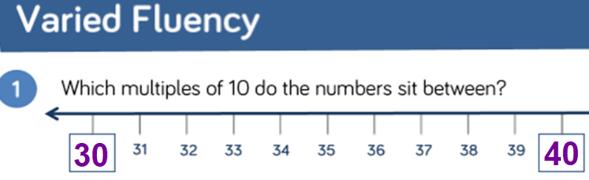
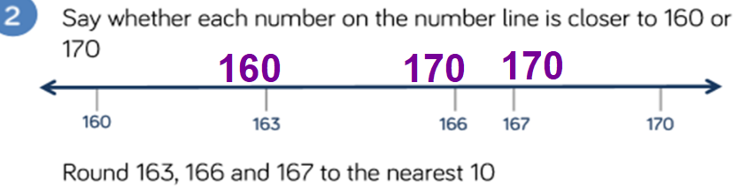
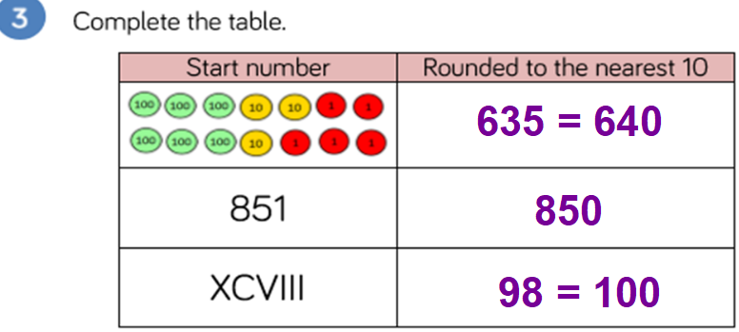
10
1) 3280  2) 4850 | 3) 53430  4) 98360 | 5) 735500  6) 735400

Reasoning
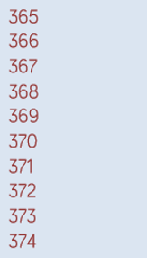 | 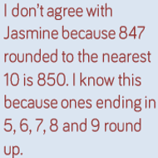
Mr Needham thinks of a whole number.
He rounds his answer to the nearest 10
The result is 3450
3445, 3446, 3447, 3448, 3449

Problem Solving
Amy chooses two of these cards.

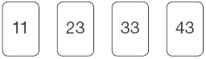
She adds the numbers on her two cards together.
She rounds the result to the nearest 10
Her answer is 60
Which two cards did Amy choose?
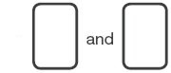
The cards would need to total 55, 56, 57, 58, 59
Or
61, 62, 63, 64

33 + 23 = 56 (56 can rounded up to 60)

2.
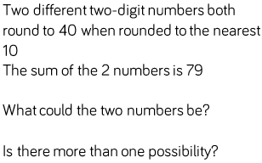

These are the numbers that round to 40 (nearest 10):
35, 36, 37, 38, 39, 41, 42, 43, 44

41 + 38 = 39
42 + 37 = 39
43 + 36 = 39
44 + 35 = 39

Using the number cards 0-9, can you make numbers that fit the following rules? Challenge: Use each digit only once. (PS)
0 1 2 3 4 5 6 7 8 9

- When rounded to the nearest 10, I round to 20. 15, 16, 17, 18, 19

- When rounded to the nearest 10, I round to 10. 5, 6,7, 8, 9

LO: To round to the nearest 100
THURSDAY
Star words: Rounding place value digits tens
hundred

Fluency
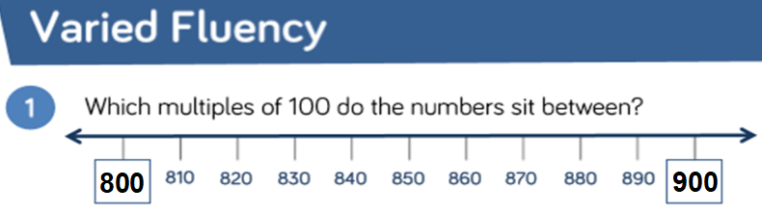
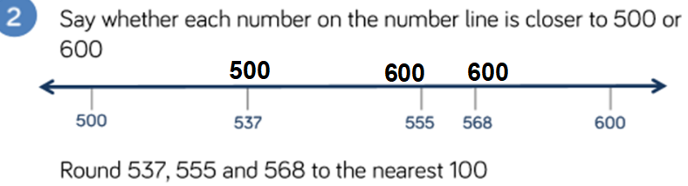
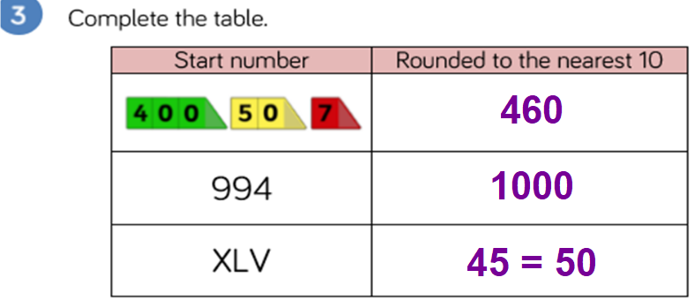
100
1) 8800  2) 8300 | 3) 8800  4) 8300 | 5) 8800  6) 8300

Reasoning
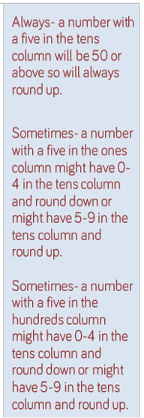 | 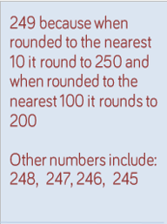
Any numbers between 47450 to 47549

Problem Solving
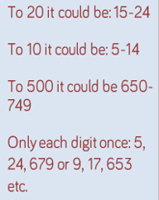

Using the number cards 0-9, can you make numbers that fit the following rules? Challenge: Use each digit only once. (PS)
0 1 2 3 4 5 6 7 8 9

1. When rounded to the nearest 100, I round to 1000.
950, 951, 952, 953, 954, 956, 957, 958, 960, 961, 962, 963, 964, 965, 967, 968, 970, 971, 972, 973, 974, 975, 976, 978, 980, 981, 982, 983, 984, 985, 986, 987,

2. When rounded to the nearest 100, I round to 7200.
7150, 7152, 7153, 7154, 7156, 7158, 7159, 7160, 7162, 7163, 7164, 7165, 7168, 7169, 7180, 7182, 7183, 7184, 7185, 7186, 7189, 7190, 7192, 7193, 7194, 7195, 7196, 7198

Friday – Arithmetic
1) 712
2) 5/11
3) 90
4) 838
5) 9
6) 200
7) 6562
8) 46
9) 81.08
10) 308
11) 90
12) 600
13) 4
14) 4,921
15) 50,000
16) 4.6
17) 6/7
18) 0.001

Maths – Miss Stonehouse and Mr Orr
LO: To covert decimals to fractions
TUESDAY
Star words: tenths hundredths decimals fractions equivalent numerator denominator vinculum

Fluency
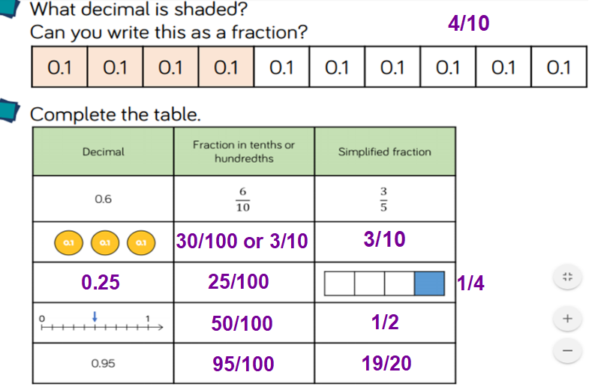
3) 0.6 = 60/100 or 6/10 6) 0.07 = 7/100
4) 0.9 = 90/100 or 9/10 7) 0.01 = 1/100
5) 0.31 = 31/100 8) 0.19 = 19/100

Reasoning
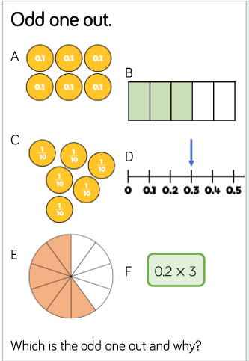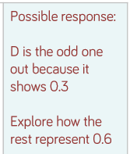 | 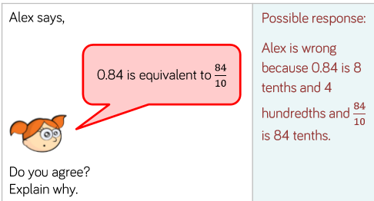

Problem Solving
1) Katie has £10 and orders a pizza. The pizza costs her £3. Write as a fraction and decimal how much she has left. 3/10 or 0.3

2) Julia is baking a cake. A bag of flour has 100g in it. She needs 40g.
How much does she need? Write this as a fraction and decimal. 4/10 or 0.4

3) James has £10 and orders a pizza. The pizza costs her £2.50. Write as a fraction and decimal how much she has left. 25/100 or 0.25

4) Jackie is baking a cake. A bag of flour has 200g in it. She needs 60g.
How much does she need? Write this as a fraction and decimal. 60/200 = 30/100 = 3/10 or 0.3

Challenge
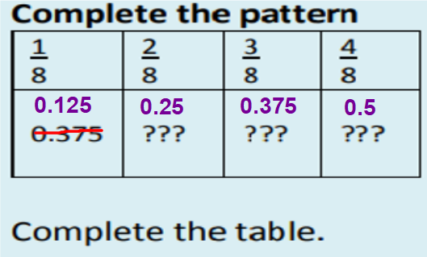
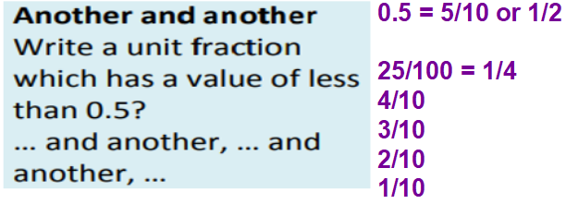

LO: To covert fractions to decimals.
WEDNESDAY
Star words: tenths hundredths decimals fractions equivalent numerator denominator vinculum

Fluency
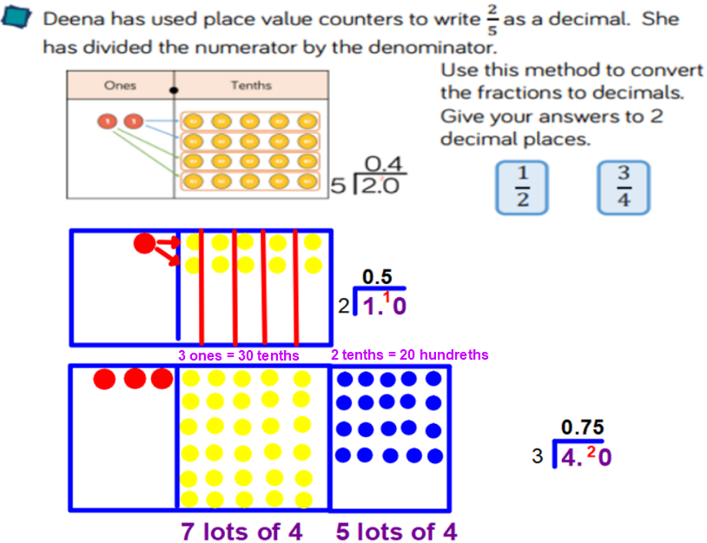
1) 5/8 = 0.625
2) 4/5 = 0.8
3) 8/5 = 1.6
4) 7/8 or 0.875
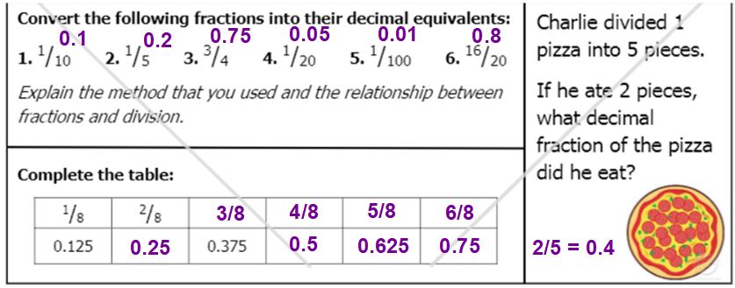

Reasoning
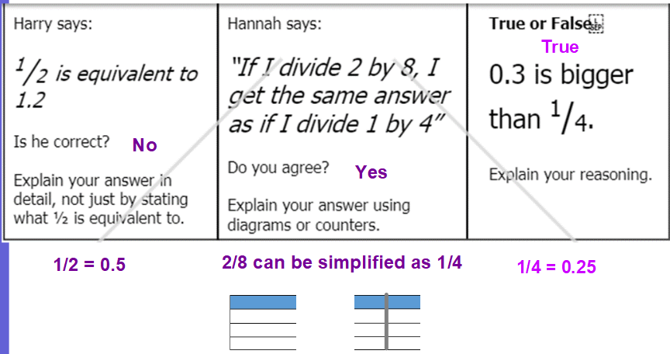

Problem Solving
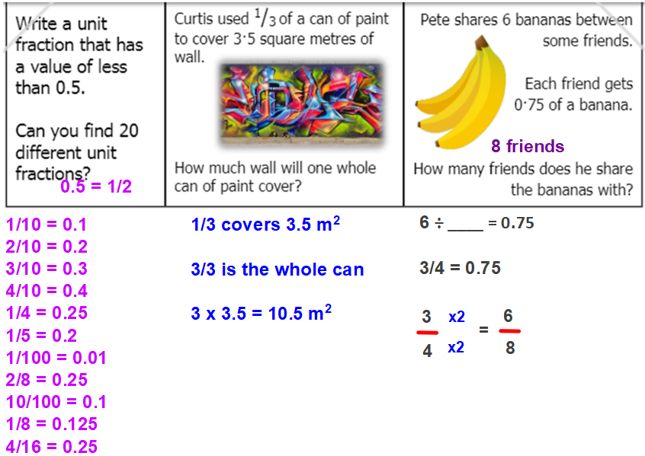

Challenge
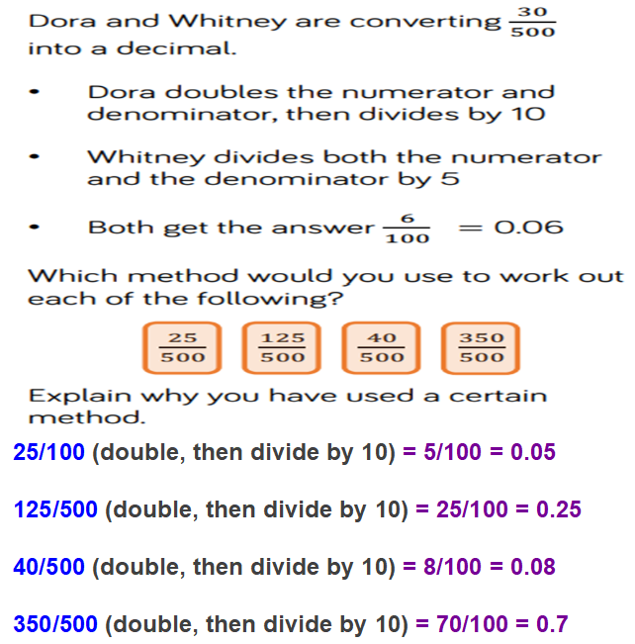

LO: To convert fractions to percentages and compare amounts.
THURSDAY
Star words: tenths hundredths decimals fractions equivalent numerator denominator vinculum

Fluency
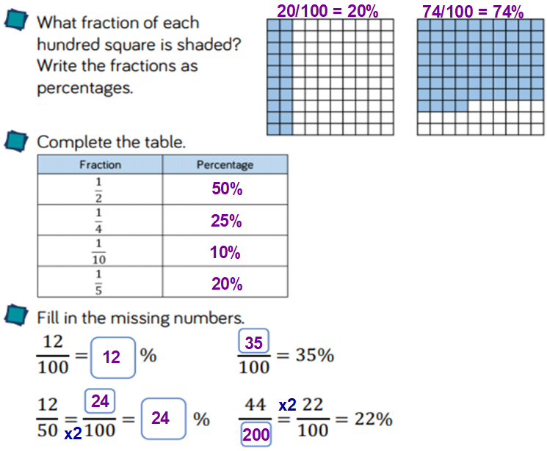

Reasoning
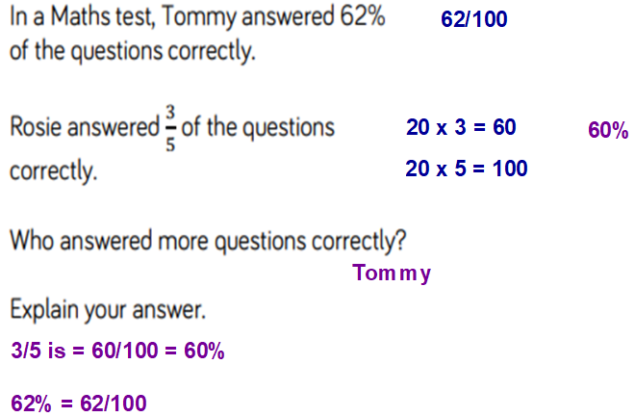 |  | 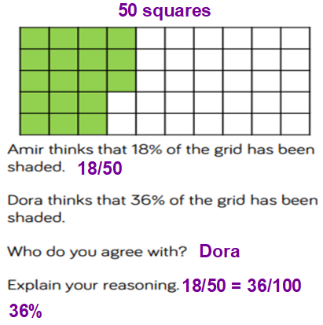
 | Problem Solving
 | 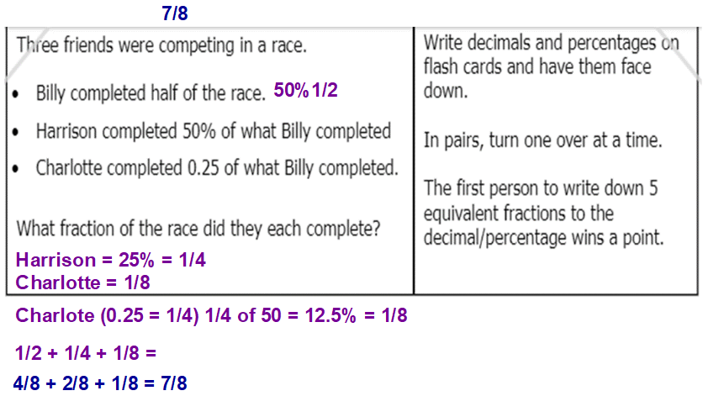

Challenge
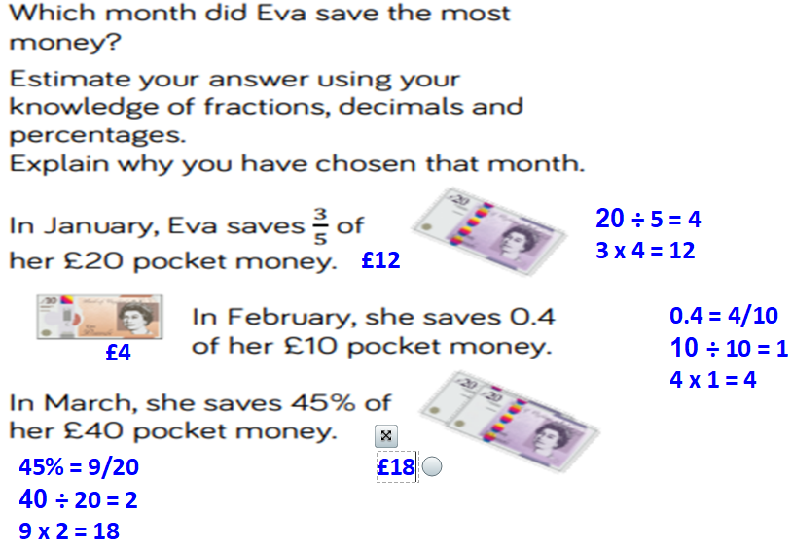

Friday – Arithmetic
1) 712 | 19) 750
2) 5/11 | 20) 18,055
3) 90 | 21) 240
4) 838 | 22) 15
5) 9 | 23) 14
6) 200 | 24) 7/10
7) 6562 | 25) 2 1/2
8) 46 | 26) 0.262
9) 81.08 | 27) 117
10) 308 | 28) 2/3
11) 90 | 29) 465,518
12) 600 | 30) 198
13) 4 | 31) 1/8
14) 4,921 | 32) 77
15) 50,000 | 33) 60
16) 4.6 | 34) 182
17) 6/7 | 35) 2 17/21 or 59/21
18) 0.001 | 36) 91

