School Closure work pack – Nursery

WB 13/4/2020

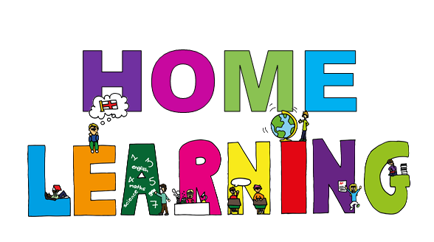

Dear Parents/Carers

I hope everyone enjoyed the sunshine and the Easter activities last week.

Mrs Moore is now on maternity leave. I with the help of Mrs Douglas and the nursery team will be providing the nursery children with home learning ideas. If you need any help or advice please contact me at [lauren.middleton@astreahartleybrook.org](mailto:lauren.middleton@astreahartleybrook.org). I am available between the hours of 9am and 3pm. I am also available on twitter at **@missmiddletonhb.** I check twitter regularly and it is a fantastic place for you to share your child’s home learning, please tag me and **@HartleyBrookPri.**

We are still using our online learning journal, **Tapestry** to share Childrens learning. The app is available for free at the app store. If you do not have a log in please get in touch and I’ll be able to set one up for you.

Attached are some ideas and worksheets to help with your childs home learning. Please bear in mind that young children learn best through play and that our nursery children learn through play activities and don’t very often sit at tables to learn. Encourage counting wherever possible and share books whenever you can.

Have fun! Keep safe!

Thank you

Miss Middleton and the Nursery Team

**Playdough Making**

4 cups of flour

1 cup of salt

4 tablespoons of oil

A generous squirt of hair conditioner

Hot water (with food colouring if you want it and have it) – keep adding it slowly as you mix, no specific measurement.

Chuck it all in a bowl, keep mixing and kneading it all together.

You could use your play dough to have your very own **‘Dough Disco.’** Every weekday morning at 9:30 check out Spread the Happiness TV on youtube. Here you’ll be able to join in with a live Dough Disco. Manipulating the dough will help your child develop their fine and gross motor skills, which help children with early writing.

<https://www.youtube.com/channel/UCj0shfH3pzhrf3dOrSj_pRw>

**Physical Development**

As well as physical time outdoors there may be times when your child needs to blow off some steam and indoors too. You can join Joe Wicks (the nations PE teacher) every weekday at 9am.

<https://www.youtube.com/results?search_query=joe+wicks>

If you prefer something a little calmer there are lots of children’s yoga on youtube at Cosmic Kids Yoga. Each yoga session has a child friendly theme which the children really enjoy.

<https://www.youtube.com/user/CosmicKidsYoga>

**Phonics and Maths**

The sound of the week is **m**.Watch the clip and practice saying and writing the sound. See if your child can spot the sound in the books you share together. <https://www.youtube.com/watch?v=_qTZNyos55Y>

Not all nursery children are quite ready for learning sounds they are still at the stage where they are developing their listening and attention skills. This week spend some time outdoors. Ask your child what they can hear and if the sounds are loud or quiet. You could even make a list of words and pictures of the things you can hear.

The number of the week is **0.** Watch the clip and practice saying and writing the number. You could use paint, chalks or paint brushes and water outside, or look for the number on your daily walk.

<https://www.youtube.com/watch?v=MeRIpU4Ibo4>

Here are more websites to support your child’s home learning

[www.topmarks.co.uk](http://www.topmarks.co.uk)

[www.phonicsplay.co.uk](http://www.phonicsplay.co.uk)

[www.twinkl.co.uk](http://www.twinkl.co.uk)

[www.youtube.com](http://www.youtube.com) – for lots of counting songs, shape songs, nursery rhymes etc

[www.bbc.co.uk/cbeebies](http://www.bbc.co.uk/cbeebies)

[www.oxfordowl.co.uk](http://www.oxfordowl.co.uk)

