Elephants and Giraffes SPaG

Monday – Spelling and Maths Test

On Monday’s test your child on the previous week’s spellings. This week they are:

Kent

sketch

kit

skin

frisky

Tuesday – Green Task

This is usually an identifying task as your child learns the skill.

Wednesday – Amber Task

This is usually a task for your child to practise or begin to apply the skill they have learn within a scaffold.

Thursday – Red Task

This is usually a task for your child to apply the skill learnt.

Friday – Purple Challenge Task

This is a task for your child to complete independently, applying the skill they have learnt, as well as using previously learnt skills.

|  |  |
| --- | --- |
| **Date:** week beginning 14th April 2020 | **I** |
| **LO:** to use the conjunctions but and so. | **S** |
|  | |
| * I can know why I use conjunctions and I can identify them. * I can use the conjunction but. * I can use the conjunction so. * I can use conjunctions in my writing. | |

Add the conjunction **but** in the right place.

The sun is shining it is cold.

I love ice cream I hate cake.

I am tired I do not want to go to bed.

James wants to skip Emily wants to run.

The sky is blue the clouds are white.

Circle the conjunctions.

and table dancing Tom

green but because jumping

cold London book so

Tick the job of a conjunction.

To describe. A place, person or object.

An action. To join clauses.

Add the conjunction **so** in the right place.

It is raining I put up my umbrella.

It is 9 o’clock I am doing phonics.

I am thirsty I will have a glass of water.

The lion is roaring I will feed him.

I went outside I put on my trainers.

Write your own sentences using conjunctions (and, because, but, so).

\_\_\_\_\_\_\_\_\_\_\_\_\_\_\_\_\_\_\_\_\_\_\_\_\_\_\_\_\_\_\_\_\_\_\_\_\_\_\_\_\_\_\_\_\_\_\_\_\_\_\_\_\_\_\_\_\_\_\_\_\_\_\_\_\_\_\_\_\_\_\_\_\_\_\_\_\_\_\_\_\_\_\_\_\_\_\_\_\_\_\_\_\_\_\_\_\_\_\_ \_\_\_\_\_\_\_\_\_\_\_\_\_\_\_\_\_\_\_\_\_\_\_\_\_\_\_\_\_\_\_\_\_\_\_\_\_\_\_\_\_\_\_\_\_\_\_\_\_\_\_\_\_\_\_\_\_\_\_\_\_\_\_\_\_\_\_\_\_\_\_\_\_\_\_\_\_\_\_\_\_\_\_\_\_\_\_\_\_\_\_\_\_\_\_\_\_\_\_\_\_\_\_\_\_\_\_\_\_\_\_\_\_\_\_\_\_\_\_\_\_\_\_\_\_\_\_\_\_\_\_\_\_\_\_\_\_\_\_\_\_\_\_\_\_\_\_\_\_\_\_\_\_\_\_\_\_\_\_\_\_\_\_\_\_\_\_\_\_\_\_\_\_\_\_\_\_\_\_\_\_\_\_\_\_\_\_\_\_\_\_\_\_\_\_\_\_\_\_\_\_\_\_\_\_\_\_\_\_\_\_\_\_\_\_\_\_\_\_\_\_\_\_\_\_\_\_\_\_\_\_\_\_\_\_\_\_\_\_\_\_\_\_\_\_\_\_\_\_\_\_\_\_\_\_\_\_\_\_\_\_\_\_\_\_\_\_\_\_\_\_\_\_\_\_\_\_\_\_\_\_\_\_\_\_\_\_\_\_\_\_\_\_\_\_\_\_\_\_\_\_\_\_\_\_\_\_\_\_\_\_\_\_\_\_\_\_\_\_\_\_\_\_\_\_\_\_\_\_\_\_\_\_\_\_\_\_\_\_\_\_\_\_\_\_\_\_\_\_\_\_\_\_\_\_\_\_\_\_\_\_\_\_\_\_\_\_\_\_\_\_\_\_\_\_\_\_\_\_\_\_\_\_\_\_\_\_\_\_\_\_\_\_\_\_\_\_\_\_\_\_\_\_\_\_\_\_\_\_\_\_\_\_\_\_\_\_\_\_\_\_\_\_\_\_\_\_\_\_\_\_\_\_\_\_\_\_\_\_\_\_\_\_\_\_\_\_\_\_\_\_\_\_\_\_\_\_\_\_\_\_\_\_\_\_\_\_\_\_\_\_\_\_\_\_\_\_\_\_\_\_\_\_\_\_\_\_\_\_\_\_\_\_\_\_\_\_\_\_\_\_\_\_\_\_\_\_\_\_\_\_\_\_\_\_\_\_\_\_\_\_\_\_\_\_\_\_\_\_\_\_\_\_\_\_\_\_\_\_\_\_\_\_\_\_\_\_\_\_\_\_\_\_\_\_\_\_\_\_\_\_\_\_\_\_\_\_\_\_\_\_\_\_\_\_\_\_\_\_\_\_\_\_\_\_\_\_\_\_\_\_\_\_\_\_\_\_\_\_\_\_\_\_\_\_\_\_\_\_\_\_\_\_\_\_\_\_\_\_\_\_\_\_\_\_\_\_\_\_\_\_\_\_\_\_\_\_\_\_\_\_\_\_\_\_\_\_\_\_\_\_\_\_\_\_\_\_\_\_\_\_\_\_\_\_\_\_\_\_\_\_\_\_\_\_\_\_\_\_\_\_\_\_\_\_\_\_\_\_\_\_\_\_\_\_\_\_\_\_\_\_\_\_\_\_\_\_\_\_\_\_\_\_\_\_\_\_\_\_\_\_\_\_\_\_\_\_\_\_\_\_\_\_\_\_\_\_\_\_\_\_\_\_\_\_\_\_\_\_\_\_\_\_\_\_\_\_\_\_\_\_\_\_\_\_\_\_\_\_\_\_\_\_\_\_\_\_\_\_\_\_\_\_\_\_\_\_\_\_\_\_\_\_\_\_\_\_\_\_\_\_\_\_\_\_\_\_\_\_\_\_\_\_\_\_\_\_\_\_\_\_\_\_\_\_\_\_\_\_\_\_\_\_\_\_\_\_\_\_\_\_\_\_\_\_\_\_\_\_\_\_\_\_\_\_\_\_\_\_\_\_\_\_\_\_\_\_\_\_\_\_\_\_\_\_\_\_\_\_\_\_\_\_\_\_\_\_\_\_\_\_\_\_\_\_\_\_\_\_\_\_\_\_\_\_\_\_\_\_\_\_\_\_\_\_\_\_\_\_\_\_\_\_\_\_\_\_\_\_\_\_\_\_\_\_\_\_\_\_\_\_\_\_\_\_\_\_\_\_\_\_\_\_\_\_\_\_\_\_\_\_\_\_\_\_\_\_\_\_\_\_\_\_\_\_\_\_\_\_\_\_\_\_\_\_\_\_\_\_\_\_\_\_\_\_\_\_\_\_\_

W/C 14th April 2020.

Let us know how you do on Twitter! @HartleyBrookPri @HBMissParkinson @HBMrsTravis @HBMissRose



**Maths**  10X table

7 X 10 = 70

8 X 10 = 80

9 X 10 = 90

10 X 10 = 100

11 X 10 = 110

12 X 10 = 120

1 X 10 = 10

2 X 10 = 20

3 X 10 = 30

4 X 10 = 40

5 X 10 = 50

6 X 10 = 60



Please ensure that your child is forming their numbers and letters correctly.

**Spellings**  ‘un’ prefix

unhappy

undo

unload

unfair

unlock

10 X table song - <https://youtu.be/8yxMJUHBslY>

|  |
| --- |
| Lesson 1 |
| LO: To apply knowledge of number bonds within 20. |
|  |

Can you make 15 in different ways?

Can you make 18 in different ways?

Maths

How many gold and silver coins are in each bag use the numbers in the circles to complete your answers.

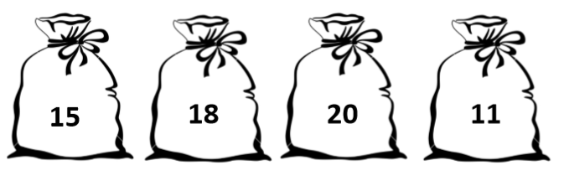

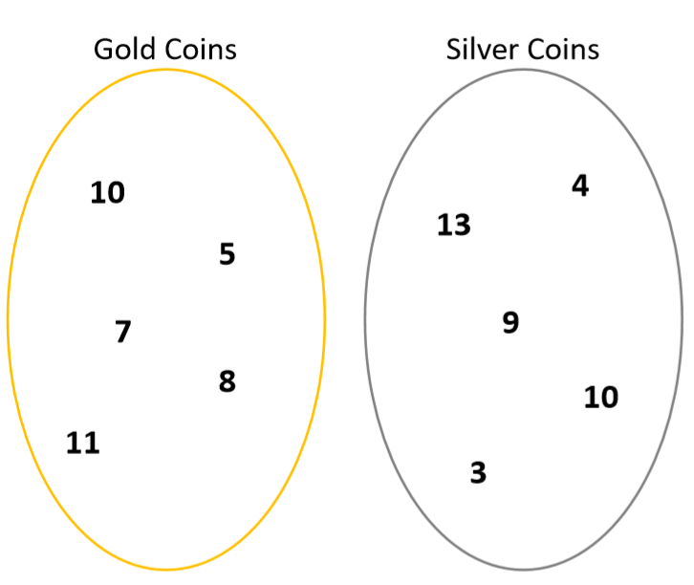

Choose a 2-digit number. How many different ways can you make it?

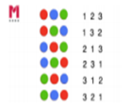

|  |
| --- |
| Lesson 2 |
| LO: To add 2 digit numbers and ones. |
|  |

Can you find the parts and the whole using the tens and ones?

Now find the parts and the wholes using numbers.



3

39

9

2

7

57

5

64

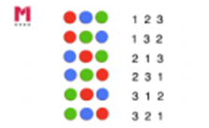

 Spot the mistake.

64

61

4

How many ways can you make the number 56?

68

8

|  |
| --- |
| Lesson 3 |
| LO: To subtract a 2 digit number and ones. |
|  |

Can you complete the missing gaps and complete the part whole model?

69 - 8 = \_\_\_

69 - \_\_\_ = 61

\_\_\_- 8 = 61

\_\_\_ = 36 - 4

32 = 36 - \_\_\_

32 = \_\_\_ - 4

Complete the equations by drawing the tens and ones.



58 - 5 = \_\_\_\_\_ 67 - 5 = \_\_\_\_\_

45 - 4 = \_\_\_\_\_ 56 - 6 = \_\_\_\_\_

How many ways can you make…



81 53

\_\_\_\_\_\_\_\_\_\_\_\_\_\_\_\_\_ \_\_\_\_\_\_\_\_\_\_\_\_\_\_\_\_\_ \_\_\_\_\_\_\_\_\_\_\_\_\_\_\_\_\_ \_\_\_\_\_\_\_\_\_\_\_\_\_\_\_\_\_

\_\_\_\_\_\_\_\_\_\_\_\_\_\_\_\_\_ \_\_\_\_\_\_\_\_\_\_\_\_\_\_\_\_\_ \_\_\_\_\_\_\_\_\_\_\_\_\_\_\_\_\_ \_\_\_\_\_\_\_\_\_\_\_\_\_\_\_\_\_

\_\_\_\_\_\_\_\_\_\_\_\_\_\_\_\_\_ \_\_\_\_\_\_\_\_\_\_\_\_\_\_\_\_\_ \_\_\_\_\_\_\_\_\_\_\_\_\_\_\_\_\_ \_\_\_\_\_\_\_\_\_\_\_\_\_\_\_\_\_

\_\_\_\_\_\_\_\_\_\_\_\_\_\_\_\_\_ \_\_\_\_\_\_\_\_\_\_\_\_\_\_\_\_\_ \_\_\_\_\_\_\_\_\_\_\_\_\_\_\_\_\_ \_\_\_\_\_\_\_\_\_\_\_\_\_\_\_\_\_

\_\_\_\_\_\_\_\_\_\_\_\_\_\_\_\_\_ \_\_\_\_\_\_\_\_\_\_\_\_\_\_\_\_\_

\_\_\_\_\_\_\_\_\_\_\_\_\_\_\_\_\_ \_\_\_\_\_\_\_\_\_\_\_\_\_\_\_\_\_

\_\_\_\_\_\_\_\_\_\_\_\_\_\_\_\_\_ \_\_\_\_\_\_\_\_\_\_\_\_\_\_\_\_\_

\_\_\_\_\_\_\_\_\_\_\_\_\_\_\_\_\_ \_\_\_\_\_\_\_\_\_\_\_\_\_\_\_\_\_

|  |
| --- |
| Lesson 4 |
| LO: To add a 2 digit number and ones by regrouping. |
|  |

Re draw the tens and ones and complete the equations.

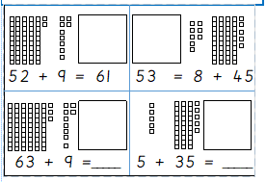

Do you notice anything about the tens and ones in the parts and in the whole?

\_\_\_\_\_\_\_\_\_\_\_\_\_\_\_\_\_\_\_\_\_\_\_\_\_\_\_\_\_\_\_\_\_\_\_\_\_\_\_\_\_\_\_\_\_\_\_\_\_\_\_\_\_\_\_\_\_\_\_\_\_\_\_\_\_\_\_\_\_\_\_\_\_\_\_\_\_\_\_\_\_\_\_\_\_\_\_\_\_\_\_\_\_\_\_\_\_\_\_\_\_\_\_\_\_\_\_\_\_\_\_\_\_\_\_\_\_\_\_\_\_\_\_\_\_\_\_\_\_\_\_\_\_\_\_\_\_\_\_\_\_\_\_\_\_\_\_\_\_\_\_\_\_\_\_\_\_\_\_\_\_\_\_\_\_\_\_\_\_\_\_\_\_\_\_\_\_\_\_\_\_\_\_\_\_\_\_\_\_\_\_\_\_\_\_\_\_\_

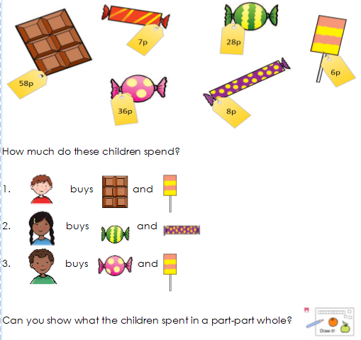

|  |  |
| --- | --- |
| **Week 1 Lesson 1** | **I** |
| What classification of animal are we? | **S** |
|  | |

|  |
| --- |
| 4965060[1] |
| 4331114[1] |
| appearance_fish[1] |
| appearance_amphibian[1] |
| mammal1[1] |

Science

Using the guidance sheets can you cut out the animals below and stick them in the correct categories on the first page? Is the animal a bird, a fish, a mammal, a reptile or an amphibian?

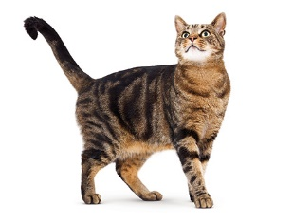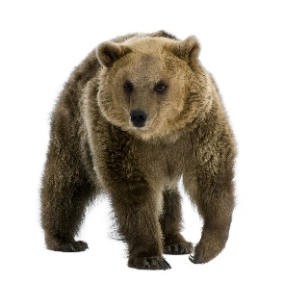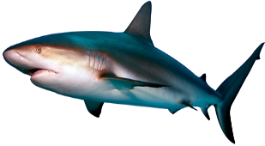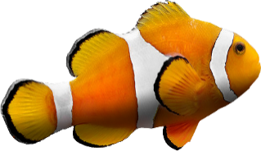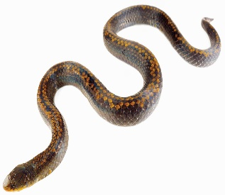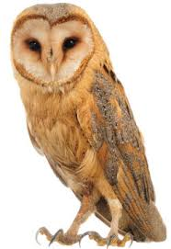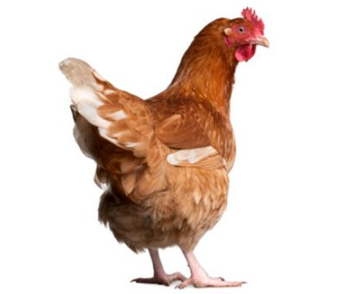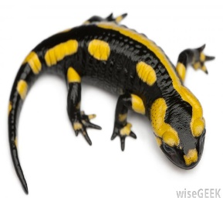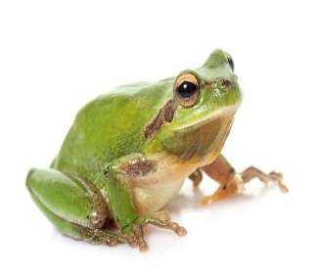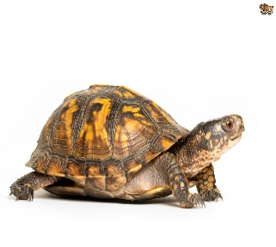

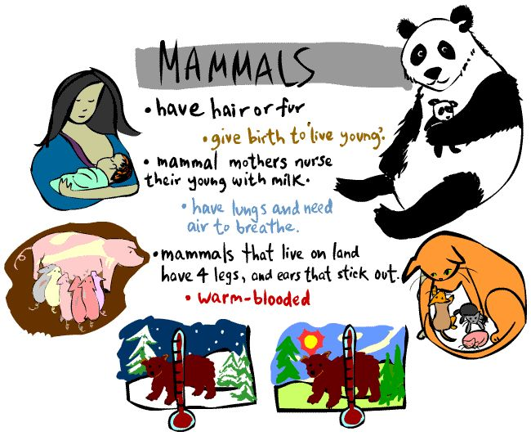

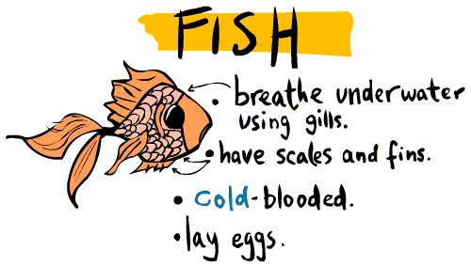

[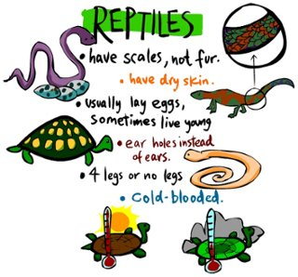](https://www.google.co.uk/url?sa=i&rct=j&q=&esrc=s&source=images&cd=&cad=rja&uact=8&ved=0ahUKEwiji8XdkprUAhWDWhQKHRnlBGUQjRwIBw&url=https://www.thinglink.com/scene/520057005008748544&psig=AFQjCNGXCi-y6EkwzW7SniUSkC_u-rOftw&ust=1496320500486032)

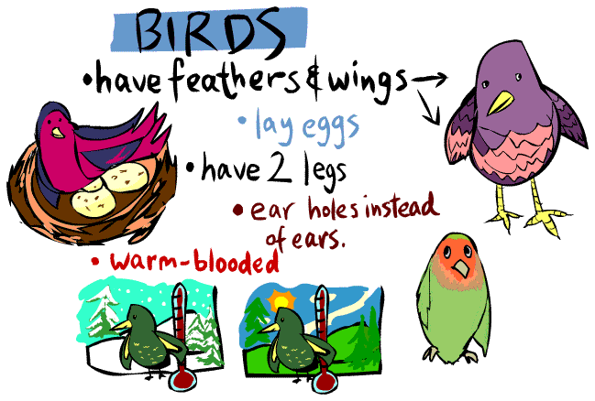

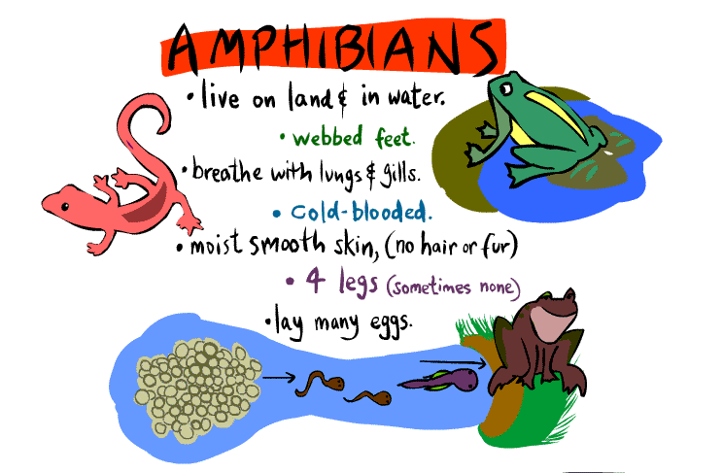

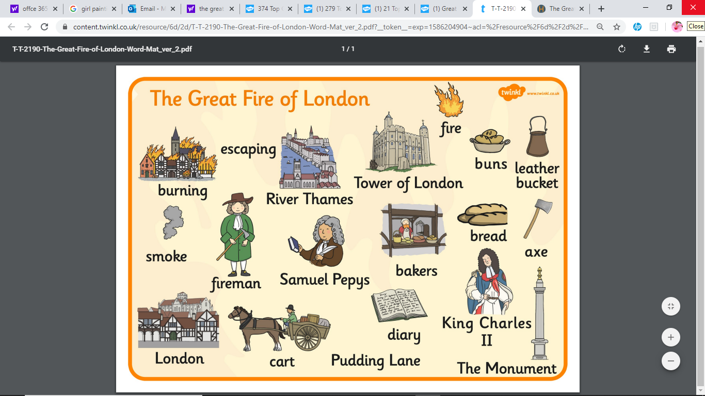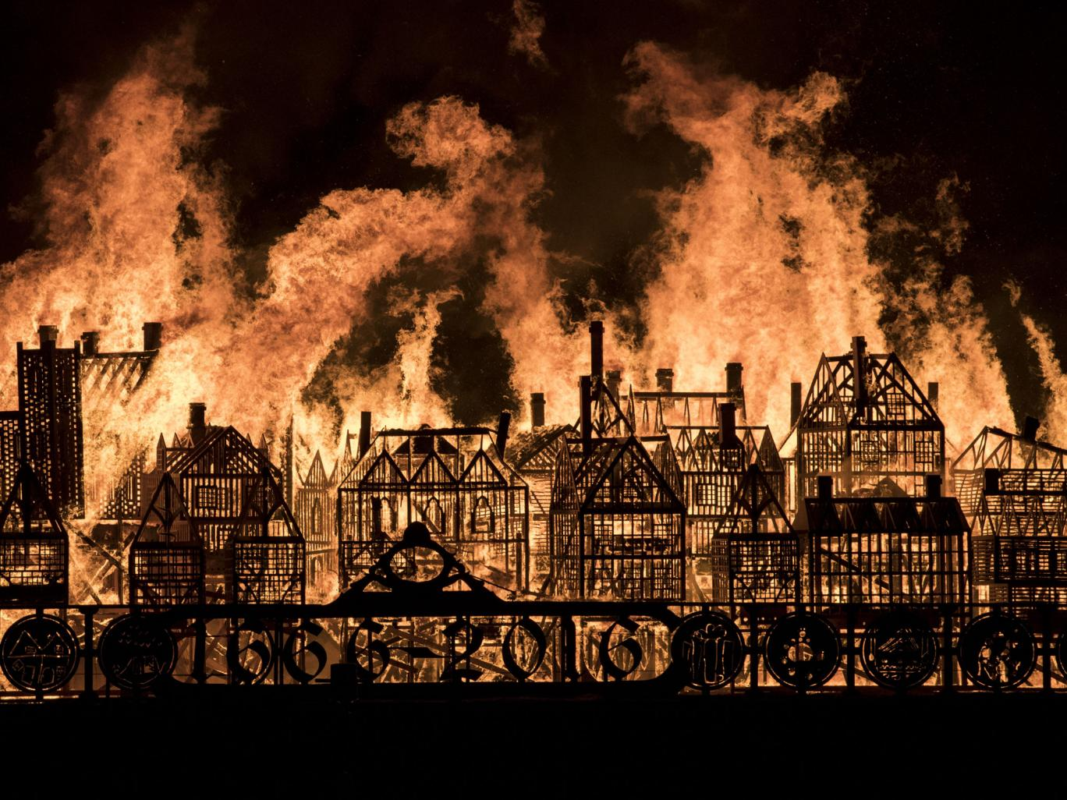

Curriculum

New topic: The Great Fire of London

Please watch these videos <https://www.youtube.com/watch?v=Er3GKw8Z3R4>

<https://www.youtube.com/watch?v=VarSSAwiimU>

|  |
| --- |
| **Date: WB**  13th April 2020 |
| **LO:** To learn about the Great Fire of London and understand the difference between the past and present. |
|  |

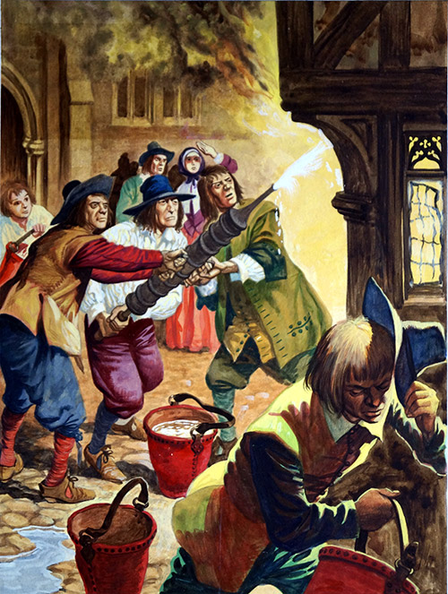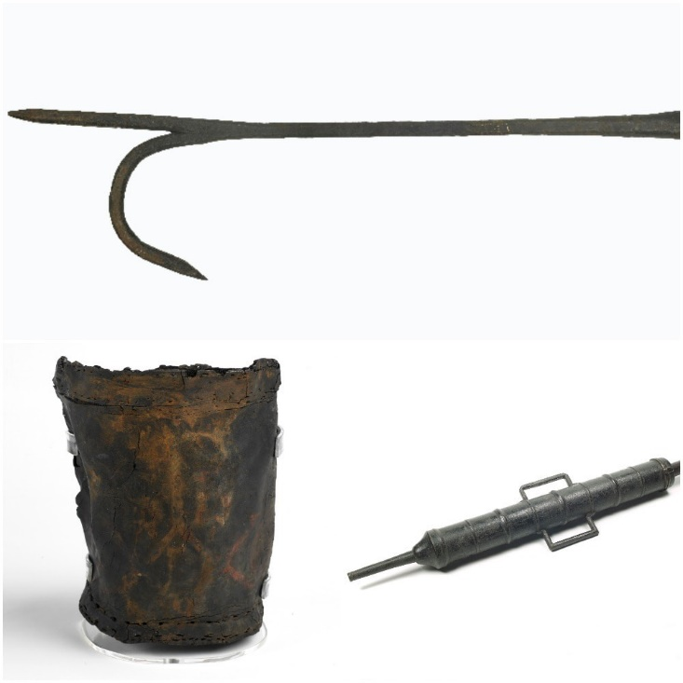

Compare the ways that they fought the fire of London and how we fight fires now.

What can you see?

\_\_\_\_\_\_\_\_\_\_\_\_\_\_\_\_\_\_\_\_\_\_\_\_\_\_\_\_\_\_\_\_\_\_\_\_\_\_

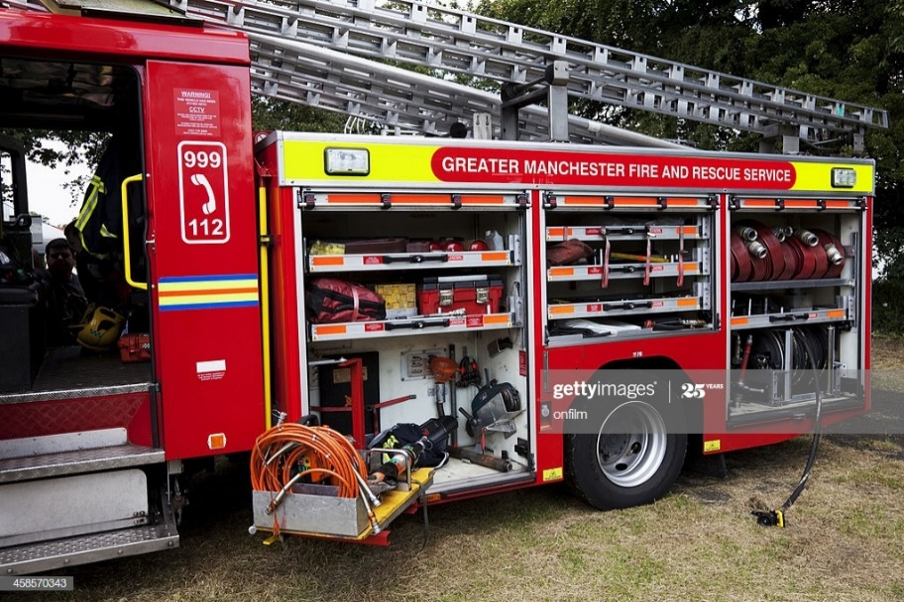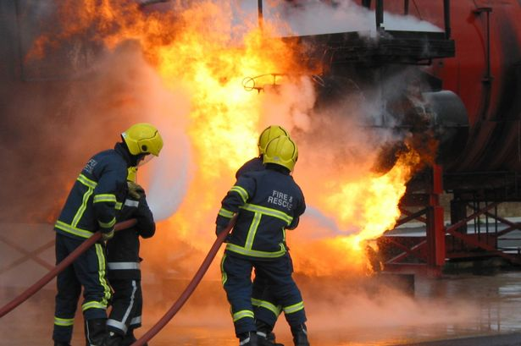

You can see the old and new St Paul’s here! <http://www.explore-stpauls.net/oct03/pano_pages.htm>

Same as 1666

\_\_\_\_\_\_\_\_\_\_\_\_\_\_\_\_\_\_\_\_\_\_\_\_

Different to 1666

\_\_\_\_\_\_\_\_\_\_\_\_\_\_\_\_\_\_\_\_\_\_\_\_

What can you see?

\_\_\_\_\_\_\_\_\_\_\_\_\_\_\_\_\_\_\_\_\_\_\_\_\_\_\_\_\_\_\_\_\_\_\_\_\_\_