Lesson 3 – all groups | I
How do features help animals survive? | S
Identify, describe, similar, same, amphibian, mammal, fish bird, reptile amphibian

Although all animals are different some animals have similar features and some have very different features.

Can you write down similarities and differences between two animals like I have done below? Use the word mat to help you.

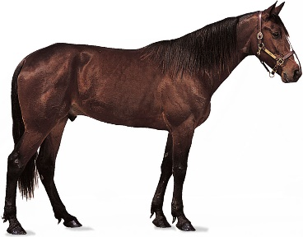 | 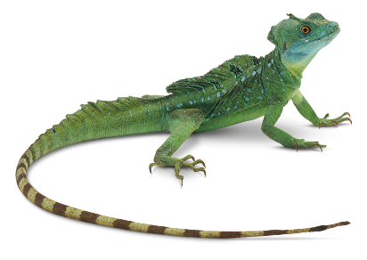
Similarities:  - 4 legs  - tail | Differences:  - Hair  - Sticking out ears  - Hooves and claws  - scales

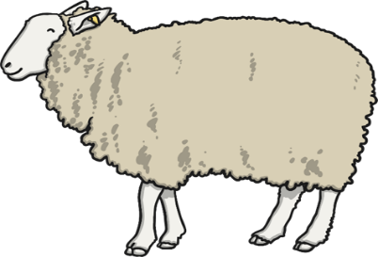
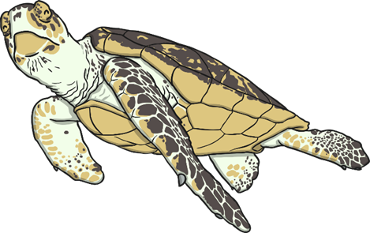

Similarities: | Differences:

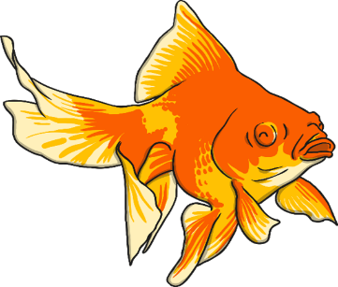
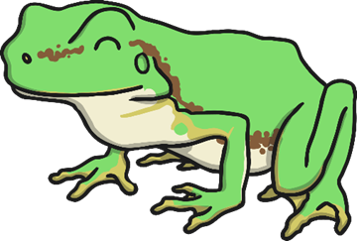

Similarities: | Differences:
Which one is the odd one out? Why?

Which of your features do you find most important and why?







