Rocket Room Maths Week starting 27/4/20

This week we will be naming 2D and 3D shapes and thinking about their properties.
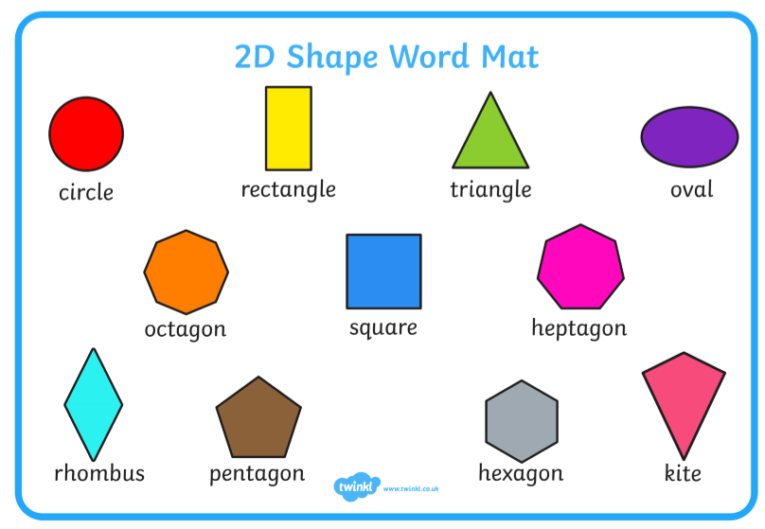

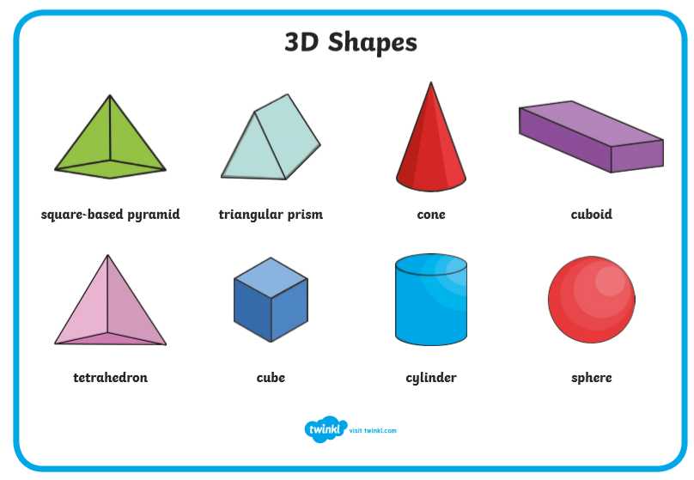

Rocket Room Maths Mrs J Jones Week starting 27/4/20

Name the 2D shapes:
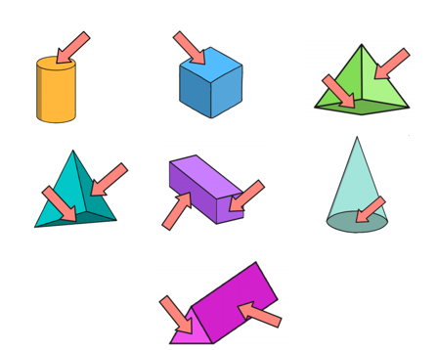
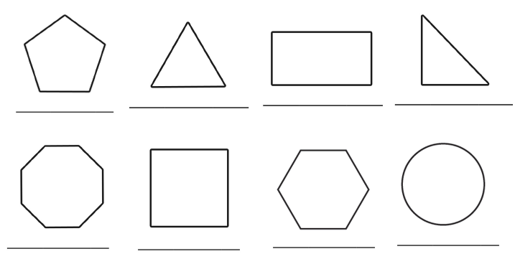
Name the 2D shape that the arrow is pointing at
Rocket Room Maths Mrs J Jones Week starting 27/4/20
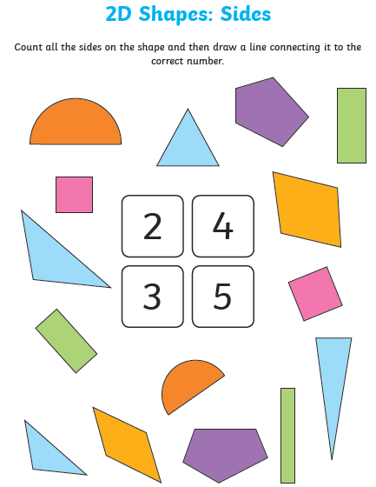

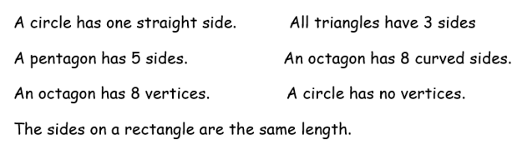

Draw or stick the shape next to the description.
Rocket Room Maths Mrs J Jones Week starting 27/4/20

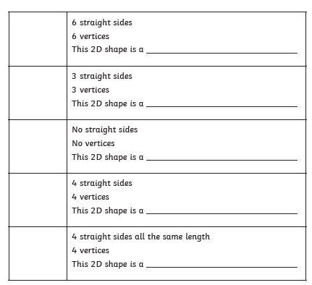

Rocket Room Maths Mrs J Jones Week starting 27/4/20

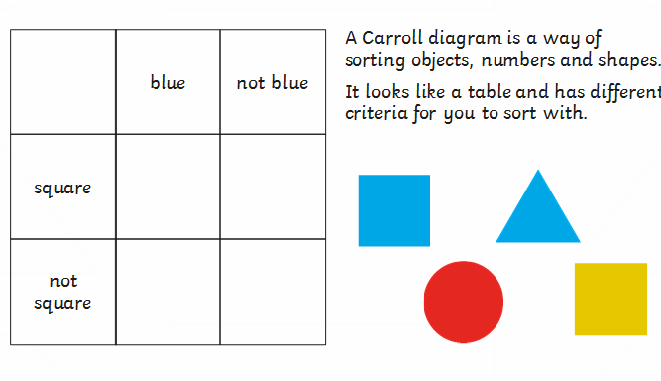

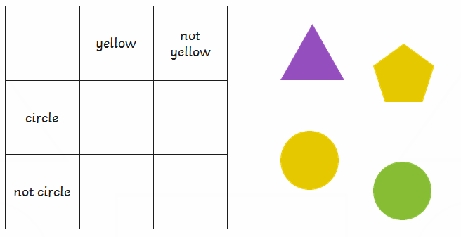

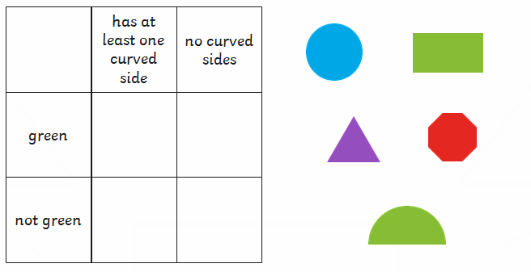

Rocket Room Maths Mrs J Jones Week starting 27/4/20

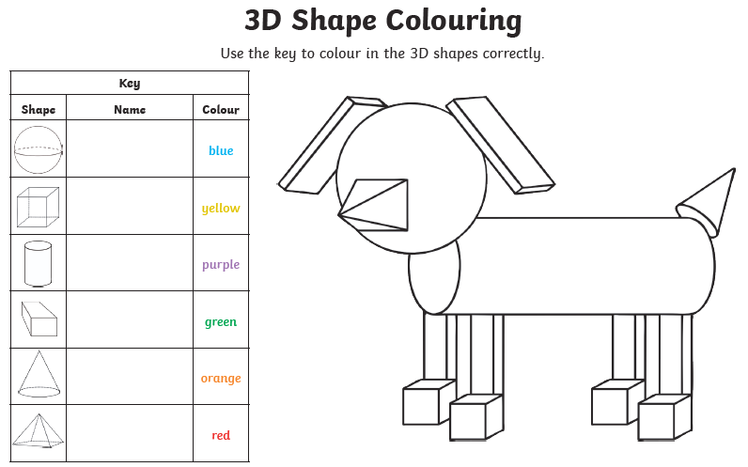

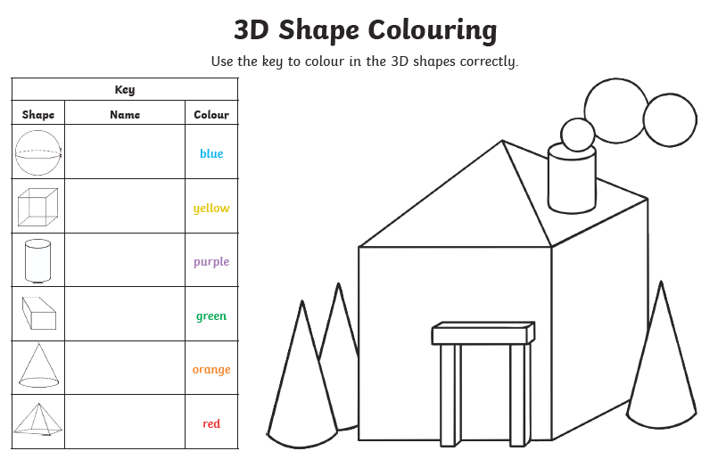
Rocket Room Maths Mrs J Jones Week starting 27/4/20

Cut out and match the 3D shapes
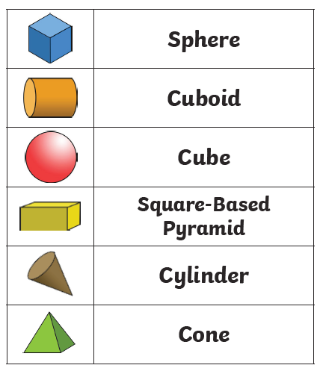

Rocket Room Maths Mrs J Jones Week starting 27/4/20

vertices

face

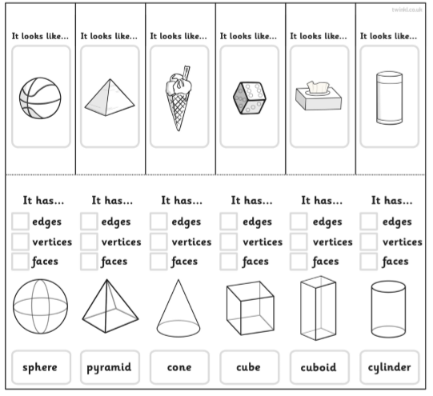

Rocket Room Maths Mrs J Jones Week starting 27/4/20

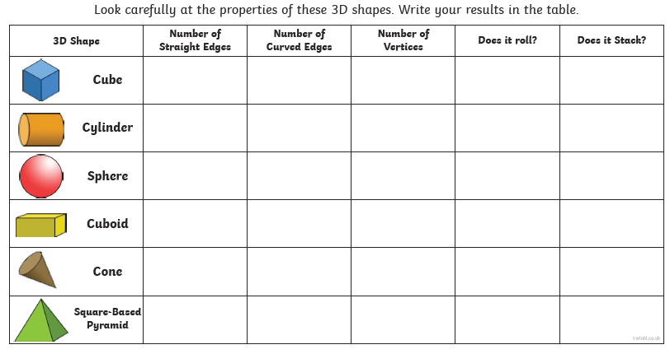

Week starting 27/4/20
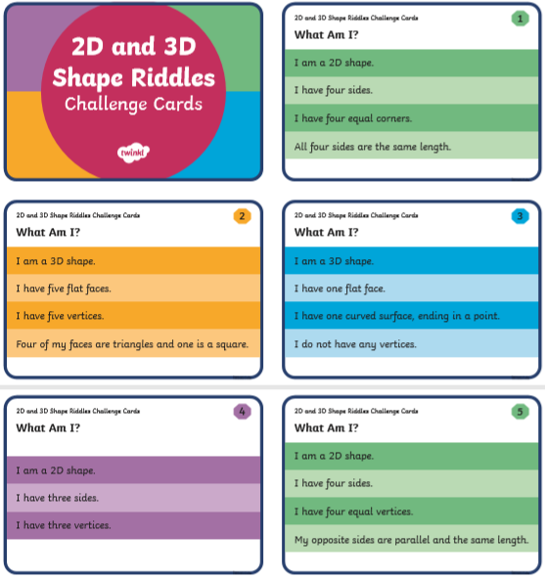

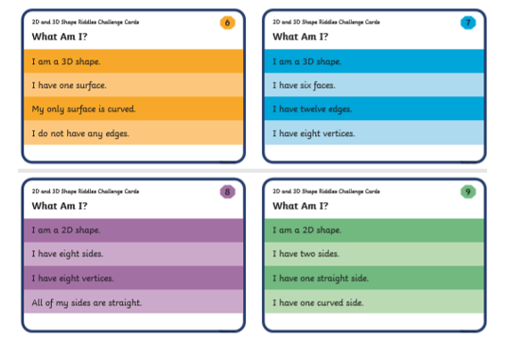

Rocket Room Maths Mrs J Jones Week starting 27/4/20

Try cutting out the nets and making 3D shapes yourself.
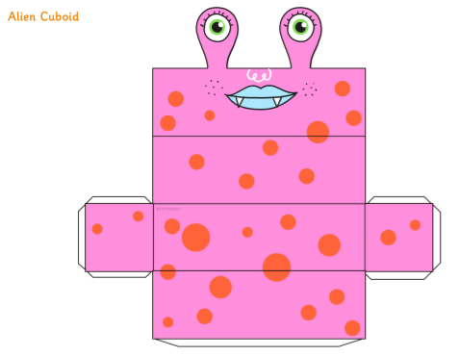

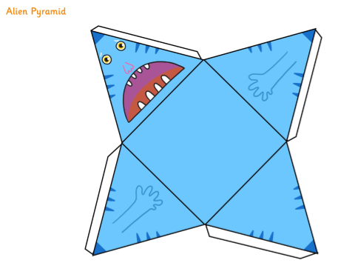

Rocket Room Maths Mrs J Jones Week starting 27/4/20

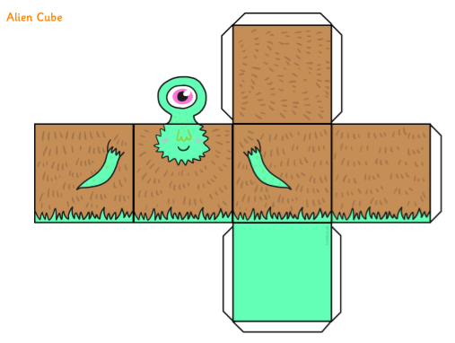

Rocket Room Maths Mrs J Jones Week starting 27/4/20

Answers:

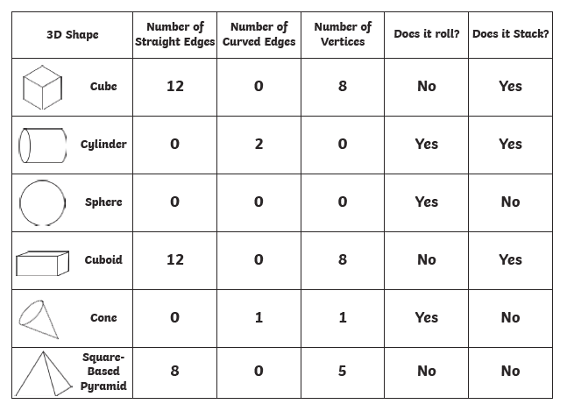

Riddle answer:
- Square
- Square based pyramid
- Cone
- Triangle
- Rectangle
- Sphere
- Cube/cuboid
- Octagon
- Semicircle

Rocket Room Maths Mrs J Jones Week starting 27/4/20

