Read, Write Inc
igh – fly high?
Word time!
- Show or write the word and ask your child to spot the “special friends”
- eg bright
- Ask children to say the sounds in “Fred talk” and then to read the words
eg b-r-ight-t - bright
- Count out the sounds on their fingers. Repeat the word and pinch their fingers as they say the sounds.
- Write the word and pinch their fingers as they say the sounds.
- Underline the special friend “igh”
- Tick the word if it is correct or try again.

high night light fright bright sight might
Just add “igh”
Can you match the “igh” word?
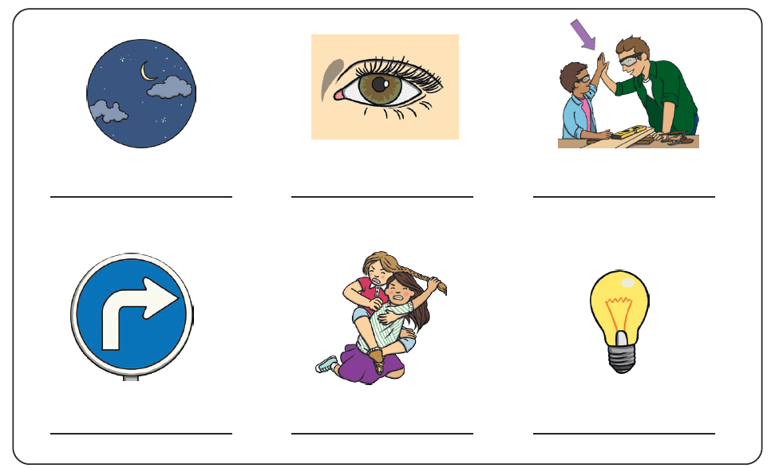

Write or say a sentence for 5 different “igh” words. Make sure your sentence has a capital letter and a full stop.

- _________________________________________________________

- _________________________________________________________

- _________________________________________________________

- _________________________________________________________

- _________________________________________________________

Fill in the correct “igh” word:

I go to sleep during the __________.
Turn __________ at the traffic __________s.
Did you get the question ________?
The kite is flying __________ above me.
That spider gave me a terrible _________.
I painted it with ________ colours.
Can you turn the _________ on please?

Read the story and highlight all the “igh” words.

