Read Write Inc
This week’s “Spag” (spelling, punctuation and grammar) theme is nouns. We will also be reminding ourselves of when and how to use capital letters first. Here are a variety of activities to work through with your child:
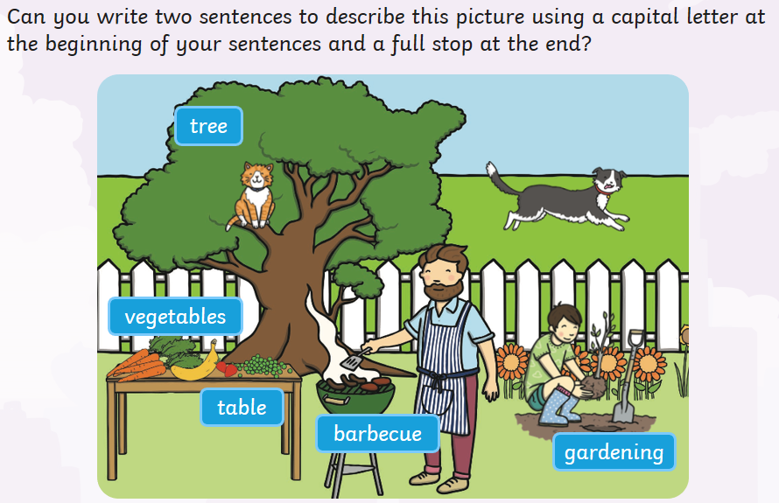

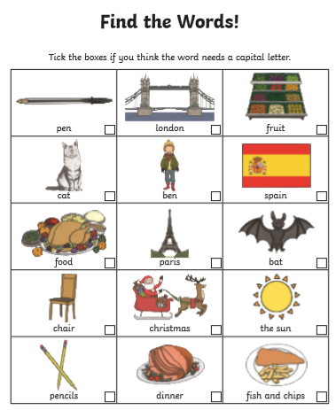
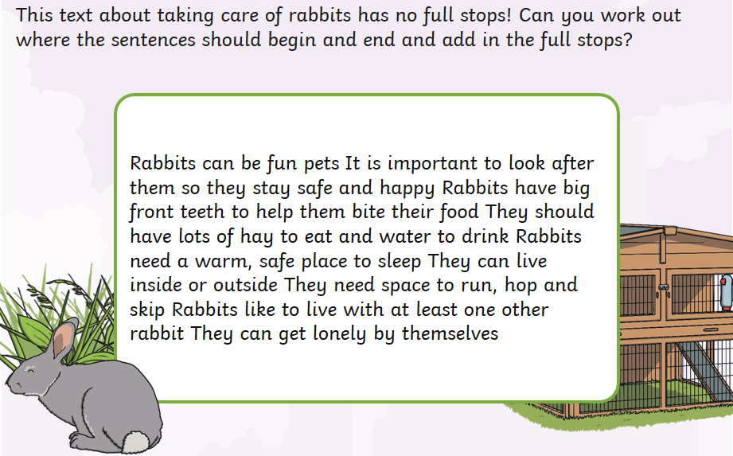
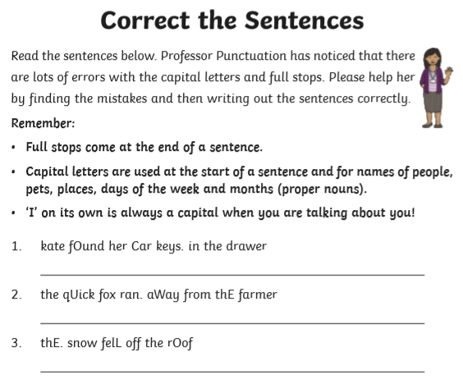
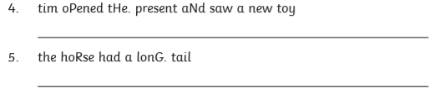
A Guide to Terminology
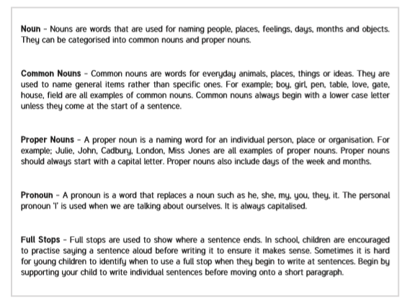

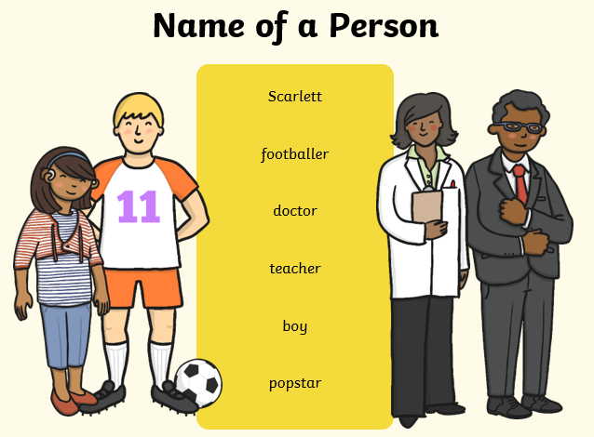
A noun is a naming word. It can name a person, place or thing. Look at the examples below.
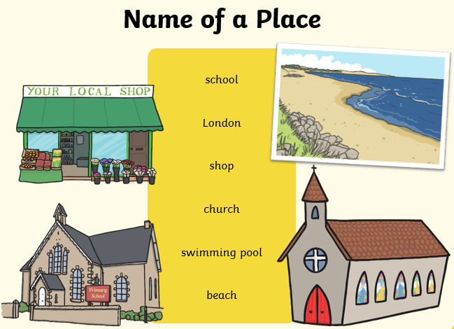

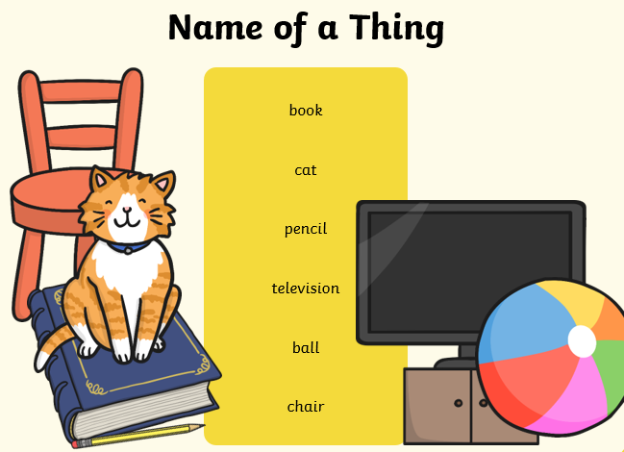

Put a circle around the nouns in the list below:

candle car dog tall bird
pretty Josh trousers tree coat
dancing brown flying t-shirt hungry
owl plane Sheffield crispy bed

Put a circle around the Proper Nouns:

man Spiderman Yorkshire town hamster
Mr Bump princess day Wednesday chair
Read the story below. Circle all the nouns and
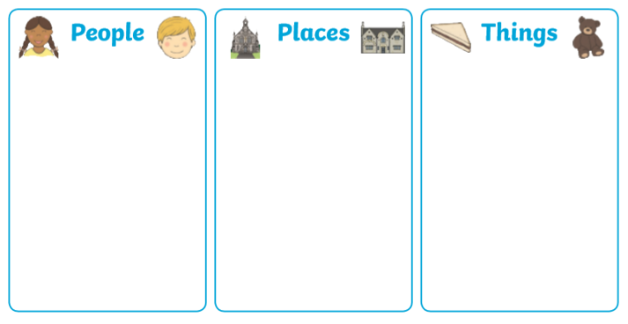
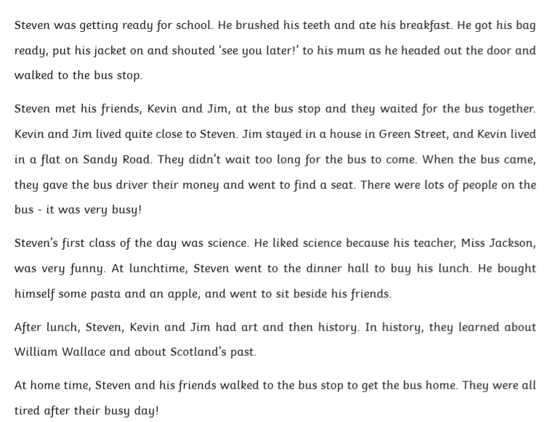
then decide if they are a person, place or thing.

Add your own nouns to these sentences:

The __________ played in the garden.
“My _______ hurts!” shouted the boy.
Look at the ___________ in the sky.
Three cats sat on the ___________.
A ___________ was walking through the forest.
Whose _______ is this?
My sister lives in ____________.
The __________ splashed in the puddle.

