Monday 27th April 2020
Questions from myminimaths.co.uk:
11a) 2,553 - 605 =
11b) 448 - _______ = 15
11c) 4,466 - 828 =
11d) 8,734 - 459 =
11e) 703 - _______ = 562
11f) 5,892 - _______ = 2,430
11g) 7,839 - 348 =
11h) 2,198 - _______ = 1,477
11i) 1,560 - 890 =
11j) 593 - _______ = 189
11k) 8,765 - 387 =
11l) 13,651 - _______ = 10,894
11m) 613 - _______ = 508
11n) 4,902 - 566 =
11o) 14,114 - _______= 6,254
11p) 6,275 - _______ = 3,193

Answers: https://myminimaths.co.uk/arithmetic-16-answers-question-11/

LO: To add two 4-digit numbers.
Tuesday 5th May 2020
Star words: place value addition greater altogether in total increase by whole

Fluency
1) Using the place value mat, draw counters and calculate 242 + 213
1000s | 100s | 10s | 1s
2)
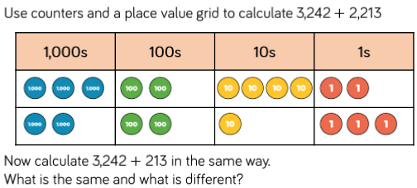
3) 4241 + 1234 = | 4) 5243 + 2517 =
5) 3617 + 2152 = | 6) 6258 + 4253 =
7) 2435 + 5352 = | 8) 5342 + 2837 =
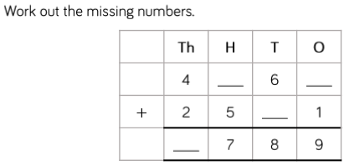

Reasoning
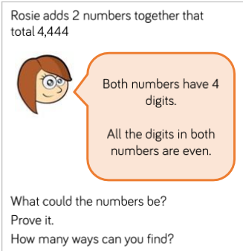 | 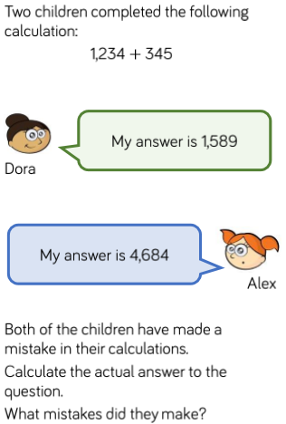

Problem Solving
1. Mr Needham decides to paint his fence. He buys 5324 litres of paint. The next day he buys another 2345 litres of paint. How many litres of paint did he need to paint his fence?

2. Miss Dean drove 4123 miles in total last year. This year she has driven 3846 miles. How many miles has her car driven altogether?

3. On Monday, Superman flew 3351 miles from London to New York. The next night he flew 3625 miles from New York to Paris. How many miles did he fly in total?

4. On Saturday, McDonalds sold 8472 cheese burgers. On Sunday they sold 1527 cheese burgers. How many cheese burgers did they sell altogether?

Challenge
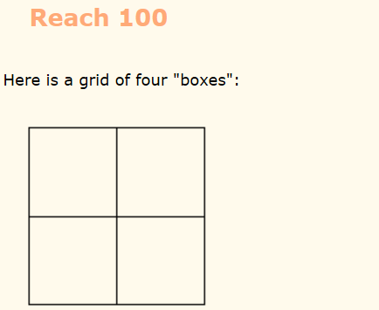
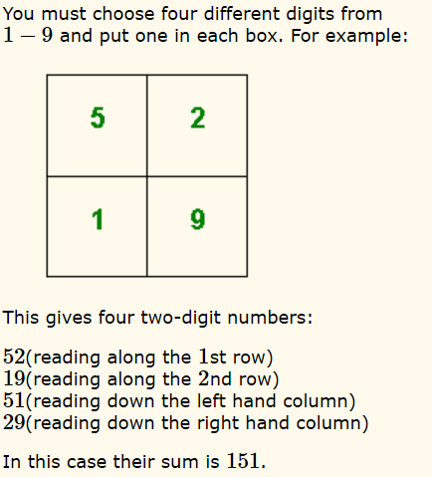

LO: To add two 4-digit numbers with multiple exchanges.
Wednesday 6th May 2020
Star words: place value addition greater altogether in total increase by whole

Fluency
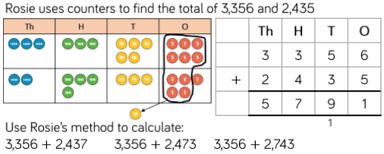

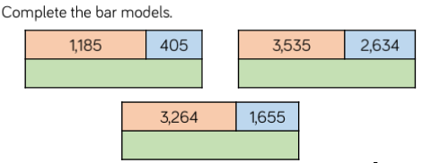
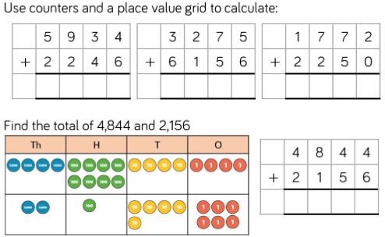

Reasoning
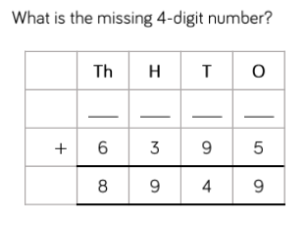 | 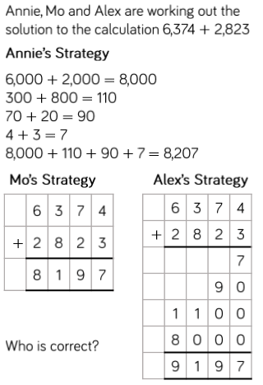
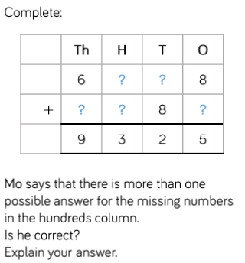

Problem Solving
1. Dexter buys a laptop costing £1265 and a TV costing £2497. How much do the laptop and TV cost altogether?

2. John spends £5672 on car and £2353 on a new kitchen. How much does he spend in total?

3. Rotherham United’s attendance is 4738 one weekend. The weekend after the attendance is 3425. How many people went to watch Rotherham United play over 2 weekends?

4. Shaylan kicked 3738 footballs over the fence. Mr Needham kicked 4453 footballs over the school fence. Altogether, how many footballs did they lose?

5. Jack scored 6342 points on his computer game on Monday. On Sunday he scored 5263 points. What is his total score?

Challenges
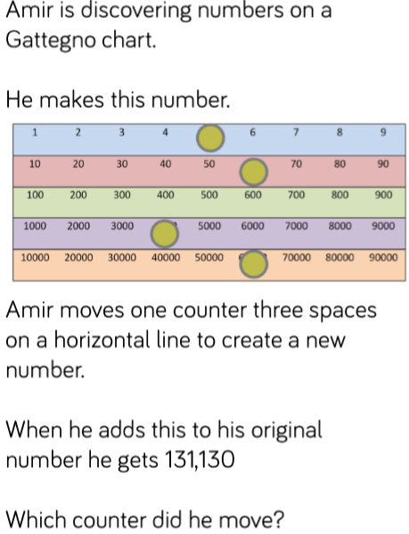

LO: To subtract more than 4-digit numbers.
Thursday 7th May 2020
Star words: place value subtract takeaway difference minus decrease by how many more

Fluency
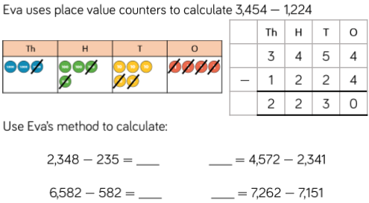
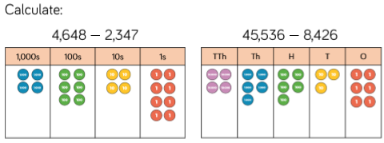

Reasoning
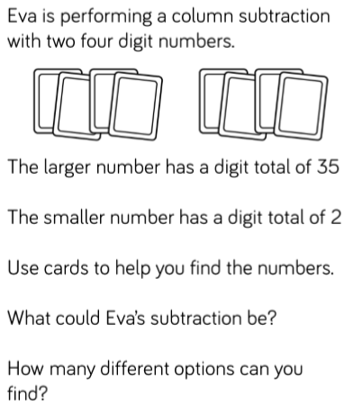 | 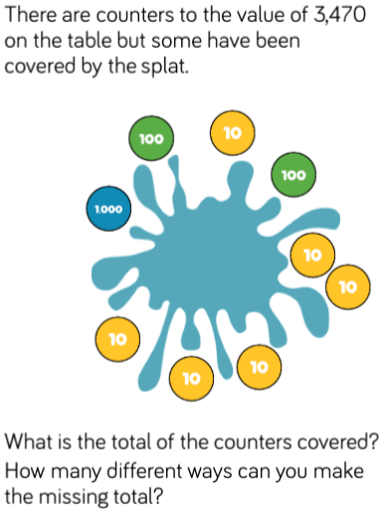
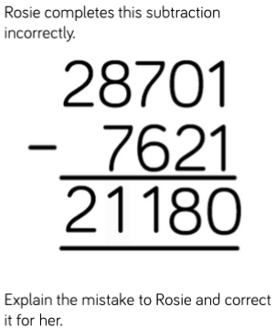 | 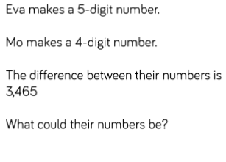

Problem Solving
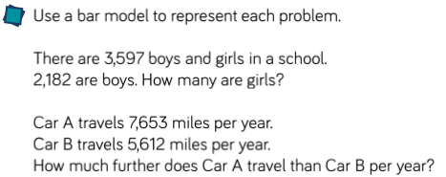

Challenges
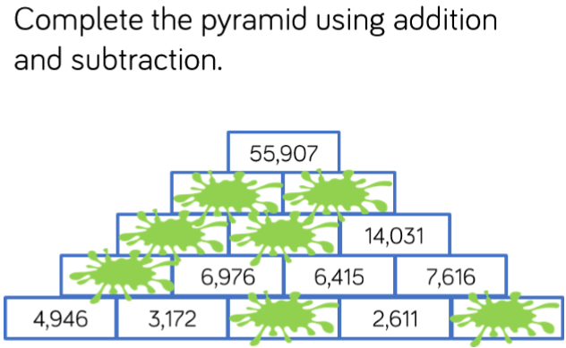

Friday 8th May 2020
Arithmetic
