Story Starter
!
He stood there next to his mother,
hand outstretched towards the
sky. They were both protected by
their coats and a large black
umbrella held by the tall woman.
The mother and her son were still
soaked to the core, however, as
the rain had been cascading down
for many hours.
!
They had known that something
strange was happening when they
had first heard the storm back at
home. The normal, distant rumble
of thunder had been accompanied
by a strange wind, almost a
whooshing sound. The only time
the boy had heard a noise like
that before was when they’d been
near a busy motorway.
!
They stared up at the remarkable
view above them, and wondered
what on earth was happening…
Pobble.com
Image by: Erik Johansson
Pobble365.com
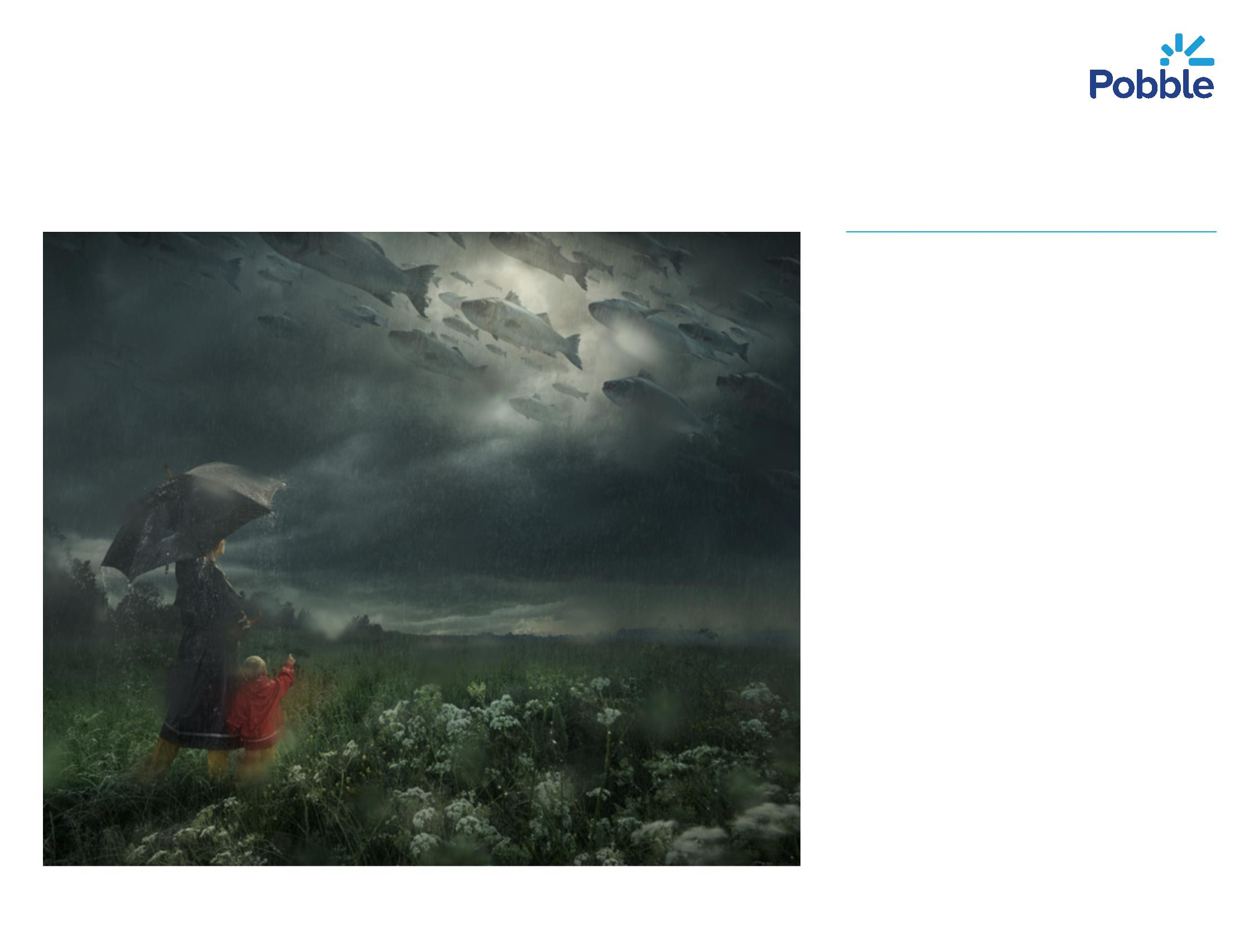

Sentence Challenge
Can you place the missing
brackets in the sentences
below?
The pair looked up at the
sky. The clouds which had
been gathering for a few
hours now) were a
worrying shade of black.
To their surprise, they saw
a shoal of enormous fish
swimming through the
cloud-filled sky. The fish
(of which there appeared
to be thousands were
moving at tremendous
speed.
Pobble.com
Image by: Erik Johansson
Pobble365.com
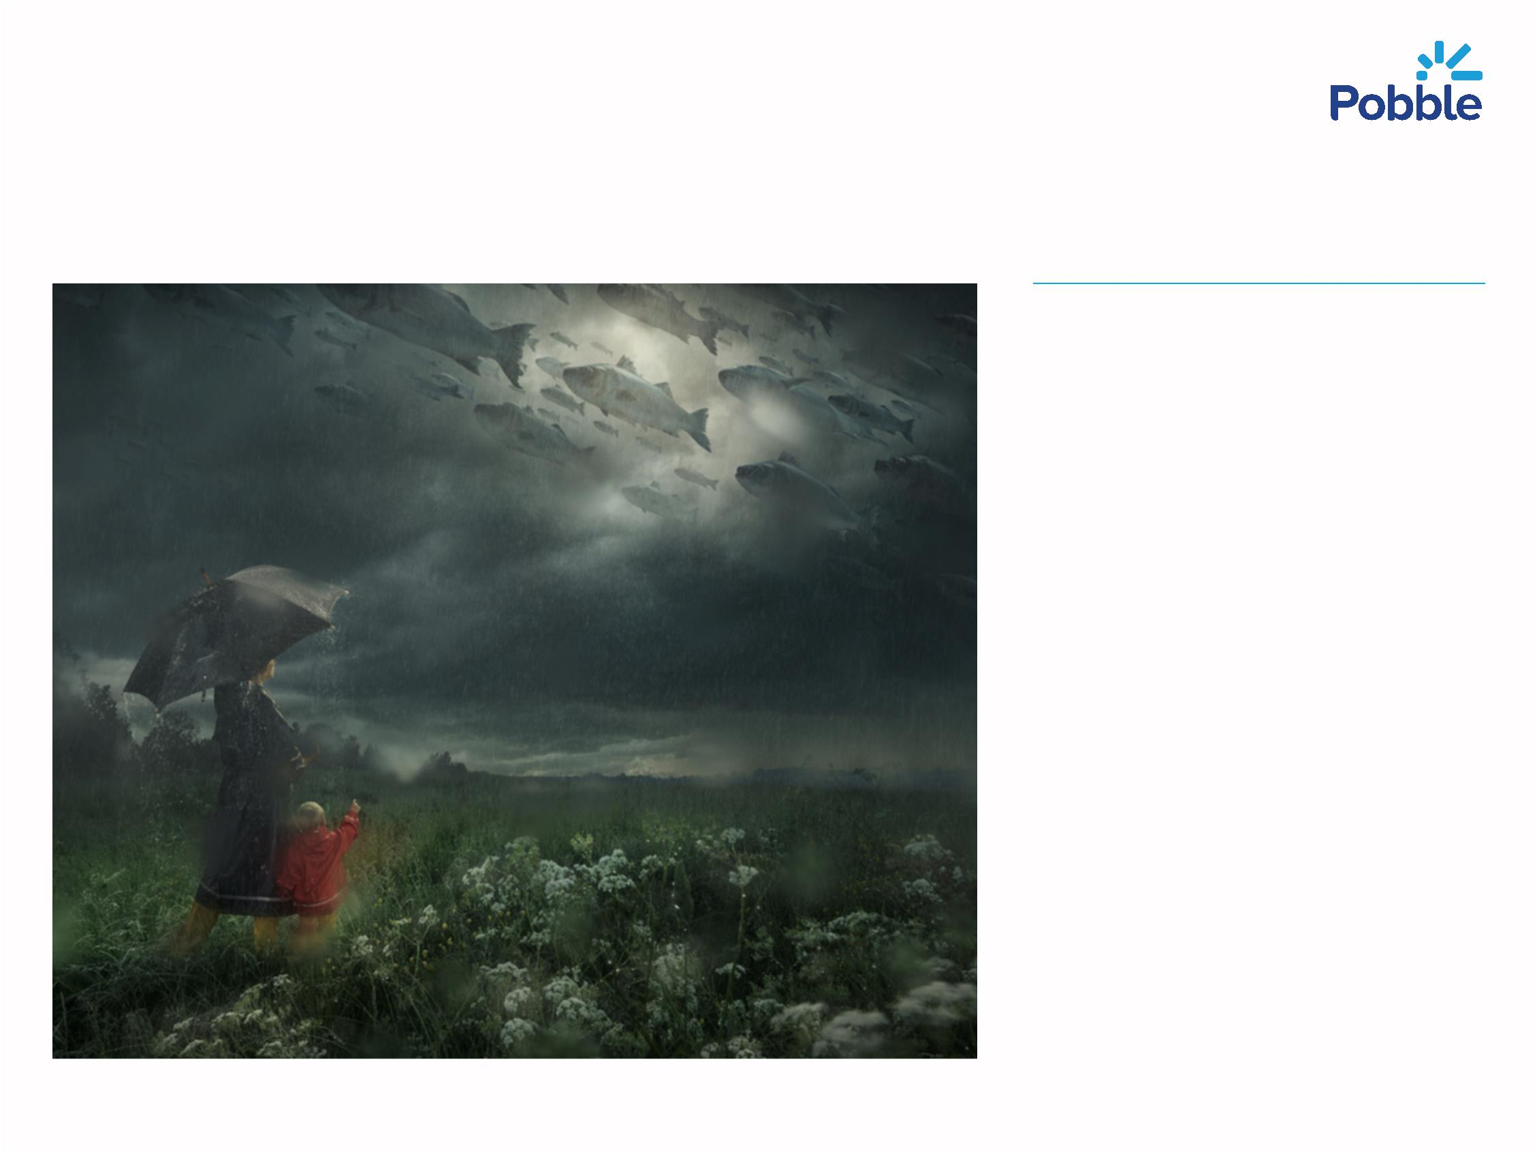

Question Time!
!
What was the noise that
they heard when they
were back at home?
!
!
!
!
Where do you think their
home is?
What can they see in the
sky?
How might they be
feeling?
What do you think is
happening?
!
!
What might happen next?
Are the people under the
water, or are the fish in
the sky?
Pobble.com
Image by: Erik Johansson
Pobble365.com

Sick Sentences!
These sentences are
‘
sick’ and need help to
get better. Can you
help?
!
The boy stood in the
field next to his
mother. He wore a
coat. He pointed at
the sky. He saw a
load of fish.
Pobble.com
Image by: Erik Johansson
Pobble365.com

Perfect Picture!
Can you draw a picture
of what the boy’s face
might look like when he
sees the fish?
Pobble.com
Image by: Erik Johansson
Pobble365.com
